Name/title of the good practice | Burduf Challenge
Contact person (owner of gp)  Name, email, phone number | Cristian Cismaru  contact@mytransylvania.ro
Is your organisation the main institution in charge of this good practice? | No, the organizer of this charity event is an NGO, My Transylvania Association. The County Council has been a co-financier of the event since the program's launch in 2018.
Thematic objective of the practice | Specific objective: the development of ecotourism offerings.
Country / region / city of good practice | Râu Sadului, Cindrel Mountains, County Sibiu
Image of the good practice | 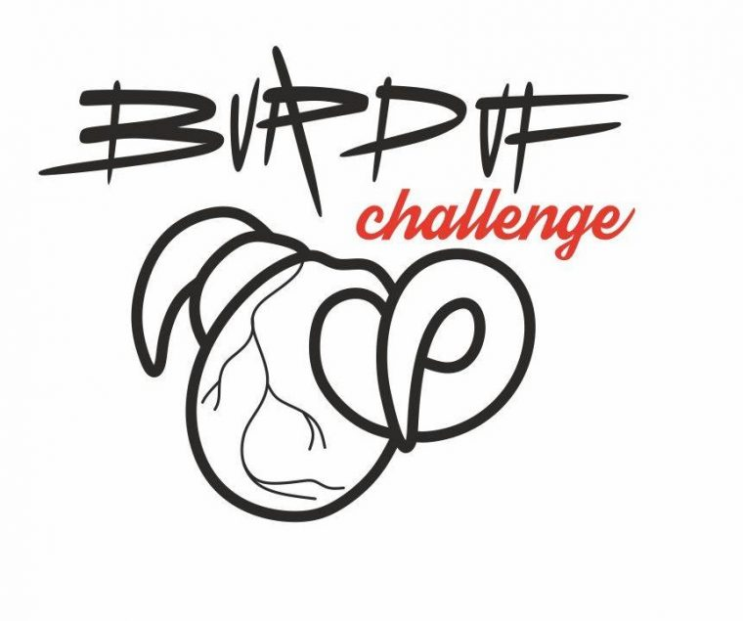
Short summary of the practice | Burduf Challenge is a mountain running competition that brings together multiple concepts aimed at promoting local heritage, particularly natural and gastronomic aspects:  - Showcasing the region’s most renowned local cheese, ”burduf de munte” (mountain cheese).  - Highlighting the tradition of transhumance and sheep farming by organizing the race in a subalpine grazing area.  - Utilizing the marked hiking trails from the ”Anii Drumeției” program as running routes.  - Celebrating local ingredients through a gastronomic event following the race.  - Promoting the region’s-built heritage, particularly traditional shepherds’ huts (” colibe”).  The project is a collaboration between the My Transylvania Association and the commune of Râu Sadului and is co-financed by the Sibiu County Council.
Detailed information about the gp: | Burduf Challenge is an event that brings together multiple interconnected fields, all centred around the responsible use of local resources.  The creativity of this initiative lies in the invitation extended by the organizers to both locals and visitors alike.  The 14 km race, featuring a 1,000-meter positive elevation gain along traditional shepherds’ trails, highlights the challenging process of cheese production. Participants are rewarded in two ways:  - Winners receive burduf de brânză (a traditional cheese).  - All runners enjoy a tasting of local products—a true culinary feast prepared by locals, using only seasonal and locally sourced ingredients.  Event Budget  The event is funded through multiple sources:  - 45% of the budget comes from the Sibiu County Council, provided as a grant through the cultural agenda funding program. This contribution covers expenses related to trail preparation, event locations, communication, and sports competition organization (including registration, race numbers, and timing).  - The commune of Râu Sadului supports the event with labour and printed materials.  - Participation fees are allocated as follows:  - 50% goes toward the renovation of traditional colibe (shepherds' huts) as part of the Țara Colibelor summer school, which takes place just before the race so participants can see the restored huts along the route.  - 50% is used for the post-race brunch, a gastronomic experience showcasing village ingredients, prepared by local residents.  Project Beneficiaries  The event creates multiple benefits for various groups:  - Visitors, who get the opportunity to run on the region’s most scenic trails in an organized setting and engage with locals.  - Local youth, who can participate in the race free of charge.  - Local producers, who can showcase and sell their goods at the adjacent fair.  - The commune of Râu Sadului, which gains recognition as an ecotourism destination.  - The Sibiu County Council, which promotes Sibiu County as an ecotourism hub while supporting small-scale producers and artisans.  - The My Transylvania Association, which raises funds for the restoration of colibe and provides students with the opportunity to learn traditional woodworking techniques.  - Colibe owners, who benefit from the renovation of their wooden structures.  Through this multifaceted approach, Burduf Challenge not only promotes mountain sports but also strengthens local heritage, gastronomy, and sustainable tourism.
Timescale (start/end date) | 2018 – 2024
Resources needed | EUR 12.000 annual  Budget sources: 45% County Council Sibiu, 5% Commune Râu Sadului, 50% My Transylvania Association (donations and registering fees).  12 organizing members, approximately 5 days of implementation before and on the day of the competition.
Evidence of success (results achieved) | 6 editions with approximately 100 runners per year.  Related Activities for Participants' Families:  - Local producers' market featuring 8-10 local producers.  - Craft workshops (3 workshops).  - Various thematic excursions for children, including plant foraging, wildlife observation, biology activities, and gastronomic workshops (cheese and honey). These activities attract around 150 participants each year.  Community Involvement and Support:  The organizing team consists of local collaborators and volunteer children.  Education:  - Encouraging creativity among local operators.  - Enhancing all participants' knowledge and understanding of local culture.
Potential for learning or transfer | - Learning how the public policy of the County Council and its financial instrument, the so-called "Funding Agenda," can support and develop an idea originating at the local level.  - Fundraising campaign for a local project: Țara Colibelor.  - Organizing a trail running competition with a clear objective of development and community involvement.  - Gastronomy as a tool for marketing and development: race winners receive cheese as prizes, and all participants, along with their families, enjoy a generous brunch made from local ingredients.
External website (optional) | https://experiences.mytransylvania.ro/burduf-challenge/
Tags related to your practice (optional) | Gastronomy, hiking, running, trail, transhumance, mountain culture,
In addition as optional: Documents, video, images | 