Municipality of Chania: The First of the Five Electric Buses has been Delivered
On Wednesday, October 4, 2023, MES ENERGY S.A. delivered the first of the five state-of-the-art electric buses that were ordered by the Municipality of Chania. The delivery of the remaining buses is expected to follow shortly.
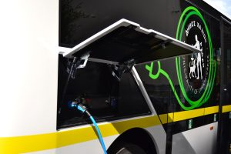
Present at the bus presentation were Chania’s Mayor, Mr. Panagiotis Simandirakis, Deputy Mayors Mr. Tasos Aloglou, Mr. Michalis Kalogridakis, Mr. Stelios Michailakis, and Mr. Michalis Tsoupakis, representatives from the contracting company MES ENERGY S.A. and TAM-EUROPE, along with the CEO of the Municipal Enterprise KYDON S.A., Mr. Charalambos Litos.
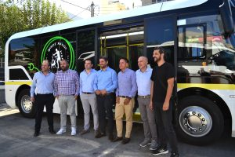
The new electric buses can transport at least forty passengers, including minimum 15 seated, with provisions for a wheelchair user and are designed to provide maximum comfort for all. They also feature ramps to facilitate boarding and disembarking for individuals using wheelchairs. With a range of over 150 kilometers per charge, these buses will be used for Chania’s municipal public transportation system to connect peripheral parking areas with the city center.
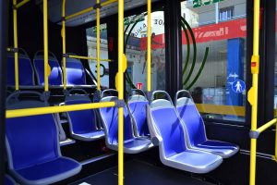
Kostis Terzis, CEO of MES ENERGY S.A., expressed his enthusiasm, saying, “We are delighted to receive the first of the five purely electric buses that will be part of the Chania Municipality’s fleet. These eight-meter buses accomodate 15 seated and 27 standing passengers, with provisions for individuals with disabilities. Depending on the conditions, the buses can cover up to 150 kilometers per day. I hope that the residents and visitors of Chania will appreciate this new, clean, and citizen-friendly technology.”
The project is entirely funded by the “Antonis Tritsis” program, which aims to upgrade the infrastructure of Local Government Organizations with a focus on sustainable development. The same contract also includes two fast electric vehicle (EV) charging stations capable of serving eight EVs simultaneously, along with an electric street and sidewalk cleaner.
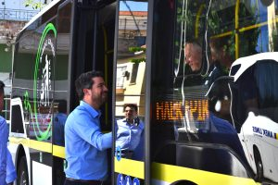
The procurement of these six vehicles and two fast chargers represents the initial significant step toward a broader and integrated approach to sustainable mobility for the Municipality of Chania, with a particular emphasis on promoting electric mobility.
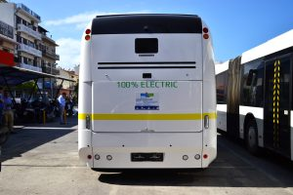

Add a video to support your good practice
Add images to support your good practice
