Good Practice template
To submit a good practice, you must register on the Interreg Europe website. You can submit your good practice through your user dashboard (good practices).
- Author contact information
Contact information is filled out automatically and comes from your profile. You can edit it in your dashboard.
Preferably, the owner of the good practice should fill in the form. If you are not the owner, please indicate this below.
Are you submitting the good practice one someone else’s behalf? | Yes, the owner of this good practice is AGADER (Galician Agency for Rural Development; Xunta de Galicia).
Your details | First name: | Paz
 | Last name: | Rodríguez Rivera
 | Email: | paz.rodriguez.rivera@xunta.gal
 | Phone number: | + 34 981 54 73 52

Are you involved in an Interreg Europe project?  If you are involved in more than one project, please choose the project for which you are submitting this good practice.  See our list of approved projects. | AGADER is involved in another Interreg Europe project (Earth to Down) but this practice is presented as a Good Practice identified by GIFT project.
In case ‘yes’ is selected, the following section appears:
Please select the project acronym: | GIFT

- Organisation in charge of the good practice
If your organisation is not the one in charge of the good practice, you can indicate the relevant organisation in this section of the form. Your contact details will still be linked to the submitted good practice.
Is your organisation the main institution in charge of this good practice? | Yes

In case ‘yes’ is selected, you can review your organisation’s details. In case ‘no’ is selected, you can select an existing organisation or add a new organisation.
- Good practice general information
If you are submitting a good practice as part of an Interreg Europe project, the thematic objective and sub-topic are chosen for you.
If you are not part of an Interreg Europe project, please remember to choose the most relevant thematic objective and sub-topic for your good practice.
Thematic objective of the practice: | “Integrated green infrastructure for forests and trees”  Biodiversity preservation
Geographical scope of the practice: | Regional
Location of the practice | Country | Spain
 | Region | Galicia
 | City | -
Practice image | 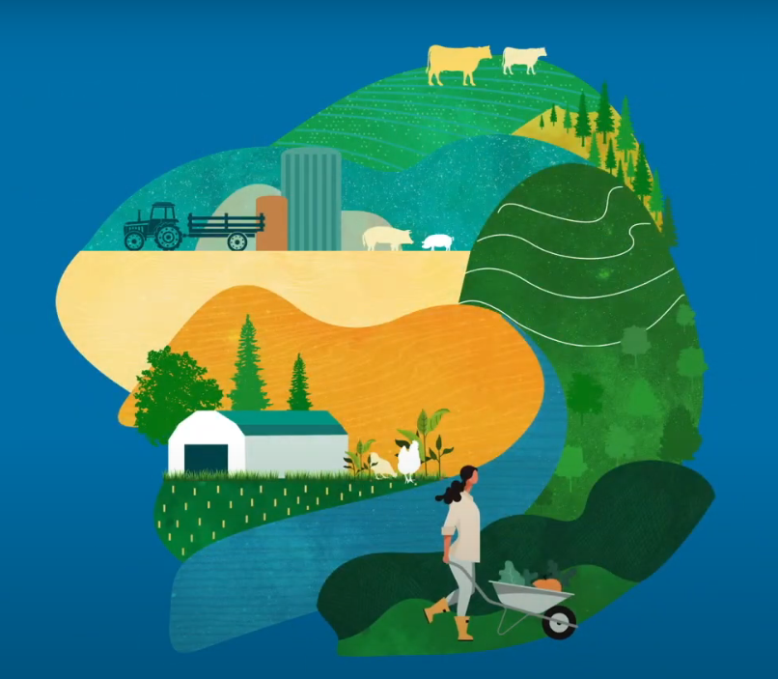
Title of the practice | Agroforestry Polygons: a multifunctional land reclamation mechanism

- Good practice detailed information
The questions below in italic are optional.
Short summary of the practice: | Agroforestry polygons serve to recovery land with good productive capacity, that are abandoned or under-utilised, and land with special environmental or landscape value
Detailed information on the practice: | Different historical reasons lead to land abandonment and underutilisation in the Galician countryside:  - Excessive fragmentation of ownership  - Ageing of the population structure  - Emigration of the working population from the countryside to the city.  - Gradual abandonment of agricultural activity  The combination of all these factors has socio-economic and environmental consequences in the short, medium and long term perspectives.  The socio-economic consequences can be summarised as follows: the existence of very small properties with little economic viability, lack of generational change on farms, abandonment of the land and even ignorance of the identity of the owners.  This prevents rational and sustainable land management and generates new problems related to the provision of ecosystem services.  In response to this, the Xunta de Galicia approved Law 11/2021, of 14 May, on the recovery of agricultural land in Galicia. One of the main objectives of the law is to connect land supply and land demand, allowing the creation of agroforestry polygons. An agroforestry polygon is created by joining several parcels of land in a state of abandonment or underutilization in order to bring them back into production, applying mixed practices (agricultural, livestock and forestry). In this way, it is achieved:  - Recovering production in areas of land with good productive capacity, abandoned or underused;  - Improve the territorial structure of existing farms or the implementation of new productive initiatives;  - Develop areas that have special environmental, heritage or landscape values but are deteriorated.  The polygons may be developed through public or private initiatives, always with the agreement of the owners of at least 70 % of the land area included in the proposed perimeter and 50 % of the abandoned or underused area.  For the implementation of agroforestry polygons, there must be a declaration of public utility and social interest.  With regard to landowners, in relation to agroforestry estates, as specified in Article 92 of Law 11/2021, of May 14, on the recovery of agricultural land in Galicia:  Until the time prior to the preparation of the restructuring proposal, the owners of the properties or, where applicable, the holders of the rights of use and exploitation over them, may choose before the Galician Rural Development Agency to:  - Assign sales commitments to the productive development agent at the minimum price set or, where applicable, exchange them. These prices must be respected or, where appropriate, improved by the development agent selected in accordance with the provisions of the competitive bidding procedure.  - Assign lease commitments to the productive development agent, for a duration consistent with the project's useful life, at the minimum price established in the project's feasibility study. These prices must be respected or, where appropriate, improved by the development agent selected through the competitive bidding process.  - Maintain and individually implement the lands in accordance with the guidelines established for the project and, within these, the good agroforestry practices included in the declaration of public utility and social interest, with the commitment to maintain these for the minimum duration of the project's useful life.  To this end, the owners of the properties included within the perimeter of the industrial estate, or, where applicable, the holders of the rights of use and exploitation over them, will be notified of the transfer prices or minimum leases, as well as the production guidelines established in the project, and they will be required to choose one of the alternatives established in the previous point or to express their non-adherence to the project.  The owners' involvement must be complete, as the area included in the project must represent a minimum of 70% of the total area of ​​the plots within the industrial estate perimeter. For these purposes, the area included in the industrial estate will be understood to be the area resulting from the signing of the commitments and the entry into production, as well as the area corresponding to the plots temporarily integrated into the Land Bank and the publicly owned plots managed by the Land Bank that are integrated into the project.  Without the agreement of 70% of the owners, the initiative cannot be carried out.
Timescale (start/end date): | 2021 - ongoing
Resources needed: | An average cost per hectare of 6.000 euros is estimated to carry out the start-up tasks of an Agroforestry Polygon (technical design, field work, preparation of plot closures).  There is also a technical team of personnel within the Agency to accompany the technical and administrative procedures, and it is necessary to hire external technical assistance for certain actions.  It is foreseen in the Strategic Plan of the Common Agricultural Policy (2023-2027), that this type of action will be financed through FEADER, for an amount of 7 million euros.
Evidence of success (results achieved): | The approval of Law 11/2021, of 14 May, on the recovery of agricultural land in Galicia, which contemplates the figure of Agroforestry Polygons , marks the beginning of the work.  At present, 34 polygons are being developed, grouping together 31,598 plots, which belong to 9,220 owners, covering an area of 9,532.19 ha.  The formalisation procedure of the agroforestry polygons is in different stages: 8 are in preliminary proceedings, 18 have already initiated agreements and 8 have drafted projects.
Potential for learning or transfer: | The good practice of agroforestry polygons can be transferred to any European region that has abandoned, underutilized or degraded lands and wants to contribute, among others, to the following objectives:  - Increasing the resilience of forests to climate change;  - Restoring degraded ecosystems;  - Promoting bioeconomy, preserving biodiversity;  - Increasing carbon stored in soils and forests;  - Increasing the use of wood and durable bio-products;  - Supporting sustainable agricultural production;  - Encouraging green entrepreneurship;  - Addressing the demographic challenge in rural areas.
External website (optional): | https://agader.xunta.gal/gl/recuperacion-de-terras/poligonos-agroforestais  https://agader.xunta.gal/sites/w_pagade/files/documentacion/PromocionRural/bloque_3_poligonos_agroforestais_optim.pdf  https://mapas.xunta.gal/visores/rtag/?extent=317317.7448688323,4592662.208048445,841675.7589048885,4863249.2881778395?layers=PNOA2020,masasconabandono,areasprodcalidadedif,poligonosagroforestais
Tags related to your practice (optional): | Rural development, land management, forestry management, trees, wood, ecosystem services, bioeconomy, climate change, food security, proximity economy, carbon sinks, erosion control, air purification, water purification, fire prevention, meeting climate targets, demographic challenge, rural depopulation, agro-livestock and forestry entrepreneurship, rural economy
Documents (optional): | https://www.xunta.gal/dog/Publicados/2021/20210521/AnuncioC3B0-190521-0001_es.pdf
Video (optional): | https://youtu.be/doZoBpcIAhM?si=JtBRygkIBm9rocWJ
Images (optional): | 