Good Practice template
To submit a good practice, you must register on the Interreg Europe website. You can submit your good practice through your user dashboard (good practices).
Contact person
A contact person should be indicated for each good practice submitted to the programme. Once published, this person can be contacted by members of the Interreg Europe community to get further information on the practice.
Per default, the contact person is the author of the practice. The details below are therefore completed automatically from your profile.
Your details | First name | Vojtěch
 | Last name | Jíra
 | Email | vojtec.jira@dex-ic.com
 | Phone number | +420 604 304 725

Do you want to indicate a different contact person for this good practice?  Only members of the Interreg Europe Community can be indicated as contact person for a good practice. | No
In case ‘yes’ is selected, the following section appears:

Email of the contact person: ______________________
Please note that you, as the author of the good practice, will remain responsible for editing this practice if needed.
Are you involved in an Interreg Europe project?  If you are involved in more than one project, please choose the project for which you are submitting this good practice.  See our list of approved projects. | Yes
In case ‘yes’ is selected, the following section appears:
https://www.interregeurope.eu/promoter
Please select the project acronym: | PROMOTER

Organisation in charge of the good practice
If your organisation is not the one in charge of the good practice, you can indicate the relevant organisation in this section of the form. Your contact details will still be linked to the submitted good practice.
Is your organisation the main institution in charge of this good practice? | No

In case ‘yes’ is selected, you can review your organisation’s details. In case ‘no’ is selected, you can select an existing organisation or add a new organisation.
DEX Innovation Centre (DEX IC) is a private innovation hub established in 2012 in Liberec, Czech Republic. Its mission is to improve society through digital innovation and research.
DEX IC focuses on healthcare, energy, and transportation sectors. Its core activities include securing funding for research and innovation projects, co-creating new innovations and products, building startups and tech teams, and educating students. Since its foundation, the center has secured over €30 million for innovative projects, supported more than 100 startups, and trained over 1,000 students.
DEX IC collaborates with key partners such as EIT Health and EIT InnoEnergy. It is involved in projects that promote entrepreneurship, healthcare innovation, and sustainable energy solutions.
More info on official website https://dex-ic.com/

Good practice general information
If you are submitting a good practice as part of an Interreg Europe project, the thematic objective and sub-topic are chosen for you.
If you are not part of an Interreg Europe project, please remember to choose the most relevant thematic objective and sub-topic for your good practice.
Thematic objective of the practice: | (viii) Sustainable urban mobility for zero carbon economy
Implementation level of the practice: | Local
 | Country | Czech Republic
 | Region | Bohemia Region
 | City | Říčany
Practice image | 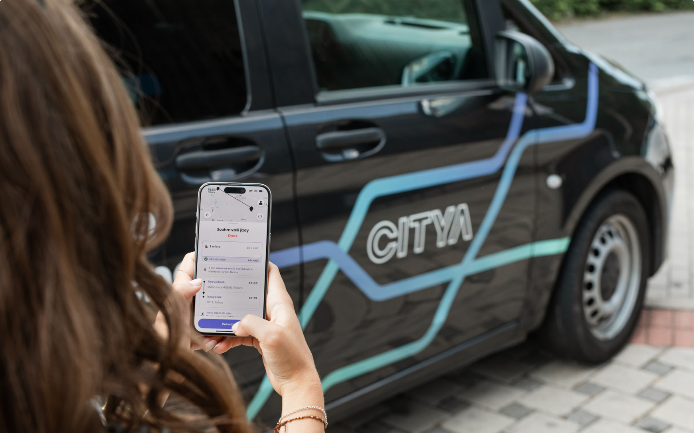  Source: https://www.citya.io/
Title of the practice | Dynamic Demand Responsive Transport (DDRT)

Good practice detailed information
The questions below in italic are optional.
Short summary of the practice: | DDRT uses data and technology to help municipalities, cities and counties safely get citizens where they need to go, when they need to go, without relying on fixed schedules.
Detailed information on the practice: | Říčany offers a unique and innovative public transportation system called Dynamic Demand Transport (DDRT), also known as your family public transport. This system utilizes real-time data and algorithms to optimize routes and schedules, providing a more efficient and flexible alternative to traditional public transportation. How it Works: Service Area and Hours: DDRT operates throughout the Říčany area on weekdays from 7:00 AM to 7:00 PM. The service has recently expanded to include neighboring municipalities like Tehovo, Tehovec, Světice, Babice, Svojetice, and Březí. Booking and Boarding: Users can book rides through a mobile application. The vehicle picks you up near your designated booking location (or an alternative pick-up point you specify). Pricing and Payment: Single rides start from CZK 30 (EUR 1.20). The exact fare is always displayed in the app before booking. You can cancel rides free of charge. Bookings can be made for multiple people. Seats are ordered, meaning you can order additional seats at a discounted price (80% off) for traveling together. Payment is cashless and secure. Enter your credit card information once in the app, and the fare is automatically charged after each ride. Additional Features: Advance Booking: You can book rides in advance for specific days and times. Family-Friendly: The vehicles are equipped with child seats and can comfortably accommodate strollers.  Benefits of DDRT: Reduced Wait Times: Unlike traditional bus schedules, DDRT dynamically adjusts routes based on real-time demand, minimizing wait times for passengers. Increased Passenger Satisfaction: The convenient booking system, flexible pick-up locations, and shorter wait times contribute to a more pleasant passenger experience. Optimized Resource Allocation: By efficiently deploying vehicles based on real-time data, DDRT optimizes resource allocation, potentially reducing fuel consumption and operational costs. Overall, Říčany's DDRT offers a convenient, user-friendly, and efficient public transportation option for individuals and families. The system fosters a sense of "family public transport" by catering to the needs of passengers with flexible scheduling and child-friendly features.
Timescale (start/end date): | 2018:First draft: The city of Říčany, in cooperation with Cytia s.r.o., is starting to consider the introduction of an innovative Dynamic Demand Transport (DDRT) system within the public transport system.  2019: Pilot project. The aim of the project is to test the technical feasibility and user acceptance of the system. Data collection and analysis. These data are analysed to optimise the system and prepare for its expansion.  2020:Expansion of the pilot project: The DDRT pilot project is extended to a larger area and a longer period of operation, providing additional valuable data and experience. Collaboration with neighbouring municipalities: The City of Říčany is establishing cooperation with neighbouring municipalities such as Tehovo, Tehovec, Světice, Babice, Svojetice and Březí with the aim of integrating DDRT into the regional transport network.  2021: Permanent introduction of DDRT: DDRT is officially introduced as part of the public transport system in Říčany and its operation is extended to the whole region of Říčany and selected surrounding municipalities. Marketing campaign: The City of Ricany launches a marketing campaign to promote the DDRT to residents and tourists, emphasising its convenience, flexibility and accessibility.  2022: Optimisations and adjustments: Based on data and user feedback, optimisations and adjustments are made to the DDRT system to further improve its efficiency and passenger satisfaction. Integration with mobile app: A mobile app for DDRT is being developed and launched to make it easier for users to book rides, track vehicle locations and manage payments.  2023: Expansion to other areas: the DDRT becomes a model for implementation in other cities and municipalities in the Czech Republic. The city of Říčany shares its experience and know-how with others interested in implementing similar systems. Sustainable future: the DDRT is proving to be a sustainable and efficient model for providing accessible and flexible public transport in Říčany and surrounding municipalities. The system is being further developed and integrated with smart city technologies.
Resources needed: | Financial: The financing of Citya shared transport in municipalities is handled by a combination of subsidies and the municipality's own resources.Subsidies: Operational Programme Transport: under this programme, municipalities can receive subsidies for the introduction of shared transport. Ministry of the Environment: the Ministry of the Environment also offers subsidies to support environmentally friendly modes of transport, which may include shared transport. Municipal own resources: The remaining costs of implementing and operating Citya shared transport are covered by municipalities from their own resources. Costs of Citya shared transport in Říčany: The total cost of introducing Citya shared transport in Říčany is estimated at CZK 5 million. The cost of operating Citya shared transport is estimated at CZK 1 million per year. Another example, Bystřice city: The following table presents possibility for Bystřice city and it’s a a comparison of the simulation results for operation with one or more vehicles. The comparison concerns in particular the number of trips offered and the associated average waiting time and possible delays. All this is specifically complemented by an economic analysis including the average daily and monthly revenue and the relevant operating costs.  Human: City of Ricany: DDRT team: responsible for planning, implementation and operation of DDRT.Works with partners to ensure smooth operation of the system. Transportation Department: Provides expertise in public transportation and works to integrate DDRT into the city's transportation network. Marketing Department: Promotes DDRT to residents and tourists and raises awareness of its benefits. IT department: Provides technical support and maintenance of the DDRT platform. Cytia Ltd: Development team: Designs and implements technology solutions for DDRT. Operations and Maintenance Team. Customer Service Team. Marketing and Sales Team: Promotes DDRT to potential partners and clients.
Evidence of success (results achieved): | The introduction of Dynamic Demand Transport (DDRT) in Říčany proved to be a great success for several reasons. A key role was played by the close cooperation between the City of Říčany and Cytia s.r.o., which enabled the effective implementation and operation of the system. Innovative technologies such as dynamic route optimization and real-time booking of rides ensure a user-friendly and flexible system. DDRT's emphasis on comfort and accessibility has contributed to its popularity among passengers. A proactive marketing campaign by the City of Říčany has helped to raise awareness of the system and encourage its use. The use of data and analysis to continuously improve and optimise the performance of the DDRT further strengthens its effectiveness. Support from the government in the form of subsidy programs helped fund implementation and ensure the sustainability of the system. While DDRT has faced some challenges, such as the need to change user behaviour, technical issues and integration with existing transport systems, the factors described above have helped to overcome these obstacles and make DDRT a thriving and popular public transport system in Ricany. The experience in Říčany shows that with careful planning, innovative technologies and a focus on users, DDRT can be successfully implemented in other cities and municipalities, contributing to the modernisation and efficiency of public transport.  Cooperation: close cooperation between the city of Říčany and Cytia s.r.o. was crucial for the successful implementation and operation of DDRT. Innovative technologies. User focus: DDRT was designed with the needs of users in mind, with an emphasis on convenience, flexibility and accessibility.Proactive marketing: the City of Říčany actively promotes the DDRT to residents and tourists, raising awareness of its benefits. Data and analysis: DDRT uses data and analysis to continuously improve the system and optimize its performance. Government support: Government programmes to promote innovative transport have helped fund the introduction of DDRT.
Potential for learning or transfer: | The portability of DDRT to other cities depends on a number of factors, including: - City size: DDRT is more suitable for larger cities with higher population and density. - Infrastructure availability: DDRT requires a robust infrastructure, including high-speed internet connections and data centres. - Political support: DDRT implementation requires support from local authorities. - Funding: DDRT can be costly to implement and operate. Some of the factors to consider when transferring DDRT to other cities: - City needs and requirements: It is important to analyze the specific needs and requirements of the city in order to select an appropriate DDRT solution. - Technology availability: It is important to consider the availability of the technology and infrastructure needed to implement DDRT. - Legal and regulatory aspects: It is important to consider the legal and regulatory aspects of implementing DDRT in a given city. - Funding: It is important to secure funding for the implementation and operation of DDRT.  Transferable activities and functions: Collaboration: Close collaboration between the City and the private sector is critical to the successful implementation and operation of DDRT. Technology Platform: DDRT uses innovative technology for real-time dynamic route planning and trip booking that is transferable to other contexts. User focus: Designing the system with comfort, flexibility and accessibility in mind is key to its attractiveness to users. Marketing and promotion: Active promotion of DDRT among residents and tourists is essential for its widespread use. Data and analysis: Using data and analysis to continuously improve and optimise the system is essential for its long-term sustainability.  Conditions necessary for adoption of the practice in other contexts: Political support: support from the city leadership and the city council is essential for the implementation and funding of DDRT. Funding: Sufficient funding is necessary for the acquisition of the technology platform, the operation of the system and marketing activities. Technical infrastructure: The availability of reliable internet connectivity and GPS navigation is essential for the operation of the DDRT. Willingness to innovate: The city and its residents must be willing to embrace new technology and change their transport behaviour. Cooperation with transport companies: Integration of DDRT with existing public transport systems is essential to ensure seamless transfers for passengers.
External website (optional): | https://www.citya.io/  https://www.ricany.cz/mesto/mestska-doprava/sdilena-doprava-citya/
Tags related to your practice (optional): | Transport, Mobility, Smart, Urban mobility
Documents (optional): | Add documents to support your good practice
Video (optional): | Add a video to support your good practice
Images (optional): | 