Good Practice template
To submit a good practice, you must register on the Interreg Europe website. You can submit your good practice through your user dashboard (good practices).

Contact person
A contact person should be indicated for each good practice submitted to the programme. Once published, this person can be contacted by members of the Interreg Europe community to get further information on the practice.
Per default, the contact person is the author of the practice. The details below are therefore completed automatically from your profile.
Your details | First name | Ivana
 | Last name | Milovanović
 | Email | i.a.milovanovic@gmail.com
 | Phone number | +381642611731

Do you want to indicate a different contact person for this good practice?  Only members of the Interreg Europe Community can be indicated as contact person for a good practice. | Yes / No
In case ‘yes’ is selected, the following section appears:

Email of the contact person:
Please note that you, as the author of the good practice, will remain responsible for editing this practice if needed.
Are you involved in an Interreg Europe project?  If you are involved in more than one project, please choose the project for which you are submitting this good practice.  See our list of approved projects. | Yes
In case ‘yes’ is selected, the following section appears:
Please select the project acronym: | DEPART

Organisation in charge of the good practice
If your organisation is not the one in charge of the good practice, you can indicate the relevant organisation in this section of the form. Your contact details will still be linked to the submitted good practice.
Is your organisation the main institution in charge of this good practice? | Yes / No  Velimir Kadović  kampvidre@gmail.com  +381607217001

In case ‘yes’ is selected, you can review your organisation’s details. In case ‘no’ is selected, you can select an existing organisation or add a new organisation.

Good practice general information
If you are submitting a good practice as part of an Interreg Europe project, the thematic objective and sub-topic are chosen for you.
If you are not part of an Interreg Europe project, please remember to choose the most relevant thematic objective and sub-topic for your good practice.
Thematic objective of the practice: | In case the good practice is not part of an Interreg Europe project, selection of one of the 24 specific objectives
Implementation level of the practice: | Select National/Regional/Local
 | Country | R. Serbia
 | Region | AP Vojvodina
 | City | Kula
Practice image | 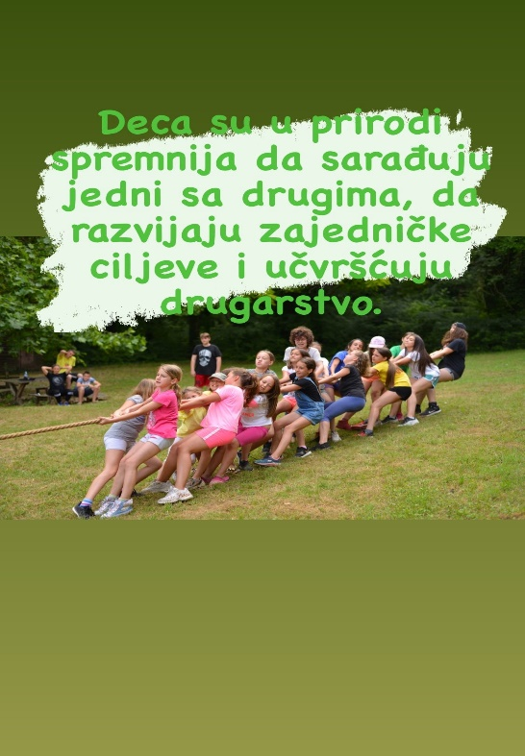
Title of the practice | Camp VIDRE

Good practice detailed information
The questions below in italic are optional.
Short summary of the practice: | This short text works as a preview for the good practice and it will appear at card level. [160 characters]  Camp VIDRE offers sports, education, and nature activities, helping children develop skills, stay active, and learn about environmental preservation.
Detailed information on the practice: | Please provide information on the practice itself. In particular:  What is the problem addressed and the context which triggered the introduction of the practice?  - Camp VIDRE was established in response to the growing disconnection between children and nature. The lack of environmental awareness and physical activity among young people were key triggers for the camp creation.  How does the practice reach its objectives and how it is implemented?  - The camp achieves its goals through a combination of ecological, educational, and recreational programs:  Environmental workshops about sustainability and nature conservation.  Outdoor sports and adventure programs, promoting physical activity and healthy habits.  Community engagement initiatives, involving local businesses, municipalities, and organizations in supporting the camp’s sustainability efforts.  Who are the main stakeholders and beneficiaries of the practice?  - Beneficiaries: Primary school students  - Stakeholders:  - VIDRE Youth Association.  - Local municipalities (Kula, Bačka Topola) – provide institutional support.  - Waters of Vojvodina & Provincial Institute for Nature Protection – contribute expertise and environmental guidance.  - Local businesses – hotels, transport services, restaurants, and craftsmen benefit from increased tourism.  - Volunteers and educators – facilitate camp activities and workshops.  - Media (local and national) – help promote the camp and raise awareness.
Timescale (start/end date): | June 2012 - ongoing
Resources needed: | Please specify the number of funding/financial resources used and/or the human resources required to set up and to run the practice.  - Partners include Vojvodina’s schools, sports clubs, ecological associations, the Faculty of Sports and Physical Education, Waters of Vojvodina, and the Provincial Institute for Nature Protection.  - The camp has 40 trainers, equipment, and 20 volunteers.  - The total financial resources required amount to 709,746.4 euros, divided as follows:  - Public grants: Municipality of Kula – 8,533 euros  - Private funds (equipment): 42,665 euros  - Parents' contributions (children’s participation fees): 658,548.4 euros
Evidence of success (results achieved): | - 20,000 children participate annually, with a high return rate.  - 5,000+ trees planted, hundreds of kilometers of riverbanks cleaned.  - Inclusive environment for children from diverse backgrounds.  - Boosts local economy, increasing demand for tourism and services.  - Recognized by municipalities and environmental organizations.  - Extensive media coverage, promoting sustainability and community engagement
Potential for learning or transfer: | Please explain why you consider this practice (or some aspects of this practice) as being potentially interesting for other regions to learn from. This can be done e.g., through information on key success factors for a transfer or on, factors that can hamper a transfer. Information on transfer(s) that already took place can also be provided (if possible, specify the country, the region – NUTS 2 – and organisation to which the practice was transferred)  - Multi-sector collaboration – Involves schools, municipalities, and environmental organizations.  - Sustainable tourism – Supports local businesses while promoting eco-tourism.  - Environmental initiatives – Includes reforestation and riverbank clean-ups.  - Key success factors: Strong community support, low-cost implementation, and suitable natural resources.  - Camp VIDRE’s model has sparked interest in other Serbian regions, with potential for expansion to neighboring countries.
External website (optional): vidre.rs
Tags related to your practice (optional): | Screen-free socializing  Outdoor education  Sports and recreation  Sustainable tourism  Active lifestyle  Nature-based learning
Documents (optional): | Add documents to support your good practice
Video (optional): | https://www.youtube.com/watch?v=ZQzwGTfuEWk
Images (optional): | 