Step 2
Good Practice
Intercorum - Interactive coaching for the development of three resilient villages in Romania - Marpod, Cincsor and Viscri

Intercorum - Interactive coaching for the development of three resilientvillages in Romania - Marpod, Cincsor and Viscri

In order to submit a practice, you will have to register in the Interreg Europe website. You can submit your practice through your user dashboard (‘Good practices’ tab).

Summary
1. Contact information 3
2. Organisation in charge of the Good Practice 3
3. Good Practice general information 3
3.1 Classification 4
4. Detailed description 5
4.1 Short summary of the Practice 5
4.2 Detailed information on the Practice 5
4.3 Timescale (start/end date) 5
4.4 Partnership 5
4.5 Stakeholders / Target groups 5
4.6. Products and services 6
5. Resources 6
5.1 Summary 6
5.2. Financial resources 6
5.3. Human resources 7
5.4. Legal framework 7
6. Monitoring and evaluation 8
6.1 Summary 8
6.2. Assessment methods and tools 8
6.3 Indicators 8
6.4. Monitoring materials available: Yes/No 8
7. Success factors / difficulties encountered 8
7.1 Summary 8
7.2. Enablers of the Practice 8
7.3. Success Factors of the Practice 9
7.4. Challenges encountered 9
7.5. Innovative content of the Practice 9
7.6. Added value of the Practice 9
7.7. Possible leverage effect to trigger further improvements in policies and Practices 9
8. Transferability and Durability 10
8.1 Potential for learning or transfer (Summary) 10
8.2. Transferable activities and features 10
8.3. Conditions required for the Practice to be developed in other contexts 10
Upload image 11
Enclosures: 11
REMINDER: 11

This Good Practice has been documented by PROMOTER Partner  | PP10
and is given the reference code | GP3
(Codes shall be inserted by Lead Partner)

Contact information
Name | Jacob Bußmann
Email | j.bussmann@umwelt-campus.de
Telephone | +049 (0) 6782 17 -14 75
Your organisation
Country | Romania
Region | Centre Region, Brasov County
City | Brasov

Organisation in charge of the Good Practice

[ If your Organisation is not the one in charge of the Good Practice, you can indicate the relevant organisation in this section of the form ]
Is your organisation the main institution in charge of this Good Practice? | No

In case ‘no’ is selected, the following sections should be filled in:
Location of the organisation in charge: | Country | Germany
 | Region | Rhineland-Palatinate
 | City | Birkenfeld
Main institution in charge | Trier University of Applied Sciences, Environmental Campus Birkenfeld, Institute for Applied Material Flow Management (IfaS)

Good Practice general information
Title of the Practice | Interactive coaching for the development of three resilient villages in Romania based on renewable energies considering biomass potentials in a biodiverse cultural landscape in Transylvania
Source of the Good Practice | Funded by Deutsche Bundesstiftung Umwelt (DBU)

Please select the project acronym | INTERCORUM
Geographical scope of the Practice (Select National/Regional/Local) | Local (Three villages: Marpod, Cincșor and Viscri)
Location of the Practice | Country | Romania
 | Region | Transylvania (Counties Sibiu and Brasov)
 | City | Viscri and Cincșor (Brasov County)  Marpod (Sibiu County)

  - Classification according to one of the following 5 Categories

 | 1) Legislative
X | 2) Behavioral / Organizational
 | 3) Economic
 | 4) Technological
 | 5) Operation scope and environment. Other features

7) Others (please provide details in the space below)
Sustainable rural development

Detailed description
4.1 Short summary of the Practice | Initiate the transformation of three Romanian villages into resilient villages considering sustainable use of their locally available renewable resources.
4.2 Detailed information on the Practice | The project developed by IfaS focuses on coaching for the development of resilient villages in Viscri, Cincșor and Marpod. The aim is to develop climate protection measures considering local potentials. This includes, in addition to the further development of renewable energies and the increase of energy efficiency, the promotion of sustainability by using locally available resources in an energetic and ecological sense. The context that triggered the introduction of this practice is the need to create resilient and sustainable villages that manage their comunity, pastures and forests in a traditional and sustainable way while utilizing renewable energy. This initiative has been generated by the challenge to mitigate climate change and the need for adapting to these changes by the Romanian rural areas, taking into account at the same time the social, ecological and economical perspectives.  To increase the resilience of the villages, the villages were thoroughly analysed from 2021 – 2023 together with local stakeholders. Based on this analysis, the current state in terms of energy use and GHG emissions of the villages was documented. This served as basis for a potential analysis, at the end of which a catalogue of measures was drawn up for each village. The measures are dealing with the fields of renewable energy, bioeconomy, building renovation, tourism, water efficiency, mobility and financial mechanisms. The resulting project measures and network form the basis for applying for further funding.  The particular situation of Viscri village, which is listed as a UNESCO World Heritage Site, with very strict imposed rules and regulations, has been rather difficult to analyse and provide solutions because of the challenges to reconcile the energy transition and at the same time to maintain the required monument protection.
4.3 Timescale (start/end date) | February 2021 - June 2024

4.4 Partnership
List of partners involved in the Practice:
Partner 1
Name of Institution/company: Institute for Applied Material Flow Management (IfaS)
Brief description: Research Institute promotes the sustainable optimization of regional and operational material flows in specific and practice-oriented projects worldwide
Web: https://www.stoffstrom.org/?lang=en
Partner 2
Name of Institution/company: ADEPT Transylvania Foundation
Brief description: NGO – dedicated to biodiversity conservation and rural development in the Transylvanian region
Web: https://fundatia-adept.org/ro/home/
Partner 3
Name of Institution/company: Mihai Eminescu Trust Foundation
Brief description: NGO- dedicate to preserving the local heritage and reviving the villages and communes of Transylvania and Maramureș, two of the most authentic areas in Europe
Web: https://www.mihaieminescutrust.ro/en/
Partner 4
Name of Institution/company: S.C. SVB CONSULTING S.R.L.
Brief description: Private entity - Business and other management consultancy activities
Web: -
Partner 5
Name of Institution/company: Cinsor Transilvania – Case de Oaspeti (House Guests)
Brief description: Private entity – that restored old houses and introduced them in the touristic circuit as guest houses, and is ECO certified
Web: https://transilvania-cincsor.ro/de/home-2/

4.5 Stakeholders / Target groups
Identify Stakeholders and target groups/customers of the Practice, by crossing the relevant cell (column ST if stakeholder, column TG if target group, or both if applicable)
ST TG
 |  | National authority
X |  | Regional authority
X |  | Local authority
 | X | Private companies (large)
X | X | Private companies (SMEs)
 |  | Chamber of Commerce / Economy
X |  | Regional Innovation Agency
X |  | Financing institution
 |  | Business incubator
 |  | Research institution
X |  | University
 |  | Technology transfer institution
 |  | Regional Development Agency
 |  | Planning institution
 |  | Educational institution / training centre
 | X | Association (e.g. friends of the theme)
 |  | Employers' association
 |  | Trade union
X | X | Environmental interest group
 | X | Cultural initiative group / organization
 | X | Non-Governmental Organisation
 |  | Transport operators
 | X | Other interest groups (provide details in the space below)
- Inhabitants
- Local farmers
- general public – all interested citizens from rural area

4.6. Products and services
Describe specific products and services l developed in the framework of the Practice (i.e. physical assets, services, manuals, training courses, catalogues, software, maps, agreements or other regulations, websites, newsletters, etc):
1. Workshops: As a part of the project the team organized and carried out workshops, in order to discuss the local situation and to refine the proposed measures together with the local stakeholders.

2. Catalogue of measures: The results of the potential analysis were written down in specific measures which in summary are listed in one catalogue of measures for each village.
The following measures were proposed within the catalogue:

- Photovoltaic - 9 measures
- Building renovation - 8 measures
- Mobility - 5 measures
- Biomass - 6 measures
- Water use - 3 measures
- Tourism - 5 measures
- Other - 5 measures

3. Factsheets: In order to provide specific information materials to the local communities, the project team designed factsheets about specific topics related to the project contents (PV, building renovation, decentralized heating systems, the project scope of the village).

Resources
5.1 Summary | The project INTERCORUM was funded by the Deutsche Bundesstiftung Umwelt (DBU) with 124.861 €. The project team of IfaS consists of one project director, two project managers and three further project team members.  [300 characters] Please specify the amount of funding/financial resources used and/or the human resources required to set up and to run the Practice.

5.2. Financial resources
Specify the resources utilized for financing the different stages of the Practice (design, implementation. maintenance, management) providing a breakdown by stage:
The sources of financing were 100 % provided by public funds (DBU). The project design, the analysis as well as the methodology used for the catalogue of measures were developed without additional costs by the experts from the Institute for Applied Material Flow Management (IfaS).

Following are the stages of implementing the project.

Analysis of current situation:
• Data collection
• Stakeholder analysis

Potential analysis:
• Renewable energy
• Energy efficiency
• Biomass etc.

Analysis of future situation:
•Potential analysis consideration

Stakeholder participation:
• Identification of key actors
• Continuous coordination
• Catalogue of measured

The implementation, maintenance and the management of the project was carried out by IfaS with the support of the 3 Romanian partners without additional costs other the amount already received for the project implementation.
As for the next future steps after implementing the project, such as: village Networking; establishing of a cooperation network between neighbouring villages for knowledge sharing, future projects and joint development; forming working group; local organizations, institutions (e.g. the Protestant church), village administration, active citizens to form a working group in each village; develop new projects; using the provided measures and by creating new ideas and jointly applying for funding- we envisage no additional costs, since all the partner’s involvement will be on a voluntary basis in an effort to empower the communities and to make them more resilient and independent.
Specify the source/s of financing (divided between public and private funds, in % terms) also broken down by stage as applicable:
100% Deutsche Bundesstiftung Umwelt (DBU)

5.3. Human resources
Specify the persons (type & n°) engaged in the Practice, including their specialization / background:
- Prof. Dr. Peter Heck (managing director and project leader)
- Thomas Anton (head of department “renewable energies and energy efficiency”)
- Karsten Wilhelm (project manager, biomass and bioeconomy)
- Jacob Bußmann (project manager, financial administration, material flow management)
- Dejan Rastovac (project manager, energy efficiency and renewable energies)
- Emanuel Altmeier (project manager, energy efficiency and renewable energies)

5.4. Legal framework
Specify any regulatory requirement relevant to the implementation of the Practice
- Historically preserved building structure and UNESCO World Heritage Site
- Law no. 220/2008 and subsequent supplements, the Romanian Parliament established the system for the promotion of renewable energy production
- Law No 123 concerning Electricity and Natural Gas, which establishes the regulatory framework for carrying out activities within the electricity and thermal energy sector produced in cogeneration
- Governmental Emergency Ordinance (GEO) no. 163 from November 29th, 2022 regarding the completion of the legal framework for the use of energy from renewable sources promotion

Monitoring and evaluation
Insert: If the Practice has not been assessed yet, please enter NONE in 6.1

6.1 Summary
For the ex-post evaluation and monitoring, during the 24th to 26th of May 2024 the financer - Deutsche Bundesstiftung Umwelt (DBU) will carry out a follow-up evaluation workshop in the three local communities so as to assess the project results and impact.

6.2. Assessment methods and tools
Ex-post evaluation workshop carried out by the financer.

6.3 Indicators
Specify the qualitative and quantitative indicators used to assess the Practice:
-Number of conducted regarding the potential for renewable energy resources for the three target villages – Viscri, Cincsor and Marpod
-Number of measures to be developed and included into a catalogue aimed at using the potentials can be exploited by the villages in the future towards more resilient and environmentally friendly measures
-Number of fact sheets to be developed for each village from the perspective of their photovoltaic, building renovation and heating system capacity and potentials

6.4. Monitoring materials available: Yes/No

Yes No
x

If Yes, please specify (report, spreadsheet, etc.)

-

Success factors / difficulties encountered

7.1 Summary
The methodology used enabled the project team to analyse the villages in detail and develop suitable measures for the transformation to resilient villages. The project partners, who involved the local stakeholders, also played an important role in this process. The catalogue of measures that was developed identified and analysed the potentials of each village so in the future all that knowledge and potential can be exploited by the village, thus providing an important advantage for achieving resilience and sustainability for the rural areas.

7.2. Enablers of the Practice
Identify among the actors mentioned in 4.5 those who contributed the most to the success of the practice and list them below:
Non-Governmental Organisations:
- ADEPT Transylvania Foundation
- Mihai Eminescu Trust Foundation
- SVB CONSULTING SRL
- Cinsor Transilvania – Case de Oaspeti (Guest Houses)

Local authorities:
- Viscri,
- Cincșor
- Marpod

Other:
- Environmental interest group
- Cultural initiative group / organization
- Local inhabitants
- Local businesses

7.3. Success Factors of the Practice
Describe success factors:
- First type of extensive study on rural villages in this area of the country
- Showed the potentials in the fields of building efficiency, PV, biomass, bioeconomy and listed up additional measures in the fields of tourism, water efficiency, mobility, financial mechanisms
- Increase the awareness of topics like renewable energies, potentials of the region, climate protection
- Showing a way to diversify the energy supply and increase the energy independence

(Factual evidence can be taken from the measures catalogue and the Factsheets.)

[500 characters] Why is this practice considered as good? Please provide factual evidence that demonstrates its success or failure (e.g. measurable outputs/results).

7.4. Challenges encountered
Describe difficulties encountered and solutions adopted to overcome them:
The project was influenced by the COVID-19-pandemics and war in Ukraine which resulted in a project extension. In addition, the analysis was difficult due to very little data related to Romanian rural areas/villages. For this reason, the project team carried out on site visits to gather specific information about the three villages.
[300 characters]

7.5. Innovative content of the Practice
Specify additional information useful to justify this Practice as innovative,
compared to similar practice design, implementation and management:
This project was the first to apply the material flow management approach to these villages in Romania.
Based on a detailed material flow analysis, the sources and sinks of the villages’ material flows were analysed. After that, the potentials of the villages were determined. These potentials were translated into measures which can be implemented in the future. As a result, it was shown that the villages have a considerable development potential for climate protection and regional added value. In this way, they can be transformed from energy importers into energy suppliers. However, this requires the commitment of the village community and an expansion of the infrastructure for renewable energy supply.
Therefore, the innovative approach consists in:
- The comprehensive methodology for documenting both the status quo analysis and the catalogue of measures
-The measures identified within the catalogue of measures are innovative both from a technological point of view but also because of the creative and integrated approach
- The involvement of the community in designing and adopting the appropriate measures for each of the targeted villages

Describe the innovation content in relation to one or more of the following:
Process:
In terms of process innovation, the project carried out a thorough mapping exercise to systematically identify and assess potentials within the target area. This included a detailed study of the specific consumption of the buildings in the villages, with a particular focus on identifying energy efficiency potential. The compendium of measures was designed to integrate modern technologies into traditional infrastructure, while employing a participatory and interactive method in order to customize the appropriate solutions for each community. Through this process, the project provided the basis for informed decisions and strategic measures to transform the villages.

Product:
In terms of product innovation, the project developed a robust set of measures, complemented by detailed information sheets. These resources serve as valuable tools for stakeholders, providing practical insights and actionable recommendations to promote the transformation to a resilient village. By compiling a comprehensive collection of measures and accompanying documentation, the project has facilitated the implementation of effective solutions tailored to the specific needs of the communities involved.

Result:
In terms of results, the project has reached an important milestone by filling a critical gap in existing research. Prior to this initiative, there was no comprehensive study that specifically addressed the status quo of energy consumption in the small villages studied or that identified untapped potential for improvement. Through careful data collection and analysis, the project provided invaluable insights into the current energy landscape while also identifying opportunities for improvement and optimization.
Partnership:
Crucially, the project fostered a culture of collaboration and partnership and recognized the importance of collective action for meaningful change. By actively engaging stakeholders and fostering dialog, the initiative succeeded in building and consolidating a productive stakeholder network. This collaborative framework not only facilitated knowledge sharing, but also paved the way for coordinated efforts towards sustainable development goals.
In essence, the project's multifaceted approach to innovation underscored its commitment to addressing pressing energy challenges while fostering collaboration, knowledge sharing, and actionable outcomes within the communities it served.

7.6. Added value of the Practice
Specify returns: generated revenue or savings, other results proving added value of the Practice, as applicable:
A unique (comprehensive) cartographic approach per each village, highlighting the existing potential for energy development, energy consumption reduction, and transformation into resilient communities.

7.7. Possible leverage effect to trigger further improvements in policy instrument or practice
The project was able to identify a lack of policies and infrastructure which blocks or deters the development of the villages. For example, there is a lack of experienced and competent energy advisors or climate protection managers in rural areas who are familiar with village structures and to whom local citizens can turn. This requires a training program and state funding to create such positions.
Furthermore, the political players must make it possible for those villages that have to deal with the consequences of the large crowds during the peak tourist season to introduce a levy for day tourists. This could be used to finance projects at regional level to preserve the villages.
Most of the actions proposed in the Catalogue of measures are in the prototype stage and can be implemented in other neighbouring communities as well, with or without appropriate adjustments.

Transferability and Durability

8.1 Potential for learning or transfer (Summary)
The key findings unearthed by the project offer significant potential for learning and transfer, not only within the context of the examined villages but also for broader applications in similar settings. These findings serve as valuable insights that can inform and inspire sustainable energy initiatives in various communities worldwide.

Firstly, the revelation that more electricity can be generated from photovoltaic (PV) plants than the villages currently require presents a compelling opportunity for learning. This surplus electricity production highlights the feasibility and scalability of renewable energy solutions, emphasizing the potential for excess energy generation to be harnessed for additional purposes or redistributed within local grids. This finding could inspire other communities to explore the deployment of renewable energy technologies to meet their energy needs while contributing to overall energy resilience.

Secondly, the discovery that the current heating demand can be partially met through locally produced wood underscores the importance of leveraging local resources for sustainable energy solutions. Agroforestry has the major potential to satisfy this demand and thereby reducing the stress on the ecosystem forest, which becomes an increasing problem in Romania. This finding not only promotes energy self-sufficiency but also encourages the adoption of environmentally friendly heating practices, thereby reducing reliance on fossil fuels and mitigating GHG emissions.

Thirdly, introducing a new type of heating system, such as an air-to-air heat pump, represents a significant leap forward in energy efficiency and sustainability. This innovative technology integrates well with the existing decentralized heating systems and can be used for heating in transitional periods. Moreover, synergy between the heat pump and the household PV-system would in overall increase the efficiency of both systems and reduce dependence on fossil fuel.

Additionally, the project's findings underscore the significance of exploring nature-based insulation materials, particularly for historic buildings. While enhancing energy efficiency through insulation measures like attic and basement ceiling insulation is crucial, it's equally important to consider the preservation of architectural heritage, especially in communities with historic structures. Nature-based insulation materials, such as sheep wool and other sustainable resources, offer promising solutions for balancing energy efficiency with heritage conservation. These materials provide effective insulation properties while aligning with principles of sustainability and environmental stewardship. By incorporating nature-based insulation into retrofitting initiatives for historic buildings, communities can achieve energy savings without compromising the integrity or authenticity of their architectural treasures. The project's insights into the viability and benefits of nature-based insulation materials for historic buildings serve as valuable lessons for preservationists, architects, and policymakers alike. By embracing innovative approaches that harmonize energy efficiency with heritage preservation, communities can achieve sustainable development goals while safeguarding their cultural heritage for future generations. This is also crucial to secure the tourism as an important source of income for the villages.
Moreover, the revelation that new value chains can be created from resources such as sheep wool and animal manure present innovative opportunities for economic diversification and sustainability. By harnessing these resources to create new products or energy sources, communities can unlock additional revenue streams while promoting circular economy principles and reducing waste. Especially utilising the biogas potentials can strengthen the independence on energy imports and securing renewable energy supply when other renewables are not available.

The findings suggesting that villages can become CO2e neutral and even net energy suppliers highlight the transformative potential of integrated energy strategies. These findings demonstrate that with strategic planning, investment, and community engagement, it is possible for communities to transition towards carbon neutrality while simultaneously contributing to the broader energy landscape as net energy exporters. The proposed measures do not require any intervention in the ecosystem, but actually promote the preservation of biodiversity.

In summary, the findings from the project offer valuable lessons and insights that can be applied across diverse contexts, informing and inspiring sustainable energy transitions and fostering resilience, innovation, and economic development in communities worldwide.

8.2. Transferable activities and features
The findings of the project can be applied to countless small villages in Transylvania. The catalogue of measures and the fact sheets can also be used by other villages and serve as inspiration for their development into a resilient village. Thereby the project provides an important data base, on which future projects can build on. In addition, it suggests measures that can help accelerate the development of the rural area.

8.3. Conditions required for the Practice to be adopted in other contexts
The project focusses on three villages that are all individual and different. While Viscri must consider UNESCO heritage protection that inherently highlights certain special conditions to uphold, Marpod is the only of the three villages with access to the national gas grid and together with Cincsor, they represent a big number of villages in the region. The results can therefore be adopted in major parts of the rural area of Transylvania and beyond.
8.4. Previous transfer experience (if the Practice has been transferred already to another context)
The IfaS-Institute has 20 years of experience in applying material flow management practice globally. Even though every region has it own characteristics, the concept was already applied several times.
For this particular project that was implemented in Romania, a workshop was organised in Brasov with several relevant stakeholders.
8.5. Other information
List articles, press notes, links to available information about the Practice:
- Presentation of the project on the Deutsche Bundesstiftung Umwelt (DBU) website:
https://www.dbu.de/projektdatenbank/35853-01/

- Mihai Eminescu Trust: Annual Report 2023

- Presentation of the project on the web page of the Institute for the applied management of the material flow, University of Applied Sciences in Trier, Birkenfeld Environmental Campus, Germany: https://www.stoffstrom.org/projekte-referenzen/eu-forschungsprojekte/intercorum/

Specify any achieved public recognition of the Practice:
- Factsheets for the local inhabitants (printed out and hung up e.g. in local community halls)
8.6. Durability
Specify factors (financial revenues, limited or no costs, sponsorship etc.) which can make the Practice durable:
Since the analysed practice is a compendium of sustainable measures, a methodology aimed at improving the energy capacity by using the village’s potential, the practice could become a versatile model of action for different rural communities interested in becoming sustainable, resilient and energy independent. Therefore, the methodology is a first step towards an ongoing process by providing the proper knowledge and tools to those interested to become independent energy consumers and even prosumers, with the capacity to become more organised and competitive by establishing a REC, in order to improve people’s lives from the rural area. The fact that the use of renewable resources for energy production and REC establishment is becoming a trend, a goal for EU Countries as well as for Romania, can be deduced from the various amount of funds directed towards the renewable energy production (by individuals, private and public entities). Since the proposed practice is a pilot project and an instrument designed to help communities develop, we consider that it has the potential to become a relevant tool towards energy efficient and independent communities, and it will become selfsustained without additional costs except for those required for promoting it in different communities.

Further information
Upload image/s | Three villages included in the project: Viscri, Cincsor und Marpod:  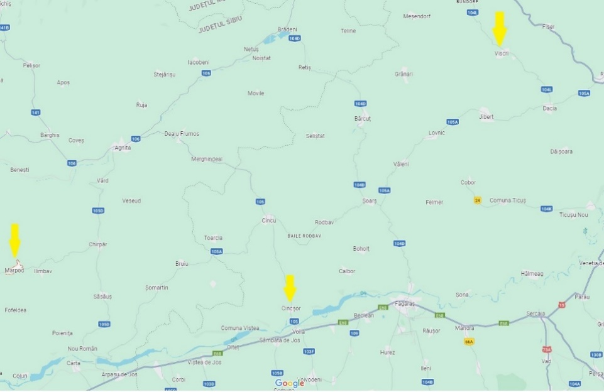  Presentation of the project results to the Brasov and Sibiu counties: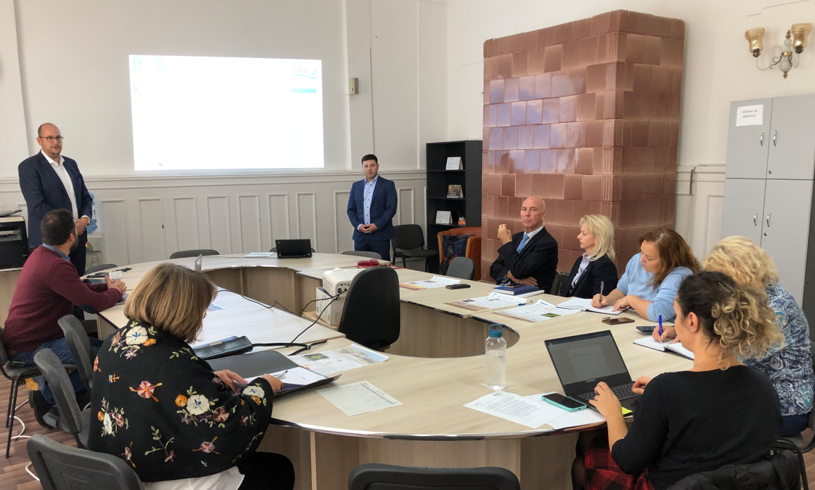 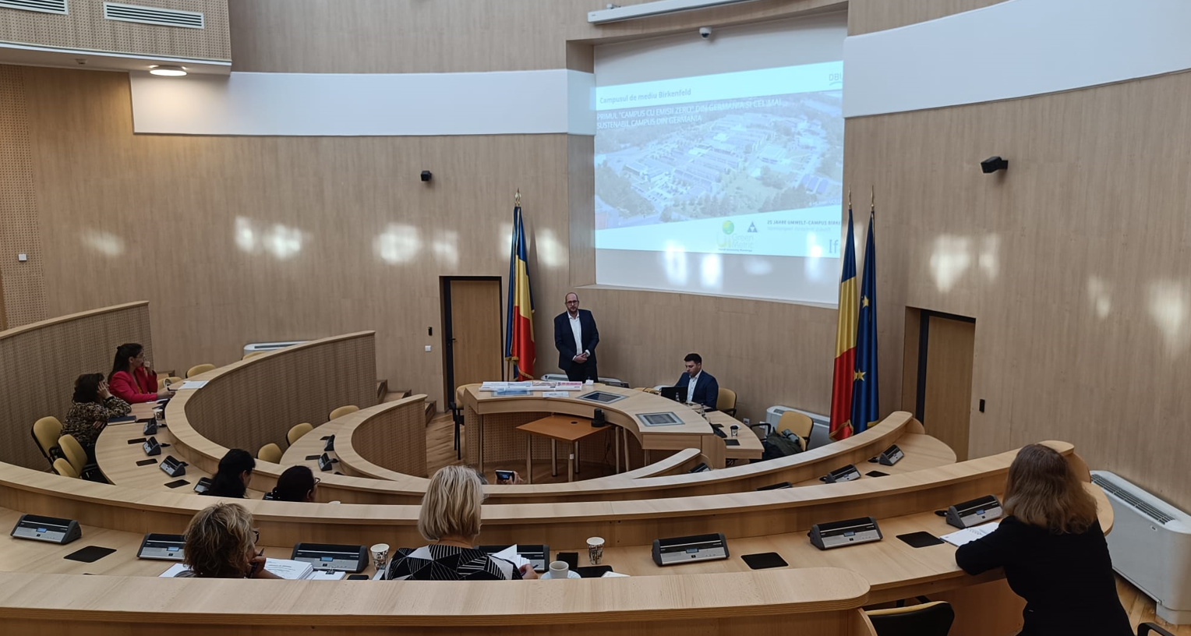

Enclosures: | Deutsche Bundesstiftung Umwelt (DBU) website: https://www.dbu.de/projektdatenbank/35853-01/  Presentation of the project on the web page of the Institute for the applied management of the material flow, University of Applied Sciences in Trier, Birkenfeld Environmental Campus, Germany: https://www.stoffstrom.org/projekte-referenzen/eu-forschungsprojekte/intercorum/  The document produced within the project that are attached next to this practice:  Catalogue of measures for Viscri (pdf)  Factsheet photovoltaic (pdf),  Factsheet building renovation (pdf),  Factsheet decentralised heating system (pdf),  Factsheet for Viscri (pdf),  Workshop presentation for Viscri (pdf)

REMINDER:
Please confirm that the consent of the project representative has been obtained allowing the information on the Good Practice information to be published on Interreg Europe website.
YES

