Good practices template

GP template
As explained above, each PP must complete the template below with potential GPs (3 or 4, at least, one template per GP) identified in its region.
[Lemons Packing – Region of Western Greece]
- General information
Author(s) | Sofia Stamou, Konstantinos Antonopoulos, Stigkas Emporiki (info@stigkas.gr)
Project acronym | DOWN TO EARTH
Policy Instrument | Regional Operational Program Western Greece
PI public authority | Region of Western Greece
Version | 1.0
Date | 2012/12/10
GP Code | GP-PP06-UPatras -GP 02

- GP basic information
Number and Title of the GP | 02- Lemons production and packaging unit in Thermo
Body responsible for the implementation | Stigkas Emporiki ΟΕ, website: https://www.facebook.com/stigkas/?locale=el_GR
Thematic objective of the GP (multiple choice if needed) | ☒Year 1. Environmental risks related with depopulation and aging population in rural areas.  ☐ Year 2. All-type of access barriers to young farmers in depopulated rural areas.  ☐ Year 3. Policy instruments to foster the role of farmers and land managers in fighting climate change and environmental risks.
Geographical scope of the GP | ☐ National  ☐ Regional  ☒ Local
Location of the GP | Greece – Region of Western Greece – Municipality of Thermo

- GP detailed description
Summary of the GP | Innovative lemon processing and packaging unit in Myrtia, Thermo, utilizing advanced technology for quality assurance and product traceability.  [160 characters max.]
Detailed information on the GP | Further information on the GP. In particular:  • What is the specific problem addressed and the context which triggered the introduction of the practice?  • How does the practice reach its objectives and how it is implemented?  • How does it contribute to the thematic objective(s)?  [1.500 characters max.]  Problem Addressed & Context: The initiative addresses the lack of a modern lemon packaging facility in the Thermo area that meets safety, hygiene, and quality standards. The project capitalizes on the local abundance and high quality of lemons, enhanced by the area's favorable microclimate.  Implementation & Objectives: The unit processes up to 60 tons of lemons annually, implementing modern technology and quality assurance systems (ISO 9000 and ISO 22000). It incorporates ERP systems, product coding, and traceability software, ensuring product safety and quality.  Contribution to Thematic Objectives: The project supports local business initiatives, enhances the income of local residents, and promotes environmentally responsible practices in agriculture.
Resources needed | Specify the number of funding/financial resources used and/or the human resources required to set up and run the initiative  Financial resources for building construction, equipment procurement, and software systems installation; human resources for operation and management.  [300 characters approx.]
Actors involved | Identify the main actors involved and beneficiaries of the initiative  [Min. 500 characters – Max. 1.000 characters]  Main Actors: Stigkas Emporiki ΟΕ, local lemon producers.  Beneficiaries: Local farmers, the community of Thermo, consumers of lemons.
Timescale | Determine the specific date or timeframe when the GP was officially implemented, and considering the overall duration of the GP, break down the timescale into relevant milestones or phases if applicable  Implementation Date: 25.07.2023  Milestones: Planning, construction, equipment installation, and marketing

- Evidence of success and transferability
Evidence of success
Short overview: A description of demonstrated positive outcomes accompanied by qualitative and quantitative (tangible and measurable) evidence of success, keeping in mind the proven successful definition by the Interreg program described in the methodology

[Min. 1.000 characters – Max. 2.000 characters]

The "Thermo Lemons Processing" project by Stigkas Emporiki ΟΕ is an exampke of innovation in the local agricultural sector. A key achievement is the establishment of a state-of-the-art lemon packaging unit, addressing the lack of such facilities in the area. Capable of handling 60 tons of lemons annually, this project bridges a crucial market gap, enhancing local production standards.
Technologically, the implementation of advanced systems like ISO 9000 and ISO 22000, along with ERP, product coding, and traceability software, signifies a major leap in agricultural practices. These technologies ensure product safety and quality, placing the enterprise at the forefront of the industry.
Economically, the project has bolstered the local economy by supporting lemon producers, demonstrating a tangible impact. The facility's role in boosting local agricultural value underlines its economic relevance.
Qualitatively, the initiative has raised industry benchmarks in food safety, hygiene, and production efficiency. Its consumer-facing traceability services, allowing detailed product information access, demonstrate a commitment to transparency and align with modern consumer expectations.
In summary, the project's infrastructural and technological advancements, coupled with its economic and qualitative impacts, demonstrate its success. This aligns well with the Interreg program's objectives, showcasing a holistic approach to agricultural improvement.

Regional impact
Short overview: Qualitative and quantitative (tangible and measurable) evidence of success keeping in mind the proven successful definition by the Interreg program described in the methodology
[Min. 1.000 characters – Max. 2.000 characters]

The "Thermo Lemons Processing" initiative by Stigkas Emporiki ΟΕ has an impact on the regional economy and agricultural sector. This project's success can be measured both qualitatively and quantitatively, aligning with the Interreg program's criteria for proven success.
Quantitatively, the facility's capacity to process up to 60 tons of lemons annually has directly bolstered the regional agricultural economy. By providing a modern processing and packaging solution, it has created a reliable market for local lemon producers, enhancing their economic stability and growth. This increase in production capacity not only benefits the farmers but also contributes to the region's economic vitality.
Qualitatively, the project has set new standards in agricultural processing within the region. The introduction of advanced technology and quality assurance systems, such as ISO 9000 and ISO 22000, marks a significant improvement in food safety and quality control. The project's emphasis on technological innovation, including the implementation of ERP systems and traceability software, has positioned the region as a leader in modern agricultural practices.
The facility's commitment to environmental sustainability and efficient resource use also contributes to regional development goals. By adopting sustainable practices, the project promotes environmentally responsible agriculture, benefiting the broader community and aligning with regional development strategies.
Moreover, the initiative has enhanced the region's reputation for high-quality agricultural products, attracting interest from both national and international markets. This not only increases the region's economic opportunities but also raises its profile as a center of agricultural innovation and quality.
In summary, the "Thermo Lemons Processing" initiative's impact on the region is multifaceted, encompassing economic growth, technological advancement, environmental sustainability, and improved market reputation. These aspects collectively demonstrate the project's alignment with the Interreg program's objectives and its significant role in regional development

Potential for transferability (Overview)
Short overview of the potential for transferability of this detected GP to another region
[Min. 1.000 characters – Max. 2.000 characters]

Potential for Transferability (Overview):
The "Thermo Lemons Processing" project, has a high potential for transferability to other regions, primarily due to its scalable and adaptable model. This project stands as example of how innovative practices in agricultural processing. Central to this project are its core elements: the establishment of a modern processing facility, the integration of advanced technology, a steadfast focus on quality assurance, and a commitment to environmental sustainability. These universally applicable concepts are designed to be adaptable to diverse regional contexts, respecting local agricultural practices and market needs. Additionally, the project's utilization of technology, notably ERP systems, traceability software, and internationally recognized quality assurance standards like ISO 9000 and ISO 22000, underscores its potential for enhancing agricultural processing standards across various regions. Crucially, the project's strategy to augment local agricultural production through value addition and market linkages is particularly pertinent for regions with analogous agricultural profiles. The economic model of the project, which concentrates on supporting local producers and fostering a sustainable market for their products, could serve as an invaluable blueprint for other regions aspiring to invigorate their agricultural sectors. Moreover, the project's focus on environmental sustainability and efficient resource use is perfectly aligned with global trends and priorities, thereby rendering it an attractive and adaptable model for regions prioritizing sustainable agricultural practices. In light of the universal challenges faced in agriculture, coupled with the escalating demand for quality and sustainability, the "Thermo Lemons Processing" project presents itself as a replicable and adjustable model, tailored to meet the specific needs and conditions of different regions. This project's holistic approach, which seamlessly blends technological innovation, economic viability, and sustainability, positions it as an eminently transferable solution for regions seeking to enhance their agricultural processing capabilities.

Rate of potential transferability
Rate this potential on a scale of 1-5, where 1 means low potential for transferability and 5 means high potential for transferability
☐ 1 ☐ 2 ☐ 3 ☐ 4 ☑ 5
The rate of potential transferability for this project is assessed as 5, indicating a high potential for transferability to other regions.

- GP methodological viability
Study visit: theoretical session
In your opinion, how likely will it be to have a theoretical session about the GP? (1 – very unlikely | 5 – very likely)
☐ 1 ☐ 2 ☐ 3 ☐ 4 ☑ 5
Add a short explanation of your rating [Max. 500 characters]
The likelihood of having a theoretical session about the "Thermo Lemons Processing" Good Practice (GP) is very high. The project's comprehensive approach, integrating advanced technology, quality assurance, and environmental sustainability, offers rich content for theoretical discussion and learning. The success and innovative aspects of this GP make it an ideal case study for exploring modern agricultural processing techniques, sustainability practices, and economic development strategies in agriculture. Such a session would be beneficial for sharing knowledge and insights, making it highly likely to be included in a study visit.

Study visit: practical session
In your opinion, how likely will it be to visit the experience? (1 – extremely unlikely | 5 – extremely likely)
☐ 1 ☐ 2 ☐ 3 ☐ 4 ☑5
Add a short explanation of your rating [Max. 500 characters]

The site will be visited subject to availability during the 13-15 February 2024 study visit.

- GP pictures
GP pictures
If possible, provide pictures of the initiative
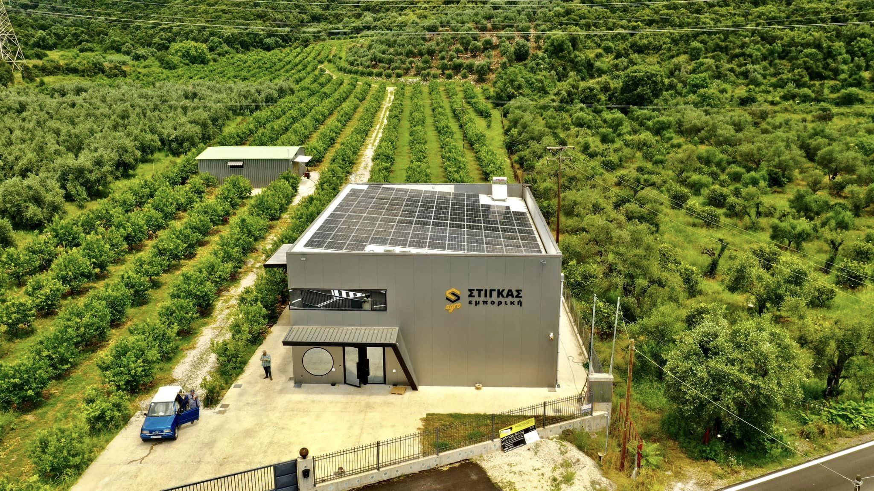

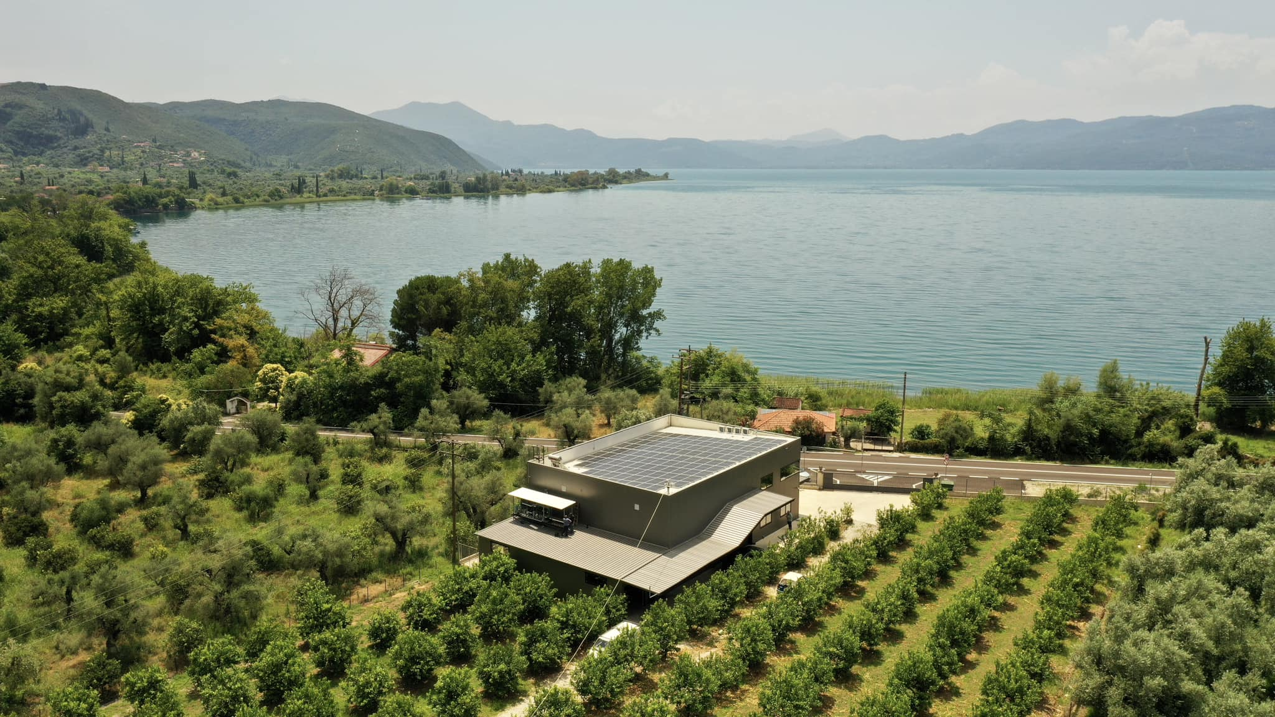

Please, fill in the GP code following the next instructions: GP-PARTNER CODE-ACRONYM- GP number (i.e.: GP-LP01-AGADER-01). PPs CODE and ACRONYMS: LP01-PP02 AGADER-FJDV / PP03 MoC / PP04 NMA / PP05 RVNA / PP06 UPatras / PP08 BSC.

