**Mindset Indicators Assessment Matrix**

**Background**

The EU Interreg Circular Mindset for Change (Circular Minds) project aims at improving the implementation of regional development policies in the field of governance of organisations for circular economy, by scaling up positive impact of public circular economy procurement practices in organisations. The approach is based on a series of interconnected steps from situational analysis to policy change. This involves improving governance to unlock the vision of “governance of circular economy” within the partners management of their policy Instruments.

Step 1 in 2024 was dedicated to situational analysis. This is where partners identified the common barriers and opportunities from their organisation, regulatory and cultural perspectives. Partners also identified specific policy needs and what stakeholders they need to work with to prioritise them, based on regional characteristics and interregional input.

The situational analysis questionnaire and this Mindset Indicators Matrix are intended to be completed together. Feedback from the partners trialling this approach suggest it is better to complete this Mindset indicators Framework first as it helps in identifying the required behaviour shifts that need to be addressed through the situational analysis questionnaire template.

**Project definition of mindset**

*Mindset*

A working definition of ‘mindset’ is useful for project partners to work towards when completing the situational analysis. Based on existing definitions, changing mindset requires a fundamental shift in the way organisations and individuals perceive, thinks, and approach the delivery of their vision, mission, objectives and roles. It involves altering attitudes and perspectives, which in turn, influences behaviour, decisions, and overall outlook on delivering goals.

*Behaviour change*

Behaviour change refers to the process by which organisations and individuals modify their actions, approaches, and procedures in response to internal or external stimuli. This involves **intentional efforts to adopt new behaviours, eliminate undesirable ones, or modify existing ones** in order to achieve specific goals or desired outcomes.

A circular mindset change is required not only by procurers but also by other organisational stakeholders involved in the procurement cycle (*Figure 1*). A mindset shift is also required within the supply chain(s) to deliver on circular ambitions.

*Figure 1* Procurement cycle (Source: CFIT)

**Mindset indicators**

This broad definition helps to provide a scope for indicators that can be used to determine shifts in mindset and the degree of progress. For example:

1. Intentional efforts to adopt new behaviours – for example, evidence of new policies, increased awareness; evidence of circular procurement actions across the whole procurement cycle.
2. Eliminating undesirable behaviours – for example barriers within the organisation structure; poor communication between procurement stakeholders; relying on business-as-usual; avoiding new ideas etc.
3. Modifying existing behaviours – for example changing existing procurement processes to ensure circularity is embedded in a proportionate way in all procurement decisions; improvement in monitoring and reporting of procurement outcomes and impacts.

**Completing the Mindset Indicators Matrix**

1. Determine the scale on which you are making the assessment. This should be ambitious but realistic. For example:

* Are you looking at a pilot project, an organisation, a government department/ministry etc.
* We might want to change behaviours at a National/Ministry level but how likely are we to achieve this?

1. In consultation with all relevant people (stakeholders), assess current performance within the organisation across each of the mindset indicators listed in the table below. Identify the current Level (1, 2, 3, 4 or 5) - see *Figure 2a* below. Scoring could whole Levels or include partial Levels, e.g. 2.5, 3.5 etc. So record these in the table below (*Figure 2b*).
2. Identify the ambition level for each of the mindset indicators by end of the Circular Minds project and ultimate organisational ambition (*Figure 2a*).
3. For simplicity each of the mindset indicators has a single variable. However having also completed the separate situational analysis questionnaire template consider whether other indicators may be necessary to demonstrate a shift in mindset. These should be added to the Framework (below) in addition to the core issues and benchmarked in the same way.
4. Finally, prioritise the indicators in importance with regards to the desired behaviour change identified in the situational analysis questionnaire. For example some may require less work than others (‘quick wins’), and some may have more impact than others.
5. Once the Mindset Indicator Matrix has been completed, complete the separate accompanying situational analysis questionnaire template.

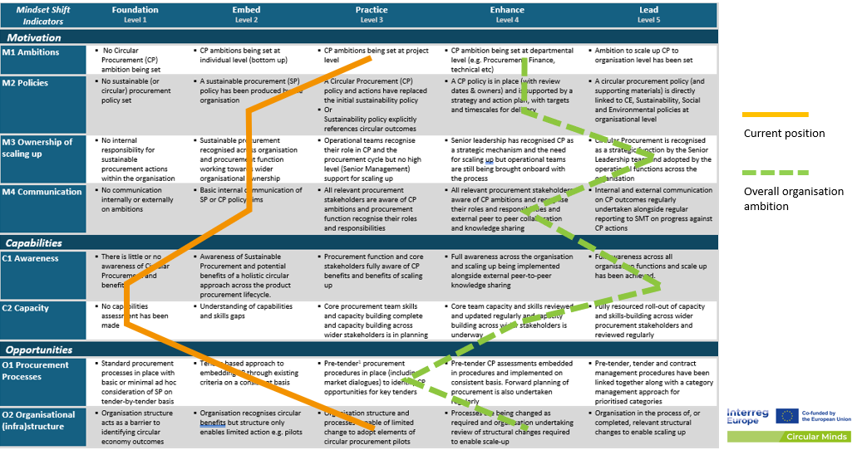

|  |  |  |  |
| --- | --- | --- | --- |
| Indicator | Current  Level | CM project ambition Level | Final ambition Level |
| M1 |  |  |  |
| M2 |  |  |  |
| M3 |  |  |  |
| C1 |  |  |  |
| C2 |  |  |  |
| O1 |  |  |  |
| O2 |  |  |  |

*Figure 2a* Example of completed Mindset Indicators Matrix *Figure 2b* Mindset Indicators Framework score

| *Mindset Shift*  *Indicators* | Foundation  Level 1 | Embed  Level 2 | Practice  Level 3 | Enhance  Level 4 | Lead  Level 5 |
| --- | --- | --- | --- | --- | --- |
| *Motivation* | | | | | |
| M1 Ambitions | * No Circular Procurement (CP) ambition being set | * CP ambitions being set at individual level (bottom up) | * CP ambitions being set at project level | * CP ambition being set at departmental level (e.g. Procurement, Finance, technical etc) | * Ambition to scale up CP to organisation level has been set |
| M2 Policies | * No sustainable (or circular) procurement policy set | * A sustainable procurement (SP) policy has been produced by the organisation | * A Circular Procurement (CP) policy and actions have replaced the initial sustainability policy * Or   Sustainability policy explicitly references circular outcomes | * A CP policy is in place (with review dates & owners) and is supported by a strategy and action plan, with targets and timescales for delivery | * A circular procurement policy (and supporting materials) is directly linked to CE, Sustainability, Social and Environmental policies at organisational level |
| M3 Ownership of scaling up | * No internal responsibility for sustainable procurement actions within the organisation | * Sustainable procurement recognised across organisation and procurement function working towards wider organisational ownership | * Operational teams recognise their role in CP and the procurement cycle but no high level (Senior Management) support for scaling up | * Senior leadership has recognised CP as a strategic mechanism and the need for scaling up but operational teams are still being brought onboard with the process | * Circular Procurement is recognised as a strategic function by the Senior Leadership team and adopted by the operational functions across the organisation |
| M4 Communication | * No communication internally or externally on ambitions | * Basic internal communication of SP or CP policy aims | * All relevant procurement stakeholders are aware of CP ambitions and procurement function recognise their roles and responsibilities | * All relevant procurement stakeholders aware of CP ambitions and recognise their roles and responsibilities and external peer to peer collaboration and knowledge sharing | * Internal and external communication on CP outcomes regularly undertaken alongside regular reporting to SMT on progress against CP actions |
| *Capabilities* | | | | | |
| C1 Awareness | * There is little or no awareness of Circular Procurement and benefits | * Awareness of Sustainable Procurement and potential benefits of a holistic circular approach across the product procurement lifecycle. | * Procurement function and core stakeholders fully aware of CP benefits and benefits of scaling up | * Full awareness across the organisation and scaling up being implemented alongside external peer-to-peer knowledge sharing | * Full awareness across all organisation functions and scale up has been achieved. |
| C2 Capacity | * No capabilities assessment has been made | * Understanding of capabilities and skills gaps | * Core procurement team skills and capacity building complete and capacity building across wider stakeholders is in planning | * Core team capacity and skills reviewed and updated regularly and capacity building across wider stakeholders is underway | * Fully resourced roll-out of capacity and skills-building across wider procurement stakeholders and reviewed regularly |
| *Opportunities* | | | | | |
| O1 Procurement Processes | * Standard procurement processes in place with basic or minimal ad hoc consideration of SP on tender-by-tender basis | * Tender-based approach to embedding SP through existing criteria on a consistent basis | * Pre-tender[1] procurement procedures in place (including market dialogues) to identify CP opportunities for key tenders | * Pre-tender CP assessments embedded in procedures and implemented on consistent basis. Forward planning of procurement is also undertaken regularly | * Pre-tender, tender and contract management procedures have been linked together along with a category management approach for prioritised categories |
| O2 Organisational (infra)structure | * Organisation structure acts as a barrier to identifying circular economy outcomes | * Organisation recognises circular benefits but structure only enables limited action e.g. pilots | * Organisation structure and processes capable of limited change to adopt elements of circular procurement pilots | * Processes are being changed as required and organisation undertaking review of structural changes required to enable scale-up | * Organisation in the process of, or completed, relevant structural changes to enable scaling up |

1. See Figure 1