Penta helix online platform
The idea of the initiative - to put innovative know-how into practice quickly, efficiently and transparently to create an electronic platform for cooperation so that companies with innovative potential can increase their competitiveness and innovative potential quickly without long administrational burden and online.

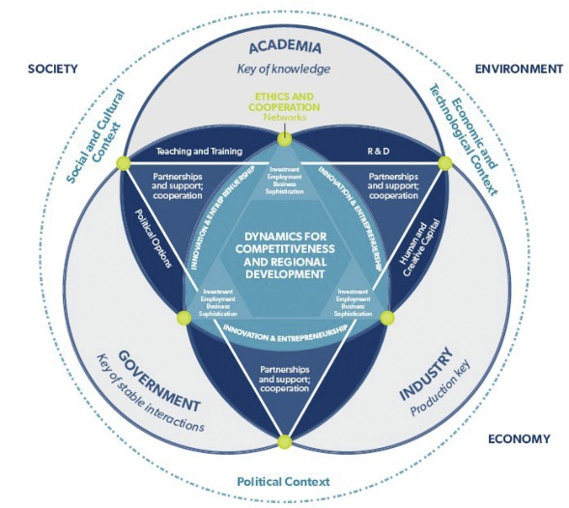
The aim of this project is a specialized platform using elements of crowdsourcing. The principle of such a platform is the publication of a request for a solution to a problem on the site and the subsequent financial evaluation of the offered solutions by external solvers. In contrast to normal procurement, already developed solutions are valued, and therefore not the best offer for future delivery. In this way, the person submitting the request will receive a topic for solving a specific problem in a relatively short time and with minimal risk.

The starting point of the project is a feasibility study, which outlined the basic framework of the project's operation. The study defines a basic set of tools that can dramatically increase the ability of public administration to use innovations with relatively small, even negligible investments and in a surprisingly short time. The very low ability of public administration to innovate is a big problem today, which causes a lengthy and less effective search for solutions.

An example of a well-functioning project directed by public institutions is the platform, which directly stimulates the search and research of innovations for various agencies of the US administration. In addition to the fact that these public platforms offer a relatively cheap and safe way of generating innovations, they also bring indirect economic benefits. These are mainly built on the support of small innovative teams, which, thanks to receiving the award, can quickly attract new investors and grow rapidly. This subsequently strengthens the innovative character of the entire economy.

Objective: Implementation of the concept of "Data-driven innovative regional development" into practice will strengten more effective cooperation between SMEs, R&Ds, universities, citizens and public administration within the penta helix model as a prerequisite for increasing the innovative potential, economic growth and quality of life in region.

Prešov Self-Governing region office (PSGR) is a public institution with competences to coordinate regional development in Prešov region. It is the first region in Slovakia, which cooperates with World Bank and
European Commission directly on innovative projects regarding regional development in “Catching-up Regions Initiative.”

PSGR has also Innovation Partnership Centre which with cooperation with other key regional stakeholders
as Prešov University, Cluster in Robotics and Automatisation, IT Valley Cluster and innovative firms creates
innovative ecosystem in the region.

PSGR for example has implemented innovation strategies for SMEs support such as regional innovation
vouchers scheme in the region. PSGR has well developed GIS system with Geoportal, pilot activity in Slovakia,
the crucial data-driven regional development system which enables to bring important data for key
stakeholders and public more efficiently with synergy effect. PSGR is also called “SMART region PSGR.” In this
year PSGR started to implement new SMART policies and strategies across the region. It emphasizes its
actions not only in economic growth, but also in increasing its citizens quality of life. Indicators such as Social progress index are for PSGR as important as for example regional GDP.

