Good Practice template

- All Good Practices identified by an Interreg Europe project and reported in the progress reports have to be submitted to the Programme.
- In order to submit a practice, you will have to register in the Interreg Europe website. Online submission will be available the first semester of 2017.
- NB: in orange: 2 optional fields. All other fields are compulsory.

- General information
Title of the practice | Dr.BetMen
Does this practice come from an Interreg Europe Project | Yes or no  [Technical: Good Practices outside the IR-E projects relevant to the topics and validated by the Policy Learning Platforms experts will also be included in the database]

In case ‘yes’ is selected, the following sections appear:

Please select the project acronym | HoCare

Specific objective | Drop-down list of the 6 specific objectives  [Technical: In case a project is selected, the specific objective is automatically completed]
Main institution involved | [Technical: The name of the institution and location of the practice are per default those of the practice author. They remain editable.]
Location of the practice | Country | Hungary
 | NUTS 1 | CENTRAL HUNGARY
 | NUTS 2 | Central Hungary
 | NUTS 3 | Drop-down list

- Detailed description
Detailed information on the practice | PLEASE NOTE THAT THE GP BELOW IS SUBJECT TO COPYRIGHT. SOME INFORMATION ARE CONFIDENTIAL DUE TO THEIR NATURE OF BEING BUSINESS SECRETS OR SENSITIVE DATA PROTECTED BY LAW, THEREFORE, UNDISCLOSED BY THE COPYRIGHT PROPRIETOR (GP OWNER).  Dr.BetMen is a user-driven web platform and application providing support to healthcare actors. It connects the key players along the patient journey to improve and develop their collaboration.  Its core functional features, marking its objectives of development, are:  • Patient pathway tracking - transparent, clear patient pathway, easy to follow list of treatments;  • Personalised patient journey - supporting personalised and optimised treatment plan and treatment itself;  • Communication - supporting doctor-patient communication to make it more efficient;  • Outcome-based funding - using an outcome-based evaluation system to identify good practices.  SEE ALL ILLUSTRATIONS ANNEXED***  The route is an institutional journey patients take when referred for further treatment by their GPs (or other health professional). From first contact with the GP, through referral, to the completion of their treatment, including the period the patient is in a hospital or a treatment centre, right up until they are discharged. The pathway gives an outline of what is likely to happen on the patient's journey and can be used both for patient information and for planning services.  DrBetMen offers a solution to reduce the administrative burden on healthcare providers, speed up patient care, make the whole process transparent for both the doctor and the patient and minimise face-to-face encounters.  It has the potential to be integrated into the National eHealth Infrastructure* (HU abbrev.: EESZT) to enable:  • different care providers (physicians and institutions, e.g. GPs, specialists) to create a personalised patient diagnostic, treatment, rehabilitation and prevention plan, and to track treatments;  • patients and their family members (or informal carers) to help them obtain clear information and navigate the maze of the care system;  • all parties involved (doctor, nurse, patient, etc.) plan and book appointments for doctor-patient meetings;  • management of health care providers, it provides information to identify good practices or bottlenecks and to plan resources optimally.
Resources needed | ca. 240M HUF financial investment and more than 18.000 man-hours
Timescale (start/end date) | Feb 2020 – Nov 2021
Evidence of success (results achieved) | The GP owner handed over the IT system source code to NDGH on 14th December 2021. However, both parties retained and reserved rights to further individual development at own discretion.  The GP owner submitted the design v14.0 for accreditation.  The accreditation procedure has been completed, and the developer has been granted the credentials as follows:  • Adminsitrative Decision OKFŐ/75017-2/2021 on the validation of DrBetMen patient route management system,  • E-certificate of Approval for Integration of DrBetMen into the National eHealth Infrastructure* digitally signed by Bálint Szabó, Deputy Director General for IT.  cf. press reports  https://24.hu/tech/2021/12/14/eeszt-betmen-betekovetes-roche/  https://www.egeszsegkalauz.hu/orvosnal/betmen-igy-segit-a-magyar-e-egeszsegugyi-rendszernek/2mqv5tf  * Note: The National eHealth Infrastructure (HU abbrev.: EESZT) is an IT system and database linking health service processes. In addition to personal data, the EESZT database is used to collect, store and share medical records, prescriptions and information on various health tests for lifetime of patients (and for five additional years after their demise). It is fully owned by the Government of Hungary, maintained and proprieted by the NDGH. https://www.eeszt.gov.hu/hu/nyito-oldal
Difficulties encountered/ lessons learned | GP owner did not reveal this information. Mainly for the reason that disclosure would involve medical, technological and medical engineering data.
Potential for learning or transfer | Protection of personal data and secure access are essential features. GDPR means reviewing how personal data is recorded and used within an organisation. In addition, patients’ health records are highly sensitive data hence security is essential.  Ease of use, user-friendly interfaces built in the software. It should be taken into account that patients are of different age, have different educational background, different attitudes and expertise in the use of digital tools. The system includes an easy to understand, practical guide to use. It is important that patients only have access to the information they really need.  Ease of use, user-friendly interfaces are also important features for the doctors who use the system, as they are professionals, but not necessarily digitally literate. Doctors have access to all available medical records of patients and their medical history.  Administrators also have access to patients’ complete medical history, but not in depth. Principal of need-to-know applies. It is important to have access only to the information that is necessary for the administrative work. This is mainly the patient's personal data or contact information.
Further information | https://www.innophc.hu/projektek/dr-betmen  https://www.youtube.com/watch?v=uEScgoqesek&ab_channel=SZEFA-INNOPHC
Contact details [Technical: the contact details will be visible only to “Policy Learning Platforms registered members”
Name | Peter Becságh, M.D. (Mr.), Member of Board
Organisation | Foundation for Hungarian Personalized Healthcare Development
Email | hello@innophc.hu peter.becsagh@innophc.hu
Expert opinion | [500 characters] [Technical: to be filled in by the Policy Learning Platforms experts]

***
Patient pathway tracking

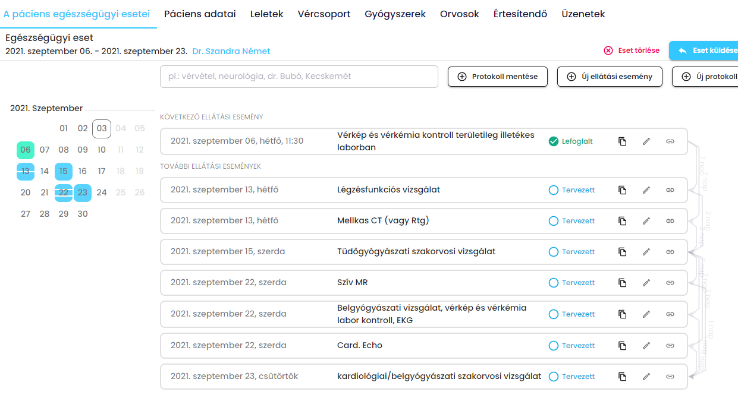

Personalised patient journey

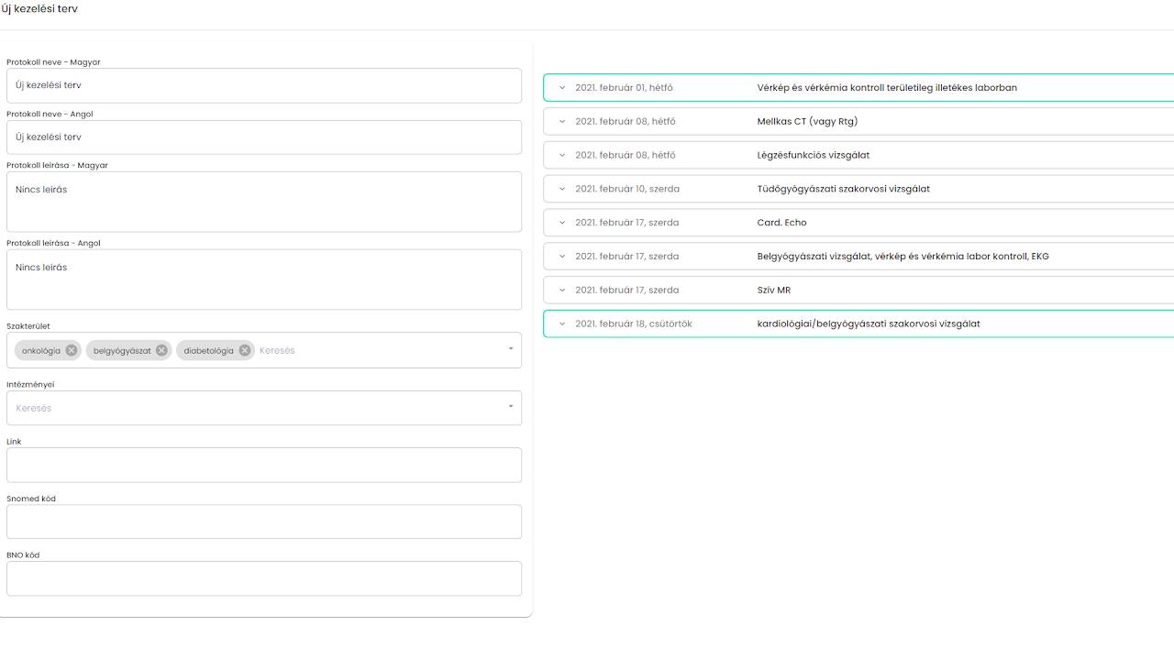

Communication

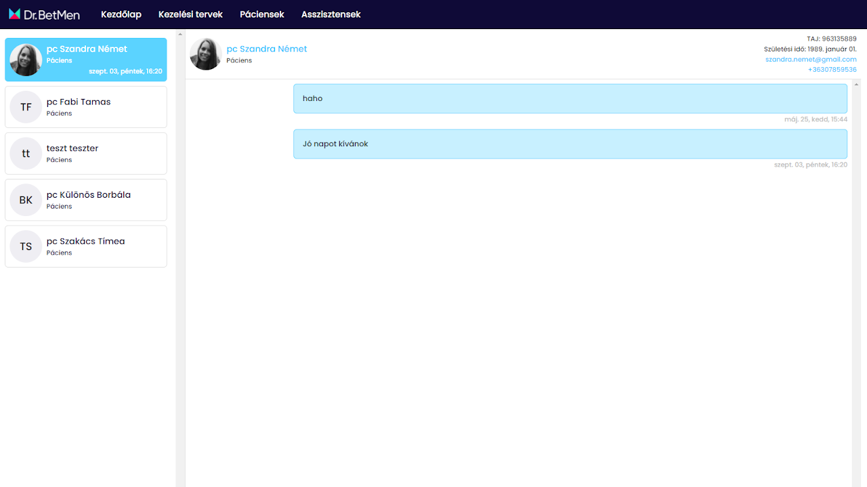

Outcome-based funding

