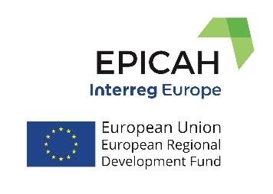
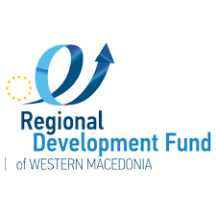
EPICAH Online SEMINAR:
Monday, April 4th, 2022
The EPICAH project, funded by the INTERREG EUROPE Program, has as its main objective the improvement of policy tools for cross-border protection and development of the natural and cultural heritage, through the exchange of experiences and good practices between partners from 8 EU countries, with significant experience in developing cross-border cooperation strategies, projects and actions.
The Regional Development Fund of Western Macedonia organizes an interesting online seminar on Monday 4 Apr 2022, at 09.00 am CET.
Representatives of all Managing Authorities of the cross-border areas participating in the EPICAH project and representatives of the partners’ regional stakeholders, will take part in presentations focusing on tourism & culture in cross-border areas of the European Union and how they were affected by the COVID-19 pandemic.
The economic and social problems that have arisen, the initiatives taken to mitigate them, as well as the adjustments that have been made to the structural programs of the cross-border areas will also be discussed.
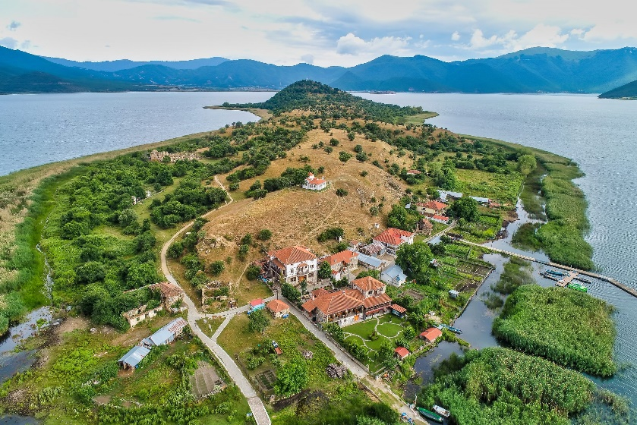

Information about the agenda and the suggestions, as well as the link for the participation in this seminar are given by Mr. Lazaridis Lazaros, tel. +30 2461350982 and email: llazaridis@pta.pdm.gr

