https://kozan.gr/archives/419911
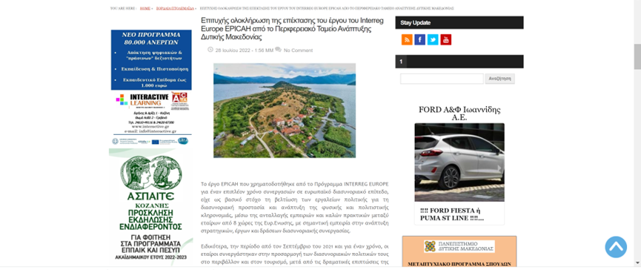

https://www.prlogos.gr/%CE%B5%CF%80%CE%B9%CF%84%CF%85%CF%87%CE%AE%CF%82-%CE%BF%CE%BB%CE%BF%CE%BA%CE%BB%CE%AE%CF%81%CF%89%CF%83%CE%B7-%CF%84%CE%B7%CF%82-%CE%B5%CF%80%CE%AD%CE%BA%CF%84%CE%B1%CF%83%CE%B7%CF%82-%CF%84%CE%BF/

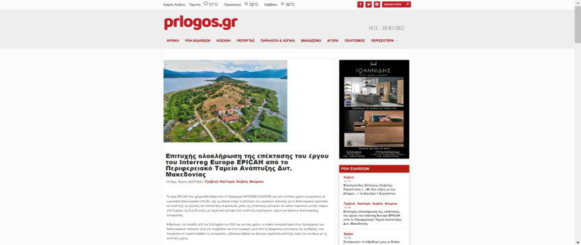

https://www.kozanilife.gr/2022/07/28/%CE%B5%CF%80%CE%B9%CF%84%CF%85%CF%87%CE%AE%CF%82-%CE%BF%CE%BB%CE%BF%CE%BA%CE%BB%CE%AE%CF%81%CF%89%CF%83%CE%B7-%CF%84%CE%B7%CF%82-%CE%B5%CF%80%CE%AD%CE%BA%CF%84%CE%B1%CF%83%CE%B7%CF%82-%CF%84%CE%BF/

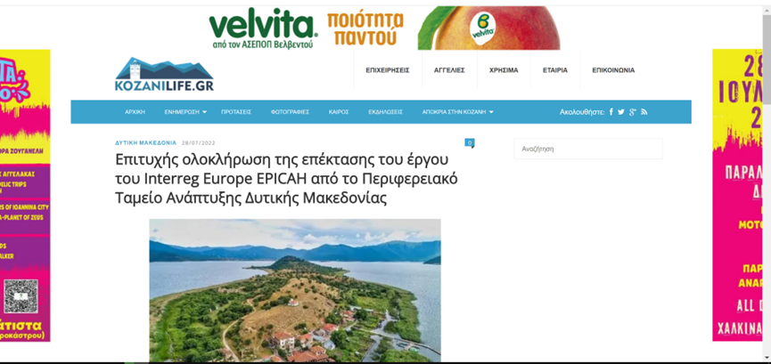

https://kozanimedia.gr/%CE%B5%CF%80%CE%B9%CF%84%CF%85%CF%87%CE%AE%CF%82-%CE%BF%CE%BB%CE%BF%CE%BA%CE%BB%CE%AE%CF%81%CF%89%CF%83%CE%B7-%CF%84%CE%B7%CF%82-%CE%B5%CF%80%CE%AD%CE%BA%CF%84%CE%B1%CF%83%CE%B7%CF%82-%CF%84%CE%BF/

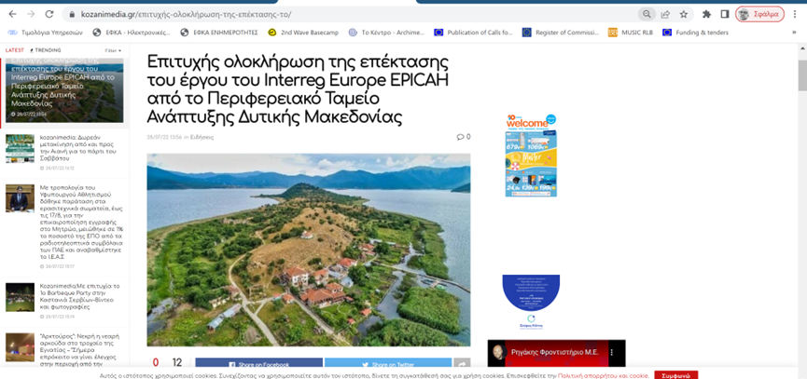

https://www.ditikostipos.gr/epitychis-oloklirosi-tis-epektasis-toy-ergoy-toy-interreg-europe-epicah-apo-to-perifereiako-tameio-anaptyxis-dytikis-makedonias/

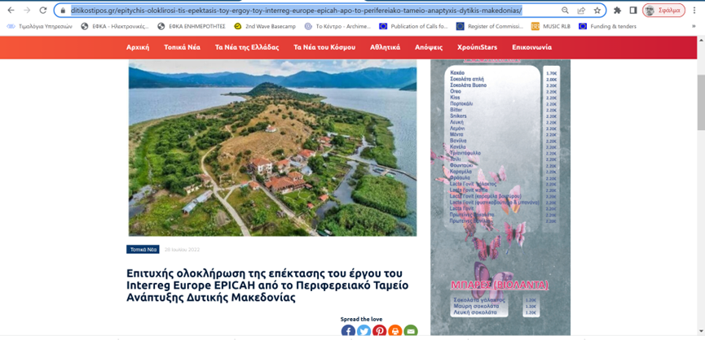

https://grevenaportal.gr/index.php/component/k2/item/1183-epityxis-oloklirosi-tis-epektasis-tou-ergou-tou-interreg-europe-epicah-apo-to-perifereiako-tameio-anaptyksis-dytikis-makedonias

http://www.floriniotika.gr/2022/07/interreg-europe-epicah.html

