Wielkopolska – hydrogen direction
The article has been written in cooperation with an expert Paweł Piotrowicz (ekspert TÜV SÜD Polska), Marshal Office of Wielkopolska Region, Departament of Economy

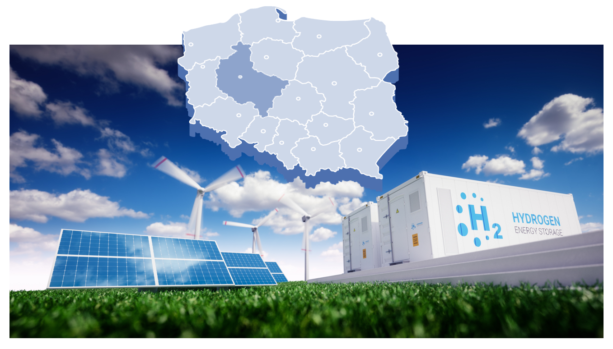

Small and Medium Enterprises are the engine of the Polish economy. The report on the condition of the small and medium-sized enterprise sector in Poland, prepared by PARP, says that the Wielkopolska took first place among other voivodships in two categories: the number of active small enterprises per 1,000 inhabitants and the number of people working in small enterprises per 1,000 inhabitants. Wielkopolska took second place, among others in terms of the number of active (micro and medium) companies per 1,000 inhabitants, working (micro, medium) per 1,000 inhabitants, the amount of revenues per person working in a small company. This shows how great potential lies in enterprises in Wielkopolska operating in all fields of the economy, including those that may directly affect the environment.

Climate change and environmental degradation pose a threat to us and our children. To meet these challenges, Europe has taken up the challenge in its strategy to transform its economy by decoupling economic growth from the consumption of natural resources, respecting the balance of all countries and regions, so as to achieve net zero greenhouse gas emissions in 2050.

Hydrogen technologies offer a chance to reduce by up to 45%. anthropogenic greenhouse gas emissions - estimates the investment bank Goldman Sachs. Today, three-quarters of the world's production of hydrogen is that produced from natural gas, which is associated with the emission of 9 kg CO2 per kilogram of hydrogen. The remainder of the production is mostly hydrogen, produced using coal, where 20 kg of CO2 are emitted per kilogram of hydrogen produced. The transition to "green" hydrogen is expected to eliminate this problem, which is a major challenge for EU countries as full decarbonisation with hydrogen in the EU requires an additional 416 TWh of electricity per year to produce 250TWh of hydrogen. Nevertheless, the European Union, by publishing its Hydrogen Strategy, shows that this is the desired direction of development, and the Member States, to a greater or lesser extent, fit into its concepts, developing their own hydrogen plans.

Poland is one of the largest producers of "gray" hydrogen in Europe. In the production process, Orlen produces nearly 45 tons of high-quality hydrogen per hour, Lotos - 13 tons, and Jastrzębska Spółka Węglowa plans to produce 8 thousand. tons of hydrogen. In Poland, about 87 tons of hydrogen are already consumed per hour (about 25 TWh per year). Refineries use about 29 tons of hydrogen per hour, and ammonia production consumes 51 tons per hour. However, in order to meet the requirements of the European Union, these large enterprises will have to undergo technological changes and focus on the production of "green" and, temporarily, "blue" hydrogen. This trend of greening production is supported by both the adopted plans of the European Commission and the target funds included in the new version of the EU budget (e.g. the New Green Deal plan). Such a plan is a huge driving force for the development of green technologies, including the production and further use of "green" hydrogen.

From the point of view of the Wielkopolska SME that wants to enter the Hydrogen Supply Chain, there are two ways to achieve business success:

- cooperation with large producers and customers,
- creating a local market (clusters, valleys).

Each of these paths has its advantages and disadvantages, each of them can be a success or a business failure. Regardless of the chosen path, the company should have at least a specific product or service concept. These must be measurable and real values and a short calendar of their implementation, because competition in Poland and abroad is growing rapidly. We can observe a very dynamic development of this sector of the economy.

Two products, Power-to-Gas and Gas-to-Power play a key role here: electrolysers and fuel cells. However, it should be remembered that these products consist of components, besides, there are other accompanying components and services, without which the two most often mentioned today could not exist. The key seems to be to use the niche and supplement it with your own products and services.

There are also two ways of working here:

- individual,
- team.

In the first case, a mature technology or service that is in demand is necessary.
In the second - a few or a dozen companies can create a joint project managed by a strong leader representing the group outside. Then there is also a chance for the development of an internal market with a demand for own products.

There are certain factors that determine the company's competitiveness that should be analyzed individually for each company:

- recognizability,
- project references,
- price competitiveness

Due to the still immature nature of the green hydrogen market, the business diversification strategy seems to be the safest for enterprises in Wielkopolska. Marketing cooperation within stakeholder groups can give the value of greater visibility and a more complementary product or service, especially when cooperating with foreign clients.

Based on the dynamics of development, we can conclude that the transport and energy sectors will be strategic in the context of business development due to:

- large investment funds
- subsidies
- promotional campaigns, incentives
- tax exemptions
- public procurement
- subsidies (e.g. for the construction of a hydrogen refueling station)
- simplification of procedures
- development of clusters
- development of infrastructure
- adjusting the regulations
- pilot installations
- new small and large-scale customers
- changes to industrial processes
- energy strategies involving hydrogen storage
- dynamics of registered patents and new solutions in the sector.

A perfect example is the activity of Zespół Elektrowni Pątnów - Adamów - Konin SA (ZE PAK),
which is undergoing an energy transformation by extinguishing coal production for green energy. ZE PAK is not only investing in a large electrolyser unit (2.5-5 MW), but also in two hydrogen refueling stations for passenger cars and buses, which will be launched in 2021 in Konin and Warsaw.

Today, Wielkopolska Small and Medium-sized Enterprises have a unique opportunity to take part in the emerging Polish green hydrogen economy. The self-government of the Wielkopolska Region has prepared a project that provides for pilot support for SMEs that want to join the supply chain of the hydrogen economy. This is a great opportunity to use the knowledge of experts and obtain recommendations for projects. It will allow companies to use their strengths in a new area of ​​activity. Joint action can add value to the development of enterprises in Wielkopolska, but also to the entire region, strengthening its competitiveness and contributing to the European Green Deal, contributing to the development of a zero-emission Europe.

In addition, Wielkopolska is building a hydrogen economy ecosystem also through the Regional Action Plan (RAP) "Economic transformation of the Wielkopolska subregions - direction hydrogen", RELOS3 "From Regional to Local: Successful deployment of the Smart Specialization Strategies".
The action plan is implemented through a project approved in September 2020 under the title "Building a support system for high-quality R&D&I projects, in particular developing low- and zero-emission technologies, with particular emphasis on hydrogen – BSW-H2" ( ROP for Wielkopolska 2014+)" . As part of the project, strategic and analytical documents are produced:

Global hydrogen value and supply chain - analysis of the global state of affairs with an indication of the largest players in the hydrogen technology supply chain;
Opportunities for the Wielkopolska economy in implementing the ‘Clean planet for all’ strategy - analysis of business opportunities emerging for Wielkopolska companies in connection to EU decisions implementing policies related to climate protection and counteracting the effects of its changes.

In line with the RAP, work is continued under the Hydrogen School: a program of cooperation with high schools and universities based on bilateral agreements with these institutions. Currently, 33 agreements on cooperation with high schools and 5 universities have been signed, at the same time the procedure for signing agreements with more schools is underway. Work has begun to prepare educational materials on hydrogen economy intended for teachers in secondary schools and university lecturers.

Under BSW-H2 project operates also Wielkopolska Hydrogen Platform involving business, R&D sector, authorities and society. The platform meets on-line on monthly webinars on the following topics for example: hydrogen law, hydrogen technologies and their impact on National Smart Specializations, the objectives of the European Hydrogen Strategy, new proton-conducting materials for cellulose-based fuel cell applications, the "NeptHyne" project connected with the production of hydrogen and its distribution „from sea to land".

For more information go to:

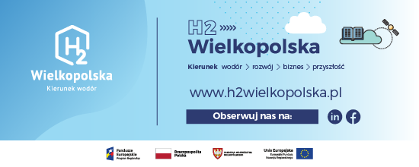

Departament Gospodarki
Urząd Marszałkowski Województwa Wielkopolskiego
al. Niepodległości 34, 61-714 Poznań
tel.: +48 61 626 62 48, 48 61 626 62 66 e-mail: h2wielkopolska@umww.pl

Report on the state of the small and medium-sized enterprise sector in Poland, 2020, PARP PFR Group
Goldman Sachs in a study entitled Carbonomics, 6/16/2020
Electrolysis breaks down the water into hydrogen and oxygen using electricity. If the electricity consumed came from renewable energy sources such as wind or solar energy, and the hydrogen produced was used in a fuel cell, the entire energy process would not generate net greenhouse gas emissions. In this case we would be talking about "green hydrogen" [https://hydrogeneurope.eu/hydrogen-production-0]
Most of the hydrogen used in industry is currently produced from natural gas via methane steam reforming. If CO2 is released as a by-product during production, such hydrogen is called "gray hydrogen" [https://hydrogeneurope.eu/sites/default/files/Hydrogen%20Europe_2x40%20GW%20Green%20H2%20Initative%20Paper.pdf]
[https://www.jsw.pl/odpowiedzialny-biznes/jsw-na-rzecz-srodowiska-naturalnego/eko-projekty-jsw/produkcja-wodoru]
"Blue Hydrogen" is produced from natural gas in the Steam Methane Reforming (SMR) process. Although CO₂ emissions are generated during the SMR process, the manufacturer is required to manage them through market compensation or technical reduction to offer a carbon neutral product https://www.woodside.com.au/innovation/hydrogen]
https://zepak.com.pl/pl/o-firmie/biuro-prasowe/aktualnosci/11610-zielone-kierunki-strategii-ze-pak-sa.html
https://www.zepak.com.pl/pl/elektrownie/elektrownia-patnow-konin/elektrownia-konin/produkcja-wodoru-w-ze-pak-sa.html
[https://zepak.com.pl/pl/o-firmie/biuro-prasowe/aktualnosci/11641-ze-pak-kupuje-pierwsze-stacje-tankowania-wodorem-samochodow-osobowych-i-autobusow.html]

