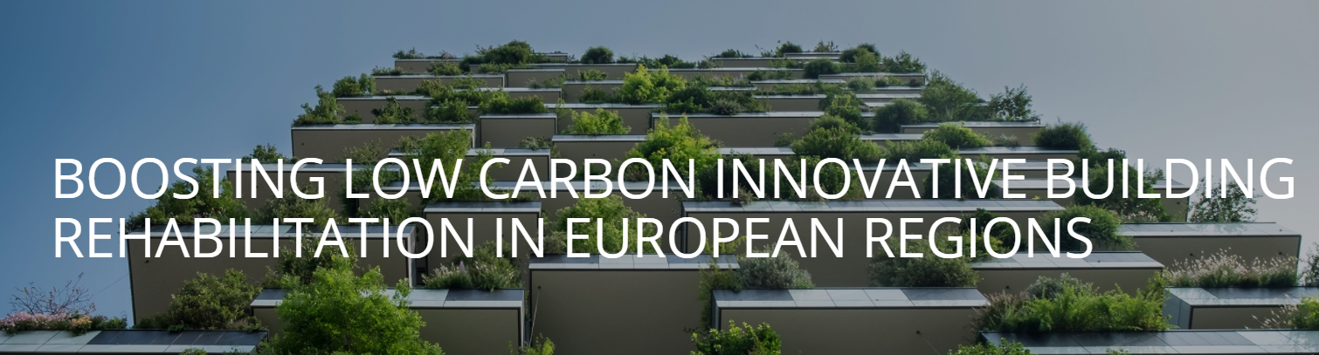
BUILD2LC “Boosting Low Carbon Innovative Building Rehabilitation in European Regions”, ON- LINE FINAL MEETING
Thursday, 3rd December 2020
AGENDA
9.00hours-13.30hours ( C.E.T)

9.00-9.15 Connections.
9.15-11.00 Session I. Opening session.
9.15-9.30 Welcome by Francisco Javier Ramírez, General Manager, Andalusian Energy Agency
9.30-9.50 Brief presentation of BUILD2LC Boosting Low Carbon Innovative Building Rehabilitation in European Regions. Working with regions and stakeholders on the building sector under the Interreg Europe Programme. Joaquin Villar, Andalusian Energy Agency AEA.
9.50-10.10 Interregional Cooperation among regions at the Interreg Europe Programme. Opportunities for regions at next programming period. Main projects results. Charo Camacho, Joint Secretariat, Interreg Europe Programme.
10.10-10.30 S3 Interregional Partnerships. The interregional partnership on Sustainable Buildings. European Commission. Isabelle Seigneur. Joint Research Centre, European Commission.
10.30-10.50 The European way of bringing buildings into the circular economy. Josefina Lindblom, Project officer. DG Environment, European Commission
10.50-11.00 Questions

11.00-13.00 Session II. Technical Sessions
11.00-11.30 New financial Instruments. Encourage the demand and promotion of investments, facilitating that citizens undertake energy rehabilitation activities.

New financial Instruments at the Public Investment and Development Agency of Lithuania, by Justinas Bučys, VIPA.

New Financial Instruments at Slovenia´s Action Plan. Črtomir Kurnik from Local Energy Agency of Gorenjska, LEAG.

Andalusian Sustainable Construction Plan, Andalusia A+ at the Andalusian Action Plan. Presentation by Marisa Borra, Andalusian Energy Agency.

11.30-12.00 Professionalization of the Construction Sector. Promoting the competitiveness of the business network: reformulating business models (ESCOS) and integrating all actors in the value chain of the energy rehabilitation sector.
Professionalization on the Construction Sector. Action Plan by Marek Duda, Rzeszow Regional Development Agency, RRDA, Poland.
Professionalization of the Construction Sector at Region Jämtland Härjedalen, by Katarina Ryckenberg, RJH, Sweden.
Presentation by Marjana Sijanez Zavrl, Building and Civil Engineering Institute Slovenia, stakeholder from LEAG, Slovenia.
Training Future Installers at South Gloucestershire and Stroud College by Eileen O’Haire, Severn Wye Energy Agency.
12.00-12.30 New energy culture, citizen involvement and energy poverty.
Housing and Health by Severn Wye Energy Agency, UK. Rob Hargraves, SWEA, and Neil Penny, Gloucestershire Clinical Commissioning Group.
Energy Poverty Action Plan in Croatia by Diana Horvat, Ministry of Physical Planning, Construction and State Assets, Croatia.
New energy culture, citizens involvement and energy poverty at Slovenia’s Action Plan by Črtomir Kurnik from Local Energy Agency of Gorenjska, LEAG.

12.30-13.00 Innovation. Encourage innovative solutions, the use of new materials, boosting public procurement, and the cooperation between companies and knowledge institutes.
REDEJA Energy Management Network of the Andalusian Government IT monitoring at Andalusian Regional Action Plan, by Marisa Borra, Andalusian Energy Agency.
Innovation-System Dominum Increasing energy efficiency in buildings by greatly enhancing your home’s value by Črtomir Kurnik, LEAG, Slovenia.
Pilot project. Innovation Passive Building at Rzeszow Regional Action Plan by Piotr Chmura, Member of Podkarpackie Chamber of Civil Engineers, Stakeholder from RRDA, Poland.
Presentation of Innovation Actions at Action Plan of Region Jämtland Härjedalen, by Katarina Ryckenberg, RJH, Sweden.
13.00-13.30 Session III. Closing session.
Questions, Conclusions and Closing remarks.

Further information: https://www.interregeurope.eu/build2lc/

