.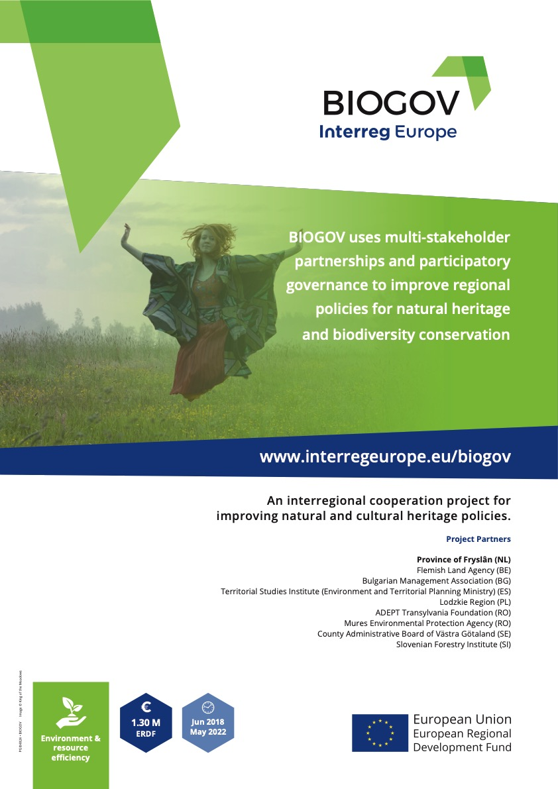

Action plan BIOGOV 2018–2022

BIODIVERSITY GOVERNANCE

Endangered extdangerdangerdangerosuTITLE
Rural landscapes
Galicia - Spain

Project: BIOGOV
Partner organisation: Landscape Studies Institute - Environment, land planning and housing ministry of Galicia
Other partner organisations involved (if relevant): Country: Spain
NUTS2 region: Galicia
Contact person: José Marcial Díaz Manso
Email address: jose.marcial.diaz.manso@xunta.gal
Phone number: +34 981 545848 - + 34 630842565

Part II – Policy context
The Action Plan aims to impact:
Investment for Growth and Jobs programme European Territorial Cooperation programme
Other regional development policy instrument
Name of the policy instrument addressed:

Galician landscape protected act
Galician ERDF / EAFRD funds
Galician green infrastructure strategy
Galician Climate change and energy strategy 2050

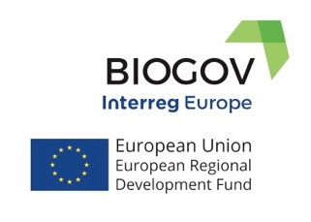
This action plan has been developed with the support of
the European Union through Interreg Project BIOGOV 2018-2022.

Biodiversity governance

Improving regional policies for nature conservation and cultural heritage through participatory processes between multistakeholder partnership and international learning

Galician society has as one of its main objectives the fight against climate change. It is a global phenomenon we cannot turn our backs. In Galicia it could become more problematic if we do not eradicate forest fires occurrence due to, among other causes, the abandon of the countryside.

Galician government proposal to mitigate the effects of climate change is the Galician Strategy for Climate Change and Energy 2050 to which the BioGov project aims to contribute.
The BioGov project in Galicia has as its main objective the maintenance and improvement of biodiversity through a sustainable and intelligent management of the territory taking into account multistakeholder partnership participation in such a way that the experience gained contributes to the improvement of public policies and citizenship recognition of the ecosystem services that nature provides.

Executive summary

The plan described below emerges from the work carried out by the multistakeholders partnership in the municipality of Cervantes (Natura 2000 and Biosphere Reserve Area) and the international learning of IET technicians in the framework of the BioGov project.
The action plan is developed in three actions about three strategic aspects. It tries to develop the Landscape Protection Act of Galicia and to improve the effectiveness of the funds of the ERDF regional operational program of Galicia (among others), related with the protection of biodiversity, the promotion of ecosystem services in the areas of the Natura 2000 and green infrastructure building.
Always with a territorial perspective, the first action seeks to provide solutions from the point of view of scientific knowledge, the second from the perspective of property structure and the third action from the perspective of environmental awareness emphasizing the local population (farmers) contribution in its function as biodiversity managers.

Political instruments

Some of the activities contemplated in this action plan are new projects, others are related to improvements in the governance; some could involve a change of approach to political instruments and others could contribute to establishing synergies between different instruments such as the CAP, land use planning policies, those related to climate change or those contemplated in the Galician Landscape Protection Act.
The development of this law contemplates to carry out action plans of the landscape inside the spaces under the figure of Natura 2000 taken as reference the catalogue and the guidelines of the landscape.
BioGov's action plan includes a proposal of three activities for each action that will be compatible and complementary with the instruments of planning and management of this natural space (ZEC Ancares - O Caurel) such as PRUG and PORN focused on biodiversity protection within the Great Landscape Area of ​​the Eastern Mountain Range, thus defined in the Catalogue of Landscapes of Galicia, in which is located the pilot area of ​​BioGov, the municipality of Cervantes in Lugo province..

This Landscape Large Area has a unique biodiversity values which Galician government aims to conserve and promote their sustainable use.
The consequence of losing ecosystem services that nature provides for free can translate into a serious deterioration of the natural balance, soil and life of people.

The BioGov project envisages the elaboration and implementation of an action plan as a tool for improving the efficiency of priority 6.4 of the ERDF Galicia regional operational program, through the promotion of technical and scientific knowledge on the elements to be conserved by identifying the main threats, developing inventories and territorial models that support the implementation of the most adapted measures from the point of view of active conservation, the promotion of the sustainable use of semi-natural habitats, restoration actions and the protection of priority habitats required by the UE. The action plan will try to reinforce good agricultural practices and valuing the role of the local population in environmental awareness.

Geographical description of the pilot area

The pilot area of ​​this project is the municipality of Cervantes in the Ancares mountain range, located in Lugo province, bordering the autonomous communities of Castilla-León and Asturias. This area is integrated into the Natura 2000 with the figure ZEC Ancares-Courel.

Ancares area has a rich biodiversity mainly due to its high altitudinal, geographical and geological variability. Located in the western Asturian-Leonese paleogeographic area, the mountains are dominated by metamorphic rocks with some small carbonated areas of special importance for biodiversity. The morphology of these mountains is strongly influenced by the geological orientation of the E-W.
This area is one of the two most singular in Galicia where the native forest still maintains an important degree of coverage, biodiversity and high natural values. The rivers and riparian forests are also very well preserved with rich areas for fishing.
Other areas very rich in biodiversity are its lakes and rocky habitats, as well as wetlands and continental swamps. The anthropogenic areas include agricultural systems (mosaic of agricultural land, meadows, orchards, hedges and deciduous forests) and forest plantations (mainly Pinus spp.).
Most of the priority habitats in the area have a good or excellent degree of conservation. The richness in flora and fauna is also especially high, concentrating in a relatively small area a high number of species with presence in Galicia (75% of vertebrates, 77% of amphibians and reptiles, 79% of birds and 85% of mammals ), including the presence of iconic species for conservation such as the brown bear (Ursos arctos).

This landscape is especially rich and appreciated due to its physiography in addition to its natural values ​​and biodiversity. The municipality of Cervantes, in Ancares area, is included in the Biosphere Reserve "Ancares Lucenses and Montes de Navia, Cervantes and Becerreá" and the region also has several special areas of landscape interest established by the Galician Landscape Protection Act.

Action plan BIOGOV 2018 - 2022

The following actions are proposed to be carried out during phase 2 of the project (2020 - 2022) contributing to the improvement of the coordination of regional policies related to land use planning, biodiversity conservation, green infrastructure, climate change, the protection of the landscape and the fighting against forest fires.

Action 1: Spatial information, knowledge and territorial strategy
With the aim of making more efficient the resources invested to prevent the loss of biodiversity and serve to support the green infrastructure strategy proposed in Galicia, a territorial model of a green infrastructure will be created and launched through a cartographic database. This territorial model will be fed from existing databases, inventories and studies and will be characterized according to the natural value, the function of the territory as a connector and protector against the occurrence of forest fires and as provider of ecosystem services to the society. This model will also include those boccage areas with elements of special interest that are singularly favoring biodiversity such as: walls, hedges, groves, ponds, irrigation canals… The integration of this territorial model in land use planning instruments will be proposed.

Action 2: Longitudinal elements of high environmental value, associationism and good agricultural practices
With the aim of making more efficient the effect of the resources destined to the implementation of the Galician strategy of green infrastructure, longitudinal polygons that are contributing the protection against the forest fire, containing habitats of special interest like riverside meadows, mountain pastures or chestnut areas will be selected. In these areas, an associative figure of owners and managers of adjacent plots will be promoted which will commit themselves to the joint application for measures that improve biodiversity values.

Action 3: Local population, urban young people and environmental awareness
With the aim of making more efficient the action of the resources addressed to the implementation of the Galician green infrastructure and its maintenance in the time, a training strategy as a guides or ambassadors of the green infrastructure will be carried out focused in the local population (farmers and foresters) in order to promote environmental awareness about ecosystem services provided by green infrastructure among the younger population of urban areas. An awareness campaign will be developed that will consider a pedagogical training-adaptation courses aimed at the local population, the development of teaching material based on story maps, lectures in urban schools and the promotion of an interpretation place about green infrastructure, biodiversity and landscape values in an emblematic place that will be promoted among secondary schools in Galicia as a visitor centre.

Date: _____________________________________

Signature: __________________________________

Stamp of the Organisation:

Part III – Details of actions envisaged
Action 1 | Spatial information, knowledge and territorial strategy  With the aim of making more efficient the resources invested to prevent the loss of biodiversity and promote support to the green infrastructure strategy proposed in Galicia, a territorial model of a green infrastructure will be created, launched and implemented through a cartographic database. This territorial model will be fed from existing databases, inventories and studies and will be characterized according to the natural value, the function of the territory as a connector, protector against the occurrence of forest fires and as provider of ecosystem services to the society. This model will also include those boccage areas with elements of special interest that are singularly favouring biodiversity such as: walls, hedges, groves, ponds, irrigation canals and others.  The integration of this territorial model in land use planning instruments will be proposed.
1.Background | There is a lack of a structured program of information acquisition and knowledge generation related to biodiversity especially from the point of view of connectivity, reflected in cartographic databases, so it is necessary to define an integrative territorial model of a green infrastructure that emphasizes the characterization, location, segmentation and natural values of the habitats as well as of other relevant singular elements of the landscape.
2.Activities | 1. Development and implementation of a territorial model of a “green infrastructure” (core areas, corridors, buffer zones and multifunctional areas), where the linear elements will be a priority for connectivity and protection against the occurrence of forest fires. The Santiago Ways as major providers of cultural ecosystem services will be taken into account in this model.  2. Development of an inventory of boccage areas with singular elements that favoring biodiversity and the landscape values such as hedges, groves, walls, irrigation canals, wells, mills, etc.  3. Development of an integration proposal of the territorial model on the green infrastructure in planning tools like the general land planning at municipality level - Plan general de ordenación municipal (PGOM).
3.Players involved | Promoter: Ministry of the Environment, Territory and Housing.  Collaborators: The contribution of multistakeholder partnership in phase 1 will continue participating in phase 2.  In phase 2, the cooperation carried out between different departments of the Ministry of the Environment, Territory and Housing with other departments of the Galician government related to the rural affairs will also be highlighted.
4.Timeframe | Phase 1 of definition of the plan: 2018 - 2020 / Phase 2 of plan implementation: 2020 - 2022
5.Cost | 1. 12.000 euros (IET and General Directorate Natural Heritage own resources)  2. 6.000 euros (IET and General Directorate Natural Heritage own resources)  3. 6.000 euros (IET and General Directorate Natural Heritage own resources)  Financed by IET and General Directorate Natural Heritage own resources. Action 1 will impact ERDF funds for establishing Green Infrastructure in Galicia to an estimated amount of euro 300.000.
6.Funding sources | Ministry of the Environment, Territory and Housing
7.Lessons learned from BIOGOV | During the visit that the partners from Sweden and the Netherlands took place in October 2019 to Galicia, the issue of territorial models related to biodiversity was discussed. Swedish group showed their biodiversity index development that aroused our interest in this activity.
8.Policy instrument improvement | The activities of action 1 contribute to establishing synergies between different policies such as the CAP, those related to landscape protection, those in charge of biodiversity conservation and those of protection against the occurrence of forest fires from a land use planning perspective.  The ERDF operational program in its investment priority 6.4 focuses on the protection and restoration of biodiversity, soil and the promotion of ecosystem services in the areas of the Natura 2000 / ecological infrastructure just as the Galician Landscape Protection Act will be improved taken in into the account its future integration of the green infrastructural model into territorial planning tools.  This action will mean an improvement in their performance in these two political instruments especially in the habitats of meadows, pastures and chestnuts groves.
9.Monitoring indicator | Number of hectares included in the territorial model of Galicia's green infrastructure.  Number of boccage areas with singular elements inventoried.

Part III – Details of actions envisaged
Action 2 | Longitudinal areas of high environmental value, associationism and good agricultural practices.  With the aim of making more efficient the effect of the resources invested to the implementation of the Galician strategy of green infrastructure, longitudinal polygons that are contributing the protection against the forest fire, containing habitats of special interest like riverside meadows, mountain pastures or chestnut areas will be selected. In these areas, an associative figure of owners and managers of adjacent plots will be promoted which will encourage themselves to the joint application for measures that improve biodiversity values.
1.Background | The plots that will be included in the green infrastructure are under different legal figures of property (public, private, private common land …). In many cases these figures need actions that support their owners and managers in the conservation of the ecosystem services that these areas are providing to society. The purpose of this action is to optimize the resources used to conserve territorial elements and habitats of high environmental value and landscape interest. The same amount of resources focused on promoting good practices, or regenerative actions, focused on groups of adjacent or nearby plots will achieve better results over biodiversity perspective than the same effort carried out in small plots spread over a larger territory.
2.Activities | Identification of longitudinal polygons, such as meadow areas in small river valleys in which implement measures against biodiversity loss (hot spots / core areas) where will be prioritised the joint applications (groups of plots) to apply for measures that promote biodiversity, good agricultural practices and prevent the occurrence of forest fires.
3.Players involved | Promoter: Ministry of the Environment, Territory and Housing.  Collaborators: The contribution of multistakeholder partnership in phase 1 will be valued and they will continue to participate in phase 2.  In phase 2, the cooperation carried out between different departments of the Ministry of the Environment, Territory and Housing with other departments of Galician government de Galicia related to the rural affairs will also be highlighted.
4.Timeframe | Phase 1 of definition of the plan: 2018 - 2020 / Phase 2 of plan implementation: 2020 - 2022
5.Cost | 12.000 euros (IET and GD Natural Heritage own resources)
6.Funding sources | Ministry of the Environment, Territory and Housing
7.Lessons learned from BIOGOV | During the first meeting of the project in the Netherlands in July 2018, Frisian partner outlined the contracts between farmers with adjacent plots (groups of plots) to access agri-environmental measures as a figure recognized by the EU of High Nature Value Farming (HNVF). This model is currently being carried out in the Netherlands with success and it seems very interesting to adapt it to Galicia.
8.Policy instrument improvement | The action 2 proposes to identify core areas and promote improvements in governance through associationism among landowners and managers.  The ERDF operational program in its investment priority 6.4 focuses on the protection and restoration of biodiversity, soil and the promotion of ecosystem services in the areas of the Natura 2000 / ecological infrastructure just as the Galician Landscape Protection Act will optimize the resources used to conserving these habitats located in longitudinal polygons promoting good practices carried out in adjacent or nearby plots due this practice will have achieve better results on biodiversity than that same effort carried out on small plots spread over a large territory.  This inventory of boccage polygons created will be proposed as support in administrative procedures to related meadows and chestnut groves: ‘Registro de Masas Consolidadas de Frondosas Autóctonas’ and ‘Registro de Montes Vecinales en Mano Común / Montes de Baras’.
9.Monitoring  indicator | Number of boccage polygons identified.

Part III – Details of actions envisaged
Action 3 | Local people, urban young and environmental awareness  With the aim of making more efficient the effect of the resources addressed to the implementation of the Galician strategy of green infrastructure and its maintenance, a training as a guides or ambassadors of the green infrastructure strategy will be carried out focused in the local population (farmers and foresters) in order to promote environmental awareness about ecosystem services provided by green infrastructure among the younger population of urban areas. A pilot awareness campaign will be developed that will consist of a pedagogical training-adaptation aimed at the local population, the development of teaching material based on story maps, lectures in urban schools and the promotion of an interpretation place about green infrastructure, biodiversity and landscape values in an emblematic place that will be promoted among secondary schools in Galicia as a visitor centre.
1.Background | Local population has a feeling of exclusion in terms of biodiversity loss policy definition. The aim of this action is to raise awareness and put in value local traditional wisdom as well as strengthen the rural-urban link in the fight against biodiversity loss due the youngest population is going to carry out the changes and challenges of climate change. Then raising awareness, educating, promoting contact with nature and increase the knowledge of how local people have been living in harmony with nature for centuries is an action that needs to be implemented in this scenario of climate change. This action is also about avoiding the monoculture of tourism and the disappearance of human been as a fundamental component of biodiversity in remote areas of high natural value.
2.Activities | Develop and promote a training program from the pedagogical point of view focused on the local population (farmers and foresters) in order to integrate their experience as guides - teachers of green infrastructure. Creation of didactic material like story maps where the strategy of the Galician green infrastructure is related with the history of the common areas, the traditional cattle ranch, the transhumance, the good agrarian practices, the culture of the chestnuts groves, the circular economy, the consumption of ecological products of proximity in the schools, awareness campaigns, ...  Develop and promote a pilot program of lectures in urban schools taught by local people (farmers and foresters) in order to raise awareness of the value of these areas and the positive effects they have on biodiversity.
3.Players involved | Promoter: Ministry of the Environment, Territory and Housing.  Collaborators: The contribution of multistakeholder partnership in phase 1 will be valued and they will continue to participate in phase 2.  In phase 2, the cooperation carried out between different departments of the Ministry of the Environment, Territory and Housing with other departments of the Galician government related to education, culture and tourism will also be highlighted.
4.Timeframe | Phase 1 of definition of the plan: 2018 - 2020 / Phase 2 of plan implementation: 2020 - 2022
5.Cost | 12.000 euros (IET and GD Natural Heritage own resources)
6.Funding sources | Ministry of the Environment, Territory and Housing
7.Lessons learned from BIOGOV | During the visit of the Galician partners to Sweden in June 2019, Swedish partner showed a bird interpretation centre and an educational program based on story maps related to biodiversity.  During the project meeting and the visit that took place in October 2019 in Galicia, the representatives of the Slovenian partner explained the program that exists in their country related to environmental education in which the protagonists are foresters which aroused our interest.
8.Policy instrument improvement | The action 3 is strategic projects with a longer-term vision that will help reduce the loss of biodiversity through awareness.  The ERDF operational program in its investment priority 6.4 focuses on the protection and restoration of biodiversity, soil and the promotion of ecosystem services in the areas of Natura 2000 / ecological infrastructure just us the Galician Landscape Protection Act will see its effectiveness improved by establishing meeting points in their actions and by allocating part of their efforts to organize activities for environmental and landscape awareness jointly in which members of the local population will participate as guides or teachers of the youngest urban people in terms of promoting the green Infrastructure and landscape values.
9.Monitoring  indicator | Number of story maps created.

