4th Local Stakeholder Group Meeting,
Miercurea Ciuc, Harghita county

REPORT
Host Partner | Harghita County Council
Date of meeting | 08/05/2020
Format of meeting | 4th Local Stakeholder Group Meeting
PARTICIPANTS
Total Number (all participants signed an attendance list) |  | 10
Number from the Policy Owner and the Partner |  | 7
Number from Entrepreneurial sector |  | 2
Number from Education Sector
Number from Civil Society |  | 1
Any other comments or information about participants
MAIN TOPICS DISCUSSED
(briefly)
During the meeting the main topics discussed were:

1- Brief introduction of E-COOL and progress – next steps of the project/ Mrs. Erőss Bea, project manager

2- Presentation and discussion on Good Practices of the 2nd Interregional Seminar in Groningen / Mrs. Erőss Bea, project manager

3- Assessment of Good Practices presented
MAIN ACTION POINTS
(briefly)
At the beginning of the meeting Mrs. Farkas Enikő, deputy director on behalf of Harghita County Council welcomed the participants of the on-line meeting, presented the agenda and the aim of the 4th stakeholder meeting.
Following the greetings Mrs. Erőss Bea, manager of the E-COOL project took a brief introduction of the project and of the activities undertaken within project implementation process.
The presentation of the progresses was followed by a detailed presentation of the good practices presented within the second interregional seminar, held in Groningen, Holland.
The participants of the meeting had the opportunity to address their questions related good practices, and following they assessed the good practice in the relevant template that they received by e-mail.
The active participation of the local stakeholders was very important, because according to the identified good practices, they can take part in the elaboration of the Action Plan, according to the good practices that can be adopted also in Harghita county.
At the end of the meeting there were discussed also financial and reporting related topics concerning E-COOL project.

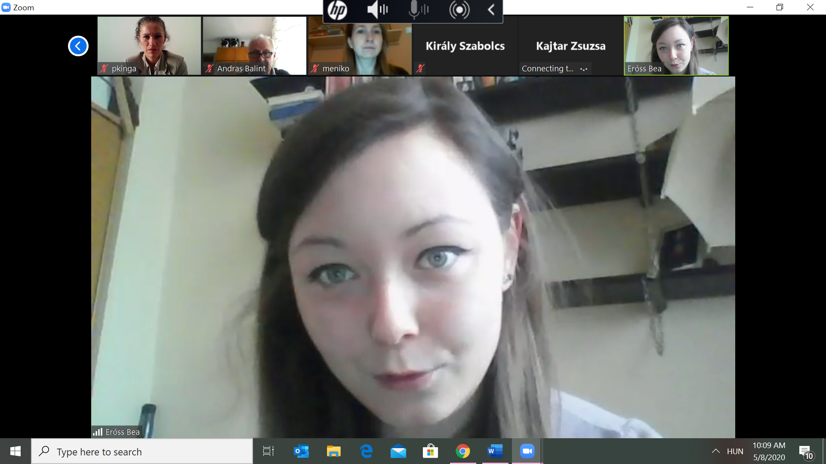

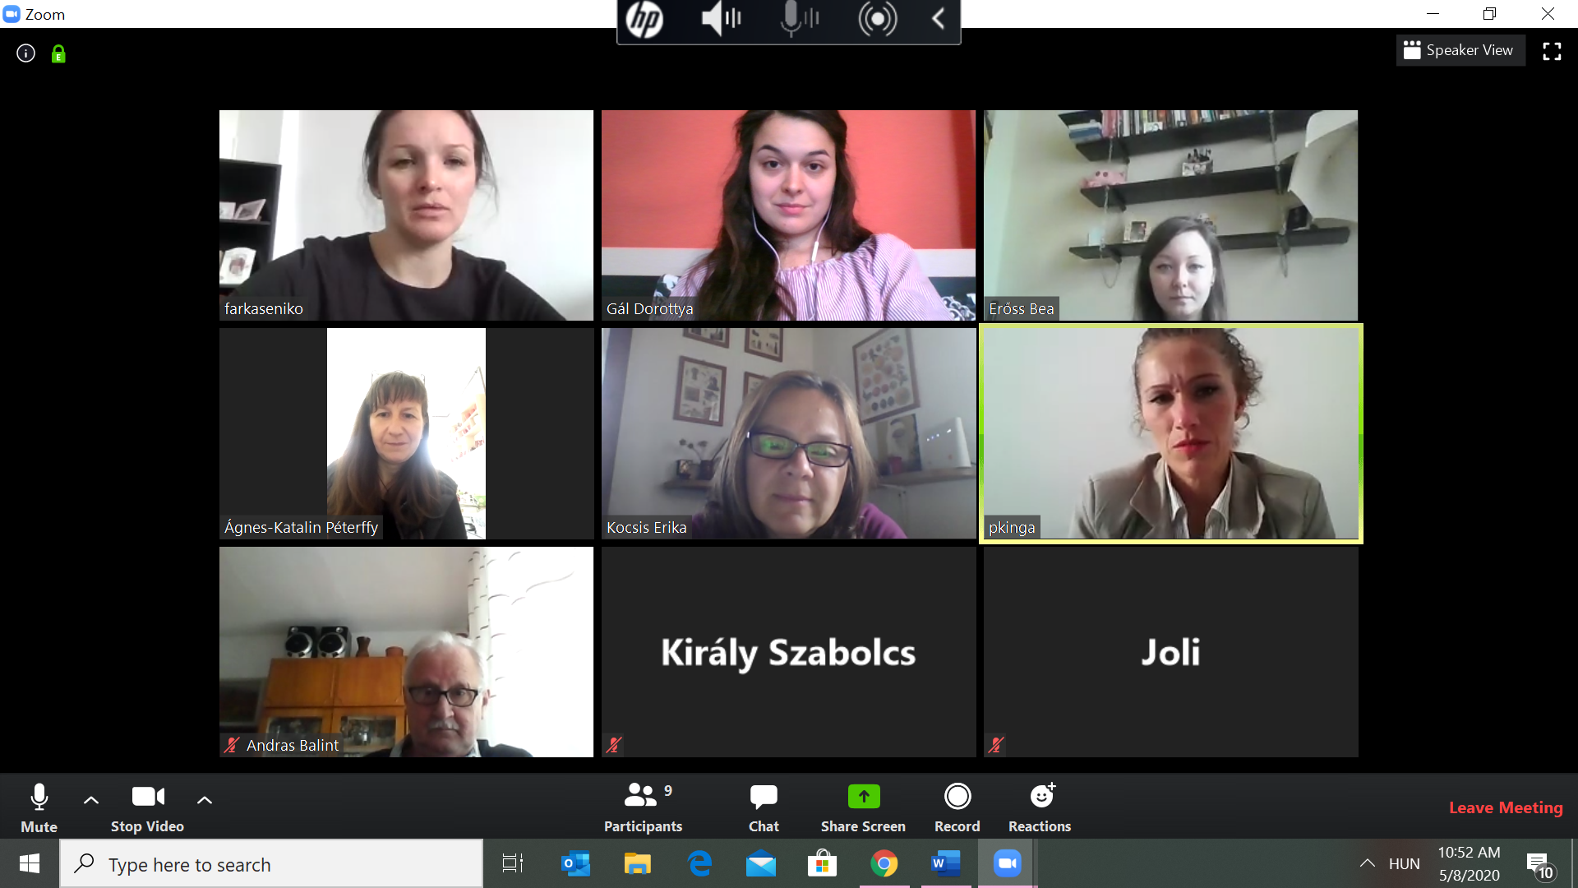
ATTENDANCE LIST
Name | Organization
Farkas Enikő | Deputy director Harghita County Council
Erőss Bea | E-COOL project manager Harghita County Council
Kajtár Zsuzsa | E-COOL project team member HCC
Bálint András | E-COOL project team member HCC
Bíró Kinga | E-COOL project team member HCC
Gál Dorottya | E-COOL project team member HCC
Péterffy Ágnes | Counsellor Harghita County Council
Kocsis Erika | Planificatio Company
Miklóssy Enikő | Hargita Megyéért Association
Király Szabolcs | Development Agency of Harghita County

