Interregional Learning Event 1 (IRLE 1) | Summary report

Date 4-5 February 2020 | Location Leeuwarden, North Friesland, The Netherlands

FRIESLAND, THE province WITH DEMOGRAPHIC CHALLENGES THAT IS BECOMING A EUROPEAN ROLE-MODEL ON CIRCULAR ECONOMY
“We are not the richest province in the Netherlands, yet we have the happiest people”, says Mr. Tjeerd Hazenberg, circular economy policy advisor at the Province of Friesland. He calls it the ‘Friesland paradox’. Friesland, a small 869 km² province of 650 000 inhabitants in the north of the Netherlands, has a strong cultural identity, its own language, an economy mostly devoted to agriculture, lots of companies (20 000, 99% of which are SMEs) but is facing economic and demographic challenges.
Yet it is becoming one of the best examples of a successful transition towards a circular economy. Policymakers and reporters from all over the country and the continent are coming to Leeuwarden, Friesland’s capital, to get to know more on this little miracle.

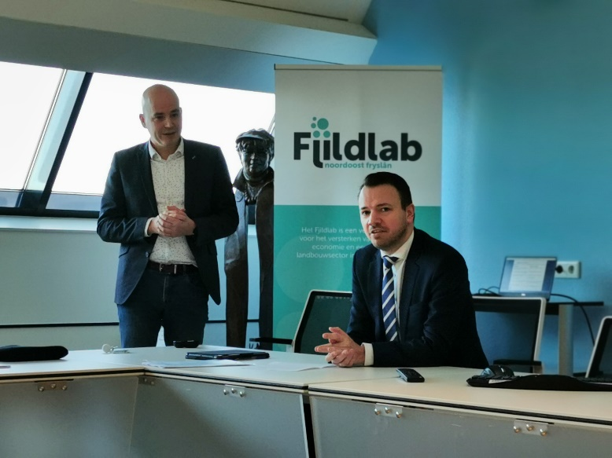
The Province has 3 lines of action when it comes to circular economy “Doing. Learning. Telling”, chants Mr Sander de Rouwe, the 39 years old Provincial Commissioner on Economy. Doing: the Province has specific public policies on circular economy, finances circular SMEs, research (on the Fjildlab, a quadruple helix field-lab, read below) and has an ambition on developping public procurement. “The companies started this movement” reminds Mr Tjeerd Hazenberg. “We have a specific budget on circular economy, out of the economic department. But it is also important that other departments have circular economic rules.” Learning. The Province is an active member of the Association of Cities and Regions for sustainable Resource management (ACR Plus) and is involved in different European projects: SCREEN (Horizon), REPLACE, CIRC NSR and COLOR CIRCLE. “We don’t have to invent everything on our own, that iss why sharing experiences with European partners is so important” says Mr de Rowe before concluding “let’s tell our story together, ‘cause no story, no glory”.
Sander de Rouwe 5 Feb 2020 “We don’t have to invent everything on our own, that’s why sharing experiences with European partners is so important.”

According to Tjeerd Hazenberg, there are 3 mains reasons why circular economy works so well in Friesland:
- A transparent economic structure with no dominant company;
- A culture of cooperation with knowledge institutes and local governments, the ‘Frisian Mienskip” (litteraly the ‘community’ but used to express the interconnection needed to protect the community);
- World class knowledge on tech and more (especially on water technology, circular plastics, and agrofood).

Two categories of stakeholders – farmers and entrepreneurs - played a key role in Friesland to put circular economy on the agenda and design new approaches with the Province. Both were able to organize networks and associations that could start and structure the dialogue.
The Noardlike Fryske Walden www.noardlikefryskewalden.nl is a 800 members association of eco-friendly farming entrepreneurs, “We, farmers, keep landscape in shape”. “Our mission is to be in balance with nature and landscapes”. Founded in 2002 as the umbrella organization of 6 agricultural nature associations (ANVs) it merged in 2016 to 1 association with 6 departments. It counts 800 members, mostly farmers but also individuals. The initial concern was acid rain in the 1990s: new rules were introduced, with financial incentives for farmers who would cut trees, and a direct impact on the landscape. From 2005, the Common Agricultural Policy started to fund landscape management. Step by step this was also put on the regional and national agenda. While connections are made with entrepreneurs to value landscape management through tourism and local products from wood, landscape management can not be borne by private economy alone, and public funding still plays a key role. Growing on the concept of ‘Kringloop landbouw’ (literally agricultural cycle, can be translated as ‘agroecology” i.e. less inputs, less outputs), Noardlike Fryske Walden manage key landscapes and habitats such as drylands, wetlands open arable land, etc., do ecological assessments and offer educational excursions to general public. They also offer farmers and nature managers services (help in finding subsidy and writing reports, etc.). They “contribute to policy making and to applied researches”, collaborating for example with VHL and the Fjildlab.

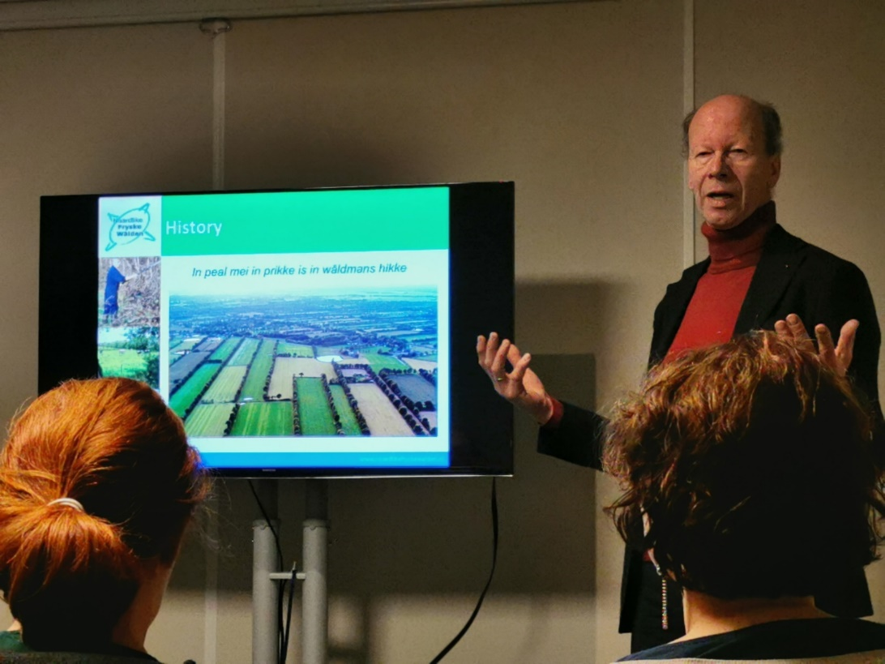
Albert van der Ploeg is the Noardlike Fryske Walden’s chairman. He was born on a farm, became a teacher for 20 years while still helping on his father’s establishment and eventually bought its own. “I was quite famous for my big mouth and the other farmers told me I should go into politics. In 2002, I became an elected representative and supported farmers to be proud of their landscapes, telling them but also civilians and politics that a farm can grow without damaging the landscapes, quite the opposite.” 3 years ago, he became Noardlike Fryske Walden’s chairman, the umbrella organization of 6 agricultural nature associations in charge of landscape management.

Another key player in Friesland is VCF, the association for Circular Friesland, presented by Mrs Ingrid Zeegers, Program Director. In 2015, 7 companies, alongside the Province of Friesland and the Municipality of Leeuwarden, commissioned an analysis of the flow of raw materials in Friesland: what comes in, how is it processed, what comes out. They looked at cross paths - how someone waste could become secondary raw resources for someone else - and came out with 9 transition paths in which each member as an active role to play. The association now counts 100 companies, knowledge institutes and governments as members. They developed educational and consultancy activities.
“When a new member comes to the game it has to engage for at least 3 years and to either come with project or get involved in another project. We also go to their companies, at least twice to really assess their local context and needs, and help to educate them in circular economy”.
The association recognizes 7 pillars for circular economy (1. Materials and resources 2. Renewable energy 3. Water 4. Biodiversity 5. Cultural diversity 6. Health & wellness 7. Added Value) and works around 10 themes: agriculture, biomass, food, water (the biological cycle); building & infrastructure, plastic, energy, mobility (the technological Cycle ); recreation & tourism ; education. Yet when it comes to methodology, they recommend not to divide circular economy but to start working around 5 starting points:
- Design a self-restorative system. Biological cycle, technological cycle (you got to close the loop for this one). It is when you mix these 2 cycles that pollution comes out.
- Think ahead, through time
- To know where the resources come from and where it goes and end, ideally at every moment in time
- Know the true impacts, not only the economical one but also envt and socio
- Integral propositions based on design principles.

More info: https://circulairfriesland.frl/app/uploads/2019/09/Circulair-Friesland-EN.mov
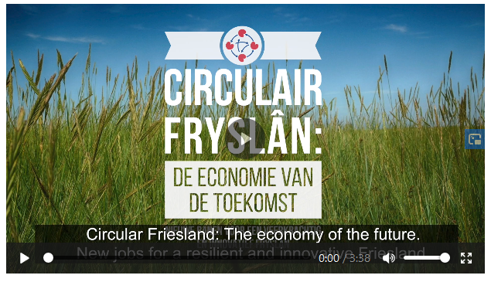

Fjildlab, a 4-HELIX field laboratory TO DEVELOP A CIRCULAR AGRICULTURAL ECONOMY in NORTH EAST FRIESLAND
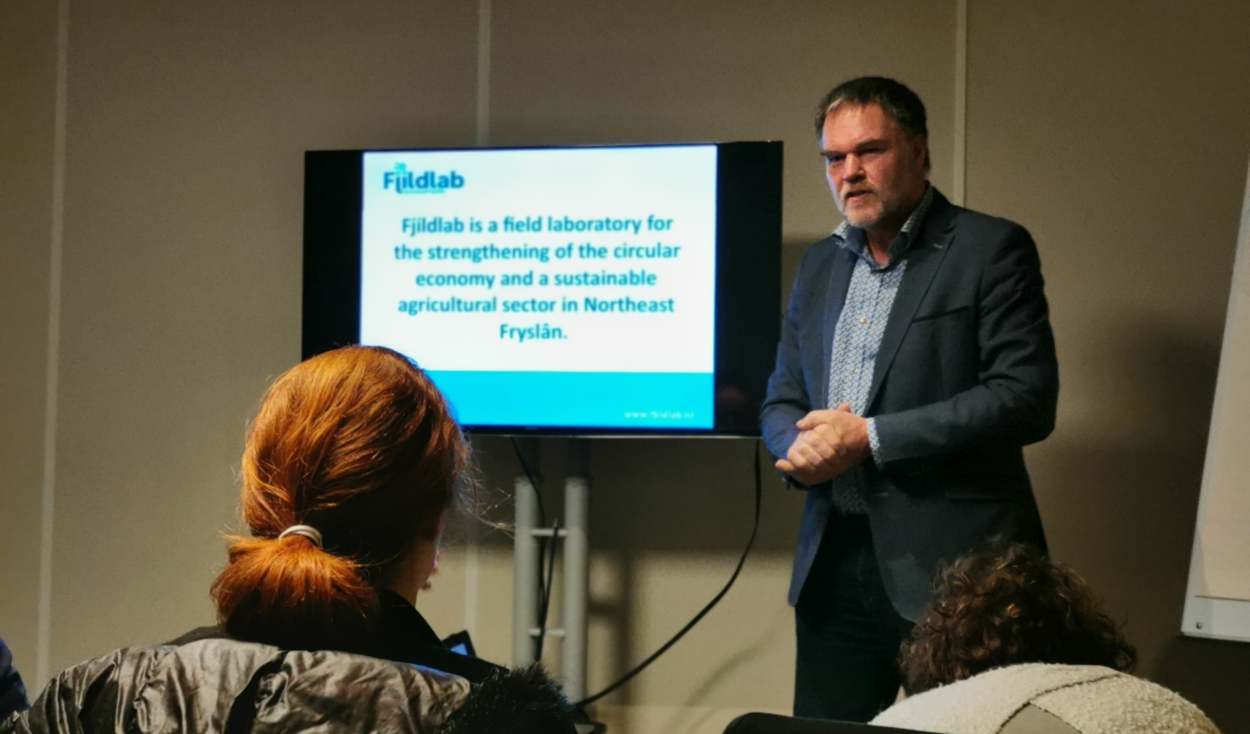
The Fjildlab was presented by its Project Leader, Mr. Durk Durksz, who is also an experimented professional in agricultural education and a former municipal council member.

The Fjildlab is a field laboratory in which entrepreneurs, environmental associations but also researchers, local governments are working together to develop a more sustainable agriculture in Northeast Friesland. It starts from a simple observation “producing always more puts pressure on prices but also on landscapes, a phenomenon that will increase with climate change” explains Durk Durksz, Fjildlab’s project leader. “So, we are looking for new earning models, a new form of agriculture and economy. We strive for a high-quality landscape, an agriculture resistant to the influences of climate change. We call it ‘nature-inclusive circular agriculture’”.

How does it work? The approach is of course bottom-up, but the true originality resides elsewhere. It is called the quadruple helix. We all know of the DNA “double helix”. This field-lab is made of 4 helixes: administration, experts, entrepreneurs, citizens (NGOs). Together, they are the core structure of the field-lab.

They meet around 8 knowledge tables, all chaired by a researcher. The 8 topics are: nature, landscape and biodiversity; soil; water and agriculture; sustainable energy; manure; feed; mitigation and adaptation to salinization. Here, ideas start bottom-up. Local governments, farmers, entrepreneurs and stakeholders discuss issues, opportunities and come up with business plans and projects (almost 100 already).

The Fjildlab is part of the regional public policy called RegioDeal. The regional authority, here called the Province of Friesland, funds 16.2 million euros of the lab on a 5 yea plan (2018-2024). 10 other million come from the government and 6 other million must be funded by farmers, entrepreneurs, or universities such as VHL.

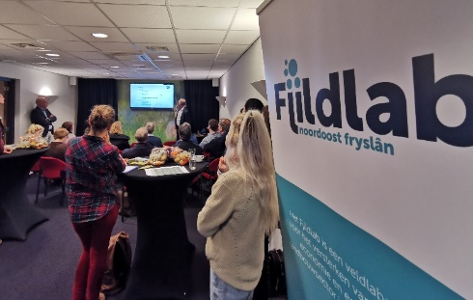
Project partners met with some of Fjildlab’s active members on 4 February 2020 at KEI-NOF, a knowledge and network center for entrepreneurs in Northeast Friesland.

4 people (farmers, researchers and entrepreneurs) gave short pitches on the latest projects and project ideas by members of roundtables: Sietze de Kievit (Food Waste Market), Inez Dinkla (Wetsus), Marc van Rijsselberghe (Marc Foods), Mindert de Vries (Van Hall Larenstein).

Food waste is an unexplored economic market. The VerspillingsMarkt (literally Food Waste Market) aims at reducing waste throughout the food chain. It investigates which products can be made from the residual flows, side flows, losses and how they could be marketed together with creating new job opportunities. Project partners got the chance to taste delicious old bread fries, old vegetable balls as well as tomato wine (just a sip). Several of these products were elaborated with VHL students. More info http://www.verspillingsmarkt.nl/
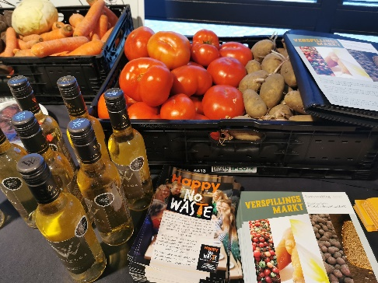
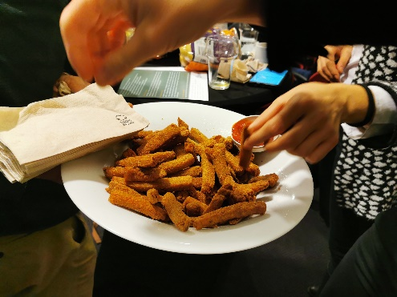
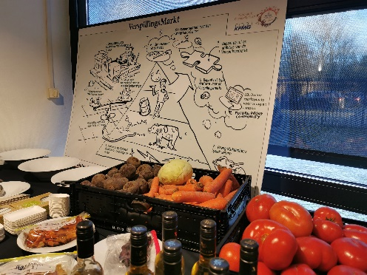

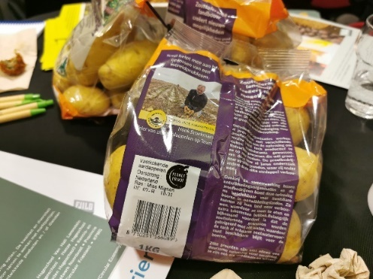
Salinization of farming land is a fast-growing worldwide problem, especially with climate change. Vast areas of formerly arable land are no longer being used, which causes unemployment and food shortage. For this purpose, the Salt Farm Foundation created a state-of-the-art outdoor lab: a trial field where can be examined the salt tolerance of a variety of crops with great precision. They discovered many crops, ranging from potatoes and carrots to strawberries and tomatoes, that thrive under saline conditions. Project partners all got home with 1kg of salt-tolerant potatoes. More info : https://saltfarmfoundation.com On the open-air laboratory: http://www.saltfarmtexel.com/research-station

HOW TO ELABORATE A 4-HELIX FIELD-LAB? TIPS FROM THE ONES WHO ALREADY MADE IT

“Circular economy is based on 3 principles”, says Dr Toine Smits from Van Hall Larenstein University. 1. Design out waste and pollution 2. Keep products and materials in use 3. Regenerate natural ecosystems.

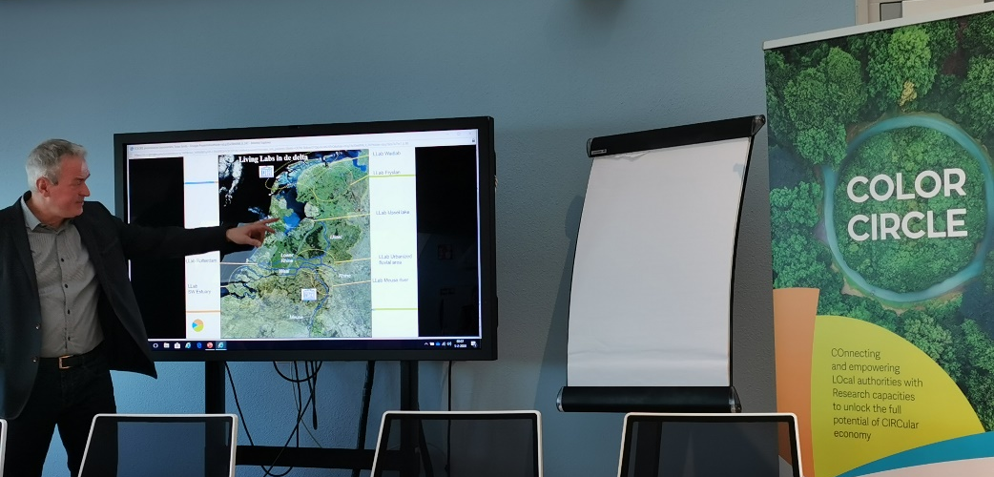
The Dutch expert in delta areas and resource management initiated a network of 7 living-labs or field-labs across the country. “In a living-lab, it is not all about tech innovations, it is about 3 level of simultaneous innovations: business innovation and new markets, clean tech / smart engineering, innovative governance”. A living-lab, in Dr Toine Smits’ opinion, should be based on the quadruple helix, meaning administrations’ representatives, experts (civil servants), entrepreneurs, citizens (NGOs) should all participate to the elaboration and implementation of the living-lab, all equal.

His living-labs followed the ABCD process from Robèrt:
A - 1st step. Awareness combined with vision: what do we want to do, what core values do we embrace now for our future?
B - 2nd step. Baseline: where are we now? “All stakeholders should put their data on the table and share it with others”
C- 3rd step: The way forward: define small steps to go forward, decide on priorities.
D- 4th step. Creative solutions. Ask yourself ‘Does it move us in the right direction?’. Take into consideration its flexibility, can you adapt it when changes will happen? Is it a good return on investment?

With Jeroen van Wijk, from the Netwerk Noordoost/ ANNO, they gave project partners a selection of feedbacks, good practices to implementing a field-lab:
- Identify a suitable initiator, preferably non-political;
- Hire a full-time facilitator/project manager; a university can appear as a neutral stakeholder able to run a balanced process
- Do in-depth interviews of stakeholder candidates to prevent hidden agendas; start with “smaller” stakeholders
- Make sure to involve decision makers who dare to take decisions and go into actions;
- To assure the budget, use the leverage effect of different funding sources, try to make a financial deal with the stakeholders;
- Research can provide expertise for free, or leverage research funding that can help in the local transition to circular economy
- Meet with stakeholders often;
- Make people understand that they are part of the solution, and that environmental and economic goals are not conflicting : greater value can be reached through new approaches and new business models
- Communication is key. Have a clear website, make video presentations. Publish in local media regularly. Make yourself visible internationally, it helps when looking for new fundings.
- New people will arrive during the process, have an on-going learning process.
- Some existing structures will disappear in the process and because of it. Make sure you have knowledge institutions with you and an on-going teaching strategy.

ANNEX - FIELD VISITS: EXAMPLES OF COOPERATIONS BETWEEN local communities, stakeholders and researchers

Started in 2002, ECOLANA is a group of 4 farmers (potato-producers, and dairy farmers) who share machinery, labour, and manure. It started in 2002. With a circular mindset, ECOLANA tested solid manure (richer in biology and biodiversity than liquid manure) with straw to benefit soil life. In Netherlands farmers have too much manure, because of the import of soja. The quality of manure is a problem because this is too mixed. ECOLANA is trying to close the loop by improving the quality of the manure. ECOLANA approach was challenged by the regulatory authority because current norms and limits do not give room to alternative manure applications. ECOLANA started a cooperation with HVL researchers and students to increase and sharpen the knowledge base of their approach both from an agroeconomic and a legal perspective.

BOWINN is a cluster and building campus located in Dokkum, started by northeast Friesland companies to work on future-oriented developments for the construction and living environment. The campus is a place where Knowledge and experience are brought and shared. The focus is on innovations that affect all (construction) sectors, across the board. For instance, from March 2020 at local companies working with researchers and students will be able to test isolation of facades in climate chambers. Entrepreneurs, governments and education get to know and inspire each other here. Support through the campus extends beyond the basic location. Bowinn also facilitates innovations on location. This gives entrepreneurs the opportunity to work on innovative projects in-house. The building campus makes companies visible, helps them strengthen each other. Bowinn does this by opening up the network and sharing the knowledge of its members.

VHL is engaged with farmers and local communities in soil management and the development of new sustainable products in the framework of the Better Wetter initiative. Better Wetter (which means "better water” in Friesland language) aims at a better, healthier and more sustainable water system in the peat meadow area in the northeastern Fryslân region. That's what Better Wetter wants. But it's more. Our climate is changing. How should we deal with it? How do we adapt our way of life to it? With an expensive word, it's called 'climate adaptation'. How can we live in a more sustainable and environmentally friendly way? Better Wetter is working on this as well. We call it a 'circular economy'. An economy in which as many products and raw materials as possible are reused and where as little as possible is thrown away. Van Hall Larenstein University of Applied Sciences and the research group Sustainable Water System are participating in the 'Better Wetter' project. Various students from, among others, Environmental Sciences are working on various subjects. The Kenniswerkplaats offers a place for students who will carry out various tests and assignments in the area in the coming years. Several internships are possible where the students will sit and work directly in their research area.

The visit included a meeting with :
- material and product designer Tjeerd Veenhoven who teaches students how to make plastic free soft touch tables out of cattails (https://www.huisveendam.com/about-3/about_us/)
- applied professor NNNN, who works on new ways to make value of the peatlands, by introducing less intensive cultures in peatlands, that would yield more sustainable and still valuable products, and would avoid soil pressure and restore the natural capacity of peatlands to store water and mitigate gas emissions.

