**RFC Interregional Thematic Workshop 1**

Topic - Preservation and development of the cultural heritage by the improvement of the mutual impacts of Fortresses and Cities (positive x negative)

Partner contributions to Interregional Thematic Workshop

Project partner: Regional Landscapes Antwerp

|  |  |  |  |
| --- | --- | --- | --- |
|  | ISSUE | YES/NO | Identification/Comments |
| 1 | Is the topic solved in the partner area? |  | Fortress of Lillo (1580, one of the oldest fortresses around Antwerp), built together with Fortress Liefkenshoek on the other side of the River Scheldt. |
| 2 | Main problems and burdens |  | * Masterplan 2010 needs update * because of relocation difficulty marine/port and conflict with rising the dikes * also due to financial issue the renovation can not be implemented in total, choices have to be made. Total renovation or semi renovation? * and the big parking lot is maybe not needed anymore, the Waterbus is now the main gateway to the fortress of Lillo * possible conflict increasing tourism and locals, need for distribution and organization of visitor flows. Current no information on street, no scenery ... |
| 3 | Successfully solved examples |  | * Improved acessiblity and more tourism due to Waterbus connection between Antwerp city centre (1 hour) people like the authenticity and characteristisc * Re-use of the powder house as a theater fot cultural events, storry telling about fortress of Lillo and other plays as an attraction inside the fortress * Masterplan development and participation (despite the need for update this is a best practice in total vision of the fortress structures) |
| 4 | Wishes-what you would like to improve? |  | * Solving problem total or half renovation and implementation of the masterplan on the best possible way. Keep Lillo as it is (charming)? Also the little marine? * maybe review of the parking lot design * maybe some financial solutions for relocation of the marine * maybe renew guiding tours and information in the fortress (first idea of combination heritage, future masterplan and cultural event in the powderhouse) |
|  |  |  |  |

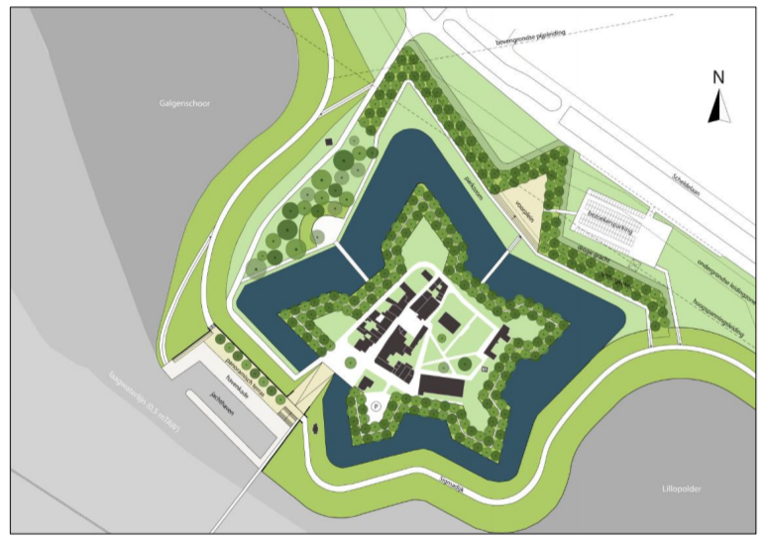

*Masterplan Lillo (CLUSTER landscape architecture)*

|  |  |  |  |
| --- | --- | --- | --- |
|  | ISSUE | YES/NO | Identification/Comments |
| 1 | Is the topic solved in the partner area? |  | Village of Zandvliet (fortress structure built between 1622-1627 by Spanish general Spinola |
| 2 | Main problems and burdens |  | * No protection of the fortress structures, apparently it is a unique fact of fortress cities with seven strongholds (similar like Damme, nearby Bruges) * The only remains are the road Conterscherp, small path and footway *Bergske af* and some height differences on private property |
| 3 | Successfully solved examples |  | * RUP (spatial iplementation plan) Landschapskamers to keep open spaces open (in procedure, no results yet) |
| 4 | Wishes-what you would like to improve? |  | * Protection of green areas, open spaces – to keep open spaces and prevent them for building * Increase of total experience, visibility and knowledge of fortress structure in Zandvliet. Current it is not obvious it is or was a fortress (Lillo is more attractive) * 2022 as goal for first projects or quick wins (400 years of memorial, 1622) also for some cultural event, the aniversery could also be the ideal moment to ask inhabitants and for example children (school) for some ideas. * Start procedure of protection? Steps needed? |
|  |  |  |  |

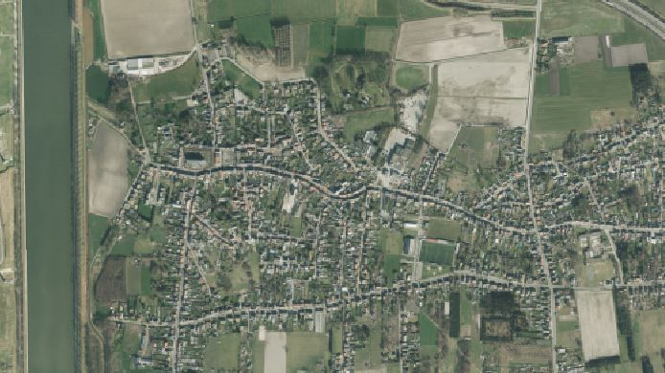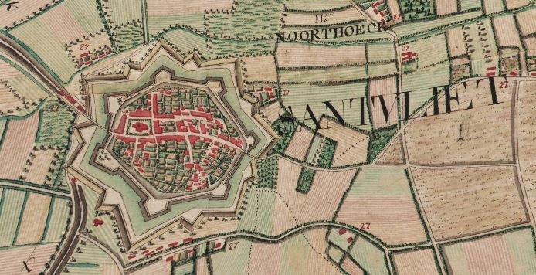*Map Ferraris 1777*

*Current aerial view*

|  |  |  |  |
| --- | --- | --- | --- |
|  | ISSUE | YES/NO | Identification/Comments |
| 1 | Is the topic solved in the partner area? |  | city of Herentals |
| 2 | Main problems and burdens |  | * No experience as the fortress structure as a whole, although the remains are still recognizable in both landscape and urban context * Most visible and famous are the building structures, the two gates: Upper Gate and Sand Gate * Less visible and recognizable are the landscape structures such as remains in park Le Paige, Kattenberg, Begijnenvest and Nonnenvest * Molenvest as a parking lot, conflict heritage values * Split up and fragmented property structure of the fortress structures and therefore there is no continious and accessible connection (walking, bicycle) * There is no plan that covers the fortress structure as a whole, the approach is fragmented and there is no global policy about the fortress structure. Maybe only on spatial / environmental level and only for the north part and this only makes spatial statements. |
| 3 | Successfully solved examples |  | * Masterplan Olympiadelaan (only ½ fortress structure, north part), gives a whole new ambition for the north part of the city with a fortress park, nature corridor, heritage, development zones and water infiltration * although the masterplan has good actions and vision, the translation for real implementation has stil to be made. |
| 4 | Wishes-what you would like to improve? |  | * Besides the two building remains (Gates) need for integration and disclosure of the landscape elements (wall and dike) of the fortress structures; so it it recognizable and experienced as a whole, as part of the DNA and collective memory of the city * To reach this goal there is a need for coordination of the many projects (18! in total) this number is indicative and gives a certain call for urgency for proper coordination on ths level. * The fortress structures are both in public and in private property, this also needs proper coordination and vision   + City property or management: Le Paige, Kattenberg, Molenvest, Begijnenvest, public domain in general   + Private property: Nonnenvest, Voorzienigheid, Koetshuis ... * Priorities: need for proper detail and design for landscape/public space and calculating water buffering * Increase touristic value, this will be started on local level and use for recreation. On the long term this local base will also be international implemented. |
|  |  |  |  |

**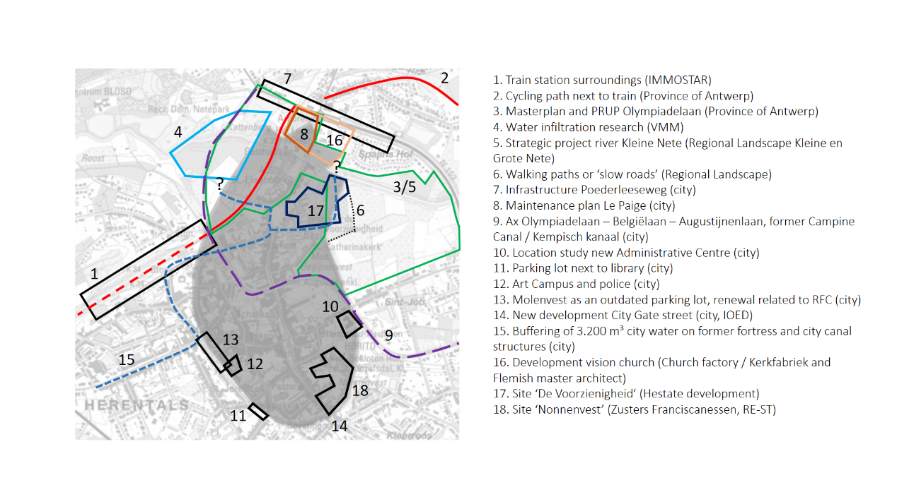*18 projects ! connected with the fortress structure*

*property situation (rough view): OCMW (blue), city (rose)*

*For city of Lier, city of Mechelen and city Dendermonde are first thoughts, this draft has to be checked and discussed with the cities.*

|  |  |  |  |
| --- | --- | --- | --- |
|  | ISSUE | YES/NO | Identification/Comments |
| 1 | Is the topic solved in the partner area? |  | city of Lier |
| 2 | Main problems and burdens |  | * Only day tourism |
| 3 | Successfully solved examples |  | * Managment plan (Province of Antwerp, final phase) |
| 4 | Wishes-what you would like to improve? |  | * Historical education, upgrading and strengthening recreational and green values city walk, tourism (at the resuest of council Rik Verwaest) |

|  |  |  |  |
| --- | --- | --- | --- |
|  | ISSUE | YES/NO | Identification/Comments |
| 1 | Is the topic solved in the partner area? |  | city of Mechelen |
| 2 | Main problems and burdens |  | * Infrastructure, only Brussels Gate has been remained (of twelve gates in total) |
| 3 | Successfully solved examples |  | * Zandpoortvest, Melaan as good practices of green blue integration (also heritage?) |
| 4 | Wishes-what you would like to improve? |  | * Greenblue approach, water infiltration, greening of the ring road (as connection between city and surrounding landscape, connection future National Park around Mechelen? |

|  |  |  |  |
| --- | --- | --- | --- |
|  | ISSUE | YES/NO | Identification/Comments |
| 1 | Is the topic solved in the partner area? |  | city of Dendermonde |
| 2 | Main problems and burdens |  | * Remains need proper vision and for example re-use to give new meaning * Hollandse kazerne needs proper restoration and meaningfull function in the heart of the city |
| 3 | Successfully solved examples |  |  |
| 4 | Wishes-what you would like to improve? |  | * Funding research * Wellingtonbarrière as framework for future challenges (in cooperation simon stevin stichting and EFFORTS) |