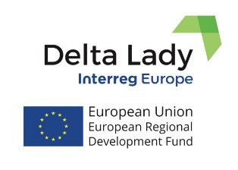
Press Release
April 2020

THE DELTA LADY PARTNERS ONLINE MEETING
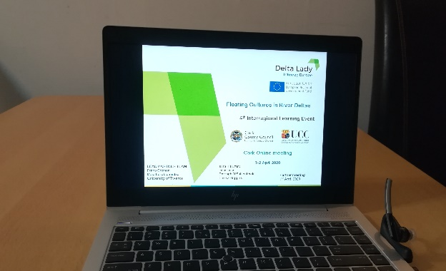
The 4th Interregional Learning Event and Partner Meeting of the Delta Lady project was held online on the 1st and 2nd of April, 2020, as the Covid-19 outbreak prevented the planned meeting in Cork, Ireland. The main focus of the discussion of the meeting was on the development of the action plans for delta regions. 25 participants joined the meeting. The 1st day was dedicated to the presentations of partners highlighting the main issues and activities to be included in their regional action plans. The Regional Natural Park of Camargue (FR) presented the context of their policy instrument which is the Charter of Commitment of the Regional Natural Park of Camargue. Two issues emerged on the territory to be addressed in the regional action plan: the reed beds exploitation and pesca tourism development in Camargue. Cork County Council (IE) presented the steps and preferred actions identified for inclusion in the regional action which are inspired by interregional learning and good practices observed and highlighted by RSG, these are analyzed and grouped by themes: 1) Policy Related Actions; 2) Funding Related Actions; 3) Other Actions. Selection will be through collaboration with project group, RSG members and other relevant stakeholders in the region. ART-ER and Po Delta Park (IT) introduced envisioned actions for the regional action plan. They aim to define tools to include PES in the policy instrument which is Po Delta Park Territorial Plan. The questionnaire will be used to quantify the values of the ecosystems for decision-making processes and to quantify the value of cultural services. Province of Friesland (NL) presented two actions to be addressed: the first action will consider including delta and its characteristics into a policy documents, and the second will be development of tools: a tipping wheel, and an evaluation tool to value investments in nature which will be developed in cooperation with the University of Groningen. Different investment cases were presented as well: Investment in a fish-migration river at the Afsluitdijk (the dike between the salt Wadden Sea and the fresh water IJssel lake); Investment in the Silence of the Bees-project, on the key role of bees in the landscape; Investment in Fryske Trui (Frysian Sweater), to use renewable resources for sweaters, like hemp, flax, reed, including a traditional cultural heritage design. Council of Chamber of Commerce of Valencia (ES) introduced new good practice identified in the Albufera delta, Rice of Albufera, and the actions to be included in the regional action plan: regulation of boat trips, as a sustainable tourist activity in the Albufera Natural park linking to other activities (such as restaurants, bird watching, culture and environmental education). The Danube Delta National Institute for Research and Development (RO) presented envisioned actions related to the improvement of reed beds management in the Danube Delta, the integration of the environmentally friendly and locally oriented elements in tourism infrastructure and development of associated activities, establishment of the Delta Bird Watching Guides Association and connecting to unused infrastructure, modernization of some species to connect to the tourism businesses and mapping of a non-listed and intangible Danube Delta heritage for inclusion in the ROP and Management Plan. The first day was finalized by the presentation of the University College Cork (IE) on the results of the study on the valuation of ecosystem services in the River Black Water delta, with the aim to diversify the supply of benefits obtained from the ecosystem services. The 2nd day was dedicated to the expert’s presentation from the Southern Regional Assembly on what is expected from a Regional Action Plan. This was followed by the Q & A session and by the Steering Committee meeting. Consequences of Covid-19 for the project were discussed, partners were encouraged to organize web meetings with the regional stakeholder groups. The two-day online meeting was successfully concluded with identifying further steps and activities for continuation of the project and preparation for the next meeting. The next 5th Interregional Learning Event and partner meeting is planned to be held in September 2020 in Tulcea, Romania. However, the final decision on this matter will be made in June 2020 with the hope that the situation will improve and the meeting will take place as planned.
For more information, please, contact the lead partner, University of Twente (CSTM)
f.h.j.m.coenen@utwente.nl +31 53 489 3216; m.lordkipanidze@utwente.nl +31 53 489 6080;

Delta Lady (Floating Cultures in River Deltas)
Project funded by Interreg Europe programme
Facebook page

