Interreg Europe action plan template
Produced by each region, the action plan is a document providing details on how the lessons learnt from the cooperation will be implemented in order to improve the policy instrument tackled within that region. The minimum information to be provided per action includes the way the action is linked to the project, the nature of the activities to be implemented, their timeframe, the stakeholders involved, the costs and funding sources. If the same policy instrument is addressed by several partners, only one action plan is required. The action plan should also include actions that may have already been initiated in phase 1.

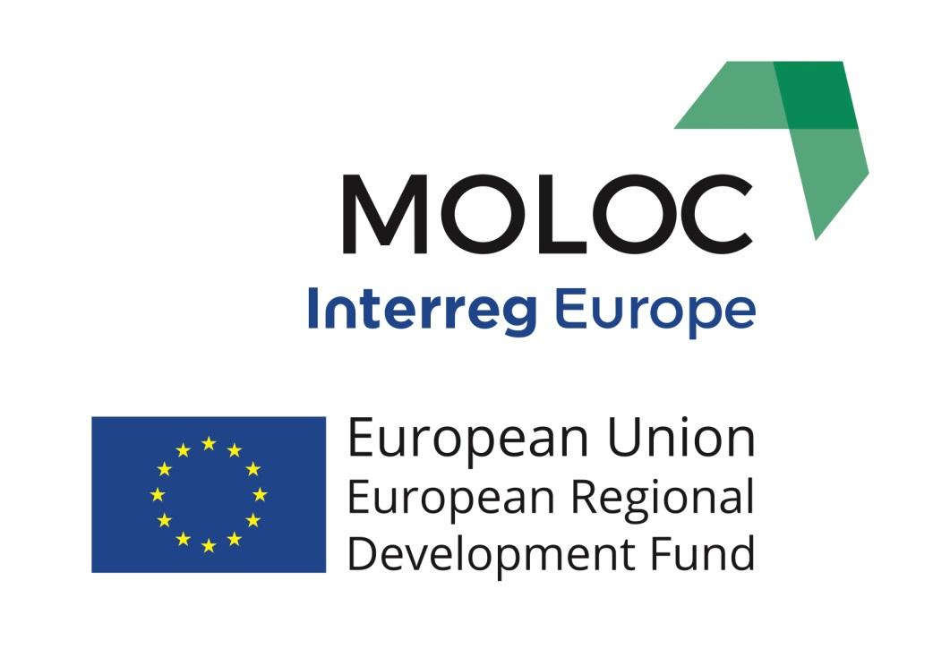
Action Plan for the City of Turin

Part I – General information
Project: MOLOC “Low Carbon Urban Morphologies REF. PGI01979 – CUP C12D16000000007 Co- finanziato dal programma Interreg Europe 2014-2020”

Partner organisation(s) concerned: City of Turin

Country: Italy

NUTS2 region: Piemonte

Contact person:Liliana Mazza – Antonio D’Arpa

Email address: liliana.mazza@comune.Torino.it, antonio.darpa@comune.torino.it

Phone number: +39 01101130417 cell: +39 3494161517

Part II – Policy context
The Action Plan aims to impact: € Investment for Growth and Jobs programme
€ European Territorial Cooperation programme
X Other regional development policy instrument

Name of the policy instrument(s) addressed: Piano Regolatore Generale della Città di Torino - General Master Plan of the City of Torino

Further details on the policy context and the way the action plan should contribute to improve the policy instruments:

The City of Torino, after 25 years since the approval of its General Master-Plan (GMP), set itself the goal of updating it by activating policies aiming at improving the quality of life of its citizens. The environment, in its widest meaning, is the focus leading the whole updating process through an holistic approach and by adopting local strategies, awareness rising and training activities.
The GMP is the planning tool for the whole municipal territory that identifies: zoning, building ratio index, designated use of the single areas, viability and the rules by which the city can change and that safeguard historical buildings and environment.
The general guidelines are about the future development of the city in respect of its current economic and demographic situation. The Urban Planning Office of the City is in charge of updating the GMP and it takes advantage of universities and local territorial bodies to further analyze specific issues.

Part III – Details of the actions envisaged
ACTION 1:
Name of the action: Development of an environmental performance certification for the transformation areas (brownfield) and for the single buildings foreseen in the General Master Plan of the City of Torino to improve its environmental quality.

- Relevance to the project (please describe how this action derives from the project and in particular from the interregional exchange of experience. Where does the inspiration for this action come from?)

The action, carried out together with the Piemonte Region and the Metropolitan Region, will entail lower carbon emissions in the atmosphere and the improvement of other indicators such as soil consumption, energy consumption, sustainable mobility, etc. The action will capitalize on the results of the Interreg Med CESBAMED project that the City of Torino led (final conference held in Torino on October 11th 2019) while the experiences acknowledged thanks to MOLOC - Hamburg Hafen City and social housing in Lille - were extremely useful to define the environmental aspects to be taken into account and investigated further in the GMP.
The study visits in Hamburg, Lille and Katowice were extremely useful to understand the best practices in place in MOLOC partners’ countries. More into detail, the HafenCity Master Plan and the Climate Protection Concept in the IBA area were extremely interesting since they are the largest projects of urban transformation in Europe and most importantly they’ve addressed environmental issues and found remarkable solutions dealing with the energetic transition of buildings in order to achieve the a low carbon city, a goal that the City of Torino has committed to by signing the Covenant of Mayors. Also the selection of urban projects presented by Lille - the eco-neighborhood “Rives de la Haute Deule”, the “Sustainable Housing Centre”, the urban park “Jean-Baptiste Lebas” and the “Pépinière” project were particularly significant to further analyze similar issues in the updating process of the GMP. Finally, the study visit in Katowice highlighted how some brownfields might be re-qualified into parks or into other challenging venues (congress centres, services, etc.). All the visits were important in order to acknowledge different visions and methods to solve common problems and to share an open minded culture.

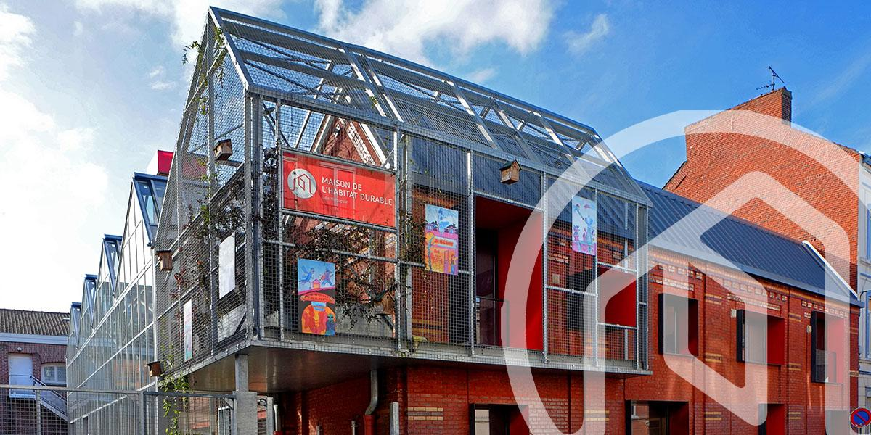
Figure 1 - Lille's sustainable housing centre ("Maison de l'Habitat Durable")

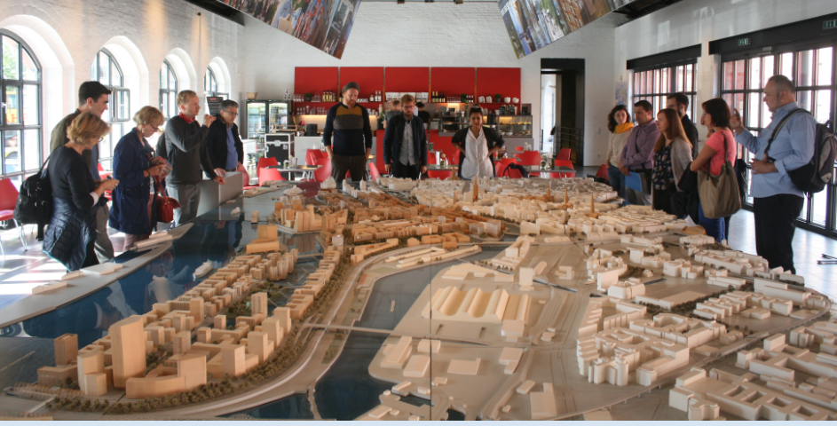
Figure 2 Model of Hafen City planning in Hamburg

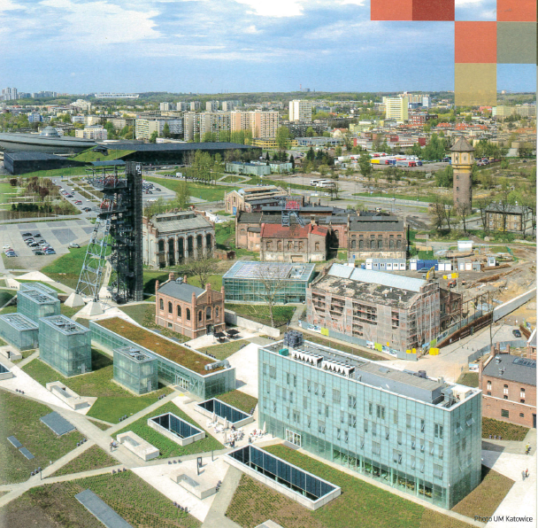
Figura 3 Picture of Katowice's culture zone

- Nature of the action

Proposal of adopting in the regulating system of the General Master-Plan of prescriptions requiring, in the case of new constructions, a medium-high level of environmental performance certification for the single buildings, allowing to compare the performances with standard values, and a certification at district level, to be applied in particular urban regeneration areas (brownfields), allowing to measure the level of sustainability of urban fabric portions. Following the experimental activities carried out throughout the CESBAMED project, the process for a national recognition of the territorial environmental certification is ongoing.

- Stakeholders involved

Territorial entities having the datasets that allow the multi-criteria model and the choice of proper indicators, institutional bodies such as the Piemonte Region, the Metropolitan City, ARPA and research bodies.

- Timeframe
2017 - preliminary political guidelines - Updating the current General Master-Plan - approved by the City Council
2018/19 - Consultation with local stakeholder phase.
2020 - Approval of the Preliminary Technical Project Proposal

- Costs
Human and instrumental resources internal to the City of Torino: working group involved in the General Master-Plan Special Project, about 15 people working full-time on the project. Further studies and environmental analysis are carried out in collaboration with the Politecnico di Torino and other territorial bodies with specific skills involved in the process.
- Funding sources

Municipality’s own human resources.

ACTION 2
Name of the action: Environmental assessment of the General Master Plan of the City of Torino: application of multi-criteria assessment model

- Relevance to the project
The action was conceived because of the need to run, within the framework of the GMP, a diagnosis of the actual level of sustainability at urban scale of the city of Torino, by verifying and mapping the Key Performance Indicators such as: energy consumption (thermal/electric), soil preservation, accessibility to public services, global emissions (CO2), local emissions (PM10, NOX). The SWOT analysis is conceived as a tool supporting strategic planning to assess strengths, weaknesses, opportunities and treats with regards to the energy transition process and resilience to climate change.
Such particularly innovating action is experimented through the Pilot Test of the MOLOC project and the City of Torino would like to exploit it in order to further analyze some general issues about the environmental quality of the updating of the GMP.
The Strategic Environmental Assessment, environmental documentation requested by the current legislation, will have to highlight, at urban level, the actions aiming at improving the environmental sustainability by dealing with soil consumption, the improvement of energy consumption, the quality of public spaces and will have to specify the general guidelines as for the environmental aspects that will have to be taken into account by the sectoral planning (Local Plans).

- Nature of the action
Application of the multi-criteria assessment model based on quantitative and qualitative indicators at urban scale, developed within the framework of the Interreg Europe Project CESBAMED, to measure and monitor environmental sustainability. Such tool might be used for the Strategic Environmental Assessment of the Updating Project of the GMP. The Pilot Study of Moloc implies the capitalization of the Cesba Med European Project. This model can be exploited in several ways:
- as decision making support for elaboration and defining strategies aimed at sustainability optimization at urban district or urban scale using qualitative and quantitative KPIs, with the possibility to envisage several possible scenarios and make the most objective and transparent choices possible;
- as monitoring system of environmental components, in this case it can be applied during the implementation phases of urban regeneration areas (browfields).
In the GMP we use in this two ways the model described above.

- Stakeholders involved

All territorial bodies having the datasets useful to measure the chosen indicators, such as AMIAT and IREN - waste collection & electricity & gas distribution, ARPA - the Regional Agency for Environmental Protection, SMAT - Metropolitan Water Company.
Units internal to the City of Torino (Environment, Urban Green, Mobility, Smart City)
Institutional bodies: Piemonte Region, the Metropolitan City.
Research bodies: Politecnico di Torino, Energy Center.

- Timeframe

November 2018 - Assignment to the Politecnico di Torino (Support Service to the activities of the MOLOC project).
2018/2019 - Consultations with local stakeholders, organization of events involving the citizens in the process of updating the GMP (Mercoledì del Piano - Rail City Lab).
2020 - Approval of the Preliminary Technical Project Proposal.
2020/2021 - Continuous involvement and engagement of citizens in the process.

- Costs

Resources of the project MOLOC to test the multi-criteria model deriving from CESBAMED during MOLOC phase 1, municipality own human resources in phase 2.

- Funding sources

Municipal human and economic resources to finance the tools needed to perform the activity.

ACTION 3
Name of the action: Awareness Raising and Communication regarding updated environmental actions of the General Master Plan of the City of Torino

- Relevance to the project
Action aiming at raising the awareness of and improving the communication to the citizens with regards to territorial and environmental policies. The case studies in Hamburg, Lille and Katowice, were useful to better define the guidelines for developing the communication of the updating activities of the GMP, which will be taken care of mainly by Urban Lab Torino.
Particularly the creation of the Municipal Energy Centre by the City of Katowice, inspired by Lille’s sustainable housing centre, will serve as model for this action. Workshops, permanent exhibition and trainings are used as examples.

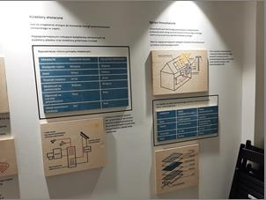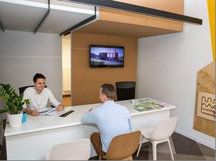

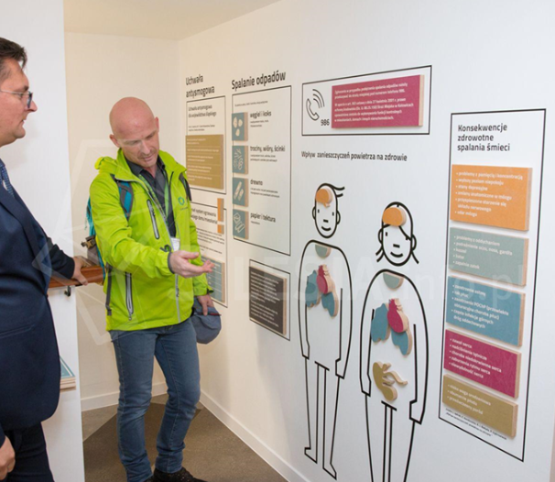

Figure 3 Pictures of Katowice's Municipal Energy Centre

- Nature of the action
Communication campaign reaching out to all possible stakeholders, including the citizens, of both urban planning and environmental choices and good practices (dedicated site, social media, newsletters, local events involving all the interested subjects of the territory).

- Stakeholders involved

Citizens, professionals, economic operators, etc.

- Timeframe

2020-2021 - Beginning of the activities.

- Costs

Human and instrumental resources of the City of Torino.

- Funding sources

Municipality own funds.

ACTION 4
Name of the action: Apply for energy CERTIFICATION ISO 50001 to ensure sustainable management of Torino’s public buildings

- Relevance to the project
In each meeting in which the City of Torino participated within MOLOC, the common interest of the partners to adopt a system of control energy consumption of the respective real estate assets emerged as a common need.
In this context, it was possible to identify actions that arise precisely from the collective needs of the partners and that the City of Turin has adopted first, putting its experience at the disposal of the Project partners so that they can take advantage of it in the immediate future.
From the comparison with the other project partners, in particular with the Katowice partners, it emerged that it is very important to involve the entire organization in the energy management of public buildings. Without the involvement of the entire organization and the leaders in the first place, it is extremely difficult to obtain the results hoped for in terms of reducing energy consumption. For this reason, after several meetings with the partners, the City of Turin has decided to undertake the path of the ISO 50001 energy certification also as a system for involving the entire organization of the Municipality and the heads of the Municipality itself.
The Municipality of Turin is going to obtain the ISO 50001 international energy certification. This action stems from the policy already adopted by the City, and already exposed to our partners, to have a control system on energy consumption in public buildings. Certification makes the system more widespread and systematic within our organization, involving top management.
The certification process helped us to create that network of collaborators that could identify energy problems within our buildings. The creation of this network is one of the driving forces for certification. In the near future it is our intention to show the results of the certification and the path that led to the certification to our partners, so that they can evaluate the opportunity to take the same path.

- Nature of the action

The main activities are those already discussed with the project partners:
- Creation of a secure system for collecting consumption data.
- Creation of a network of collaborators capable of assessing the energy problems of individual buildings and identifying possible solutions.
- Evaluation of consumption data of buildings compared to already determined reference consumption.
- Set credible annual targets for lowering energy consumption.
- Implementation of actions to contain consumption according to the different buildings.
- Intermediate evaluations of the results obtained.
- Possible adjustment of the final objectives.

- Stakeholders involved

The main stakeholders are IREN, Politecnico di Torino and CSI (IT Center – Centro Sistemi Informativi).
IREN, as service company of the City, has to implement the energetic policy in the way the Municipality wants to make it. In the same time, it can experiment with new technologies to get new or better results.
Politecnico di Torino, as well as IREN, can suggest new technologies to us to experiment in our buildings.
CSI, the public IT company, provides the instruments and the software for the data transmission and, in the same time, make some experiments on the same subjects and on its cloud.

- Timeframe (please specify the timing envisaged for action 1)

The network of colleagues of the energy team has been already created and it’s going to be completely operating in a maximum of 4 – 6 months. The City will get the certification within the next year.

- Costs (please estimate the costs related to the implementation of action 1)

The costs of the action 1 are related to the contract for the certification company and are estimated to be around 6.000 euros during 2020. Other 4.000 euros are estimated for internal auditors’ courses and basic energy’s elements’ courses.

- Funding sources (please describe how action 1 will be financed. Is it through the policy instrument(s) indicated in part II):

All sources used are internal.

ACTION 5
Name of the action: Energy Center: an efficient cross-departmental collaboration

- Relevance to the project
The idea was born from the collaboration with the City of Katowice, to create a permanent pole of public and private subjects that can collaborate and exchange information with continuity.

- Nature of the action
During all the visits to each partner site, in Suceava, as well as in Katowice, Hamburg or Lille, we were able to appreciate the importance of collaboration between public bodies, universities, research institutes and private companies in order to obtain the best results in terms of reducing polluting emissions, reducing energy consumption and consequent costs, starting from the wealth of experience and knowledge that each of the subjects can bring. In Turin the Municipality has decided to create a common place, the Energy Center, in which the Energy Management office of the City can compare with that of the Metropolitan City and the Region, with the Polytechnic of Turin and with various companies that deal with energy savings bringing innovative ideas.
In the next year, the office of energy management of the City of Torino will move to the building of the Energy Center, built by the municipality and managed by the Politecnico di Torino.
There will be set up a new private public pole that will work together to find new ways in the search for greater energy efficiency for both public bodies and private citizens and a public help desk will be opened with the collaboration of the Polytechnic where everyone will be able to obtain information about the energy efficiency, current regulations and incentives.

- Stakeholders involved
Every company hosted by the Energy Center,
Politecnico di Torino
Professional associations
- Timeframe

6 - 8 months starting early 2020

- Costs

There are no costs for this action

Date:19/12/2019

Name of the organisation(s): City of Turin

Signatures of the relevant organisation(s): _______________________

https://cesba-med.interreg-med.eu/
https://www.interregeurope.eu/policylearning/good-practices/item/1689/hafencity-master-plan/
https://www.interregeurope.eu/policylearning/good-practices/item/1690/iba-hamburg-2013/
Please refer to the study visit report on MOLOC website for more details : https://www.interregeurope.eu/fileadmin/user_upload/tx_tevprojects/library/file_1575303015.pdf
Please refer to the study visit report on MOLOC website for more details : https://www.interregeurope.eu/fileadmin/user_upload/tx_tevprojects/library/file_1530008077.pdf
More details on : https://www.interregeurope.eu/policylearning/good-practices/item/1688/the-cultural-zone-in-katowice/
More details available here : https://www.torinosiprogetta.it/ http://geoportale.comune.torino.it/web/governo-del-territorio

