**Lille: action plan for a low carbon city**

**Table of Contents**

Abbreviations 4

1 General information 5

2 The MOLOC project grounded in the target public policy: the ERDF-ESF OPERATIONAL PROGRAMME 2014-2020 Nord-Pas-de-Calais 5

2.1 The ERDF-ESF OPERATIONAL PROGRAMME objectives at the heart of Lille’s reflection in MOLOC 5

2.2 The MOLOC project’s activities for impacting the target public policy 6

3 Methodology 7

4 Details of prospective actions 9

4.1 Action 1: Ensuring the convergence of territory’s data and develop a tool to dynamically process this data 9

4.1.1 Context in the MOLOC project 9

4.1.2 Type of action 10

4.1.3 Link with the target public policy 12

4.1.4 Stakeholders involved 12

4.1.5 Schedule, budget and finances estimated for the action 12

4.1.6 Key performance indicators 15

4.2 Action 2: Lay the foundations for taking action on new buildings – constructing a sustainable urban strategy for Lille 15

4.2.1 Context in the MOLOC project 15

4.2.2 Type of action 17

4.2.3 Link with the target public policy 17

4.2.4 Stakeholders involved 18

4.2.5 Schedule, budget and finances estimated for the action 18

4.2.6 Key performance indicators 18

4.2 Action 3: Monitor urban construction delivered 19

4.3.1 Context in the MOLOC project 19

4.3.2 Type of action 21

4.3.3 Link with the target public policy 21

4.3.4 Stakeholders involved 22

4.3.5 Schedule, budget and finances estimated for the action 22

4.3.6 Key performance indicators 23

4.4 Action 4: Promote the use of sustainable and circular materials 24

4.4.1 Context in the MOLOC project 24

4.4.2 Type of action 26

4.4.3 Link with target public policy 26

4.4.4 Stakeholders involved 26

4.4.5 Schedule, budget and financing estimated for the action 27

4.4.6 Key performance indicators 29

4.5 Action 5: capitalize upon the victory of the “Habiter 2030” association at Solar Decathlon Europe 2019 by boosting energy retrofits in the private built environment 29

4.5.1 Context in the MOLOC project 29

4.5.2 Type of action 31

4.5.3 Link with the target public policy 32

4.5.4 Stakeholders involved 33

4.5.5 Schedule, budget and financing estimated for the action 33

4.5.6 Key performance indicators 34

5 Annex 34

**Abbreviations**

|  |  |
| --- | --- |
| ADULM | Development and Urban Agency of Lille Métropole |
| CD2E | Center for the Development of Eco-enterprises |
| CSTB | Scientific and Technical Center for Buildings |
| FTE | Full Time Equivalent |
| GIS | Geographic Information System |
| HdF | Hauts-de-France |
| LCEP | Low-Carbon Economy Plan |
| MEL | European Metropole of Lille |
| PLU | Local Urban Plan |
| PM | Person-Mois |
| QDV | Quality & Development |

# General information

Project: MOLOC (MOrphologies LOw Carbon)

Partner: Ville de Lille

Country: France

NUTS2 Region: FRE1 Nord-Pas-de-Calais

Contact: Aurélien Parsy

Email address: aparsy@mairie-lille.fr

Phone number: +33 (0)3 59 00 14 51

# The MOLOC project grounded in the target public policy: the ERDF-ESF OPERATIONAL PROGRAMME 2014-2020 Nord-Pas-de-Calais

The action plan seeks to impact:

* Investments for Growth and jobs program
* European Territorial Cooperation programs
* Another policy instrument for regional development: operational programme 2014-2020 Nord-Pas-de-Calais

Axis 3: Lead the energy transition in the Region Nord-Pas-de-Calais

Investment priority 4: Favour low carbon development strategies for all types of territories, especially urban areas, including the promotion of a sustainable multimodal urban mobility, and climate adaptation measures.

Specific objective 3: Increase nature-based solutions and demonstrate through experimental operations the potential of a new urban **low-carbon** model (which is adapted to the new climate context and responds to the energy transition challenges).

## The ERDF-ESF OPERATIONAL PROGRAMME objectives at the heart of Lille’s reflection in MOLOC

The ERDF-ESF OPERATIONAL PROGRAMME 2014-2020 Nord-Pas-de-Calais, a public policy targeted in the action plan prepared by the City of Lille, the leader of the MOLOC project, begins with the following observation:

* “Nord-Pas-de-Calais is a **large urban region** marked by its ancient urbanization. This provides the city with a **significant density in its historic centre**. Nevertheless, the phenomenon peri-urbanisation and urban sprawl generates **significant Greenhouse Gas (GHG) emissions,** fragments spaces, diminishes the capacity of soils to sequester carbon, and raises rates of energy consumption. Moreover, the capacity to combat the urban heat island effect remains weak”
* “The goal of reducing carbon emissions from the urban environment will thus be achieved by **reconceptualizing the city** and improving the management of land resources. This new conceptualization will systematically integrate **nature into the city** and deploy HQE buildings that **produce renewable energy** and can supplying local consumers thanks to the development of adequate storage and grid capacities (the concept of “zen-e-cities” developed under the master plan for the “third industrial revolution”). The pursued strategy consists of developing all forms of nature in the city, as well as accompanying several pilot cases of the energy transition, which prove through their innovation that a **“low carbon”** urban model(in line with the climate context and responding to the energy transition) is possible and can be generalized onto other territories. This falls entirely under the logic of the “Third Industrial Revolution”.”

At the beginning of the project in June 2017, the City of Lille met with the Climate, Air, Energy department of the Regional Council’s Energies and Transitions service, the managing authority of ERDF-ESF OPERATIONAL PROGRAMME. The objective was to **identify the needs of ERDF-ESF OPERATIONAL PROGRAMME** regarding the theme of the low carbon city, in order to identify the priorities of the actions of the MOLOC project.

Under the rubric of axis 3 – investment priority 4, the Regional Council launched a call for tender for a “low carbon pilot neighborhood”. Concerning this axis of the OP, a mutual need was identified for the Region and the MOLOC project:

* For MOLOC, understanding the evaluation criteria of this call for tender would help frame the project’s activities
* For the Region, the interest would be to draw upon their local partnership with MOLOC to understand the major difficulties encountered by the institutions tasked with conceiving and implementing low carbon neighborhoods, with the goal of improving the assistance provided to those carrying out the project

## The MOLOC project’s activities for impacting the target public policy

In line with the needs determined by the Regional Council, the MOLOC project’s activities were guided by four main objectives:

* Analyze the obstacles to developing a low carbon city, using the analysis chart prepared by Energy Cities
* Identify the ways to leverage actions to overcome these obstacles
* Gather the necessary stakeholders
* Define solutions

The lessons drawn from these actions will constitute a vital resource for the other territories in the Region, by permitting them to identify potential difficulties beforehand and to test a range of pre-identified solutions. This action plan therefore ultimately seeks to facilitate the implementation of “low carbon” urban strategies.

# Methodology

The five actions detailed in this action plan are the result of the sum of activities conducted by the City of Lille, as leader of the MOLOC project, in cooperation with its European partners and local stakeholders:

|  |
| --- |
| **Non-exhaustive list of activities conducted for the action plan**  European activities:  • Kick off meeting in Lille in March 2017: political integration  • The four interregional meetings in Suceava, Hamburg, Katowice and Turin: definition of the low carbon city analysis framework with Energy Cities, comparative analysis of the low carbon strategies of each city, feedback on the action plans  • The five study visits organized in each of the cities: involvement of experts and identification of good practices  • Participation in the activities of the Interreg Europe Policy Platform  Activities with the local partnership:  • Meetings with local stakeholders on prioritization of actions, sharing of good practices and feedback on the proposed action plan  • Organization of events for inhabitants of Lille  In addition to these activities, several internal steering committees including five elected officials involved in the management of the MOLOC project were organised. |

Two workshops with local stakeholders particularly contributed to defining the framework of this action plan.

The first workshop was organized July 2, 2019. Its theme was **“Sustainable Urbanis planning: What should the priorities be for a low carbon strategy? How can we change our practices accordingly?”** The workshop gathered around 15 participants from three different organizations. The workshop was composed of two sessions. During the first, participants were invited to identify needs, difficulties or best practices encountered in urbanism projects. Then, during the second session, they were asked to imagine tools that could allow them to address their needs and difficulties. 18 tools were conceived of in this way. Finally, the participants voted individually for the tools that seemed the most urgently needed. The first four actions correspond to the tools that received the most votes.

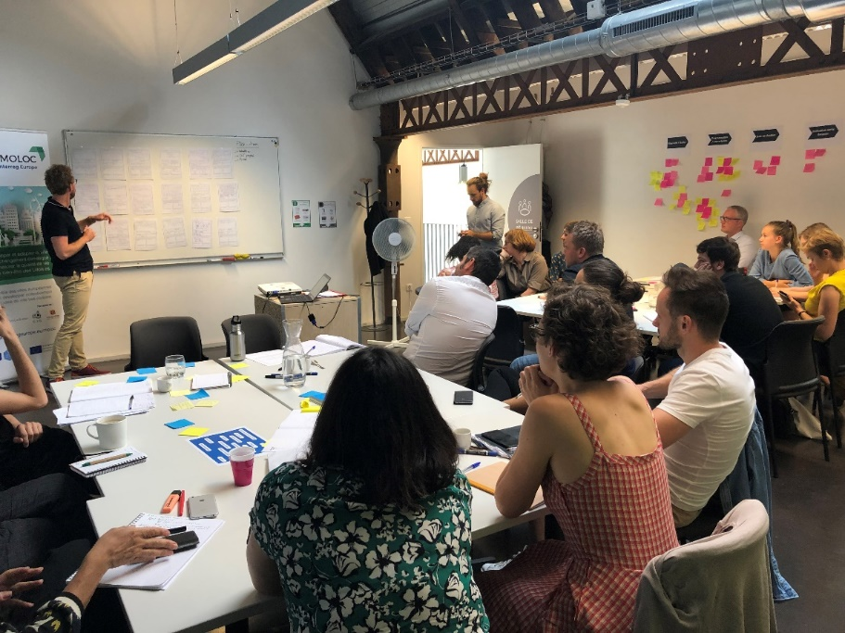

Figure 1: "Sustainable Urbanism" workshop with local partners from MOLOC

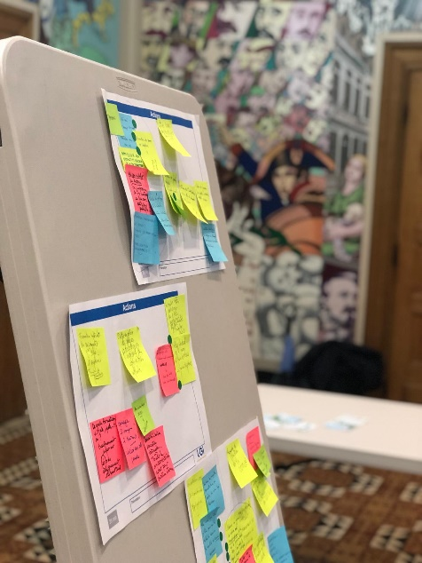The second workshop brought together around 15 participants on October 21, 2019. Its objective was to **define the next steps to be taken by the association “Habiter 2030”.** After winning the Solar Decathlon 2019 in Hungary, Habiter 2030 would like to continue growing its ecosystem of students, professionals, localities and educational teams. The workshop was divided into two sections, and during each section two themes were addressed. Actions were thus proposed for four themes in total. These four themes are: scaling up from the pilot to reality – building a construction site; communication, dissemination and awareness raising; beginning training and research; continuing education.

Figure 2: Habiter 2030 Workshop

Finally, the **report n°19-10** entitled **« Urban Morphology of the low-carbon city. Contribution of the Municipal Dialogue Council for the Lille MOLOC action plan”** that was voted on 16 October 2019 contributed to feed the work. In this document (please refer to annex 1), the Council made propositions on the following themes: governance and citizen participation; energetic renovation of old houses; nature in the city; sustainable urban planning.

# Details of prospective actions

## Action 1: Ensuring the convergence of territory’s data and develop a tool to dynamically process this data

### Context in the MOLOC project

In May 2018, the first study trip of the MOLOC project was organized in Turin and labeled as the partner event “Green European Week”. The City of Turin hosted the partners in the **Urban Center Metropolitano**. This space for information and debate about urban transformations boasts some impressive mapping resources and data that is easily accessible to experts.[1]

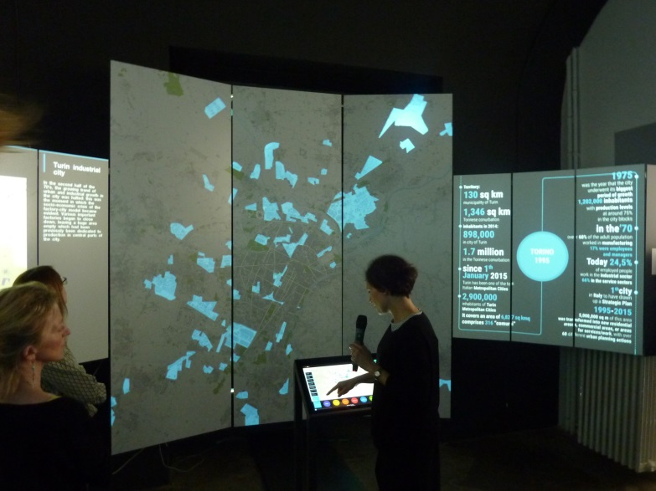

Figure 3 Presentation of the digital mapping tool installed at the Urban Center Metropolitano during the first study trip of the MOLOC project in Turin

This dynamic mapping installation particularly inspired the numerous members of the Lille’s delegation visiting Turin. A first idea was to explore the potential of **setting up a digital mapping exposition for locals**. This idea proved to be too difficult to put into practice.

Therefore, the teams from Lille sharpened their focus by identifying an important need for the city and its partners: **organizing the recent data about the key elements for a low carbon urban strategy**, like what Turin did. This would illuminate the major needs for actions in the city.

### Type of action

As of now, the City of Lille has a certain number of datasets which it hopes to use to model the low carbon city. The issue implies using modeling tools to understand how global warming phenomena will play out in Lille. A Geographic Information System (GIS) will thus be created and strongly enriched with energy data (solar mapping, geothermal…).

One part of this data is represented cartographically and freely accessible on the City of Lille’s mapping portal DYNMAP[2]. The following maps are publicly available:

* The age of buildings
* The historical evolution of the city
* Local public facilities
* Locations of parks and gardens
* A summary of urban transportation modes
* Natural, technological and sanitary risks
* Aerial thermography

Part of the data that constitutes the low carbon city is only available internally for municipal technicians, including for example:

* The total surface of green space and its cartographic representation
* The motorization rates of Lille households
* The map of land use

A certain number of other datasets are managed by the MEL and the ADULM. Accessing and using these datasets is thus made difficult by their incompatible support systems.

In order to replicate to the work that was done by Turin to build a regularly updated database, the City of Lille needs to conduct two elements:

- Organize the convergence towards a **GIS system** for this data carried out by the municipality and local partners

- Produce impactful data

All this data should be used to support impactful decision in the territory of Lille. The goal is thus to **inscribe the piloting of geographic information as a structural axis of developing a low carbon city**.

The work on gathering the data concerned and organizing them into a geographic information system should be based on the **draft Convention between the City of Lille and the Citizens for Climate association[3],** in which a series of indicators should be selected to become a support for dialogue and for the municipality on taking climate issues into account in municipal actions.

Action 1 is composed of the following sub-actions:

* 1. Reinforce the coordination of projects related to geographic information: Identify a reference person in the Office of Quality and Development of the City and form a group of transversal resources in order to conduct a preliminary census of datasets
  2. Select an external expert to:
     1. Establish an exhaustive diagnostic of existing data on the territory of Lille and GIS data within the documents produced by the City of Lille as well as other partners (MEL, ADULM…) with the goal of exploring possible data synergies
     2. Determine the needs in terms of data, maps of the territory of Lille (humid zones, thermo-solar, etc.) and identify the missing data
     3. Rewrite the specifications that the GIS tool (formatting and technical services) of the City of Lille must respond to
     4. Identify and quantify the technical solutions supporting the data within the new GIS system
     5. Guarantee that geographic information conforms to national and European directives
     6. Explore the hypothesis of interoperability between different data producing tools used internally and by the Metropole, where applicable
  3. Produce/get data and missing territory maps to answer the city’s needs
  4. Put out a call for tender to select a provider that will accompany the City of Lille in implementing a GIS tool (Assistance for Project Management)
  5. Train the technical offices to use the tool (access and exploit geographic information, produce maps based on geographic information)
  6. Ensure the functional and technical administration of the GIS tool and perform regular checks on its use

At the end of these actions, the City of Lille plans to have a dynamic tool that gathers the necessary data to understand spatial issues related to its work and establish a goal-oriented strategy with precise data metrics. Corrective actions developed within the low carbon strategy will thus be measurable, easy to access and regularly updated.

### Link with the target public policy

The Regional Council of Hauts-de-France, through priority 4 of the ERDF-ESF OPERATIONAL PROGRAMME 2014-2020, the political instrument targeted in MOLOC, asks for cities in the region that want to develop a low carbon strategy to have the following datasets available:

* The environmental and energy performance of buildings
* The consumption of water and energy
* Emissions of pollutants
* Waste management
* Transportation produced by projects
* Air, light and sound pollution
* Biodiversity analyses

At the beginning of the MOLOC project, the Regional Council’s demand for the City of Lille is to act as a pioneer of low carbon pilot projects for other cities in the region. There is therefore an essential need to gather the necessary data required by the Regional Council in order to analyze the ongoing and future projects responding to the criteria in the call for tender for low carbon projects.

### Stakeholders involved

The following stakeholders are involved in this action 1:

* The City of Lille: reference person for the action, the observatory and the relevant departments taking a census of existing maps and data, identifying existing needs, establishing new maps and GIS data, putting in place the GIS tool, as well as the team in charge of the Convention for Climate.
* External actors, such as the MEL, the Regional Council, the Agency for Urban Development of Lille Metropole (ADULM), the Ministriy of the Environment and Energy (l’ADEME), the CERDD, ATMO Hauts-de-France who will share their data and maps with the City of Lille
* Subcontractors tasked with producing new maps and gathering GIS data as needed
* A project management assistant who will create the diagnostic and the requirements for GIS support in converging all Lille data including that which is in the energy atlas being created

### Schedule, budget and finances estimated for the action

The total length of action 1 is estimated at 2 years. After these 2 years, there should be a continual assessment of how the GIS tool is used. This action represents an effort of 27,4 person months (PM) for the City of Lille (FTE 1,14)[4].

The additional costs that were identified are:

* Producing the supplemental data, necessary for the territorial diagnostic: 100k€[5]
* Conducting a study on available GIS tools (Assistance of Project Management): 50k€
* Implementing a GIS tool: 30k€[6]



Figure 4: Schedule and budget estimated for action 1

The sources of financing for action 1 are the following:

- the City of Lille

- MEL

- ADEME

### Key performance indicators

The following indicators will allow for action 1 to be monitored:

* Working group formed and manager identified (1a)
* Call for tender published for the choice of the Assistance of Project Management that will intervene to help choose a GIS tool that is well adapted to the needs of the City of Lille (1b)
* Maps and supplemental data recovered (1c)
* Implementation of the selected GIS tool (1c)

## Action 2: Lay the foundations for taking action on new buildings – constructing a sustainable urban strategy for Lille

### Context in the MOLOC project

Imposing a sustainable development strategy onto construction actors in the city requires a clear vision of what actions to prioritize. To avoid pushing people away from targets that seem too unrealistic to attain, the City of Lille wants to choose some priorities for a low carbon city.

To have an impact on practices, these priorities need to be understandable, but even more so they need to have political will behind them. For example, the housing regulations imposed in the local urbanism plan (PLU) align with the Mayor’s ambitions to keep the rate of social housing at its current levels. We could also imagine similar rules relating to low carbon themes.

This idea was further reinforced by the work carried out by colleagues at the **City of Turin**, a partner in the MOLOC project, along with the **University Politecnico di Torino**. To elaborate their action plan, the City of Torino and Politecnico organized a workshop on June 11 2019 with 30 representatives from their local partnership. The objective was to identify the most important criteria related to energy and sustainable development for revising their target public policy, the “general master plan metropolitano”.

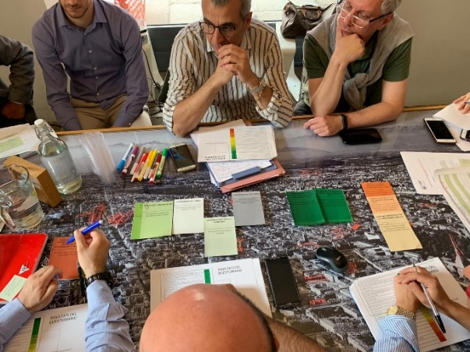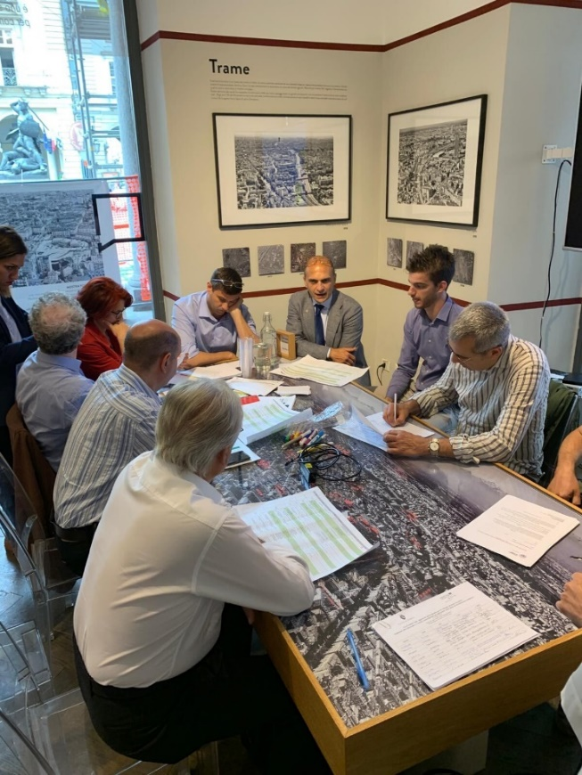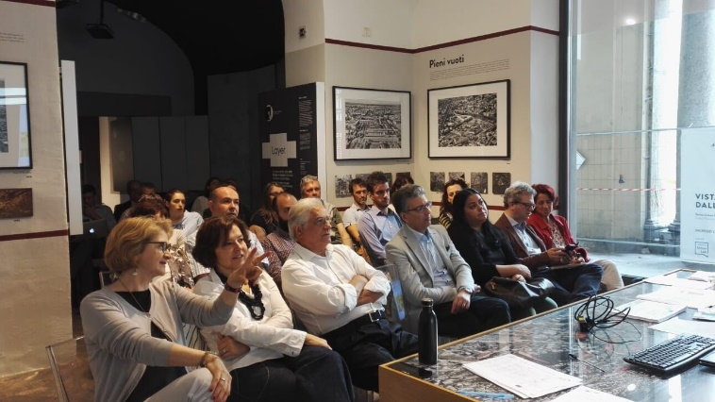

1. Figure 5 : Photos of the workshop at the Urban Center Metropolitano

By the end of the workshop, participants had thus chosen their priorities which they considered to be the most important.

1. Proximity to **green spaces**
2. **Air quality** (in particular PM 10 rate over one year)
3. Urban **heat island effect** on a local scale
4. Reloading the **water table** through the use of permeable materials
5. **Greenhouse gas emissions** linked to the use of fossil fuels induced by development operations
6. **Land** consumption
7. Facilities promoting **intermodality**
8. Involvement of **residents** in urban planning projects
9. **Canopy** index for shade and lower ambient temperatures
10. Energy consumption of **public lighting**
11. Final energy consumption of **buildings** delivered

Figure 6 : Selected criteria from the workshop in Turin

The City of Lille was inspired by this work, and organized its own workshop on the 2 July 2019 to identify barriers and look for sustainable urban solutions. 18 participants from 4 organizations took part. After this workshop, several meetings took place with elected officials that related to the initiative known as the “**Club of 10.000**” conducted by the City of Lille, in order to deliberate about the primary criteria. When applying in 2019 to become European Green Capital 2021, the City of Lille created a new informal institution focused on the dialogue between the City and construction actors: the “Club of 10.000”. This initiative focuses on information sharing, dialogue, debate around the issues related to building new construction in Lille.

The City of Lille would like to thus pursue this work and select the criteria that officials deem to be the most pertinent to be transcribed in the City’s regulations.

### Type of action

Several important subjects for sustainable urbanism include: urban agriculture, sustainable and bio-based materials, energy efficiency, nature in the city, etc. Increasing **green spaces in the City** is a major issue. In order to adopt a common vision a facilitate dialogue with the primary actors involved in constructing the city, the City of Lille wanted to define the priorities of a sustainable urban strategy.

This work will be based on:

- the conclusions of the work carried out on data convergence within the framework of action 1

- the priorities for action which will arise from the work carried out within the framework of the "Club of 10 000"

- the work on indicators conducted by the climate convention

The teams mobilized for this action 2 will therefore be able, at the end of this work of defining the priorities carried out by the steps mentioned above, to propose a translation of these elements in the form of regulatory and enforceable documents.

### Link with the target public policy

In relation with the stated goal of action 1, formalizing ambitious criteria for a “low carbon” project necessitates political will from local officials. The Regional Council hopes to achieve a “change in eco-citizen behavior induced by a low carbon project”*[7].* The priorities selected by local officials are essential to begin changing behavior at an important scale and thus avoid that this subject is confined to being treated as purely technical.

This is why the City of Lille wants to become a pioneer at the regional level in its capacity to select essential criteria for urban strategies of sustainable development. The selection of a “short list of criteria” will thus allow other cities in the region that want to conceive of similar strategies to begin deploying them in line with these criteria.

### Stakeholders involved

The following stakeholders are involved in this action 2:

* The City of Lille: the planning directorate (reference person of the action), the operational directorates of the QDV office, and more specifically the Habitat department, in charge of the coordination of the “”Club of 10 000” elected officials to co-create the city’s sustainable urbanism priorities.
* The participatory democracy directorate if it is solicited for aspects of participatory democracy and the communication directorate if officials would like to communicate publically
* Eventually the MEL and construction actors.

### Schedule, budget and finances estimated for the action

The total duration of action 2 is estimated at 24 months with a total effort of 23 person-months (FTE 0,96)[8].

Operational costs of 10k€ were identified:

* 5k€ to produce communications materials
* 5k€ to organize larger meetings with all the territorial partners.

This action will be financed internally using existing staff and resources to cover supplemental costs.

### Key performance indicators

The following indicators will allow for action 2 to be monitored:

* Creation of a working group and reference person (2a)
* Preliminary list of priority criteria is approved (2b)
* Definitive list of priority criteria is presented internally (2c)
* The integration process into workplace manuals is defined and established (2e)
* The communication campaign is conducted (2g)
* Meetings are planned to inform relevant constituents about the sustainable urban strategy for construction (2f)

## Action 3: Monitor urban construction delivered

### Context in the MOLOC project

During the third study trip of the MOLOC project, which was organized in September 2018 by the City of Hamburg (PP4), a bilateral site visit was organized with the planning department of the City of Hamburg and the Deputy Planning Mayor of the City of Lille as well as the Director of the Planning and Development Department for the City of Lille. Local partners from the ADULM, the MEL and The Neighborhood Factory The Neighborhood Factory also took part. HafenCity Hamburg GmbH tasked some of their project managers to guide us through the HafenCity project.[9] One aspect of the project particularly stuck out to us: the **HafenCity Ecolabel**. The following photos show examples of projects that received the label.

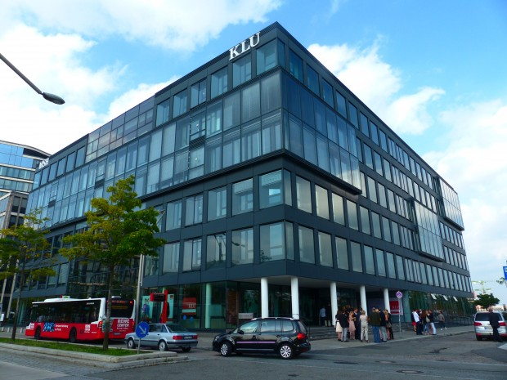a.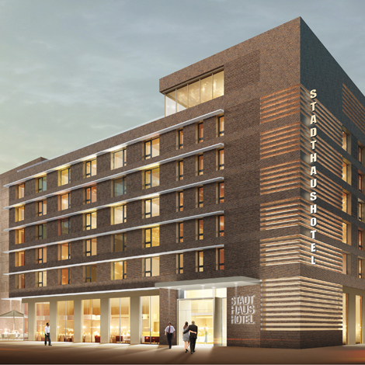 b.

Figure 8 : a. Stadthaushotel - HafenCity b.Kühne Logistics University - Hafen City

The steps to obtain the label are the following[10] :

* The purchaser of the lot and HafenCity Hamburg GmbH draw up a contract committing the purchaser to construct a building that fulfills the label criteria. The investor must comply with 3 out of 5 criteria, one of which is obligatory: the sustainable management of resources. These conditions are integrated into a competition and judged by a jury.
* The contractual and regulatory elements are then evaluated by an independent inspection institute appointed by HafenCity Hamburg GmbH. If the buildings meet these criteria, they can be granted a preliminary certification.

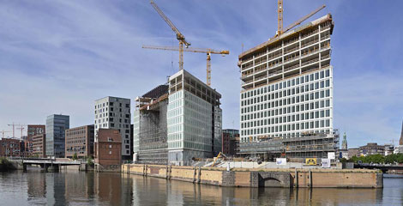

Figure 9 Headquarters of the SPIEGEL Newspaper- Preliminary certification before delivery

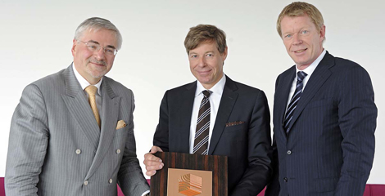

Figure 10 Bestowing the Ecolabel to the project developer

* Once the building is completed, independent specialists prepare an inspection report. If the result is positive, the final label is awarded.

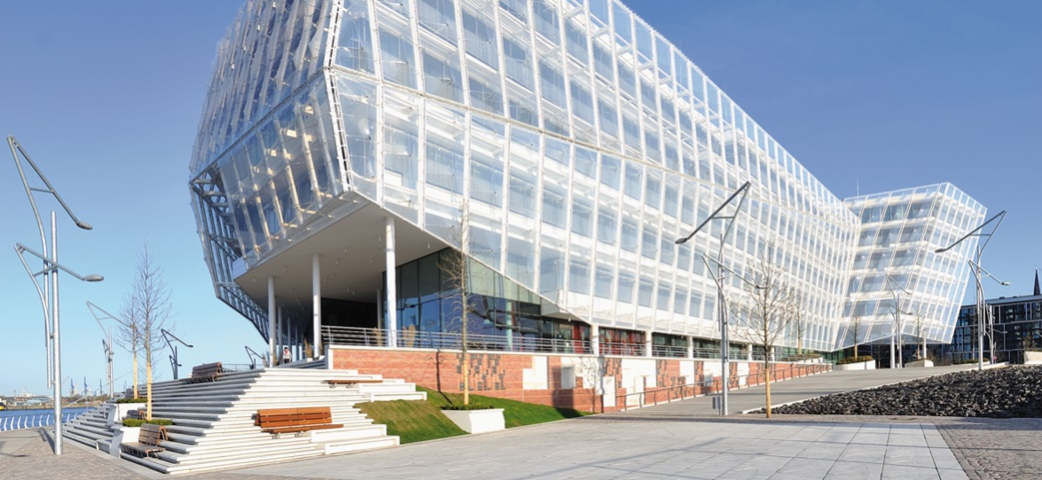

Figure 11 The UNILEVER headquarters – Gold Ecolabel

* The energy efficiency inspection occurs one year after the building is finished. If the ambitions set when the label was granted haven’t been met, improvements must me made. If, despite these efforts, this level of performance still isn’t met, the label can be withdrawn. This case has still never occurred.

Learning about this label and the way it can be obtained motivated the City of Lille to reflect on how to implement a similar process.

### Type of action

In order to conceive of how to eventually create a similar label, the City of Lille wants to first **develop effective tools to monitor urban construction**.

Once buildings are delivered to their developer, the City of Lille struggles to access results about a building’s energy performance. Likewise it’s difficult to gather feedback from building users. To determine which technologies or areas (materials, energy efficiency, green space, etc) pose the greatest problems or are addressed in the best way, the City of Lille would like to **monitor urban constructions.** Targeted projects would be diffuse but also those in joint development zone.

The tool (s) developed as part of this approach must be **incentive** and not prescriptive, for example in the form of an intention notice.

Action 3 is composed of the following sub-actions:

* 1. Define a person of reference and the people involved
  2. Define the necessary information needed to evaluate the performance of an urban construction once built (evaluation indicators, qualitative questions)
  3. Target the building operators and inform them of the follow up procedures
  4. Set up a tool to gather information that will allow for urban constructions to be monitored and compared
  5. If officials decide: launch a communication campaign to inform constituents about the existence of the tool and boost performance indicators
  6. Contact the previously identified interlocutors to gather information about performance
  7. Organize follow up meetings with builders
  8. Work on the **proposal of a tool to monitor** future operations

### Link with the target public policy

Specific objective 3 – axis 4 specifies in its objectives that projects soliciting support from the Regional Council must show the *“environmental impact of investments, notably the energy and environmental performance of buildings, water and energy consumption, emissions of pollutants, waste management, transportation generated by the project, light pollution and pollution treatment where applicable*”.

In order to sustainably train both the project stakeholders and developers in the conception of sustainable and energy efficient buildings, a rigorous monitoring of actions undertaken will allow the Regional Council to draw upon exemplary resources to raise awareness and accompany all communities in the Hauts-de-France region.

### Stakeholders involved

The following stakeholders are involved in action 3:

* The City of Lille: the planning department (person of reference for the action), the department of building and construction and of sustainable development, the officials in charge of planning, housing and sustainable development
* External actors including the MEL, the Regional Council, the Neighborhood Factory, citizens and private sector actors including: companies involved in construction, real estate, promotion, building management, energy efficiency, etc. that can list information about their experiences
* A communication team (internal or external) to create the communication campaign that will inform the monitoring tool
* The builders after follow-up meetings

### Schedule, budget and finances estimated for the action

The total length of action 3 is estimated to be 21 months with a total effort of 20,7 person months (FTE 0,99)[11].

6k€ of **optional costs** were identified:

* Fees for workshops/ interviews: 4k€ for organizing workshops, catering, renting rooms, traveling to the interviews, etc. to define with the stakeholders what information to gather during the feedback sessions (3b), and to organize monitoring meetings with the builders (3h).
* If the officials want to launch a communication campaign: 2k€ to print communication material to inform citizens about the existence of the monitoring tool.

This action can nevertheless be carried out without additional costs apart from internal human resources.



Figure 12: Schedule and budget estimated for action 3

This action will be financed internally by making employees available and covering additional costs.

### Key performance indicators

The following indicators will allow for action 3 to be monitored:

* Identifying a reference person (3a)
* A document describing the necessary information to evaluate the performance of urban projects once constructed (defining evaluation indicators, qualitative questions, etc.) (3b)
* Specifications published integrating the obligation to inform the City of Lille about project management, interlocutors, and expected performance (3d)
* A tool allowing information to be gathered is made available (3e)
* Communication campaign conducted among constituents (3f)
* Meetings with constructors have been organized (3h)

## Action 4: Promote the use of sustainable and circular materials

### Context in the MOLOC project

During the third study trip of the MOLOC project, which was organized in September 2018 by the City of Hamburg (PP4), a bilateral site visit was organized with the planning department of the City of Hamburg and the Deputy Planning Mayor of the City of Lille as well as the Director of the Planning and Development Department for the City of Lille. Local partners from the ADULM, the MEL and The Neighborhood Factory also took part.

ZEBAU, the Centre for Energy, Construction and the Environment, a local partner of the City of Hamburg, presented us the “‘sustainable Wilhelmsburg’ Concept of Climate Protection”**[12]** that was designed for the international architecture exposition of the IBA in 2013.

In order to translate the ambitions of the IBA regarding climate change and arrive at an energy efficient territory, an international committee of experts collaborated with the IBA to develop a “concept of climate protection for sustainable territories”. The result of this concept corresponds to an “energy atlas”. The idea behind this atlas is to use local energy generated at the city or neighborhood level in order to improve the efficiency of local energy consumption. The atlas demonstrated that by 2050 its possible to provide the Island of Elbe with locally sourced renewable energy even accounting for population growth (from 55 000 today to an eventual 73 000). The objective of this climate protection concept is to combat climate change through:

* The development and implementation of local energy sources
* Energy savings and improved efficiency
* The use of renewable energy

With respect to “energy savings and improved efficiency”, ZEBAU showed their low carbon pilot buildings using bio-sourced innovative materials.

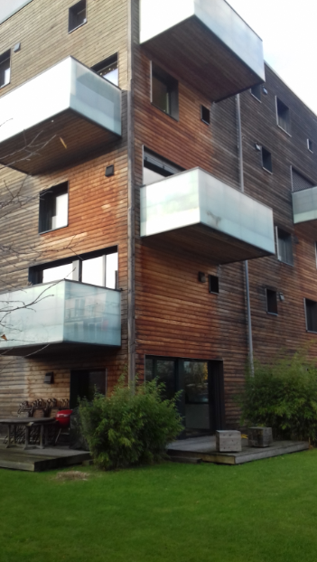

Figure 13 Pilot Building on the IBA – Large scale wood

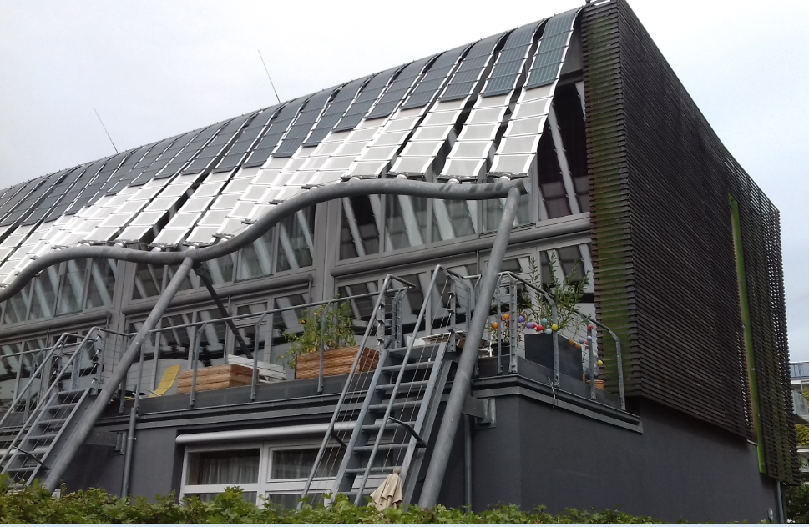

Figure 14 Pilot building on the IBA – using flexible solar PVs

The use of wood for large scale projects, as well as hemp and straw to insulate some buildings on the IBA site further encouraged the City of Lille to promote the usage of these materials within its territory.

### Type of action

The materials used in construction are key for the energy performance of buildings. In order to stimulate the growth of the sector, the technical and operational teams of the City of Lille want to follow the Hamburg model by exploring ways of using bio-sourced and circular materials in order to integrate them into the specifications and habits used by property developers.

At the end of the work on this action, the City of Lille will be able to envisage the creation of a notice on the circular economy to be filled in declaratively by the promoters of projects.

This action is composed of the following sub-actions:

* 1. Identify the reference person or people on this subject. The **Sustainable Housing Centre** will be an essential support for carrying this action.
  2. Identify the knowledge gaps on this subject (through workshops or internal discussions) and establish an inventory of existing initiatives
  3. Organize meetings to share knowledge about sustainable and circular materials
  4. Expert interventions about circular and eco-materials
  5. Create summaries of the results of this knowledge sharing
  6. Organize training sessions for the urbanism team
  7. Provide the urbanists with the results of this work
  8. Organize meetings to analyze how to integrate circular and bio-sourced materials into the technical specifications
  9. Communicate internally

### Link with target public policy

The ERDF-ESF OPERATIONAL PROGRAMME 2014-2020 encourages the “use of renewable energy and eco-materials”, as indicated in priorities 4e and 6c. This sector is still underdeveloped in the Region, given the lack of structure in the industrial sectors. Through the MOLOC project, the City of Lille would like to contribute to structuring the regional circular and eco-materials sector. This will happen primarily through informing developers hired during public procurement of the technical requirement to integrate circular and eco-materials.

### Stakeholders involved

The following stakeholders are involved in action 4:

* The operational divisions of the Office of Quality Development: planning, building maintenance, sustainable development; the economic action division working on the social solidarity economy.
* Training organizations, research centers, universities…. To provide the training – especially the CSTB (Scientific and Technical Center for Buildings)
* Center for the Development of Eco-enterprises (CD2E)
* Communication team (internal or external) to create flyers, support trainings and define internal messaging
* The Regional Council of Hauts-de-France and the CCI to include the contributions of the City into the regional strategy

### Schedule, budget and financing estimated for the action

The total duration of action 4 is estimated at 18 months with a total effort of 15,7 person months (FTE 0,87)[13].

Supplemental costs of 10K€ were identified for an expert intervention to share knowledge about sustainable and circular materials. After this intervention, capitalization sheets will be drawn up internally (including costs).



Figure 15: Schedule and estimated budget for action 4

The sources for financing action 4 are the following:

* The City of Lille
* MEL
* ADEME

### Key performance indicators

The following indicators will allow for action 4 to be monitored:

* Reference person is identified (4a)
* Expert intervention conducted (4d)
* Time for acculturation has been taken (4f)
* Flyers and other materials are available (4g)

## Action 5: capitalize upon the victory of the “Habiter 2030” association at Solar Decathlon Europe 2019 by boosting energy retrofits in the private built environment

### Context in the MOLOC project

During the MOLOC project’s **kick-off meeting** March 2017 in Lille, the deputy Mayor of Katowice Mr. Mariusz Skiba presented officials from Lille the low carbon strategy developed by the “Central Mining Institute” and the City of Katowice, both of whom are partners in MOLOC. This strategy is the “**Low-Carbon Economy Plan (LCEP) for the City of Katowice 2014-2020**”, which is a political instrument of the Central Mining Institute (PP3).

Three objectives from this strategy particularly drew the attention of Lille’s elected officials:

* Objective 4 of the LCEP: increase the use of renewable energy
* Objective 5 of the LCEP: increase energy efficiency
* Objective 6 of the LCEP: develop an innovative economy based on knowledge of modern technology

Following the kick-off meeting, the Lillois officials involved with MOLOC asked the MOLOC team to develop and accompany actions that respond to the objectives set by Katowice.

The housing division of the City of Lille, involved in MOLOC, thus supported the reflections of the National Architecture and Landscaping School of Lille (ENSAPL), a local partner in the MOLOC project, regarding energy renovations for “1930s houses” in Lille.

There is a total of 140 000 housing units in the city of Lille (including Lommes and Hellemes). A large part of these houses is made of terraced houses from the industrial period (1850- 1950), built before the first thermal regulations. 25% of all dwellings are considered in energy poverty[14]. Therefore, reducing the energy consumption of these houses and developing renewables is crucially important both socially and environmentally.

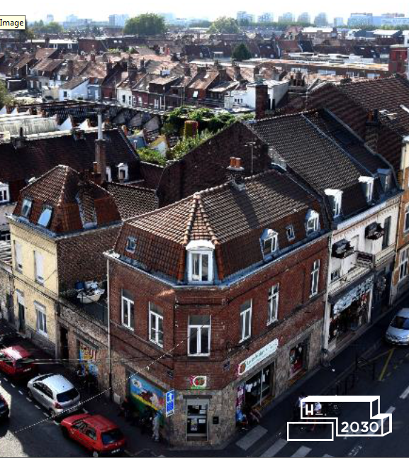

Figure 16 Typical example of workers housing built during the end of the XIXth century, the “1930s houses” are characteristic of Lille and Hauts-de-France

Inspired by the objectives of Katowice, several local partners associated with the MOLOC project therefore decided to apply their objectives onto the major issue of energy retrofitting the “1930s houses”. The **Habiter 2030 association** was thus created by ENSAPL in 2018 to take part in the international university competition Solar Decathlon 2019 organized in July 2019 around the theme of energy efficient housing.[15]

Sixteen European teams presented their prototype for passive housing run mostly on solar energy. The team from Lille was the only French team taking part in the competition, and its candidacy was unique because of its choice to tackle the **massive thermal rehabilitation of the built environment in our Region.**

In the context of their LCEP, the partners from Katowice decided to focus on replacing individual coal heaters.[16] This specificity doesn’t apply to the household appliances in the Hauts-de-France region.

The City of Lille therefore chose to support the association Habiter 2030 in preparing its candidacy for Solar Decathlon 2019, in hopes of reproducing their prototype within the municipal policy for housing renovation.

This cross-cutting work nourished important exchanges between the partners from Katowice and from Lille in the MOLOC project: Lille discovered the financial incentives and awareness campaigns to combat air pollution in Silesia; Katowice discovered the global strategy of energy retrofits for industrial housing in Lille.

### Type of action

The Lillois team Habiter 2030 won the Solar Decathlon in July 2019. This victory underlines the fact that solutions exist for energy retrofitting industrial housing in Lille and the surrounding region and opens new perspectives.

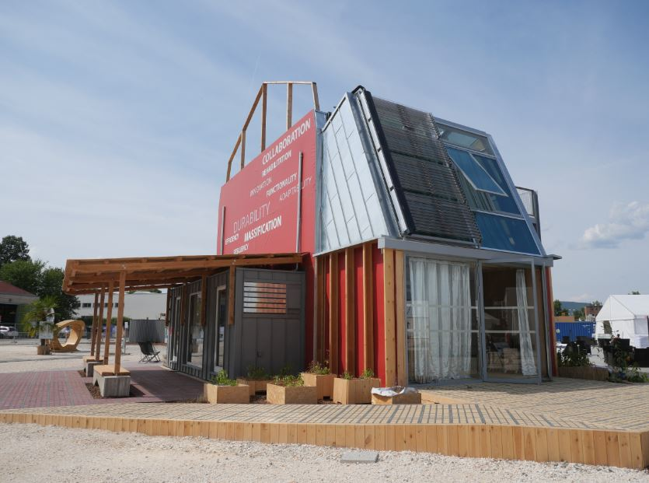

Figure 17 Photo of the prototype developed by the association Habiter 2030 that won the Solar Decathlon 2019

It is now necessary to **capitalize upon this victory**, so that the lessons learned from this adventure contribute to **boosting energy retrofits of industrial housing**. The prototype that won the competition couldn’t be repatriated to Lille, due to financial and technical reasons.

There are thus several relevant issues, particularly the following:

* Finding a site to reproduce the prototype
* Associating the universities and schools to build the construction
* - Developing the communication tools needed to inform experts and the general public
* - Building a business case

The tasks envisioned for phase 2 of the MOLOC project are therefore the following:

* 1. As part of a **permanent laboratory**:

- coordinate a “real” construction site together with stakeholders to test solutions developed by Habiter 2030 during the contest

- support to organize a regional and annual workshop/event between schools with stakeholders on Habiter 2030 topics

5.b. As part of **demonstration**: help in pooling the results of construction sites by different partners and in the dissemination and animation of co-design workshops to move towards massification.

5.c As part of the **skills development of stakeholders**: assistance in the preparation of professional visits to the house “Proof Of Concept Habitat”, which will be built as part of Lille World Design Capital 2020, where the recommendations made by Habiter 2030 will be presented at the Solar Decathlon Europe 2019

5.d Within the framework of **popularization for all audiences**: Communication and awareness-raising: production of communication documents and audiovisual supports, in particular for the POC Habitat house

### Link with the target public policy

The ERDF-ESF OPERATIONAL PROGRAMME 2014-2020 supports, through priority 4c, “*investment relative to the conceiving, implementing and piloting intelligent systems for energy management and micro-grids, as well as investments in preliminary training to use these new systems*”.

The Regional Council of Hauts-de-France, the managing authority of ERDF-ESF OPERATIONAL PROGRAMME, financially supported the candidacy of the Habiter 2030 association for the Solar Decathlon Europe 2019.

An estimated 700,000 houses from the industrial era need important energy retrofits, notably in the mining basin where 64,000 houses built between the mid-19th century and 1965 are located.

The Regional Council therefore has a strong interest in supporting the work of Habiter 2030. During a meeting with the housing division of the Regional Council on August 20 2019, the Regional Council decided to support the activity of the MOLOC project in line with the actions related to Habiter 2030, and eventually to renew its support if a technologically coherent and economical model of renovation is developed that can be replicated across the region.

As part of this activity, regular meetings will be held to provide status updates between the housing division and the Rev3 division of the Regional Council.

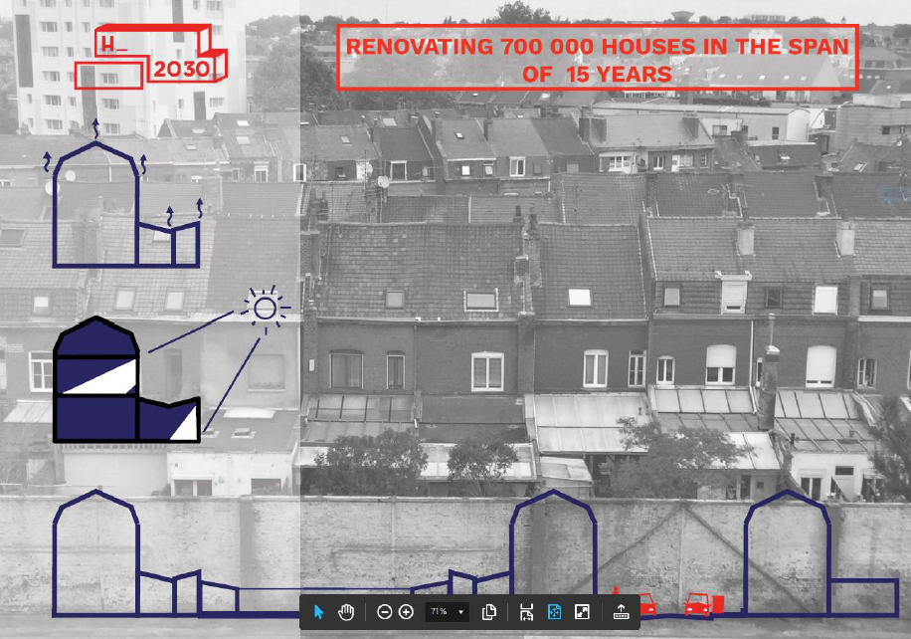

Figure 18 Houses from the industrial era that are typical of the Hauts-de-France region

### Stakeholders involved

The following stakeholders are involved in implementing the actions detailed in 4.5.2:

- The City of Lille: planning division (coordination), housing division (implementation)

- the Regional Council – housing and Rev3 divisions

- Representatives from the Habiter 2030 association

- Houses and buildings (social agency)

- Fédération Française du Bâtiment (French Building Federation)

- Union Régionale pour l’habitat (Regional Housing Union)

- The Neighborhood Factory The Neighborhood Factory

- SORELI

- SOLIHA

- EDF

- Les Compagnons du Devoir

- Schools : ENSAPL, Université Lille 1, EDHEC, Catholic Institute of Lille etc.

This list is non-exhaustive and other partners may be mobilized.

### Schedule, budget and financing estimated for the action

The following figure presents an estimated calendar of the sub-actions for action 5.



Figure 19 : estimated calendar of action 5

The predicted costs are the following:

* Production of communication supports: 500€ (roll-up, brochures, design)
* Fees related to organize meetings with local partners and workshops: 2k€

Moreover, 4 person months are estimated to be needed for this action by the City of Lille (which corresponds to 3 days per month for 2 years).

This action will be financed internally by making staff available and covering additional costs.

### Key performance indicators

The following indicators will allow action 5 to be monitored:

* Annual regional workshop is organized between higher education, municipalities and professionals about the themes of Habiter 2030 (5a)
* One or more tools are made available to share results from construction sites (5b)
* The number of co-design workshops organized to promote scaling up (5c)
* The number of professional visits organized to the “Proof of Concept Habitat” (5d)
* The number of documents made available to communicate and disseminate the results of of Habiter 2030 (5e)

# Annex

Office Notice of CCC N°19 10 GT MOLOC from 16 October 2019

1. Information about this project is available at the Interreg database <https://www.interregeurope.eu/policylearning/good-practices/item/1684/urban-center-metropolitano/>
2. <https://cartographie.lille.fr/dynmap/extensions/index.php?module=cartotheque2&cont=cartotheque>
3. On 13 October 2018, a group of citizens symbolically gave Lille’s Mayor the last IPCC. The City of Lille and the association “Citizen for climate” share the objective of decarbonizing the city: carbon neutrality by 2050 et reducing by half GES emissions by 2030. Since this date a dialogue started between these citizens and the City of Lille around a joint energy-climate-environment initiative. The definition of shared performance indicators shall ensure efficient project monitoring.
4. A person month is the unit that indicates the number of months it takes a single person to carry out a task. The full time equivalent measures the capacity to work. A task with n FTE needs “n” people working on it full time for the duration of the task.
5. This number is a preliminary estimate. The production cost of additional maps and data will strongly depend on the number and type of maps being created, and the amount of georeferences to recover. These needs will be defined during action 1b2.
6. Implementing a GIS tool could cost between a few thousand and a few hundred thousand euros, depending on the performance of the tool, the number of users, the amount of existing data to make compatible with GIS, etc. The 30k€ figure is therefore merely a preliminary, ballpark estimate.
7. Cited from ERDF-ESF OPERATIONAL PROGRAMME Nord-Pas-de-Calais 2014-2020
8. A person month is the unit that indicates the number of months it takes a single person to carry out a task. The full time equivalent measures the capacity to work. A task with n ETP needs “n” people working on it full time for the duration of the task.
9. Des informations sur ce projet sont disponibles sur la base de données Interreg Europe : <https://www.interregeurope.eu/policylearning/good-practices/item/1689/hafencity-master-plan/>
10. <https://www.hafencity.com/en/faq-concepts-planning/how-is-the-hafencity-ecolabel-awarded-.html>
11. A person month is the unit that indicates the number of months it takes a single person to carry out a task. The full time equivalent measures the capacity to work. A task with n FTE needs “n” people working on it full time for the duration of the task.
12. Information about this project is available at the database Interreg Europe: <https://www.interregeurope.eu/policylearning/good-practices/item/1690/iba-hamburg-2013/>
13. A person month is the unit that indicates the number of months it takes a single person to carry out a task. The full time equivalent measures the capacity to work. A task with n FTE needs “n” people working on it full time for the duration of the task.
14. County data
15. <http://solar-h2030.eu/en/>
16. See the associated best practice on the Moloc website “Policies against air pollution in Katowice” : <https://www.interregeurope.eu/policylearning/good-practices/item/1687/policies-against-air-pollution-in-katowice/>