Learning cases Gelderland, the Netherlands

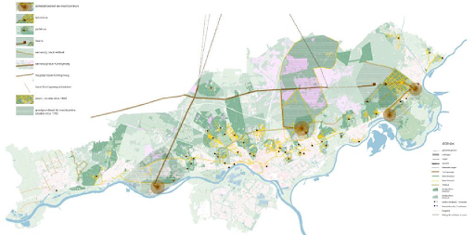

Introduction to the region

The Province of Gelderland, located in the eastern part of the Netherlands, is the province with the largest amount and density of rural estates in the country, with hundreds of them listed as national or municipal monuments. This heritage collection contributes largely to the economy and the province wants to further improve its touristic appeal and benefit from tourists coming to the surrounding areas.

Both municipalities and private owners should provide more future-oriented solutions toward the betterment of the rural estates in the area. Finally, the return of investments from private owners need to be better safeguarded. The province of Gelderland aims to direct its policy measures at better facilitating these stakeholders by supporting the development of heritage communities, place-based strategies and regional marketing.

Targeted policy instrument

The main objective of the targeted policy instrument, the Policy Programme Culture and Heritage, is to enhance the conservation of protected heritage in the province of Gelderland in combination with suitable use and a better experience of the heritage involved. Heritage needs to become a structural part of spatial plans of the region, whose heritage sector needs to be better organized in the future. Good condition of listed heritage is ensured by the innovation of the heritage practise, notably on economic significance, sustainability, skills and financing. To achieve this, advise in legislation and databases, covenants and other forms of agreements, subsidies and loans and pilot projects like the learning cases should be at the disposal of the province.

Challenges in the region

The largest of the 12 provinces of the Netherlands, the province of Gelderland is a mix of rural landscapes and modern urban areas with the most castles in the country. Due to its strategic location and links to important surrounding areas, Gelderland welcomes about 4 million visitors annually. The province has its own administration where it coordinates on matters such as traffic and transport, urban and country planning and the environment. Therefore, Gelderland is well suited to make assessments from a broader perspective still focusing on its own region.

At the end of 2019, a discussion paper has been sent to the parliament with one of the aims of having a focus on funding projects. Three Gelderse estate zones have been chosen to participate in Innocastle, through which the province hopes to learn more about the role of government in relation to others maintaining and developing castles and estates. Working on the learning cases in the Innocastle program will be helpful to understand the benefits and challenges of a spatial approach.

Action plan

With the help of the learning cases, a new approach will be implemented in 2020 to find new partners and for the estates to adopt a new role. Connecting the field of historic estates to other policy fields like climate adaptation (Baakse Beek), tourism (Gelders Arcadië) and spatial fragmentation (Twello) will play a big role in this too. The findings of the learning cases will support the province of Gelderland in renewing the Culture & Heritage policy program.

Power Landscapes of Gelders Arcadia – Finding a common ground between the estate landscape, heritage tourism and values
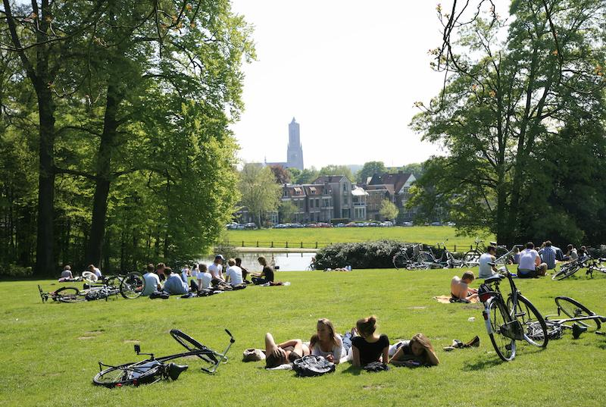
Region: The estate zone of Gelders Arcadia
Theme: Heritage Tourism and spatial quality
Stakeholder: The municipalities, the country house and estate owners and tourism boards

Introduction

In total, over one hundred countries and landed estates have been identified in an area now known as Gelders Arcadia. Particular valuable features in this estate zone are the landscapes created by the stakeholders and their noble friends, such as the so-called King’s roads. In recent years several educational and art projects have taken place in Gelders Arcadia. As yet, no large scale restoration or redevelopment has been implemented on a regional scale, although much has happened on individual estates.

Issue

A joint vision and management of the power landscapes, created by the most important estate owners in the 17th, 18th and 19th centuries, such as King’s remains difficult to realize. Not many (heritage) tourists are aware of the history of these power landscapes, and the precious features of the area are not always well recognizable.

Objective

Through Innocastle, heritage tourism on a regional scale needs to be developed with the emphasis on the power landscapes. The story of the castles and country houses should be widely told to the public. In the Gelders Arcadia estate zone, the municipalities of Arnhem, Renkum, Rheden, Rozendaal and Wageningen and owners such as Middachten and the Gelderland Trust will work on finding a good balance between strengthening heritage tourism in the estate landscape and preserving heritage values.

Estate zone of Twello – Bringing all parties together to create a sufficient plan for the future

Region: Twello, municipality of Voorst
Theme: Spatial fragmentation
Stakeholder: The municipality of Voorst, the country house and estate owners

Introduction

Voorst is described as "the green heart of the “City triangle” (Stedendriehoek) enclosed by the cities of Apeldoorn, Deventer and Zutphen. It has a wide ranging estate zone, a park-like landscape full of monumental buildings. This rich cultural history is a crucial part of the identity of Voorst that it wants to retain and - where possible - strengthen.

Issue

At Voorst, spatial fragmentation has occurred due to infrastructural and urban expansions. The necessary steps to recreate coherence and cooperation need to be identified with the help of Innocastle.

Objective

To be able to recognize the municipality as a quality zone in the process of urban developments, new legislation to reinforce the character of the area needs to be developed. Therefore, it is vital to create awareness amongst the community and involvement of the public, as well as remind them about the history and possible future developments of the area. The most important thing is to bring private estate owners, governments and possible funding bodies together to create a sufficient plan for future estate management.

Estate Zone Baakse Beek – Active ‘climate adaptation’ and landscape design
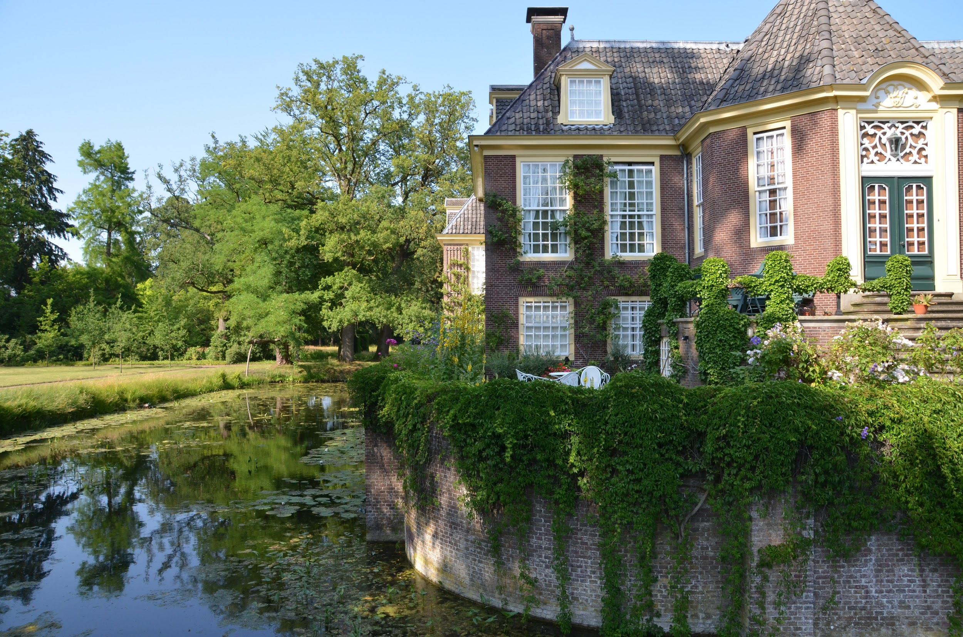
Case name: Estate zone Baakse Beek
Region: HCME-zone Baakse Beek, municipality of Bronckhorst
Thema: Climate adaptation
Stakeholder: Water authority Rijn en IJssel, estate owners

Introduction

The Baakse Beek zone consists of landed estates and agricultural land, interconnected by the system of the small river Baakse Beek. Most of the estates are A-listed as ensembles of buildings, gardens, parks and water features and tourism has developed on the quality of the castle-and- estate-landscape. The regional water authority ‘Waterschap Rijn en IJssel’ has started a process of involving owners of the estates in an area based approach to find solutions for present day challenges on water management, nature and agriculture.

Issue

Climate change has brought up issues such as drought and short intervals of heavy rainfall, that need to be fixed through actively implementing ‘climate adaptation’. The responsibilities of the provincial authority are manifold: on water management, nature conservation and development, landscape planning and protecting heritage.

Objective

Baakse Beek has many opportunities to connect various themes of nature, heritage, water management and exchange of landed property. Through landscape design, heritage can be made part of changing the water system in the area. The right role for the province to play in the adoption needs to be further investigated.

