Learning cases Badajoz, Spain

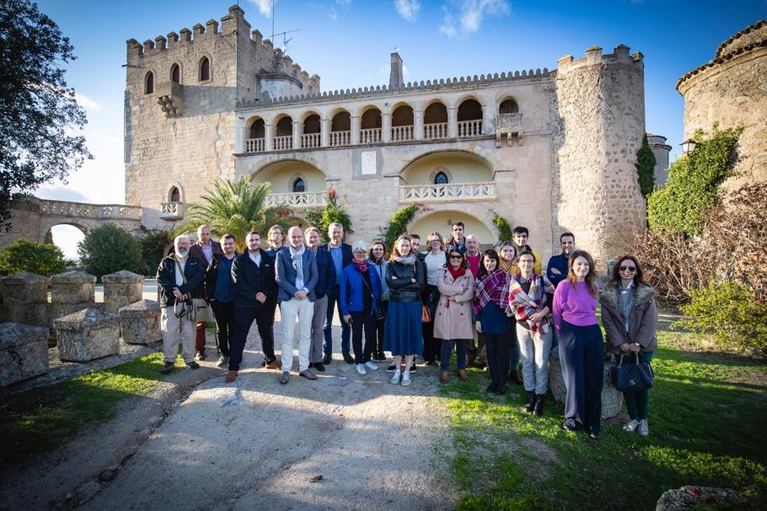

Introduction to the region

The Province of Badajoz collaborates in a daily basis with the Regional Government, the other Province of the Region (Cáceres) and with all the Municipalities in the Province in tourism and heritage issues, and it has a big capacity of involvement also of private entities. The Province implements a big number of programs and projects for local development that include heritage, tourism, infrastructure, training, environment, energy or waste issues among other programs. This results in close relation with all counties and municipalities in the territory.

The main objective of the targeted policy instrument, Extremadura ERDF Operational Program (2014-2020) Objective OE 6.3.1 ”To boost the protection, promotion and development of the Cultural Heritage”, is the valorization of cultural and natural heritage resources of the Region. One of the main actions to be funded under this priority is the creation of natural and cultural itineraries in order to promote sustainable tourism and the economic development of rural and urban areas.

Challenges in the region

The need for a clearer strategy for heritage exploitation and maintenance for the present period and future programs draws the different governmental bodies to work together. With a limited budget for the regional heritage departments, the partners in the region struggle to find the best design and implementation of the policy instruments.

Through Innocastle, the Province of Badajoz will be improving communication between different stakeholders and defining stable coordination structures, and more detailed strategies for the use of funds, taxation and subsidies. At the moment there is but very little foreseeable public funding for restoration. Therefore, the experiences of collaboration and joint efforts between the public and private sector (i.e. administrative bodies with the private agents) need to be further investigated and efficient schemes for castle owners to afford the maintenance and restoration are needed.

Action plan

The main focus in the region of Badajoz is to seek valuable business models both in the private and public sector to manage the historic castles, manors and estates in the area. Better promotion and product development will result in valuable development of the cases. Finally, identifying legal and fiscal barriers concerning these heritage sites will ensure efficiently exploited castles in the future.
Luna castle – Underused potential for the region
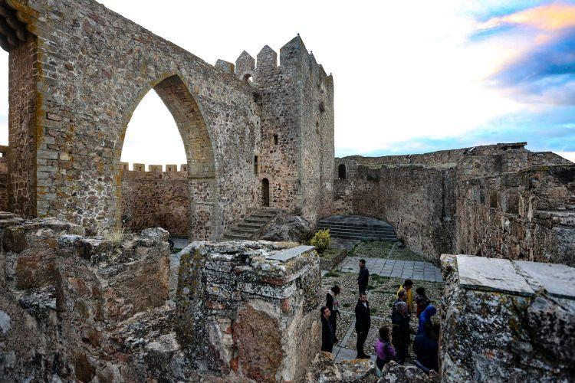

Asset name: Luna Castle
Location: Alburquerque, Badajoz, Spain
Ownership: public (regional government)
Spatial level studied: castle
Heritage status: listed
Conservation status: good
Visits allowed: yes
Present use: open and guided visits under appointment, historical play (annual festival)

Introduction

Luna Castle is a beautiful medieval castle in the center of Alburquerque, situated on top of a hill at the border with Portugal, as it is part of an extensive defence line characterizing castles in the region. Moreover, it is situated within the Dehesa landscape, providing rich wildlife and a stunning landscape.

Issue

After being restored through European funds in the previous programming period, this castle later received an investment of 8 million euro and it was going to be transformed into a publicly run hotel. However, due to the financial crisis, administrative and political issues, the hotel could never be open for the public and the castle is currently being underused.

Objective

The site is in urgent need of an efficient exploitation plan and an inclusive partnership between the public, private and community actors to ensure the good administration of the site. Through Innocastle, the Province of Badajoz is working on identifying current legal and fiscal barriers and implementing new policy tools to ensure the efficient management and exploitation of castles in the region.

Related good practices

A good practice of how governments can work with individual sites as policy test ground is the collaboration between the Middachten castle and the Province of Gelderland. Middachten was a policy test ground on which ideas were developed on managing historical estates, e.g. on simplifying local planning procedures and maintaining monumental gardens and parks.

The Province of Gelderland works very closely with all private estate owners in the region to stimulate well restored, economically sustainable sites, as well as a high-quality landscape and tourism influx in the region.

Zafra castle – Linking the Parador-hotel with its neighbours

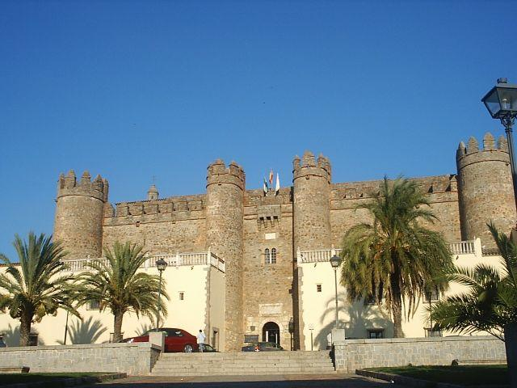

Asset name: ‘’Palacio de los Duques de Feria’’
Location: Zafra town (Zafra Municipality/County)
Ownership: Public (managed as a private institution)
Heritage status: protected
Conservation status: excellent
Visits allowed: yes
Present use: Parador-hotel and restaurant; social events; professional meetings and conferences

Introduction

The medieval castle Palacio de los Duques de Feria is located at the town of Zafra and it is currently used as a state-run hotel and a restaurant, for social events and as a place for professional meetings and conferences. Zafra has many important architectural renaissance elements including 8 circular tours with a courtyard, the well and chapel with an outstanding coffer ceiling.

Issue

With the help of the project, Paradores, the public company managing the castle, would like to improve links between the asset and its current use with the local surrounding community. So far, the Parador is mainly frequented by visitors and not so much by the local community, which see the Parador as a high standard accommodation, feel proud of the building but don't necessarily feel comfortable using its premises and frequenting its gardens, restaurant or coffee shop. The connection of the building with the local community is crucial for the understanding of the heritage value and the integration of the heritage issues in local policy.

Objective

Through Innocastle, the aim of the project is to better understand and further develop the current exploitation model. A public asset managed as a private institution that has good consideration among citizens will be a useful tool for others to learn from.

Related good practices

- Paradores model as a good practice themselves
- The Diputación de Badajoz is, through the Innocastle project, Learning from National Trust (UK) how to increase community engagement
https://www.interregeurope.eu/policylearning/good-practices/item/3058/everything-speaks-increasing-visibility-of-heritage-through-cultural-programming/
Medellin castle – Warranty for future restoration needed

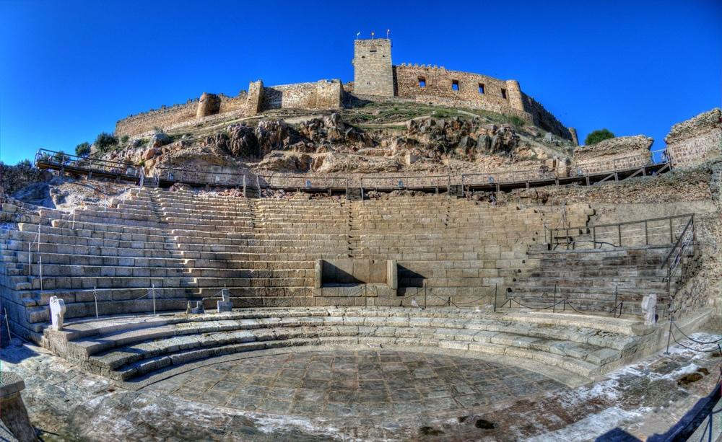
Asset name: “Castillo de Medellin”
Location: Medellin town (Medellin Municipality)
Ownership: Public
Heritage status: listed
Conservation status: good/undergoing restoration
Visits allowed: Yes
Present use: Open and guided visits, a theater festival

Introduction

The castle of Medellin is a publicly owned military castle on top of a hill in Medellin town, as it is part of one of the defence lines in the Reconquista period. Thanks to successful exploitation of EU social funds as well as support from local cultural associations and civil society, the site has been restored efficiently over the past 5 years by a joint effort made by the government of the region, the province and the municipality.

Issue

A unique celebration of the prestigious theatre festival takes place once a year in an adjacent roman theatre attached to the caste and it should be an essential part of the long-term management of the site. A good practice of restoration it partly implemented through the festival, although there is no continuous use of the castle throughout the year.

Objective

The castle of Medellin will need further elaboration and implementation of set and stable procedures to guarantee the continuity of the efficient coordinated and collaborative castle restoration and exploitation exercise done by the different public and local community agents.

Good practice

- Valorization of the Castle and Roman Theatre of Medellin - a good practice - link to SHARE - https://www.interregeurope.eu/policylearning/good-practices/item/1870/valorisation-of-the-roman-theatre-of-medellin/
- Programming from National Trust - To ensure continuous exploitation of the site, a good practice on how to design a more strategic and consistent programming of events need to take place in this learning case.https://www.interregeurope.eu/policylearning/good-practices/item/3058/everything-speaks-increasing-visibility-of-heritage-through-cultural-programming/

