1st Local seminar

Event report and monitoring
[Cyprus Energy Agency]

Venue | Nicosia Municipality
Date | 10 June 2019
Number of people attending | 16
Type of Stakeholders involved (categories) | Policy Makers, Academic, Local authorities, Energy Agencies, others (Technical Chamber, Cyprus Land Development Cooperation)
Total number of representatives of the types of stakeholders involved | 3 Policy Makers, 1 Academic, 4 Local Authorities, 6 Energy Agencies, 2 others

Agenda of the event

Pictures of the event

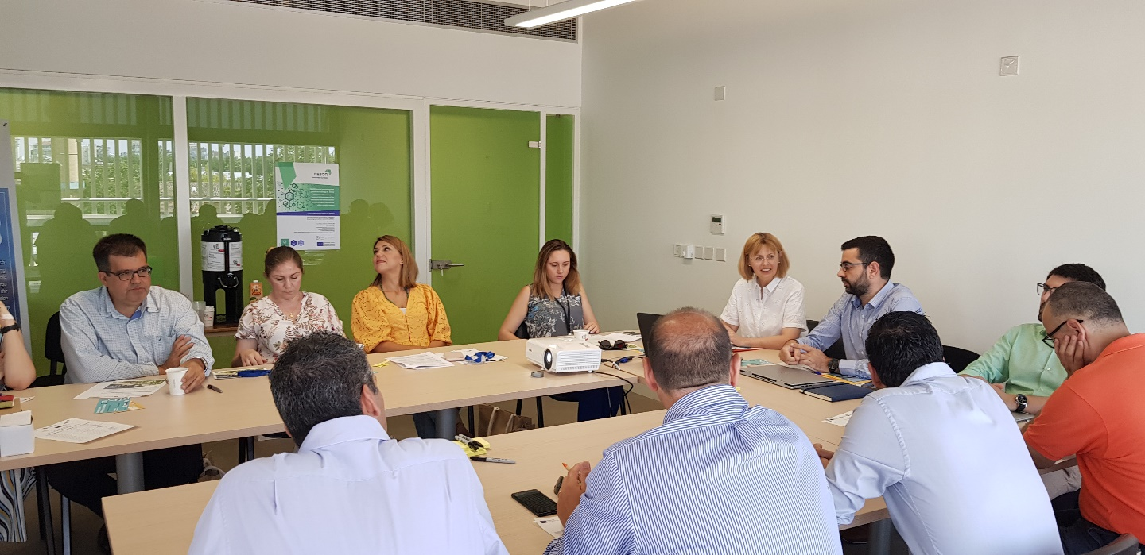

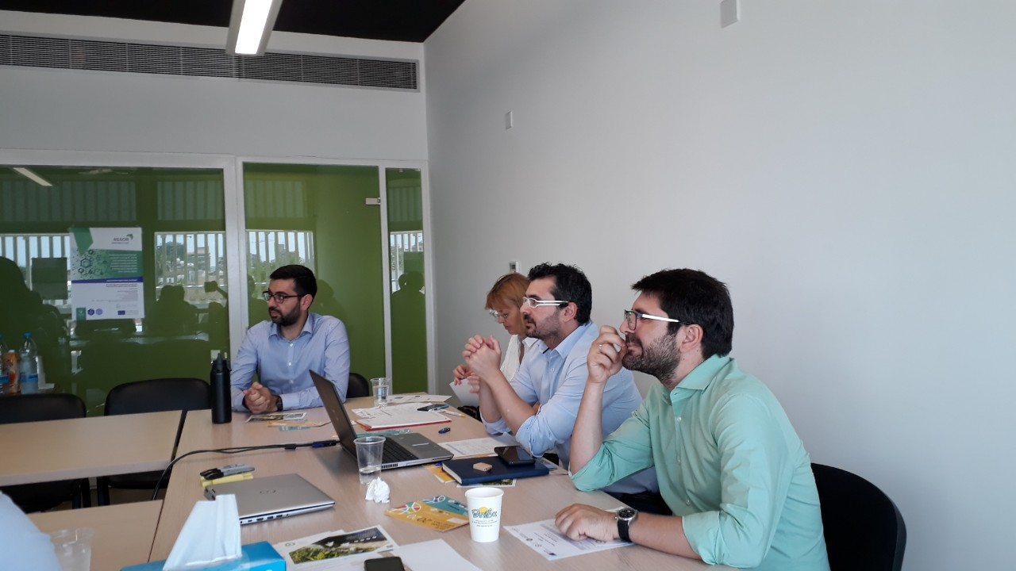

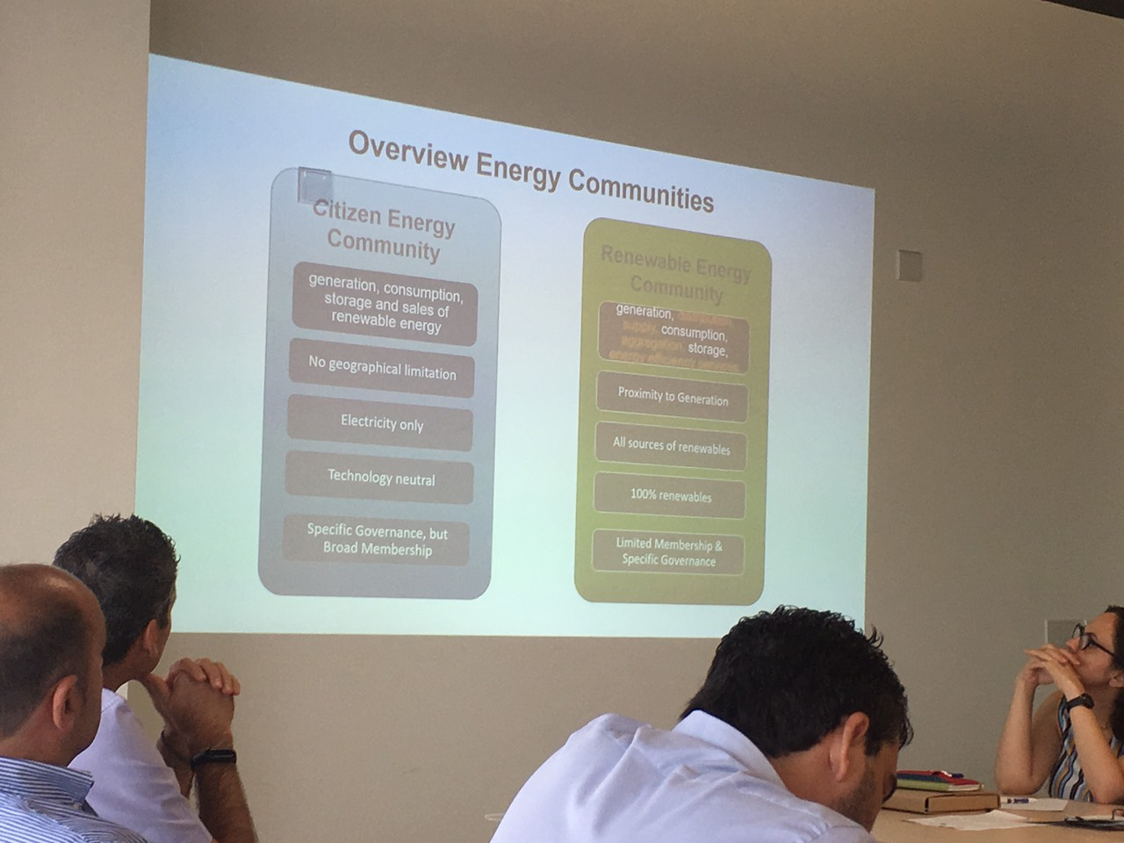

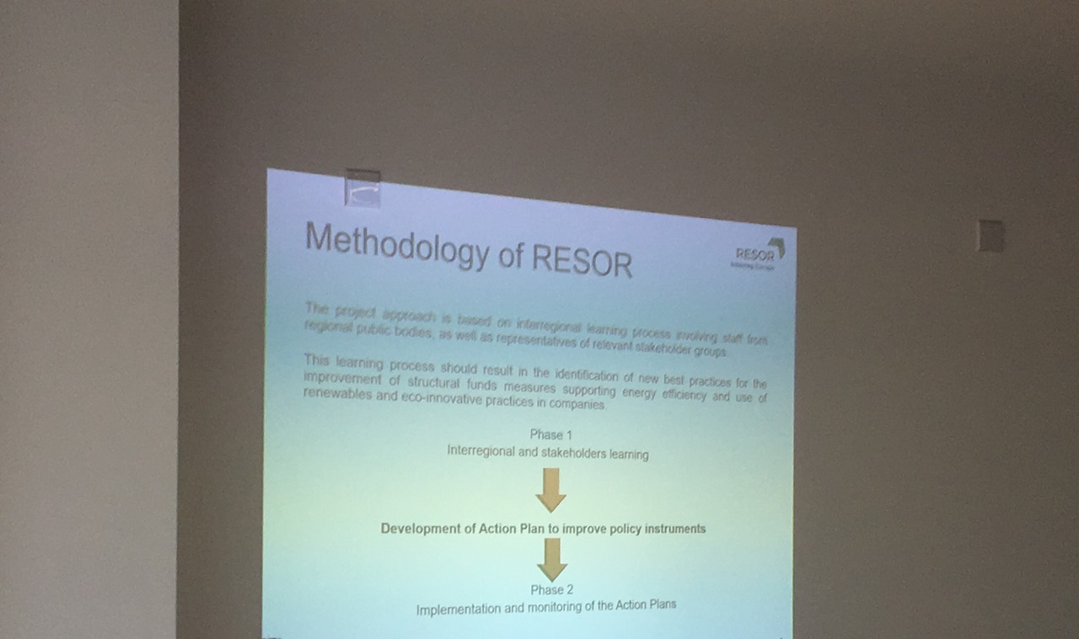

Event assessment

Overall how would you rate the success of this specific event?
☐very successful
☑fairly successful
☐not too successful
☐not successful at all

Please briefly describe the event including:
- Main experiences, viewpoints and suggestions of stakeholders on existing regional measures, projects, initiatives on energy efficiency and use of renewable energy, their effectiveness and impact.
- Main specific needs and constraints identified by stakeholders for the promotion of energy efficiency and use of renewables in companies in the region.
- Best practices / examples proposed directly by stakeholders, if any.
- Views / suggestions on the measures / policies / good practices identified in other regions.
- Specific relevant comments made by representatives of the different types of stakeholders involved on the regional analysis.
- Facilitation techniques used, if applicable (ex: brainstorming, role playing, storytelling, etc)

The Local seminar in Cyprus was organised together with the visit of “Experts Mission” by the ManagEnergy, with main expert Mrs Christiane Egger, OÖ Energiesparverband. The presentation of the objective of the RESOR project was combined with the topic of the Energy Communities, where Mrs Egger presented and transferred the gained experience from Austria.

Energy Communities legal framework it is expected to be adopted at national level in the years 2021-2022 in Cyprus. This will be a major step for mobilising the research and innovation in the business sector but also to create synergies between the different companies.

All the stakeholders stressed the need to have a strong legislative framework on Energy Communities in order to empower the cooperation between public and private sector but also to promote innovate policies in the business sector. Local green fiscal policies (green taxation) was a subject of discussion, proving the important role of the Municipalities for shaping the energy behaviour of the private sector. The hosting organisation of the local seminar, Nicosia Municipality, is one of the first best practices in Cyprus for implementing green taxation in the Hotel sector, with aim to create a funding scheme and provide free Energy Audits at the local hotels of the area.

Please briefly describe main success and difficulties related to this specific event, if any. Please provide suggestions for similar or future events (including improvement you would like to apply already in the next local group events you will organize in the framework of RESOR), if any.

The main effort in the next local seminar-meeting will focus to gather at the same table all the authorities responsible for shaping the operational programme.

