https://www.youtube.com/watch?v=aM-gDCJF-h8
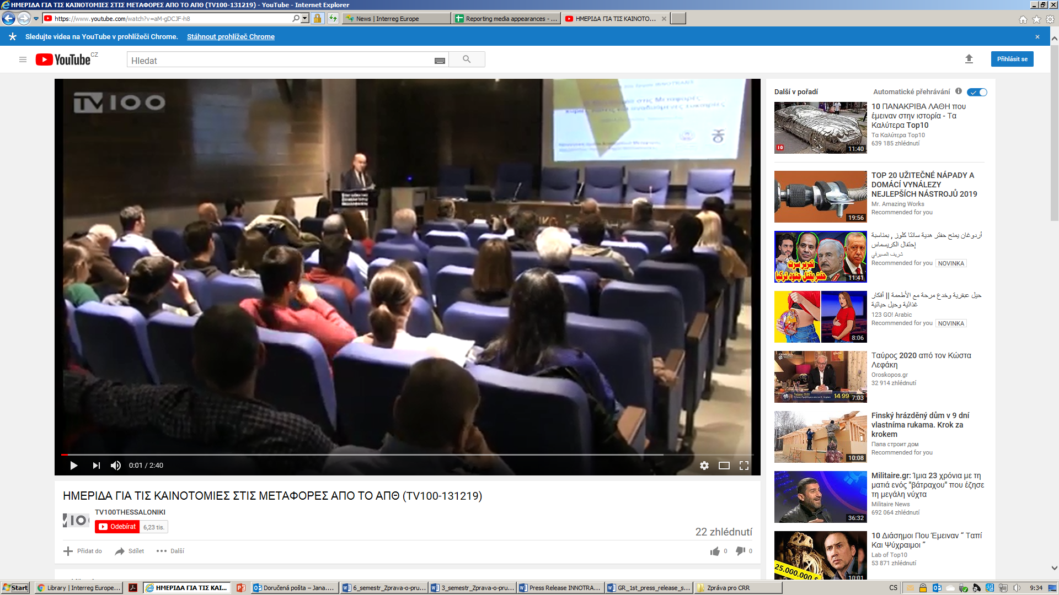
https://www.metaforespress.gr/mesa-mazikis-metaforas/%ce%b5%cf%83%cf%80%ce%b5%cf%81%ce%af%ce%b4%ce%b1-%ce%b3%ce%b9%ce%b1-%cf%84%ce%b7%ce%bd-%ce%ba%ce%b1%ce%b9%ce%bd%ce%bf%cf%84%ce%bf%ce%bc%ce%af%ce%b1-%cf%83%cf%84%ce%b9%cf%82-ce%bc%ce%b5%cf%84%ce%b1/

http://www.ses.gr/index.php/nea-kai-anakoinoseis/2010-09-09-11-59-02/1110--q-q.html

https://www.wepost.gr/%ce%b7-%ce%ba%ce%b1%ce%b9%ce%bd%ce%bf%cf%84%ce%bf%ce%bc%ce%af%ce%b1-%cf%83%cf%84%ce%b9%cf%82-%ce%bc%ce%b5%cf%84%ce%b1%cf%86%ce%bf%cf%81%ce%ad%cf%82-%ce%ba%cf%8d%cf%81%ce%b9%ce%b5%cf%82-%cf%84/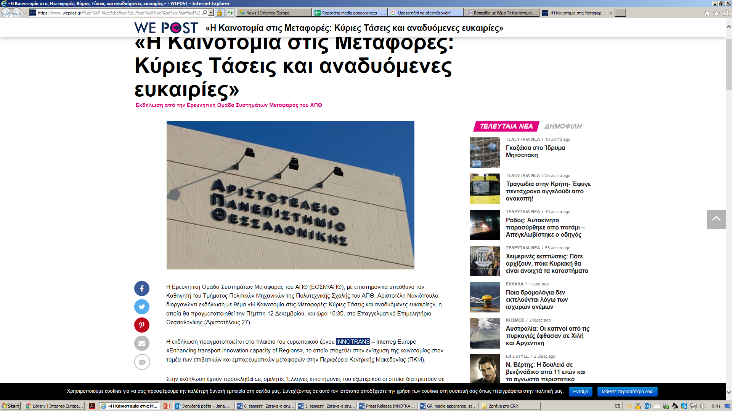

http://www.eeth.gr/news/2297/30/imerida-me-titlo-i-kainotomia-stis-metafores-kuries-taseis-kai-anaduomenes-eukairies.html
https://www.voria.gr/article/ekdilosi-gia-tin-kenotomia-stis-metafores-apo-to-apth
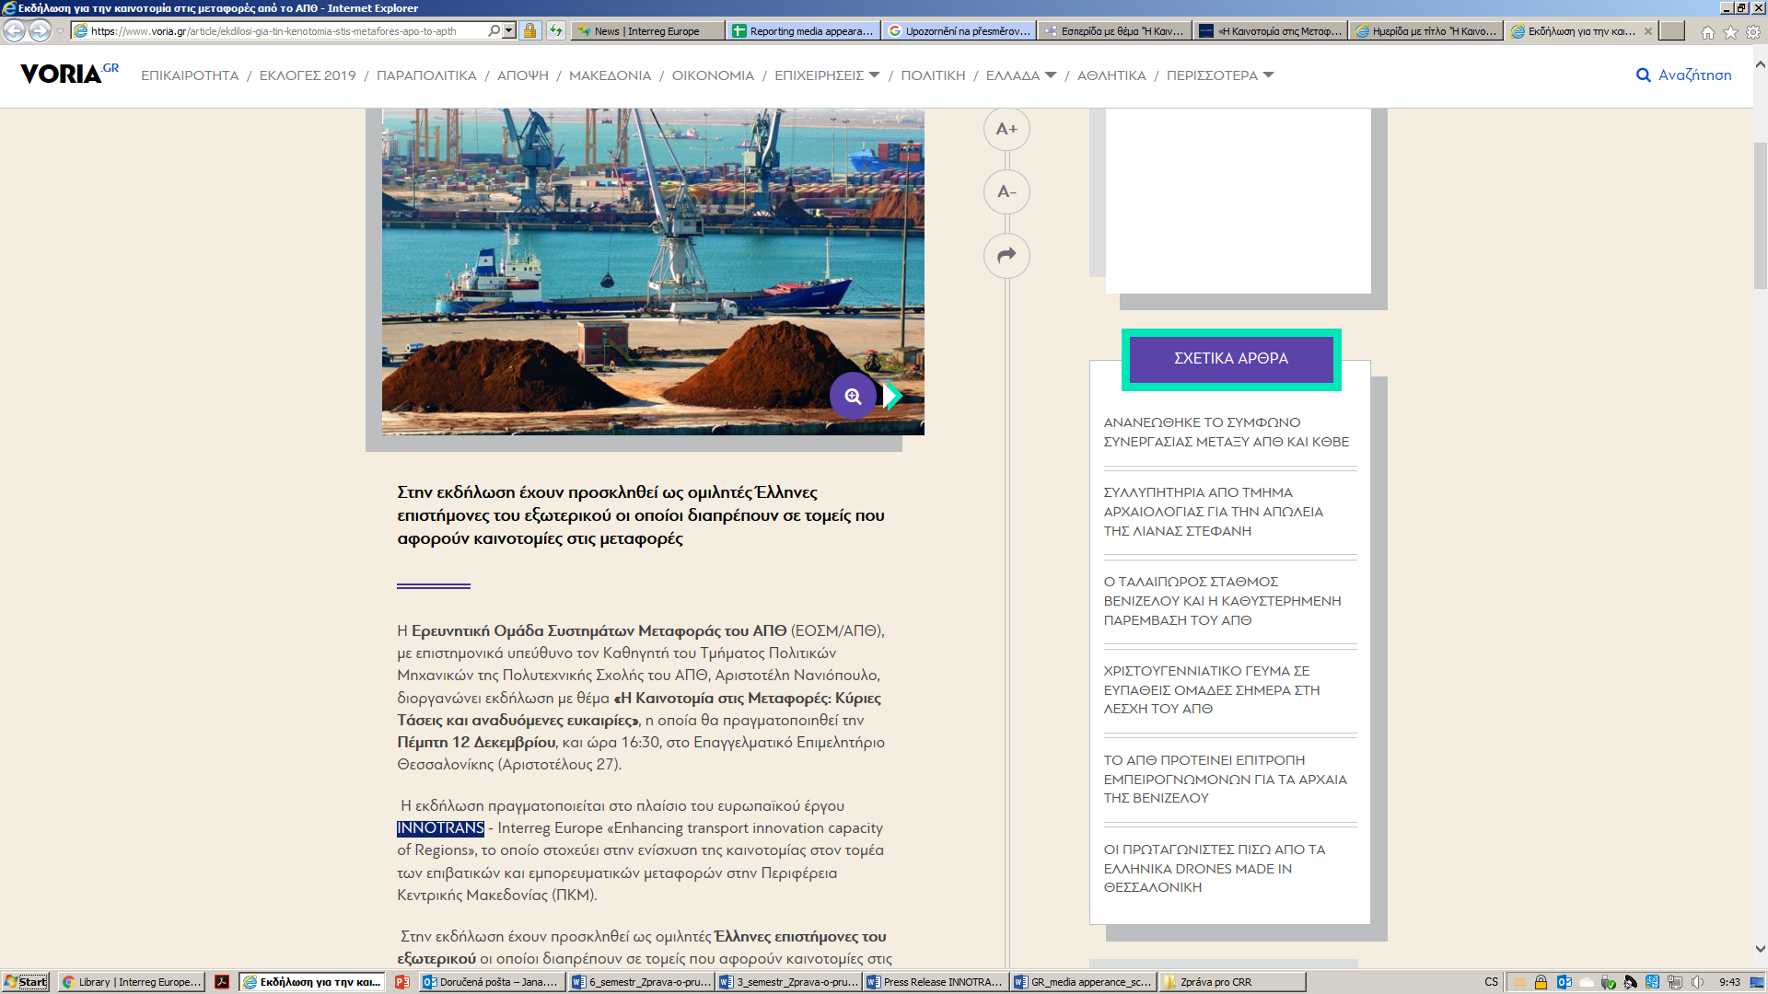

https://www.dailythess.gr/me-diethni-diagonismo-ideon-to-2020-to-kentro-kainotomias-gia-ta-logistics-toy-olth/

https://www.makthes.gr/sta-protypa-toy-limanioy-toy-roterntam-schediazetai-to-kentro-kainotomias-toy-olth-246608
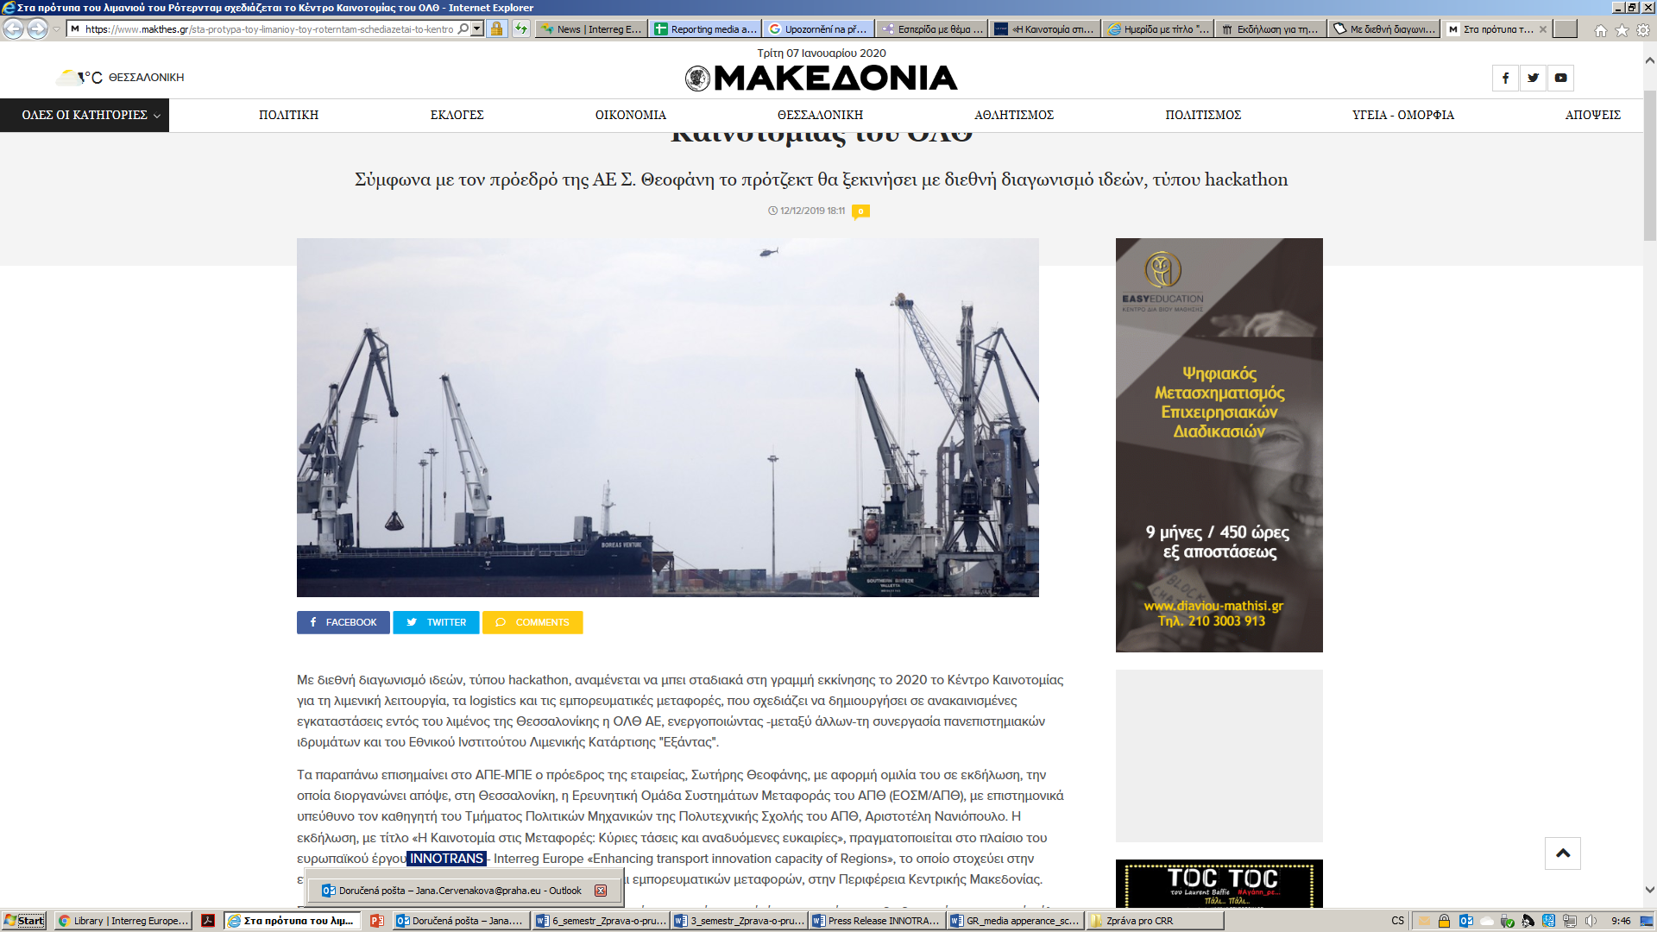

https://parallaximag.gr/epikairotita/olth-mpainei-sti-grammi-ekkinisis-to-kentro-kainotomias
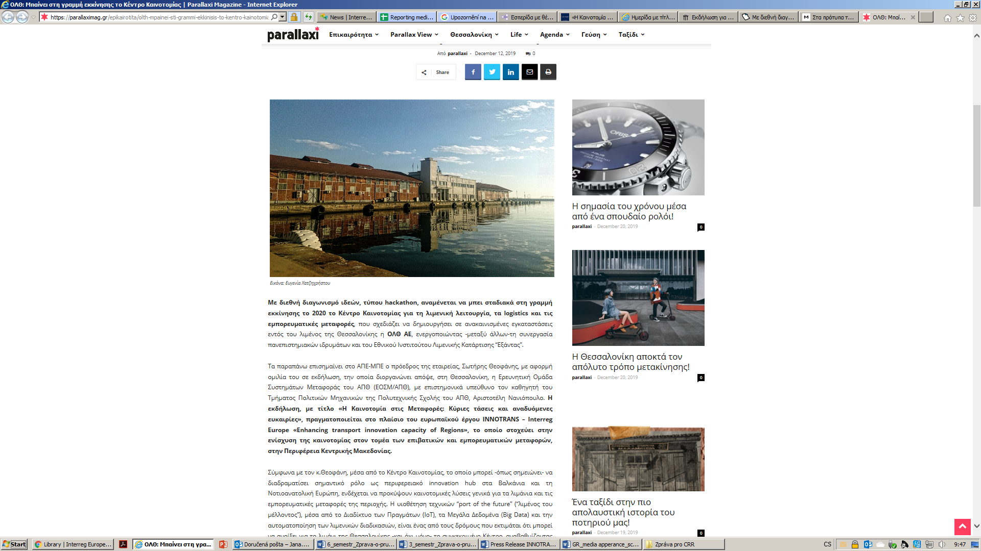

https://www.youtube.com/watch?v=q03LOqmPHO4
