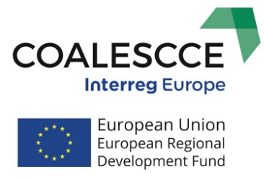 | 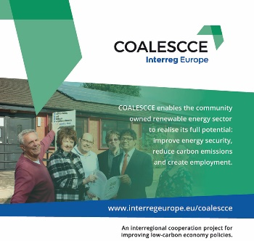 | What comes next?  Implementation of 5 Regional Action Plans in Phase 2
+
COALESCCE
in semester 5
www.interregeurope.eu/coalescce

COALESCCE project is  now at the end of Phase 1  Seven partners across Europe exchanged knowledge, experiences and good practices to increase the capacity for community based approaches to local renewable energy provision across Europe.  “By placing democratic control, shared benefits and active participation at the centre of the energy system, community energy can create a foundation for the significant infrastructural and cultural change we need to reduce the impact of climate change and increase our energy security.”  From: Community Energy England https://communityenergyengland.org/ | Good Practice Toolkit  A toolkit was developed in Semester 5 of the project bringing together good  practices from the 7 partner regions. It provides useful information on how to  start and develop community energy project, how to develop the business  plan and raise finance for the project realization, and what are the benefits for the community.
It containes the following good practices:
- Germany
Regional Energy Agencies for Citizens
Bioenergy villages
Solar Bundesleague
- Italy
Citizens and Climate change; Participatory process
Sustainable Industry, the Pescara Charter
- United Kingdom
Oldam Community Power
Community Energy England
Specialists Sector Support
- Romania
Major retrofit of residential blocks – Prahova
Ploesti – public-private networ serving half of the city
- Spain
Cooperative model for generation of electrical energy distribution and consumption
- Hungary
Biobriquette in Told
Straw bale house community
- Bulgaria
Biogas heat thermal station, Ihtiman Municipality
Energy Efficiency Measures in Municipality of Bratsigovo trough biomass and solar panel heating

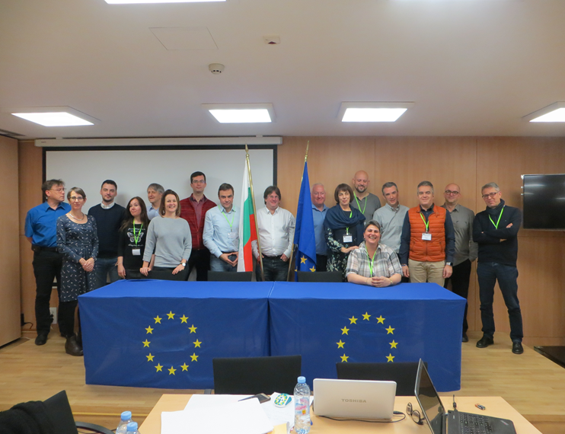 |  |  |  |  | Partner meetings  in Sofia, Bulgaria in January 2019  and  in Pescara, Italy in May 2019  for  Good practice toolkit  and  Regional Action Plans Development
The first interregional workshop on Action Planning and Good Practice Toolkit Development took place in Sofia at the end of January 2019.  25 participants being COALESCCE project partners and stakeholders from Bulgaria, Germany, Hungary, Italy, Romania, Spain and UK participated in the workshop, divided in two main sessions.  Mr Nicola Campitelli, the Councillor for Energy of the Abruzzo Region was present to open the meeting in Pescara. He confirmed that the Region was delighted to see the progress of the COALESCCE project  and was looking forward to the finalisation of the Regional Action Plan. | Session 1 Development of Best Practice Toolkit  Session 2 Action Planning for partners  With the support of external expert, the partners were able to structure first draft of their Regional Action Plans (RAP) and to further elaborate on the good practices best suited for transfer for each RAP.  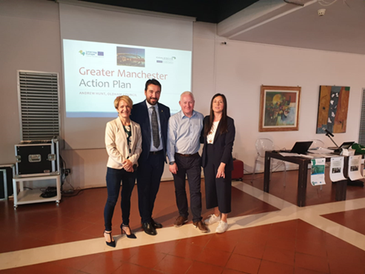
During the interregional technical workshop in Pescara, Italy the final drafts of the Action plans developed by COALESCCE project partners were presented together with the methodology for monitoring of their implementation into Phase 2 of the project period.

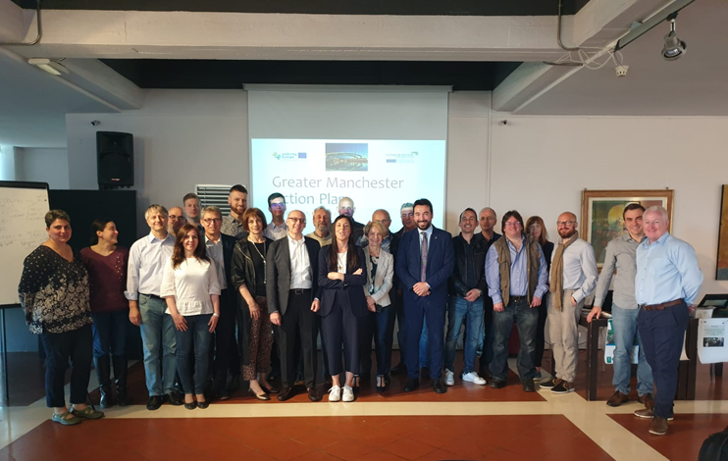
At this point the RAPs have been substantially completed however some elements of best practice in one of the partner Action Plans that can be transferred to others needed further elaboration. The meeting discussed together with the stakeholders also second phase implementation strategy. Their input on how they envisage the successful implementation of the RAPs in their respective regions is a major success factor.

In Pescara the project partners hold the final Phase 1 Steering Group meeting.

All project partners oragnised their regional stakeholder meetings to be able to complete the Regional Action Plans in compliance with the vision and strategies of the interested parties in their regions. Raising awareness among citizens of the community power benefits will increase citizen participation in Community Energy projects and contribute to reduction of CO² emissions in the coming years.
Pressures brought on by the need to mitigate climate change, increasing energy demands and energy security concerns require that we move towards a decarbonised and more efficient energy system. ‘Community power’ – where citizens own or participate in the production and/or use of sustainable energy – is an essential element in Europe’s low carbon energy transition.

The RAPs also stress that effective support for community power requires commitment from governments at local, regional and national levels. To be effective the local and regional authorities can set targets in excess of national targets and to involve local and regional authorities in drawing up national renewable energy action plans and in raising awareness of the benefits of energy from renewable sources or Local governments can also use their powers
in other areas to implement binding regulations that support community power development, for instance in the context of spatial planning and building regulations.

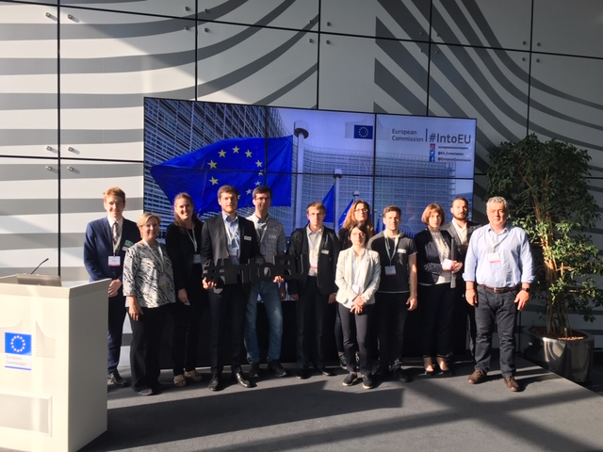 |  |  | The European Sustainable Energy Week  Brussels  June 2019

The biggest European policy conference dedicated to renewables and efficient energy use in Europe - The European Sustainable Energy Week (EUSEW) - was organised in Brussels on 17-21 June 2019.
The event brought together representatives from the European Commission, policymakers and energy stakeholders to discuss sustainable energy issues, new policy developments, best practices and sustainable energy ideas and how to secure NETO ZERO 2050. Two partners of COALESCCE project benefitted from both the presentations and events on the policy agenda and the networking village offering networking opportunities and possibilities to build new partnerships and alliances.

Community Energy has a major role to play in realization of NET ZERO 2050. Moving towards a net-zero greenhouse gas economy can only be successful with citizens that embrace change, get engaged and experience it as beneficial for their lives and that of their children. Local ownership of investments is a good case in point. Consumers have a powerful role to play in driving the transformation forward – advancing towards a net-zero greenhouse gas economy

For more news and information, follow us on:
www.interregeurope.eu/coalescce
Coalescce

