Project INTRA: 5th Regional Stakeholder Meeting

REPORT
Maribor Development Agency

1. Introduction

The fifth Slovenian RSG meeting was held on Wednesday, September 26th, 2018 in Maribor at the premises of MDA.

There were 8 participants present at the event (for more details see the full list attached).

The meeting featured the following agenda points:
- Overview of INTRA activities in the last semester of project phase 1;
- Report on the 2nd round study visits;
- Report on participation at External events;
- Workshop: Preparation of 2 future project to be funded through the OPIC 2014-2020.

2. Set up of the task

The participants at the meeting came from three helixes of the quadruple helix approach, with, with representatives of:
- Government – Ministry of Economic Development and Technology;
- Academia – University of Maribor;
- NGOs – Institute Angita.

Additionally, the participants were representing all three levels of impact MDA is influencing through the INTRA project:
- Regional level: University of Maribor, Maribor Development Agency;
- National level: Ministry of Economic Development and Technology.

- Overview of INTRA activities in the last semester of project phase 1:
Project manager dr. Amna Potočnik presented the workflow of the project INTRA, explaining the 2 rounds of study visits as the exchange of experience model implemented by INTRA.
Next, an overview of policy recommendations was presented.
In conclusion the structure of an action plan that will consist of two models and two projects was presented.

- Report on the 2nd round study visits:
The good practices selected for the 2nd round of study visits were presented, with the experience of stakeholders from both academia and national ministry providing feedback into the transferable aspects that are to be implemented in East Slovenia. The study visits were conducted in June (Extremadura) and September (West Midlands) of 2018, with Slovenian stakeholders learning details of the confirmed good practices to be transferred.
The findings were presented to the RSG.

- Report on participation at External events:
In September 2018 MRA participated at the external event 51st MOS in Celje, where project INTRA was disseminated. Furthermore, the event was used for a conduction of a small scale survey into the opinions of SMEs about the proposed projects to support SME internationalization, where the need for capacity building in the field of internationalization experts was confirmed, as well as readiness for cooperation on a regional B2B and B2C website under the joint brand name.

- Workshop:
The Workshop was dedicated to brainstorming the feedback and ideas connected to the observed good practices that were presented in detail during the 2nd round of study visit.
The stakeholders came up with three proposals that were feasible and were addressing the gaps recognised within the regions, in order to strengthen the regional internationalization among SMEs:
- developing integral tools to support SMEs internationalizations;
- preparation of export plans for foreign e-markets;
- support to commercialization of final agro-food products.

3. Evaluation of the task

As the stakeholders were well familiar with the project and its goals and are involved in the operational support to companies, the RSG was very efficient and result oriented, therefore the three areas for development of the future projects for supporting regional SME internationalization were elaborated and will have a follow-up with a concrete proposition to be submitted to the Ministry of Economic Development and Technology in October 2018.

4. Conclusion

The meeting was successful. The project partner will prepare and submit the propositions for the projects in the three areas supporting regional SME internationalization that were discussed and elaborated upon during the workshop session of the RSG.

5. Annexes

- Attendance sheet
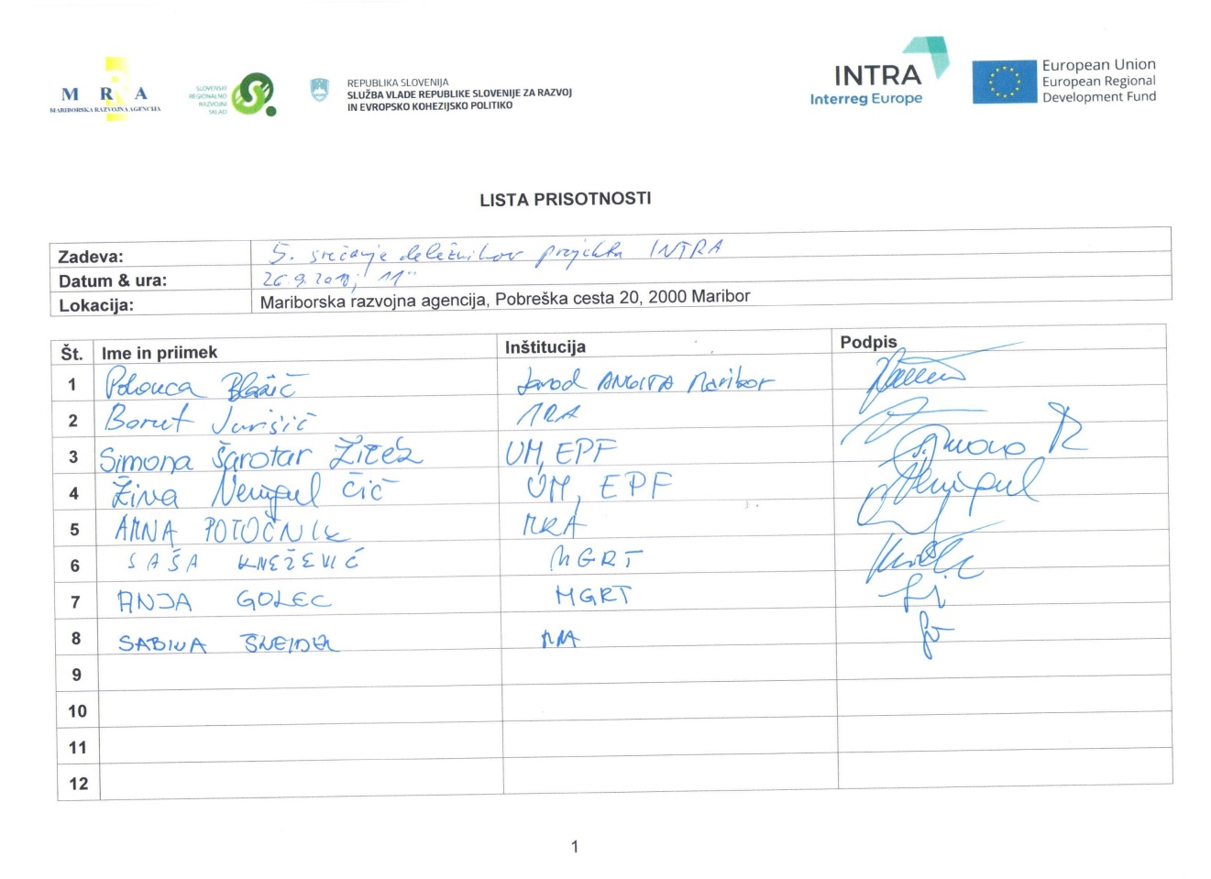
- Photos
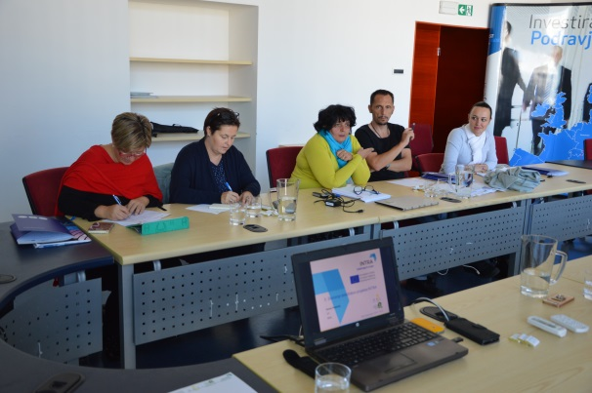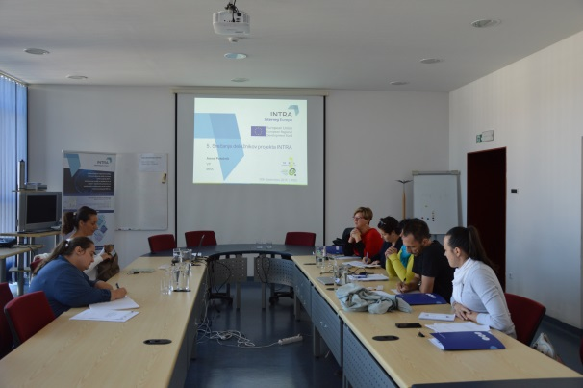

- Media coverage web-links
NONE, the event was not open to media.

- News for the INTRA website
https://www.interregeurope.eu/intra/news/news-article/4031/5th-regional-stakeholder-meeting-in-maribor/

