Action Plan

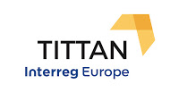
Translation, Innovation and Technology Transfer in Ageing Network

Partner:
Fondazione Regionale per la Ricerca Biomedica (FRRB)

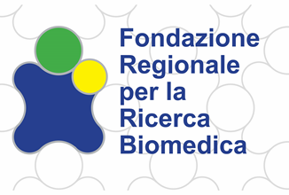

October, 2018

Part I – General information
Project: PGI01366 Network for Technology, Innovation and Translation in Ageing (TITTAN)
Partner organisation: Regional Foundation for Biomedical Research (FRRB)
Other partner organisations involved (if relevant): N/A
Country: Italy
NUTS2 region: Lombardia(Lombardy)
Contact persons: Carmen De Francesco/Paola Larghi/Paola Bello
email address: progetti@frrb.it
phone number: +39 0267650166

Part II – Policy context
The Action Plan aims to impact: x Investment for Growth and Jobs programme
€ European Territorial Cooperation programme
€ Other regional development policy instrument
Name of the policy instrument addressed:

- ERDF Operational Programme of the Region: Axis I “Strengthening research, technological development and innovation”
- Regional S3 – TA Health industry.
***
- The ERDF Operational Programme of the Region of Lombardy is the regional policy instrument that manages ERDF funds. The actions of the TITTAN project concern the Axis I “Strengthening research, technological development and innovation”, with a focus on the following areas: promotion of new markets for innovation – support to PCP and PPI actions; support to projects concerning the regional innovation strategy for smart specialization (RIS3) – of which one of the specific work programmes is “active ageing”; support to actions enabling the regional stakeholders to participate in innovation platforms, such as clusters, as well as to participate in European programmes for research and innovation; enhancing the level of innovation practised by business, with the intent also, but not exclusively, of industrialising research results. The Operational Programme could benefit from the expertise of other European regions, particularly with regard to the transfer of transnational research results to businesses, and to the policies and projects about telehealth and its application in the public healthcare system.
- The “Smart Specialisation Strategy” (S3) of Lombardy Region outlines the strategy of integrated and sustainable development that the region intends to pursue, together with the means to embark on a pathway of smart, enduring and inclusive growth.
Within the designing phase of the Strategy, Lombardy Region, in order to increase the competencies of its territory, has conducted an analysis of the territorial system of research and innovation and policies dedicated to these macro areas of intervention too.
Consequently, Lombardy Region has set up as priorities the following areas:
- Aerospace
- Agri-food
- Eco-industry
- Creative and cultural industries
- Health industry
- Advanced manufacturing
- Sustainable mobility
Lombardy’ RIS3 helps build connections of ideas, finance and trade with similar activities becoming a long term strategic framework. The identified challenge is to support, to accelerate the transformation of traditional and/or mature industries in emerging industries.

Part III – Details of the actions envisaged strengthen the link to the TITTAN objectives
ACTION 1 – ENCOURAGING INNOVATION THROUGH PUBLIC PROCUREMENT IN LOMBARDY REGION
The background (please describe the lessons learnt from the project that constitute the basis for the development of the present Action Plan)
As the general population, in Lombardy and in Europe, grows older, new societal challenges arise. Perhaps nowhere is the challenge greater than in answering the increasing call for healthcare services and the treatment of chronic diseases. Traditionally, Europe’s healthcare system has predominantly focused on a hospital to outpatient care cycle. Lombardy region has been one of the first regions in Europe to carry out a stratification of the population based on the level of chronicity and reorganized the processes of patients management, in order to improve the quality of treatment (and eventually, the quality of life) and reduce the costs borne by the healthcare system.
However, to meet these challenges there is a need to shift the focus towards providing preventative and self-care technologies and ICT-based solutions.
During the first Semester of the TITTAN project FRRB developed a strong interest in one of the Good Practices illustrated by the Partners and related to Thematic Area 1 (TA1) “Outside In Technological Innovation”.
As described in the application form, TA1 aimed at “promoting models for the acquisition of innovative products and solutions for public healthcare systems, mainly through the implementation of innovative procurement practices, such as Pre-commercial Procurement (PCP) and Public Procurement of Innovative Solutions (PPI), but also through the analysis of other approaches”.
Getting these technologies to the market can be quite challenging, with one of the biggest obstacles being the initial procurement of innovative solutions. This is because, in general, health and procurement public authorities have not yet fully embraced such novel, innovation-centric procurement instruments as PCP and PPI.
A strategic framework of Innovative procurement, able to support innovation in the territory and capable of improving the efficiency of the healthcare system, could greatly benefit the Region facing the challenges ahead.

Thanks to the activities run in TITTAN, we had the chance to learn how different public institutions in different countries deal with similar issues.
ACIS, in Spain, put in place some PPI programmes such as Innovasaúde and H2050 which have proven the possibility to implement such strategic framework with the successful development and placement on the market of a wide range of health-related technologies, leading to an innovation flow into the healthcare system and supported the industrial competitiveness of the Region. This was possible thanks to a close collaboration with the Ministry of Economy and Competitiveness with encouraging results.
Within Innovasaúde, the following 14 sub-projects were developed:
- Mobile diagnostic-therapeutic healthcare point;
- Medical imaging centre;
- Hospital at home;
- Multi-speciality telecare products;
- Digital home. accessibility to healthcare services
- Patient expert in 2.0 innovation and active information for patients;
- Smart multilevel alert system;
- Advanced medical simulation centre;
- Computer-aided diagnosis systems;
- Professionals 3.0;
- Innovation space for healthcare services;
- Integrated information and management system for clinical and epidemiological data for research:
- Transfer of the results of research and innovative healthcare projects;
- Integrated system for digitalisation, indexation, custody and management of clinical information.

Within H2050, 9 sub-projects were developed:
- Smart management system in emergency services;
- Integrated traceability system for patients and resources;
- Hospital robotics;
- Self- sustainable hospital;
- New 2050 integrated management system;
- Smart ward;
- Experimental hospitalization H2050;
- Secure digital hospital;
- Preservation of clinical information.

On March 21st 2018, four out of the seven TITTAN Partners signed a “Declaration of Intent” for the establishment of an Interregional Buyers’ Group. In the document, building on each Partner’s experience on PCP-PPI, the Partners reaffirmed their commitment to set up a consortium of buyers for the acquisition of innovative technologies in the field of health, which is one of the expected specific results of the Thematic Area 1.
Lombardy Region, in line with its ROP ERDF and its Smart Specialisation Strategy (S3), has recently implemented a PCP procedure (following the positive outcome of the pilot PCP in 2013), with regard to the procurement of goods and services specific to the Healthcare sector. The aim is to allow on one hand Public bodies, mostly Hospitals and Health Research centres, to benefit from innovative solutions, and on the other Companies and SMEs to develop innovative products in line with the demand and the needs of the market.
More information on the current PCP procedure can be found here : Lombardy Region (http://www.fesr.regione.lombardia.it/wps/portal/PROUE/FESR/Eventi/DettaglioEvento/presentazione-appalto-pre-commerciale-2018)
As explained in the graph below, the topics selected for PCP were:
- Safe Bronco Aspiration
- Robotic exoskeleton for motor rehabilitation in neurological patients with upper limb motor deficit
- Evaluation of the fragility of the coronary atherosclerotic plaque

Through the Regional Law nr. 29/2016 “Lombardia è Ricerca e Innovazione (Lombardy is research and Innovation)”, Lombardy Region strongly committed to invest in research and innovation, in order to promote the competitiveness of the regional economic-productive system, the growth of human capital, the sustainable development and to contribute to the quality of services provided to citizens and SMEs. Moreover, the Region intended to pursue these objectives thanks to a relevant territorial dialogue, in particular with the Regional Clusters, which gather universities and other public and private institutions dedicated to pursue quality research and innovation.
Also, the Region has invested greatly in the implementation of an Open Innovation Platform, a collaborative platform for participation, sharing and collaboration of all stakeholders active in the fields of industry, research and society.

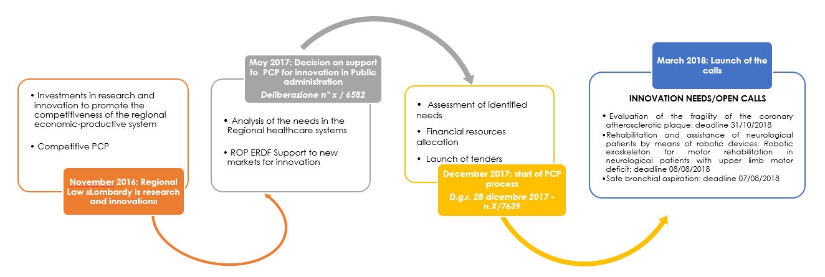

- Actions (please list and describe the actions to be implemented)

The Actions envisaged in Phase 2 will build on the knowledge acquired in Phase 1, specifically :
- Improvement of the framework programme of Innovative Procurement (PCP and PPI) to meet the current needs of the Industrial sector and the healthcare system, also taking as example what has been done by ACIS. The implementation of this action will entail the setup of a governance system that involves all relevant regional DGs and define a time plan for the implementation.
- Close collaboration between Lombardy Region and FRRB. In particular FRRB will provide recommendations concerning a possible governance system to improve the framework programme, and will support the coordination with ACIS and other Regions involved in the TITTAN project for what concerns the best practices exchange.
To this aim, we plan to organize periodically meetings (approximately every two months) with representatives of the Directorate-General Research, Innovation, University, Export and Internationalization.
The meetings will be focused on the monitoring of the process and the study of other regions’ best practices in this field, offering the opportunity to compare other governance systems.
The outputs foreseen are:
- suggestions / recommendations for the next programming period 2021/2027 (OP ERDF and RIS3)
- possible governance system to improve

Specifically, FRRB will support Lombardy Region to analyse the PCP procedure by the principles of cost-effectiveness, and to evaluate the impact.

- Players involved (please indicate the organisations in the region who are involved in the development and implementation of the action and explain their role)
The main players that will be involved in this Actions will be:

- Lombardy Region through its Directorate-General Research, Innovation, University, Export and Internationalization;
- Lombardy Region through its Directorate-General Welfare and other DGs.
- Lombardy Technological Clusters such as the “Lombardy Life Sciences Cluster” and the “Lombardy Cluster Technologies for Living Environments”. Clusters promote the interaction between the multidisciplinary research system, the pharmaceutical-biomedical industries and the public institutions in the health sector, providing an important input to research and innovation in the country.
- Any other entity from the healthcare regional system interested in participating in this process.
**************
Additional Details:
- The Directorate-General Research, Innovation, University, Export and Internationalization is the Managing Authority of the ERDF Operational Programme. More information at the following link: http://www.fesr.regione.lombardia.it/wps/portal/PROUE/FESR/autorita-e-organi/autorita-responsabili/.
- The Directorate-General Welfare could be involved for its competencies in the health field, since all the PCP promoted by the Region are related to technological improvements in the health system.
- Lombardy Technological Clusters such as the “Lombardy Life Sciences Cluster (LLS)” and the “Lombardy Cluster Technologies for Living Environments (TAV)” will be involved in leveraging on small and medium enterprises and industries located in Lombardy for the developments of new PCP/PPI models.

- Timeframe
The action plan implementation will cover the entire Phase 2 of TITTAN project, until September 2020.
This would allow us to monitor the entire PCP process and to evaluate the outcomes.
The state-of-art of the 3 procedures is the following:
- Safe Bronco Aspiration: No offers were submitted by the deadline. The procedure was suppressed ;
- Robotic exoskeleton for motor rehabilitation in neurological patients with upper limb motor deficit: the following companies were selected to develop Phase 1 :
- a temporary joint venture made of the following companies Politecnico di Milano, EMAC S.r.l., Ab.Acus S.r.l, SAPRA ELETTRONICA SRL, Stam S.r.l.;
- a temporary joint venture made of the following companies Fundación Tecnalia Research & Innovation – Raggruppamento Costituendo: Fundación Tecnalia Research & Innovation - Starlab Barcelona SL, imaginary srl, Yumen Bionics BV;
- Wearable robotics S.r.l.
Next steps will lead to the signature of a framework agreement with the above mentioned companies and the first transfer of budget allocated;
- Evaluation of the fragility of the coronary atherosclerotic plaque: more detailed information about this procedure can be found at the following links:
- http://www.asst-pavia.it/node/14436
- http://eafip.eu/assistance/procurers-receiving-assistance/azienda-socio-sanitaria-territoriale-di-pavia-asst-pavia/
This represents an interesting example of collaboration among two regional public entities: Azienda Regionale Centrali Acquisti – ARCA and ASST Pavia, on the input of the Research, Innovation, University, Export and Internationalization Department of the Lombardy Region funded under the ERDF ROP 2014-2020
The aim of the three procedures is to explore, in a comparative way, the advantages and disadvantages of various alternative technological solutions in order to filter the technological risks of Research & Development before committing to a commercial contract.

- Costs (if relevant)
For the three tenders, the Lombardy Region has allocated a total amount of € 7,568,234.00 which includes phase I (launch of the Call), phase II (prototyping) and then Phase III (experimentation).

- Funding sources (if relevant):
All actions have already been funded by ERDF Operational Programme of the Region (Axe I).
ACTION 2 – THE REGIONAL FOUNDATION FOR BIOMEDICAL RESEARCH: AN ENTITY TO SUPPORT THE FULL POTENTIAL OF BIOMEDICAL RESEARCH IN LOMBARDY
- The background (please describe the lessons learnt from the project that constitute the basis for the development of the present Action Plan)
FRRB represents the main strategic platform for boosting progress, research, development and innovation within the health sector among the regional academic and industrial life science players. Its raison d'être is to serve as support to and for implementing the regional health care research policy, in order to place the Lombardy regional system in a leading position in Europe within this field.

In addition, the Foundation is responsible for assigning local and European resources to innovative basic and translational research projects, which enable a positive impact on the local health care eco-system and citizens.
The main interest of FRRB is in the development of Personalized Medicine approaches, especially concerning the field of chronicity, being the elderly more prone to develop chronic diseases.

Lombardy Region has a strong interest in these issues, as in relation to the improvement of the quality of life and the consequent increase in the average age, in the advanced countries about a third of the population suffers today of chronic diseases, the care of which absorbs over 70% of the resources. Patients suffering from one or more chronic diseases represent more than 30% of the population (more than three million people in Lombardy Region).
In order to develop new studies and new solutions to these issues, FRRB receives every year an endorsement by Lombardy Region to develop and sustain research projects. To this aim, the Region allocates economic resources to FRRB, which has the responsibility to define how to assign these resources to different projects(step 1).
FRRB defines its annual Action Plan, which is approved by Lombardy Region (fig. 1).

Fig. 1 – Steps to FRRB Action Plan

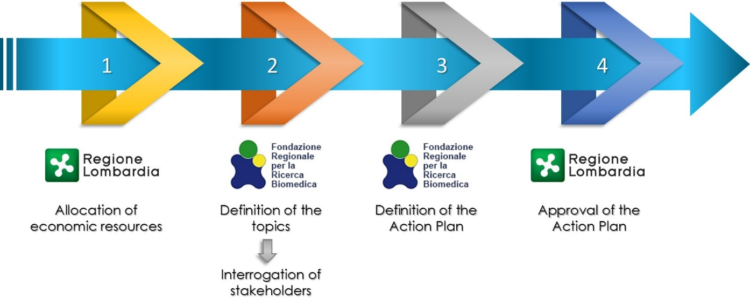

Step number 2 of this process is crucial, as it defines the orientation of FRRB activities every year; it is an important instrument for FRRB and for the Policy Makers to interface with the scientific environment.

After different internal reorganizations, FRRB in the next coming months will implement new ways for defining the topics of interest to the regional scientific community.

In doing so, FRRB will study the INNOSASUN Programme, illustrated by the Basque Foundation for Health Innovation and Research (BIOEF), during the 1st Interregional Workshop, held in Santiago de Compostela (Spain) in September 2016, considering it as an interesting model for creating connections among different parties and stakeholders.
The INNOSASUN Programme is, in fact, a support mechanism aiming at fostering public-private partnerships for the development of new products and services for the Basque Public Heath Care System.
This programme aims at matchmaking companies and technological agents with the health system representatives, facilitating the search for technological partners which have innovative solutions to respond to the needs arising from the Healthcare System.
The outcomes of the Good Practices presented during the first Workshop were shared with FRRB stakeholders’ at the Second plenary meeting with stakeholders held in Milan in October 2016, during which all stakeholders expressed their interest towards the INNOSASUN Programme for its innovative aspects and asked FRRB representatives to collect more information on this model.

In order to further deepen the knowledge of this programme, in February 2017 FRRB took part in an “In Situ Visit” to the Basque Country (Bilbao) together with representatives of other project partners (ACIS, Healthy Saxony and the University of Strathclyde).
In developing this Action, FRRB will take advantage of the already existing cooperation with two regional Clusters, the Lombardy Life Sciences Cluster Association (LLS) and the Lombardy Foundation Cluster Technologies for Living Environments (TAV).

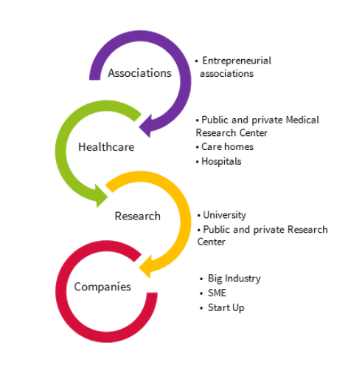
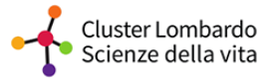
The first one is the Regional Cluster focused on Life Sciences (LLS) which encounters the participation of public and private entities operating in a variety of sectors, established by a group of businesses, research facilities, universities and business associations.
Its role is to be a driver for regional innovation in the Life Science sector and to represent a system able to build and manage innovation, to generate networks of knowledge and competencies regarding specific purposes and to catalyse development processes.

The second one is the Cluster TAV, which aims at developing highly innovative knowledge, technological solutions, plants, buildings and products, within Ambient Intelligence and Ambient Assisted Living frameworks. These expertise and capabilities allow for a redesign of living environments to foster inclusion, safety, well-being, health and eco-sustainability.
TAV takes advantage of consolidated collaborations with a number of stakeholders (see below).

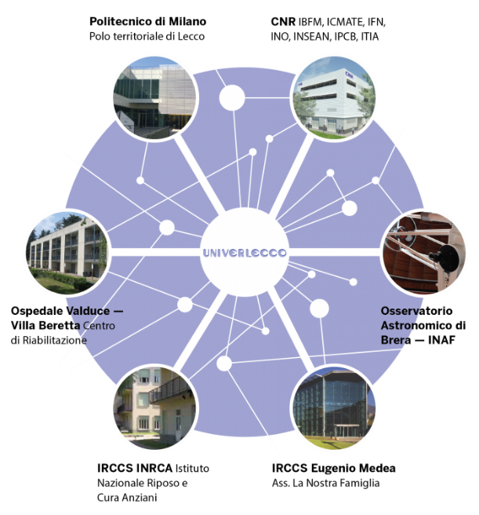

On April 11th , 2018 FRRB organized in Milan the first Interregional Workshop on Personalized Medicine with the participation of over 40 delegates from regional authorities and stakeholders with the aim to:
- Define R&D&I investment priorities,
- Align regional policies,
- Enable joint investment on Personalised Medicine

The event was organised in liaison with five health-related Interreg Europe projects, with the approval of the INTERREG EUROPE Joint Executive Board and in coordination with the TO-REACH Project, ESTHER Vanguard Initiative and PerMed secretariat representatives. The main aim of the event was to initiate a preliminary discussion on the priority/investment areas for personalised health and get validation about the main priorities for regions in “bringing Personalised Health to patients and citizen”. Keynote speakers were invited to provide guidance for further discussion and best practices were shared. The workshop was anticipated by a background document shared with all the stakeholders and participants.
Being a partner in TITTAN has encouraged the exchange of best practices and the dialogue for other Regions, which have eventually led FRRB to be part of yet another project funded by the EU focused on personalised medicine in Regions (Regions4Permed, GA 825812).

- Action (please list and describe the actions to be implemented)
FRRB needs to meet the needs of different types of stakeholders:
- Research Centres
- Universities
- Hospitals
- Industries and SMEs operating in health sector
The first action is to identify the different research topics that might be of interest for FRRB, Lombardy Region, and the scientific environment.
In this planning Phase, FRRB receives first inputs from the Policy makers, Lombardy Region, and then will prepare a survey containing different research topics that could be inserted in the Foundation Actions to be implemented, asking the stakeholders their preferences according to their research activities.
The release of the survey will be done through different distribution channels, including, for example, the Lombardy Region Open Innovation Platform (one of the Lombardy good practices illustrated in the Thematic Area 2), FRRB institutional website, sending newsletters to different stakeholders and through the regional Clusters.
The results of the survey will be then analysed and elaborated by FRRB, also with the support of its internal Scientific Committee and the possible topics will be identified.
A similar type of process is already ongoing for other funding agencies operating in Lombardy, such as Cariplo Foundation, which is indeed allocating funds to projects on active aging, as this topic has been identified of major interest for the scientific community in Lombardy.
The outputs of this action will be:
- An open consultation through a survey, to be launched in late summer/autumn 2019, addressed to FRRB Stakeholders with the aim of identifying : a) the area where investment is needed; b) the improvements to be realised in areas already recipient of investments.
- Once again, an important input to the new Regional S3. We have already been contacted by the Lombardy DG Welfare to support the identification of topics of interest to be included in the next strategy. Although this is an ongoing process, this is an opportunity to orientate the investments to be realised through the Structural Funds.

The second action will be focused on an in depth analysis of the INNOSASUN Programme that will be declined according to the context of Lombardy Region and FRRB.
In doing so, the Foundation wants to further refine the list of topics to be financed according also to a possible implementation into the industry sector. We will take advantage of the Clusters’ expertise in order to create a collaborative contact with health industries, which might be interested in dialoguing with Policy Makers and developing research topics. We plan to organize meetings (through Telcos) between Clusters, FRRB and BIOEF in order to understand how to achieve a greater involvement of third parties, as exemplified by the INNOSASUN Programme.
This process will lead to the development of the annual Action Plan of FRRB, the strategic document which contains the research topics that will be supported by FRRB, but now offering a feedback to the needs of the scientific community, and a concrete link to the market thanks to a greater involvement of the industry sector.
We foresee the following outputs:
- At least 2 meetings (including via skype or teleconference) with BIOEF
- A meeting with BIOEF, FRRB and the cluster managers

- Players involved (please indicate the organisations in the region who are involved in the development and implementation of the action and explain their role)

- Lombardy Region (Welfare Directorate General): every year the Lombardy Region allocates resources to the development of research projects and transfer these resources to FRRB, the entity that develops the different funding actions.
- Private or public I.R.C.C.S. (Italian Scientific Institutes for Health Research and Health Care)
- Public Health care providers (ASST)
- Research Institutes
- Lombardy Life Sciences Cluster Association (LLS)
- Lombardy Foundation Cluster Technologies for Living Environments (TAV)
- Universities
- Health Industry.

All these Institutions will have the possibility to have an active part in this actions by submitting research projects to FRRB.
- Timeframe
The action will start in 2019 with the development and distribution of the survey among all the players involved. The same process, once well-defined will be repeated every year.

- Costs (if relevant)
The Action will not require additional costs. It will implemented by the FRRB internal staff with the collaboration of the regional officers.

- Funding sources (if relevant):
This action will be carried on with institutional funds.

Although the actions described in Action 3 have benefitted from the experiences and the knowledge acquired in TITTAN, specifically from two best practices from other Regions, following the requests of the JTC we decided to remove Action 3, in order to avoid any overlapping or unclarities.
Date: 26/03/2019

Signature:

Stamp of the organisation (if available): Fondazione Regionale per la Ricerca Biomedica

Lombardy Region confirms that the actions described in the Action plan are in line with the Region’s ERDF ROP 2014-2020 and with its organisation’s policy.

Date:____________________

Signature: _______________________

Stamp of the organisation (if available): ____________________________________

