Build to Low Carbon (BUILD2LC) Action Plan
September 2018 – August 2020
Policy Context & Delivery Plan for
SLOVENIA

Collaboration between LEAG Lokalna energetska agencija Gorenjske and ApE Agencije za prestrukturiranje energetike on preparation of the action plan.

Managed by LEAG Lokalna energetska agencija Gorenjske, Slovenia
September 2018

Part I – General information

1.1 General information about LEAG
LEAG - Local Energy Agency of Gorenjska (Lokalna energetska agencija Gorenjske)

Company Headquarters:
Slovenski trg 1
SI-4000 Kranj
Slovenia

Office Address:
Stara cesta 5
SI-4000 Kranj
Slovenia

Foundation Year: 2009
Founder: Municipality of Kranj
Status: Public Institution
NUTS2 region: SI02

Registration Number: 3531333000
VAT ID Number: SI83738975
VAT Liable: Yes
IBAN: SI56 0125 2600 0000 335 (Bank of Slovenia)
SWIFT: BSLJSI2X

Director: Mr. Anton Pogačnik (anton.pogacnik@leag.si)
Contact person: Mr. Črtomir Kurnik (crtomir.kurnik@leag.si)

Phone: + 386 (0)59 92 49 74
Fax: + 386 (0)59 92 49 87
E-mail: info@leag.si
Web page: www.leag.si

Local energy agency of Gorenjska is closely working with:
- Ministry of Infrastructure,
- Ministry of the Environment and Spatial Planning,
- Office for Energy Rehabilitation of Buildings (representative in LEAGs Supervisory Board),
- Eco Fund, Slovenian Environmental Public Fund (representative in LEAGs Supervisory Board),
- Contracting service companies (representative of Petrol d.d. in LEAGs Supervisory Board),
- 19 Slovenian Municipalities (representatives in LEAGs Supervisory Board).

Local energy agency of Gorenjska is a member of:
- Covenant of Mayors,
- Consortium of Local energy agencies in Slovenia.

1.2 Background
The BUILD2LC is following an innovative multi-disciplinary approach by tackling challenges which impact the quality and uptake of domestic energy retrofit in order to find a more sustainable solution longer term. Therefore, the project is focusing on the six priority areas shown in figure 1.
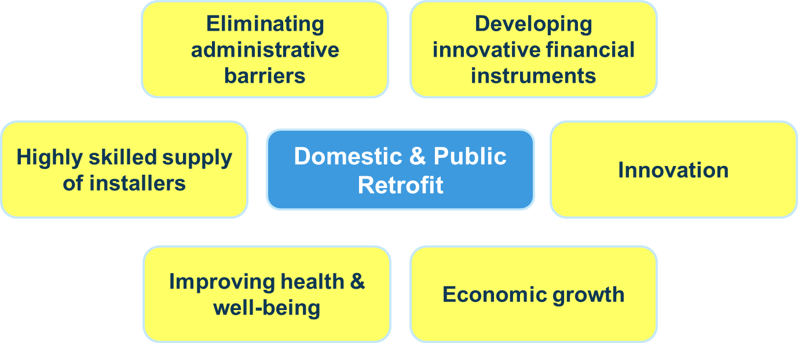

Figure 1: BUILD2LC priority areas of work

The final outcomes of the project will include improvements to domestic properties and the awareness of households alongside wider benefits such as upskilling the labour force in the county and stimulating economic growth. The whole project is underpinned by a focus on relieving vulnerable groups from energy poverty: energy rehabilitation can have a greater impact on the health and well-being of these residents. We estimate that it will be very important for realisation of the Action plan, to acquire in the collaboration the most important stakeholders and decision makers in Slovenia.
BUILD2LC is part of the EU funded Interreg programme which focuses on collaboration and learning across member states. In this case, LEAG Lokalna energetska agencija Gorenjske, representing Slovenia, is working with partners from: Andalusia, Spain; Glouchestershire, UK; Jämtland-Härjedalen, Sweden; Lithuania; Podkarpackie, Poland; and Croatia.

1.3 Sharing Good Practices
Each partner involved brings expertise in different fields and the project aims to develop regional cooperation between Member States to share good practice to inform the development of action plans within each partner region. This collaboration began with inter-regional seminars on: innovative financial instruments (Lithuania); innovation (Sweden), and new energy culture, citizen involvement and energy poverty (Gloucestershire, UK). Over 70 good practices have been shared between partners and their stakeholders to identify the most relevant good practices to adapt and adopt in each region before bi-lateral meetings took place.
In LEAG and ApE we have up to now shared good practice with:
- Region Jämtland Härjedalen (RJH), Sweden, mainly in innovation in buildings retrofitting.
- The Andalusian Energy Agency (AEA), Spain, about energy efficiency refurbishment in public social housing.
- Severn Wye Energy Agency (SWEA), Gloucestershire, UK, about the Warm & Well Scheme and program, several education projects, Link to Energy Installer network, Target 2050 and Countdown to Low Carbon Homes. Main contributions refer to energy poverty tackling and education in sustainable use of energy.
- REGEA, Croatia about defining energy poverty and implementing mechanisms to tackle energy poverty nationally.
- RRDA, Poland about defining energy poverty.
In a bi-lateral meeting in January 2017 in Lithuania we learnt further about:
- Procurement processes,
- Engaging citizens and activating demand,
- Financial instruments.
Further learnings took place from REGEA, Croatia, about their System for monitoring, measuring and verification of energy savings (SMiV) and from Solsolar, Catalonia, Spain about their solar thermal installation ESCO model.
The Slovenian BUILD2LC action plan builds on the ideas of a wide range of stakeholders across the county, national policy and European policy and agendas as well as the direct learnings from project partners.

Part II – Policy context
Slovenia received a formal reminder from the European Commission for failure to fulfil its obligations under Directive 2012/27/EU. Letter from the European Commission, no. SG-Greffe (2018) D 15110 of 20 July 2018. Slovenian government is currently preparing response to the letter. In its response and justification, the experiences from BUILD2LC program will be used. Some of the most relevant experiences from BUIILD2LC will be used to improve Slovenian policies.
Results and actions of project BUILD2LC will address both the Slovenian Operational Programme for the Implementation of the EU Cohesion Policy in the Period 2014-2020 and the Long-Term Strategy for Energy Rehabilitation of the Buildings and its Strategy. Action plan will be used to improve Slovenian energy policies to achieve better results and use of planned finances.

The Action Plan aims to impact:
- European Territorial Cooperation Programme
- Other development policy instrument

2.1.1 Name of the policy instrument addressed
- Operational Programme for the Implementation of the EU Cohesion Policy in the Period 2014-2020.
  - Priority axis 2.4 Sustainable consumption and production of energy and smart grids.
    - Priority 2.4.1 Supporting energy efficiency, smart energy management and renewable energy use in public infrastructure, including in public buildings, and in the housing sector.
2.1.2 Further details on the policy and the way the action plan should contribute to improve the policy instrument
The Slovenian Operational Programme for the Implementation of the EU Cohesion Policy in the Period 2014-2020 has in Priority 2.4.1 implementation of directions to support energy efficiency, smart energy management and renewable energy use in public infrastructure, including in public buildings and in the housing sector. Priority has two specific objectives. First specific objective is the improvement of energy efficiency in the public sector and in second improvement of energy efficiency in household. It is relatively difficult to estimate the energy savings made in the public sector in Slovenia, as the statistical record system does not provide accurate actual energy consumption values for the public sector. According to energy-end use estimates, hospitals consume most final energy in the public sector, followed by primary and secondary schools, higher education institutions and research institutions, public administration buildings, cultural and leisure buildings. Some 29% of single family detached houses have not been subject to energy renovation, 26% of them underwent only partial energy renovation and need further improvements. The same is true for multi-family residential buildings where as much as 34% of the building stock has not undergone any kind of energy renovation, 28% of the building stock having been partially renovated by a single energy renovation measure. Considerable efforts will have to be made to boost the efforts of renovation of multi-family residential buildings. The renovation of flats occupied by deprivileged households will contribute to tackling the growing issue of energy poverty.

2.2.1 Name of the policy instrument addressed
- Long-Term Strategy for Energy Rehabilitation of the Buildings (Strategy) and in 2018 the Addition to the mentioned Strategy

2.2.2 Further details on the policy and the way the action plan should contribute to improve the policy instrument
Slovenia prepared in 2015 the Long-Term Strategy for Energy Rehabilitation of the Buildings (Strategy) and in 2018 the Addition to the mentioned Strategy. The strategy was prepared according the requests and guides, from the 4th paragraph of the Directive 2012/27/EU on Energy Efficiency. The amendments were focused on the following measures:
- The quality management should follow the sustainable criteria in the whole life cycle of the buildings (design, construction/reconstruction, management/operation, etc). There is a need to get more adequately oriented collaboration between different sectors as building, architecture, space planning, energy, health, education, economy etc.
- From the approval of the PURES (Regulation on Energy Efficiency) in 2010 a lot of changes happened in the EU and national level, so there is a need for renovation of the act, especially regarding the calculation and implementation of renewable energy sources.
- The criteria for financial support of energy rehabilitation of cultural heritage buildings should be adapted in a way, that the owners of these type buildings will gain the appropriate interest for investments.
- There are the interests for development of financial instruments for further deployment of the market of energy contracting for rehabilitation of public and multi-apartment houses.
- Enlargement of the activities of the Eco Fund, Slovenian Environmental Public Fund (Eco Fund) in the field of individual buildings, information, and awareness, energy poverty sector, energy consultancy network ENSVET, education of installers and others taking part in the rehabilitation and more support for the use of wood as construction material.
- Better information system for energy rehabilitation of the buildings and use of renewable energy sources, especially for heating, where the statistics is rather poor.
- Establishment of a systems for complete rehabilitation of buildings, together with earthquake safety and other technical improvements, important for health and functionalities.
- Green public procurement should incorporate in the selection criteria not only the lowest investment price, but also the costs in the life time and environmental impacts.
- Financial supports for energy efficient rehabilitation and sustainable construction of the buildings in the public sector with the aim to develop financial instruments and removal of the barriers for energy contracting and some pilot projects.
- Implementation of the system for energy management in the public sector, with nomination of energy managers, regular following, bookkeeping and reporting on energy use.
- For the efficient implementation of the energy rehabilitation of buildings in the public sector, the Office for Energy Rehabilitation of Buildings (OERB), was created within the Ministry for the infrastructure. The OERB should reinforce the work in the system for improving the quality of designs, analysis of already executed rehabilitations, better supervision, enhancement of preparation of the projects for energy rehabilitations in the public sector and preparation of standard documentation and protocols for energy contracting.
- Financial supports for efficient energy rehabilitation and sustainable construction of multi-apartment residential buildings, with support of demonstration projects in criteria of nearly zero energy rehabilitation and energy contracting.
- Special attention is given to the people in the category of energy poverty, where additional instruments, supports and approaches should be developed.
- Enlargement of the activities of the energy consultancy network ENSVET in the field of promotion, availability of information and electronic interactions, more supports for services directly connected with implementation.
- Financing of energy rehabilitation of multi-apartments buildings requires adequate, less bureaucratic formal basis for decision making, better involvement of commercial banks and less risks connected with potential loss of ownership.
- Adequate split of supports between the owners and rentals in residentials multi-apartment buildings, where according the recent regulation, the rentals are not motivated for energy rehabilitation.
- A guaranty scheme for individual persons is not available, its implementation would enhance the acquisition of financial means of individuals for energy rehabilitation.

The key assumptions of the Long-Term Strategy of Energy Rehabilitation of the Buildings are as follows:
- grants for up to 40% of investment’s eligible costs,
- only deep energy renovations are co-funded,
- the minimum investment amounts set for Public Procurement (PP) and Public-Private Partnership (PPP).
The combination of grants and energy performance contracting shall nullify the problems of:
- exhausting economically interesting savings potential for easy partial renovation measures on building’s systems,
- desire to implement only low-hanging fruit projects,
- implementing non-optimal projects in the view of technical solutions and costs.
The main targets of the Long-Term Strategy of Energy Rehabilitation of the Buildings in the period 2016-2020 is the energy rehabilitation of 1,5% of the area of governmental buildings yearly and 0,9 million m² of the areas in the larger public sector. In the years 2016 and 2017 the results were rather poor, so there is a request to be more intensive with the activities in the remaining period.

Part III – Details of the actions envisaged

ACTION 1 – Energy rehabilitation of the governmental public buildings
The background:
Innovative financial scheme with contracting, which will allow private equity / crowdfunding to participate in energy rehabilitation of governmental public buildings. The 3% yearly rehabilitation is foreseen in the Strategy and is in accordance of the EU Directive. The good results should serve also as proper motivation for all other sectors.
Four applications for energy rehabilitation of central government buildings were implemented insofar and all operations were granted cohesion funds. The total investment of 9.9 million Euro for net floor area of 57.800 m² were granted 3.9 million Euro cohesion funds and result in 5.3 GWh/y total final energy savings. The projects are implemented in public procurement (PP) and will gave many experiences and the lessons learnt. Together with the experiences from other projects, from other countries, will represents a good basis for further implementations. As the buildings are operated by different ministries there is a need to plan and operate the action by a coordinative body.

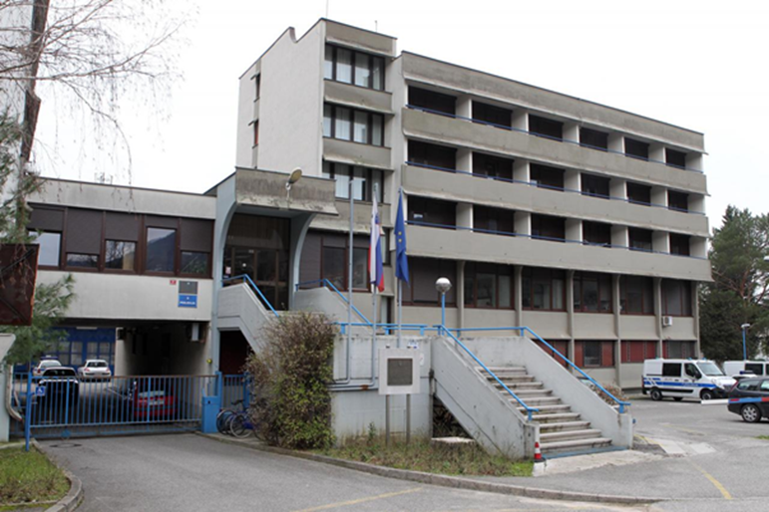
Figure 2: Planed energy rehabilitation of one of the Policy building

The ministry for Infrastructure continues the activities. On 23.2.2018, the ministry published the Invitation for „Applications for proposals of energy rehabilitation of governmental building in the year 2018, 2019 in 2020„ with the following main data:
- The available tendering amount for subsidies is 7.647.059 Euro,
- Eligible for applications are narrow public sector - governmental entities,
- The tender will be opened till the money disbursement.
The ministry for infrastructure published on 2.3.2018 also the Public tender for concession of the services for energy contracting, based on energy efficiency measures for the following buildings: policy building at Kotnikova Ljubljana, Nova Gorica and Idrija, Policy academy Tacen and Center for supply Gotenica.
The partner selection will be made in three phases:
- Phase of approval of competence of contractors,
- Phase of dialog,
- Phase of contracting.
The main criteria for the partner selection are:
- level of achieved energy decrease,
- amount of proposed measures,
- time of concession period,
- guaranties after the concession period,
- level of investments.
The bases for the proposals are the deep energy audits.

Action:
According to the Strategy, the Office for Energy Rehabilitation of Buildings (OERB) within the Ministry of infrastructure was created for the efficient implementation of the energy rehabilitation of buildings in the public sector. The OERB should reinforce the work in the system for improving the quality of designs, analysis of already executed rehabilitations, better supervision, enhancement of preparation of the projects for energy rehabilitations in the public sector and preparation of standard documentation and protocols for energy contracting.
The OERB has made the evidence of the buildings. The real situation has, to be further and deeper analysed with prioritisation, energy audits and planning of execution. Based on the gained experiences from the implemented projects in public sector in the past years, it would have sense to use the OERB for managing the energy rehabilitation of the governmental public sector.
There is a need to check the operability and capability of the OERB to directly manage the energy rehabilitation. If this option is not realistic, then it is required to find with stakeholders an appropriate body to operationally manage the action. It is important that the implementation is managed by competent institution in technical and financial means. From the partnership in the BUILD2LC project and from City of Zagreb we have got many information on good practice in Croatia. It would be useful to get further information regarding the management approach and financing of energy rehabilitation of this type of buildings in other regions and countries.

Players involved:
The main players which are involved in the action implementation are:
- Office for Energy Rehabilitation of Buildings (OERB),
- Relevant Ministries,
- Contracting service companies.

Timeframe:
The planned activities covered by the published public calls will be implemented in the period 2018 to 2020.

Costs:
The total area of 504 governmental buildings is 782.158 m². Based on the experiences from the pilot projects, the 3% yearly rehabilitation area of 23.465 m², will cost about 4 million Euro per year.

Founding sources:
For the energy rehabilitation of governmental buildings in the period 2018 to 2020 the public call has foreseen 7,6 million Euro of subsidies (6,5 million Euro from the cohesion funds and 1,1 million Euro as Slovenian contribution).
Founding for the services for energy rehabilitation of the buildings within the public call for concession will be provided by the contracting service companies.

Adapted from a case of good practice:
Reconstructed public buildings in City of Zagreb under the ZagEE project, Croatia
Zagreb – Energy Efficient City (ZagEE) project aims to refurbish 87 public buildings and 3.000 public lighting luminaries and to perform capacity building activities (technical, financial, managerial) of city office employees and building managers. Project was initiated in 2012 and funded under the Intelligent Energy Europe programme - Mobilizing Local Energy Investment Project Development Assistance (MLEI PDA) which assists local and regional authorities to develop sustainable energy projects. It aims to bridge the gap between sustainable energy plans and real investment by funding activities necessary to prepare and mobilize finance for public investment programmes.

Summary table of the proposed action, timeframe and stakeholders
NUTS code: SI - level: 0 (National level)
Action | Topic(s) | Cost and funding source | Timeframe | Main stakeholders | Main activities
1. EE rehabilitation of governmental buildings | Financial instruments  Project coordination of implementation | Ministry of Infrastructure | 2018 - 2020 | Office for Energy Rehabilitation of Buildings (OERB)  Relevant Ministries | Presentation and promotion of GPs.  Involvement at the implementation of policies of EE and RES.  Quarterly meetings with Ministry of Infrastructure.

ACTION 2 – Energy rehabilitation of other public buildings
The background:
Innovative financial scheme with contracting which will allow private equity / crowdfunding to participate in energy rehabilitation of public buildings. The energy rehabilitation of 0,9 million m² in the period to 2020 is foreseen in the Strategy and is in accordance of the EU Directive. The good results should serve also as proper motivation for all other sectors.
In the past two years some pilot projects of energy rehabilitation were implemented, namely: the CŠOD Bohinj, three buildings of curt of Celje, Slovenj Gradec and Murska Sobota, communal building in Šmarje pri Jelšah and five buildings of cultural heritage. The implementations were coordinated by a special project group and project board. Both were constituted specially for this purpose and finished their involvement with the completion of the investments. The projects were implemented in public private partnership (PPP) and gave many experiences and the lessons learnt. Together with the experiences from other projects, from other countries, represents a good basis for further implementations.
The group of pilot projects were so completed and the Ministry for infrastructure continue the activities. On the 23.2.2018 the ministry published the Invitation for „Applications for proposals of energy rehabilitation of broader public buildings in the year 2018, 2019 in 2020„:
- The tendering amount for subsidies is 14.117.647 EUR,
- Eligible is the broader public sector – where RS is the founder,
- The tender will be opened till money disbursement,
- The rehabilitation foresees the renewable energy sources (RSE), as biomass boilers, thermal solar collectors, heat pumps, but not PV!
The ministry for infrastructure published on the 16.2.2018 also the Public tender for energy rehabilitation of public buildings in the ownership or operation of local communities for the period 2018-2020:
- The tendering amount for subsidies is 17.6477.059 EUR,
- Co-financing is up to 40% of eligible costs,
- Local community must have a valid Local energy concept,
- Estimation of the contracting approach has is required,
- Deep energy audit for the buildings required,
- The rehabilitation foresees the RSE, as biomass boilers, thermal solar collectors, heat pumps, but not PV!

Both public calls are not foreseeing PV as an important renewable energy source, even-though we can see from figure 3, that there are already good experiences also in Slovenia. PV is namely the most important local RSE for buildings and it is so very important that is properly integrated in the buildings envelopes.

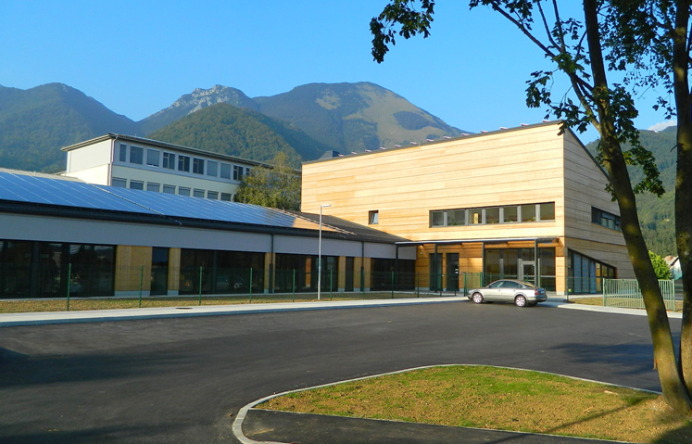
Figure 3: Integration of PV on the public kindergarten Preddvor

Action:
For the proper transfer of the experiences of the pilot projects in Andalusia, it would be good that the OERB within the Ministry of Infrastructure would operationally manage the implementation. If this approach is not realistic, then it is required to check on additional meetings with stakeholders the feasibility of the action and find one other appropriate body to run the action. There would be very useful to get the information, how the energy rehabilitation of this type of buildings is operated in other regions and countries.
The buildings (universities, institutes, medium and elementary schools, kinder gardens, elderly houses, sports halls etc.) are operated by different ministries and institutions, there is a need to plan and operate the action by a coordinative body. The Office for Energy Rehabilitation of Buildings (OERB) should find and support, within the mentioned institutions, the executive bodies for energy rehabilitation implementation. These bodies should investigate the situation in their sector and prepare the prioritisation, energy audits and planning of execution.
It is important that the implementation is managed by competent institution in technical and financial means. From the partnership in the BUILD2LC project and from the Andalusian Agency for Homes and Rehabilitation we have got many information’s on good practices. It would be useful to get further information regarding the management approach and financing of energy rehabilitation of this type of buildings in other regions and countries.

Players involved:
The main players which are involved in the action implementation are:
- Office for Energy Rehabilitation of Buildings (OERB),
- Relevant ministries,
- Local communities,
- Contracting service companies.

Timeframe:
The planned activities covered by the published public calls will be implemented in the period 2018 to 2020.

Costs:
The energy rehabilitation of 0,9 million m² in the period to 2020, foreseen in the Slovenian Strategy, is estimated to cost about 50 million Euro per year.

Founding sources:
For the energy rehabilitation of the broader public buildings in the period 2018 to 2020 the public call has foreseen 14,1 million Euro of subsidies (12,0 million Euro from the cohesion funds and 2,1 million Euro the Slovenian contribution).
For the energy rehabilitation of the public buildings in the ownership or operation of local communities, in the period 2018-2020, the public call has foreseen the amount of 17,6 million EUR (15,0 million Euro from the cohesion found and 2,6 million Euro the Slovenian contribution). The co-financing of the operations is up to 40% of eligible costs.
Founding for the services for energy rehabilitation of the buildings within the contracting approach will be provided by the contracting service companies.

Adapted from a case of good practice:
Energy efficiency refurbishment in public social housing in Andalusia, Andalusia
The Andalusian Agency for Homes and Rehabilitation began in 2013 a new Energy Rehabilitation Programme of its social housing building stock (property of the public administration) due to policy and legal changes. It acts fostering socio-economic activity by enabling the capacity building and employment of those population collectives with hard access to the labour market as well as enabling the social function of homes and showing itself as example and case study of energy rehabilitation for public bodies. Objective was to increase of indoor homes comfort and air quality, improvement of habitability, energy saving and reduction of GEI (CO₂) emissions in social housing homes.
Summary table of the proposed action, timeframe and stakeholders
NUTS code: SI - level: 0 (National level)
Action | Topic(s) | Cost and funding source | Timeframe | Main stakeholders | Main activities
2. EE rehabilitation of other public buildings | Financial instruments.  Project coordination of implementation | Ministry of Infrastructure | 2018 - 2020 | Office for Energy Rehabilitation of Buildings (OERB)  Relevant Ministries and LC | Presentation and promotion of GPs.  Involvement at the implementation of policies of EE and RES.  Quarterly meetings with Ministry of Infrastructure.

ACTION 3 – Simplification and standardisation of procedures for multi-apartment buildings

The background:
The Strategy gives the adequate importance of energy rehabilitation of multi-apartments buildings and defines that the financing requires adequate, less bureaucratic formal basis for decision making, better involvement of commercial banks and less risks connected with potential loss of ownership. The Strategy says, that the relevant ministers must find adequate solutions for these aspects, connected with all types of renovation. Unfortunately, the mentioned problems remain still unresolved.
Regarding technical approach of rehabilitation of multi-apartment buildings there were already many implementations, with good and bad experiences. The approach is left to operating administrative companies and building residents. They have no adequate knowledge and experiences so, there is a continuous risk for bad praxis. The strategy is mentioning the importance of quality in all phases of energy rehabilitation, but it is not giving concrete solutions for deployment of good practices, standardisation of approaches and implementation of innovative financial instruments.

Action:
From the BUILD2LC project we have learned, that there are already good practices, experiences and the lessons learnt for the multi-apartment sector in Lithuania, with the renovation managers. Involvement of renovation managers, simplification and standardisation of required procedures will enable to faster implementation and use of innovative financial scheme with contracting and private equity / crowdfunding to participate in energy rehabilitation of multi-apartment buildings.
In Lithuania the Local communities are obliged also to prepare the implementation plan for energy rehabilitation plan for all multi-apartment buildings in their territory. From the plan they get the comparable situation of the energy status of the buildings and made the prioritisation, approach the local communities appoint the renovation managers for energy rehabilitation of multi-apartment buildings. The administrators manage the whole process together with financing. The owners have the right to select the manager and have, to vote for the rehabilitation project. For both approvals it is needed 50% + one vote. The law income people get 100% compensation for the costs from heating compensation found.

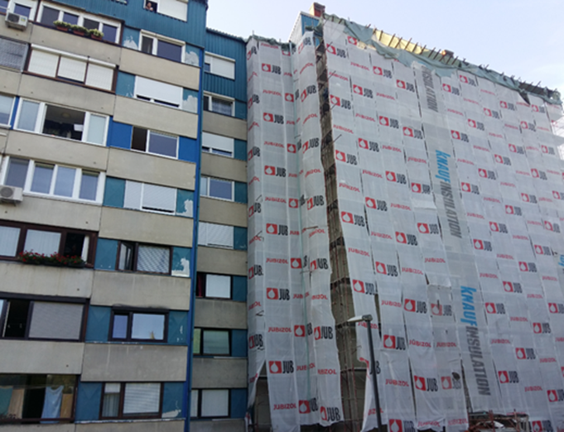
Figure 4: Example of the energy rehabilitation of one part of multi-apartment building

We estimate that the learning from the good practice from Lithuania: “Standardization and Simplification in Multi-Apartment Building Modernization” will result in changes in the laws, ordinances, management and procedures in Slovenia in a way to simplify and standardise the approach. Therefore, additional information’s will be transferred and possible meetings between the representatives of involved institutions from Lithuania and Slovenia organised in future.
The Office for Energy Rehabilitation of Buildings (OERB) should find and propose, in collaboration with all relevant ministries and institutions, the required changes in the laws, ordinances, management and procedures and foresee that they will be implemented in near future. A guaranty scheme for individual persons is not available, its implementation would enhance the acquisition of financial means of individuals for energy rehabilitation.

Players involved:
The main players which are involved in the action implementation are:
- Office for Energy Rehabilitation of Buildings (OERB),
- Relevant ministries,
- Local communities,
- Buildings associations.

Timeframe:
The required changes of the laws, ordinances, management and procedures should be implemented in the period 2018 to 2020.

Costs:
The activities are currently part of the normal work of the engaged public bodies and will not require any additional costs.

Founding sources:
In the processes of required changes of the laws, ordinances, management and procedures public bodies will be involved, so the founding will come from existing public budgets.

Adapted from a case of good practice:
Standardization and Simplification in Multi-Apartment Building Modernization, Lithuania
- The Lithuanian government decided to simplify the process for final beneficiaries by imposing some legal changes:
  - 50% +1 of apartment owners (absolute majority) needed to agree to join the program,
  - Joint liability for the building modernization investments.
- Other financial institutions introduced process simplification measures:
  - Central public procurement organization introduced simplified and shorter procedures for building modernization procurement,
  - BETA Agency created simplified application forms and reduced administration extent to minimum necessary,
  - Special standardized templates prepared for public procurement, including standardized construction agreement,
  - Improved and standardized documents for energy efficiency certification were prepared.

Summary table of the proposed action, timeframe and stakeholders
NUTS code: SI - level: 0 (National level)
Action | Topic(s) | Cost and funding source | Timeframe | Main stakeholders | Main activities
3. Simplification and standardisation of procedures for multi-apartment buildings | A more professional approach for enabling better implementation and education | Ministry of Infrastructure | 2018 - 2020 | Office for Energy Rehabilitation of Buildings (OERB)  Relevant Ministries and Local Communities | Presentation and promotion of GPs.  Involvement at the implementation of policies of EE and RES.  Quarterly meetings with Ministry of Infrastructure.

ACTION 4 – Elaboration of EE implementation plans for multi-apartment and public buildings
by all Local Communities

The background:
In Slovenia the Local communities are already obliged to prepare every four years the Local energy concept (LEC), which elaborate the recent energy supply and environmental emissions and foresee the potential to increase the energy efficiency in the local community and use of locally available RES. Implementation of the energy rehabilitation plan for multi-apartment and the public buildings is somehow already part of the LEC, but should be more explicitly and detailly elaborated.
From the partnership collaboration in the BUILD2LC project we have learned that there are already good practices, experiences and the lessons learnt from Lithuania. In Lithuania the Local communities are obliged to prepare the implementation plan for energy rehabilitation for all multi-apartment buildings in their territory. The plans give the real energy status of the buildings, prioritisation for rehabilitation, approach, time schedule, financing, etc.

Action:
As mentioned the local communities are obliged to prepare the LEC. In the above figure we can see the example of executed rehabilitation of the facades in the Local Community of Ajdovščina. In the similar information system would be possible to make the evidence, with main data and prioritisation of the energy rehabilitation for multi-apartment buildings. The Implementation plans for multi-apartment buildings if well prepared and communicate in adequate positive way, could represent an important opportunity for all stakeholders and interested parties.
For these reasons, we estimate that it will have sense to organise some working meetings, within the BUILD2LC project, between the representatives of involved institutions from Lithuania and Slovenia in coordination of the OERB, the Ministry of Infrastructure and the Ministry of Environment. The aim of the collaboration should be to prepare the required changes in the laws, ordinances, management and procedures in Slovenia in a way to simplify and standardise the approach.

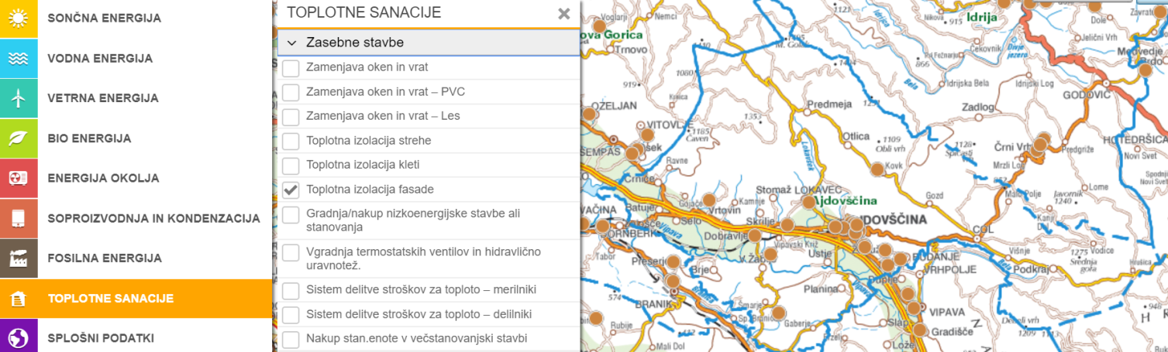
Figure 5: Energy rehabilitation of facades in the Local Community of Ajdovščina

The Office for Energy Rehabilitation of Buildings (OERB) should find with relevant institutions, the required changes in the laws, ordinances, management and procedures in Slovenia.

Players involved:
The main players which should be involved in the action of introduction of the obligation of elaboration of energy efficiency implementation plans for multi-apartment and public buildings by all Local Communities are:
- Office for Energy Rehabilitation of Buildings (OERB),
- Relevant Ministries,
- Eco Fund,
- Local communities.

Timeframe:
The required changes of the laws, ordinances, management and procedures should be implemented in the period 2018 to 2020.

Costs:
The activities of required changes of the laws, ordinances, management and procedures is part of the normal work of public bodies and will not require additional costs.
The costs for elaboration of the implementation plans by the local communities could be defined only later in the pre-implementation phase.

Founding sources:
In the processes of required changes of the laws, ordinances, management and procedures, public bodies will be involved. The founding of the required activities will come from existing public budgets.
The founding for the elaboration of energy efficiency implementation plans for multi-apartment and public buildings, will has to be provided by the Local Communities. The Eco Fund can foresee financial subsidy support for elaboration of the implementation plans.

Adapted from a case of good practice:
Municipalities involvement in Multi-Apartment Building Modernization, Lithuania.
In order to foster the modernization process Lithuanian government decided to stipulate and simplify MABR process at the level of the final beneficiaries by involving municipalities.
The National Government in Lithuania set the plan for municipalities to:
- draw lists of the worst energy performing buildings.
- appoint renovation administrators, which:
  - can borrow on behalf and in favour of apartment owners,
  - are providing all the process administration service,
  - keep loans on off the balance sheets,
  - expenses are covered by the budget funds.

Summary table of the proposed action, timeframe and stakeholders
NUTS code: SI - level: 0 (National level)
Action | Topic(s) | Cost and funding source | Timeframe | Main stakeholders | Main activities
4. Elaboration of EE implementation plans for multi-apartment and public buildings  by all Local Communities | Financial instruments  Project coordination of implementation | Ministry of Infrastructure  Local Communities | 2018 - 2020 | Office for Energy Rehabilitation of Buildings (OERB)  Local Communities | Presentation and promotion of GPs.  Involvement at the implementation of policies of EE and RES.  Quarterly meetings with Ministry of Infrastructure.  Monthly meetings with Local Communities.

ACTION 5 - Promotion and Financial Support of EE measures for individual buildings,
with special attention to energy poverty aspects

The background:
One of the reminders from the European Commission for failure of Slovenia to fulfil its obligations under Directive 2012/27/EU was over article 19. With help and knowledge gain at program BUILD2LC we presented at the working meeting in Slovenia to the Eco Fund representative’s solutions from UK.
A big series of EE measures were implemented by the owners of individual buildings and households. Up to now, majority of the actions were managed by aware and financially better situated individuals. There is a need to elaborate and widely promote the Good Practice examples and find the support models for low income building owners.
Energy suppliers and ESCOs are quite new in this business and prefer public owners with predictable stability. Low income owners represent the additional risks and so the implementation of energy rehabilitation of these type of buildings are not possible without strong supporting mechanisms by government institutions and local authorities.

Proposed activities:
There is a need to study and investigate on possible approaches for law income owners. It would be very useful to analyse and get the information, haw to motivate this type of owners and the service companies to perform the energy rehabilitation. Both, the owners and the service companies, need some special instrument of support in the way, that they get motivated for such collaboration and financially positive results.
Already aware building owners need information and some small stimulation. The law income owners need service companies and other institutions to carry on and finance the implementation on long term basis. There is a need to find instruments and supporting mechanisms to stimulate energy suppliers and ESCO companies to enter also in energy rehabilitation of this kind of buildings.
From the partnership in the BUILD2LC project we have learned that in all partner countries there are ongoing activities regarding the problems connected with energy poverty. Especially in the Gloucestershire, UK this task is elaborated and planned very widely, from social, education and voluntary activities to the pilot projects to development special financial instruments, upskilling of property owners and use of contracting approach. The well elaborated Gloucestershire approach to the energy poverty could represent a good base also for the further development of the action in Slovenia.

Players involved:
The main players, which should be involved in the promotion and financial support of energy efficiency measures for individual buildings, with special attention to energy poverty aspects are:
- Office for Energy Rehabilitation of Buildings (OERB),
- Relevant Ministries,
- Eco Fund,
- Local communities,
- Social centres,
- Energy suppliers and ESCO companies.

Timeframe:
The required changes of the laws, ordinances, management and procedures should be implemented in the period 2018 to 2020.

Costs:
The activities for required changes of the laws, ordinances, management and procedures is part of the normal work of public bodies and will not require additional costs.
The costs for the implementation of energy rehabilitation of the buildings could be defined only later in the pre-implementation phase.

Founding sources:
In the processes of required changes of the laws, ordinances, management and procedures, public bodies will be involved, so the founding will come from existing public budgets.
The Eco Fund should foresee financial subsidy support mechanisms to stimulate energy suppliers and ESCO companies for energy rehabilitation of this kind of buildings. The majority, of the financing should be provided by the involved energy supplying and ESCO companies.

Adapted from a case of good practice:
Warm & Well – Energy Efficiency Advice and Installation Scheme
The Warm & Well scheme aimed to improve energy efficiency in the home and reduce the risk of fuel poverty and associated health problems. Grants are available through the Warm and Well scheme and over the years have covered a variety of measures from solid wall installation, first time central heating systems and cavity and loft insulation.

Summary table of the proposed action, timeframe and stakeholders
NUTS code: SI - level: 0 (National level)
Action | Topic(s) | Cost and funding source | Timeframe | Main stakeholders | Main activities
5. Promotion and Financial Support of EE measures for individual buildings, with special attention to energy poverty aspects | Financial instruments  Project coordination of implementation | Ministry of Infrastructure | 2018 - 2020 | Office for Energy Rehabilitation of Buildings (OERB)  Eco Fund | Quarterly meetings with Ministry of Infrastructure and ESCOs.

ACTION 6 – Support and education of architects, engineers and installers

The background:
The European Commission Directive 2009/28/EC on the promotion of the use of energy from renewable sources requires that each country has a mandatory certification system for installers of small boilers and wood biomass stoves, solar photovoltaic and solar thermal systems, shallow geothermal systems and heat pumps. Licensed installers obtain certificate based on previous training and exams.
Architects, construction engineers and installers involved in the energy rehabilitation of the buildings have many times the lack of knowledge and experiences. The sector is continuously in development so there is a need to learn from Good Practices and, also from good and bad experiences. On the other hand, even more, the lack of knowledge and information is by the all kind of individuals and institutions, as investors in energy rehabilitation and locally available RES. In such circumstances it is difficult to get positive changes and is so extremely important to develop and spread continuously adequate verified information by independent institutions and experts.

Proposed activities:
The basic education is not giving to the involved experts and persons enough knowledge regarding the energy rehabilitation of buildings and integration of renewable energy sources. The knowledge and experiences are mainly coming from the continues research and implemented projects. There is a need for periodic training and education. For the motivation for involved experts and persons it is important, that this additional trainings and education are not formally requested.
The strategy pointed out the need to have more adequately oriented collaboration between different sectors as building, architecture, space planning, energy, health, education, economy etc., what of course need somebody, who leads the collaboration. The Office for Energy Rehabilitation of Buildings (OERB) should find the way to develop the basis and motivate the collaboration in the field of energy rehabilitation and integration of RES in the building. In some cases, there is a need for guides in some cases also prescribed regular certificates and certifications.

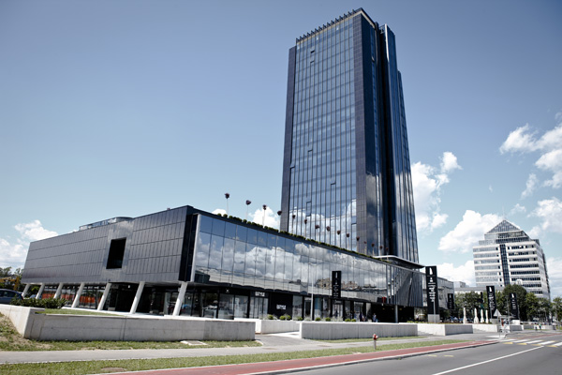
Figure 6: Example of good architectural integration of PV on the facade

From the partnership in the BUILD2LC project we have learned that in all partner countries there are ongoing activities regarding better information, education and knowledge of all partners involved in the energy rehabilitation of buildings. Further exchange of information, how the training, education and certification of involved persons in the energy rehabilitation are motivated, supported and requested in other regions and countries, it is important for detailed design of the action.

Players involved:
The main players, which should support the education of architects, engineers and installers, based on Good Practices approaches are:
- Office for Energy Rehabilitation of Buildings (OERB),
- Relevant Ministries,
- Eco Fund,
- Chamber of architecture and spatial planning.

Timeframe:
The first phase of support to the education of architects, engineers and installers, based on Good Practices approaches, should be implemented in the period 2018 to 2020.

Costs:
The basic education based on the latest achieved technology achievements is part of normal education process and do not require additional costs.
The costs for additional special education, based on the best practices could be defined in the pre-implementation phase.

Founding sources:
The basic changes in education of architects, engineers and installers should be covered by the existing public budgets.
The Eco Fund should foresee financial support for education, based on the already implemented best practices of energy rehabilitation of the buildings.

Adapted from a case of good practice:
Podkarpackie Academy Certification, Podkarpackie Region
Preparation for energy performance certificates. The training discusses the methodology of the certificates together with exercises in order to improve practical skills. Training is adapted to the situation of people over 45 years old holding a building license. Classes are conducted in a way which did not interfere with day-to-day professional work – during the weekends. The training consisted of 32 hours of theoretical and practical classes. Program of the training: Legal basis; Evaluation of the thermal protection of the building; RES; the methodology of calculation; Execution of training energy certificates; The use and operation of the thermal imaging camera.

Summary table of the proposed action, timeframe and stakeholders
NUTS code: SI - level: 0 (National level)
Action | Topic(s) | Cost and funding source | Timeframe | Main stakeholders | Main activities
6. Support and education of architects, engineers and installers – Good Practices | Professional approach for enabling better implementation and education | Ministry of Infrastructure | 2018 - 2020 | Office OERB  Relevant Ministries | Quarterly meetings with Ministry of Infrastructure.  Presentation and promotion of GPs.

ACTION 7 – Simplification and standardisation of procedures for Contracting

The background:
Energy rehabilitation of buildings in Slovenia is an opportunity for rapid economic growth and a re-launch of the economy, as well as a significant reduction in greenhouse gas emissions. In order to improve the efficiency of existing measures and increase the volume of investment in this area, the promotion of energy rehabilitation of buildings in the public sector needs to improve leverage (the ratio between subsidies and incentives) from 1: 1.2 in 2012 to at least 1:3 in in 2020 by strengthening the implementation of energy contracting. Measures will be planned to ensure greater availability of returnable funds, as well as sources of dedicated returns of international financial institutions. This will enable a greater volume of energy-related restoration of buildings in all sectors.
The Strategy is pointing out the interests for development of financial instruments for further deployment of the market of energy contracting for rehabilitation for all type of public buildings and multi-apartment houses. Contracting and involvement of ESCOs in the energy rehabilitation of buildings represent an added value for technical approaches as financial instruments, involving private capital and risks.
To have a transparent add well regulated market for the building owners as ESCOs there is a need that the rules a simple, clear, indiscriminately and standardised.
Normally there is fact, that the building owners or operators are much less skilled and experienced, as the ESCOs for contracting. With the absence of clear regulatory procedures and consultancy, brings the process to not optimal contracts, mainly for the part of owners.
The contracting for energy rehabilitation of the buildings is in operation in Slovenia only in the last few years. The main project in the contracting approach is the energy rehabilitation of about 50 public buildings in the city of Ljubljana was completed in 2018. Within the preparation phase of this project the main contracting documentation was prepared. The contracting will be in force for 15 years and only within this time we will get the information how good were prepared the basis for all involved parties.

Action:
There is a need, to study and investigate on possible approaches for contracting of public buildings, multi-apartment buildings, low income building owners, etc., because each of them needs special treatment.
The energy rehabilitation of the building are generally long-term investments. Contracting should be special planned for different type of actions (public buildings, multi-apartment buildings, low income building owners, etc.). Each of the type of the action would need special financial support and approach and standardisation of procedures.
The Office for Energy Rehabilitation of Buildings (OERB) should investigate the domestic and international practices. The OERB should technically support the owners of the buildings in contracting and negotiations, because they are generally very inexperienced in these topics.
From the partnership in the BUILD2LC project we have learned, that in all partner countries the contracting is becoming an important instrument for financing and implementation of energy rehabilitation of the buildings. Quite well developed is the market for contracting in Lithuania generally. Further exchange of information regarding contracting procedures and the of level standardisation of documents, it is important for Slovenia, where the instrument is in the initial phase of implementation and the real results will be known only in the future.

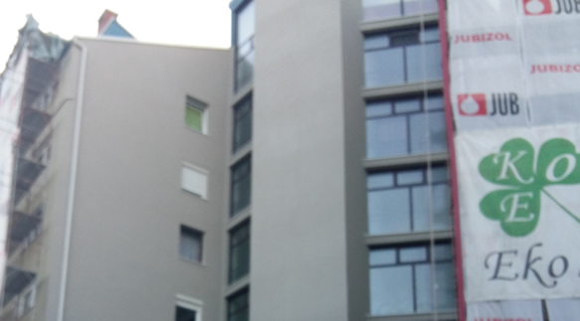
Figure 7: Standardisation of contracting procedures is important for multi-apartment buildings

Players involved:
The main players for preparation of required simplification and standardisation of procedures for contracting are:
- Office for Energy Rehabilitation of Buildings (OERB),
- Relevant Ministries,
- Already involved local communities,
- Contracting companies.

Timeframe:
The first phase of simplification and standardisation of procedures for contracting should be implemented in the period 2018 to 2020.

Costs:
The activities for required changes of the laws, ordinances, management and procedures is part of the normal work of public bodies and will not represent additional costs.

Founding sources:
In the processes for the required changes of the laws, ordinances, management and procedures, public bodies will be involved, so the founding will come from existing public budgets.

Adapted from a case of good practice:
Standardization and Simplification in Public Buildings Modernization, Lithuania
VIPA Agency signed an ELENA (technical assistance facility managed by EBRD) agreement to create project pipeline and to involve a certain number of stakeholders (Lithuanian ESCOs, public authorities and building owners participating in actual EnPC activities) big enough that they can then build on this experience and replicate the ESCO concept further. Transparent and secure framework conditions and enough demand of ESCO projects would allow a national ESCO industry to develop. The ESCO procurement is considered public-private partnership (PPP) type procurement in Lithuania. PPP project cycle was, accordingly, standardized, simplified and made shorter.

Summary table of the proposed action, timeframe and stakeholders
NUTS code: SI - level: 0 (National level)
Action | Topic(s) | Cost and funding source | Timeframe | Main stakeholders | Main activities
7. Simplification and standardisation of procedures for Contracting | A more professional approach for enabling better implementation and education | Ministry of Infrastructure  Eco Fund | 2018 - 2020 | Office OERB  Relevant Ministries  ESCO companies | Quarterly meetings with Ministry of Infrastructure and ESCOs.  Presentation and promotion of GPs.

ACTION 8 – Integration of renewable energy sources (RES) in the buildings

The background:
By the Directive on the Promotion of the Use of Energy from Renewable Resources, Slovenia assumed the obligation to achieve 25% of renewable sources by 2020 in the total energy consumption. The buildings should provide the energy for their operation from the locally available Renewable Energy Sources (RES). To all buildings is available the sun, heat and cold from the environment, to some of them also wind and biomass. Properly integrated PV on the buildings can provide much more energy as they needed for their operation.
There are already existing some Good Practices of adequate integration of PV and other RES in the buildings in Slovenia and elsewhere. There are also very many bad examples, which represents a wrong message to experts and public media.
It is very important that the RES integration, especially PV are planned at the basic architectural design of the new buildings, and at the same time when we are planning the energy rehabilitation of buildings. Even if the application of integration of RES are made in some later phase, it is important that the plans are made in advance. In majority of the cases the energy rehabilitation of the buildings is not planned at the same time with integration of the RES in the buildings.
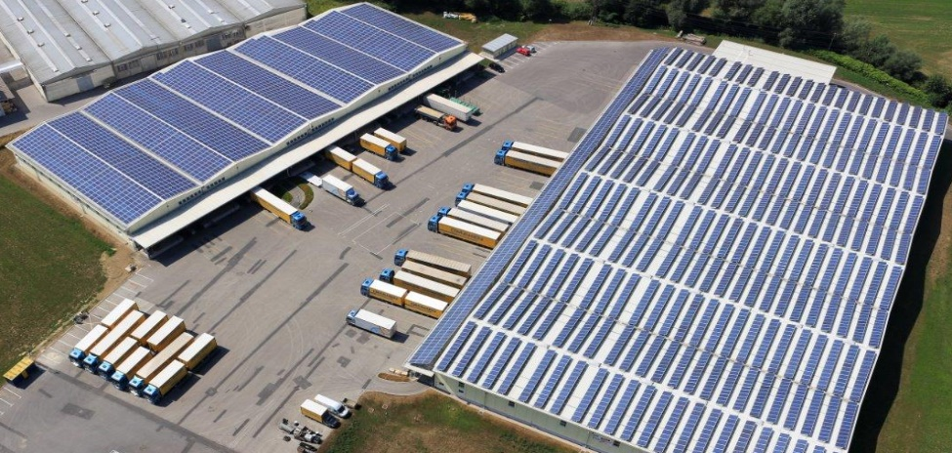
Figure 8: Example of good and non-optimal integration of PV on the building’s roof

The good practices (GP) should be well analysed, documented and widely promoted in the expert level and public media. The bad examples as well, with elaboration of negative effects.

Proposed activities:
We can see, even from the recent public tenders of the Ministry of infrastructure for energy rehabilitation of the public building, that they foresee the integration of RES in the eligible investments, but without the PV. This is a wrong message to all stakeholders in building’s energy rehabilitation. The buildings should foresee in the future as much energy as they can from the available local renewable energy sources (RES). Solar energy is available to each building, other RES are available more specifically. Well planned integration of PV modules in the building’s envelope (roofs, facades and transparent parts) can in majority of the cases, produce more energy than an individual building is requiring. That means that can foresee a part of over production of energy and sell this energy to the electrical grid for common use of the society. We are talking about energy positive buildings. In a way that such development is possible it is important that already in the conceptual architectural design of the new buildings and in the design of energy rehabilitation of building’s, that the integration of PV is part of the investment, or the buildings is foreseen for easy integration in the later future. Un-fortunately the knowledge of architects, space planners and building’s owners, is in this segment very scarce, so the big majority of implementations are bad examples. There is a need to expert work and development of obligations and guides for spatial planners and architects for the local conditions for buildings, which have to, adequately incorporate the PV integration on the buildings. Of course, there are buildings with cultural or tradition values, which are not appropriate for PV integration. Rehabilitation of such buildings without PV should be and not a norm for all buildings.
The Office for Energy Rehabilitation of Buildings (OERB), Ecological fund and the Support Centre Borzen, together with the Chamber of Architects and other expert institutions and associations should be involved in analysis of good practice (GP) approaches and widely and continuously promote the appropriate use of RES within the buildings and make attention to bad experiences, with adequate explanation.
From the BUILD2LC project partners we have learned, that regarding a proper integration of RES within and on the building, we are all in a rather initial phase. The task is involving a broad area of different experts, from the planners, architects, civil, mechanical and electrical engineers, to the photovoltaic specialists, so it is rather complex and will require a lot of common understanding and involvement, in the future design and energy rehabilitation of the buildings.

Players involved:
The main players, which should support the integration of renewable energy sources (RES) in the buildings are:
- Office for Energy Rehabilitation of Buildings (OERB),
- Relevant Ministries,
- Eco Fund,
- Chamber of architecture and spatial planning.

Timeframe:
The first phase of activities connected with better integration of renewable energy sources (RES) in the buildings should be implemented in the period 2019 to 2020.

Costs:
The activities for better integration of renewable energy sources (RES) in the buildings, is requiring knowledge and involvement of public bodies and institutions, is so part of the normal work and will not require additional costs.

Founding sources:
The processes for better the integration of renewable energy sources (RES) in the buildings, will be implemented by public bodies and institutions and the founding will come from existing public budgets.
The founding for the instruments of the commercial banks will be provided by their own sources.

Adapted from a case of good practice:
Expansion of energy infrastructure at the Higher School of Law and Public Administration using renewable sources of energy, Podkarpackie Region
Innovative installation of photovoltaic cells installed at the campus of the Higher School of Law and Public Administration in Rzeszów. It is one of the largest facilities of heat pumps and photovoltaic cells in Poland. The aim of the investment was the acquisition of electricity with a capacity of 150 KWp from solar energy using silicon technology (back-contract). The aim of the investment was also the construction of base stations for charging electric cars.

Summary table of the proposed action, timeframe and stakeholders
NUTS code: SI - level: 0 (National level)
Action | Topic(s) | Cost and funding source | Timeframe | Main stakeholders | Main activities
8. Integration of Renewable Energy Sources (RES) in the buildings, especially PV | A more professional approach | Ministry of Infrastructure  Eco Fund | 2018-2020 | OERB  Relevant Ministries  Chamber for Architects | Quarterly meetings with Ministry of Infrastructure and Eco Fund.  Presentation and promotion of GPs.

EXECUTIVE SUMMARY

The Slovenian Action Plan, within the BUILD2LC project, builds on the ideas and learnings from project partners, a wide range of stakeholders, national and European policy. Within the Action Plan we are proposing the implementation of 8 Actions, which can significantly improve the ongoing activities in the field of energy rehabilitation of the buildings and adequately contribute to the requested national targets.

Action 1: Governmental entities public buildings - Narrow public sector
Action 2: Other public buildings
Action 3: Simplification and standardisation of procedures for multi-apartment buildings
Action 4: Elaboration of EE implementation plans for multi-apartment and public buildings
by all Local Communities
Action 5: Promotion and Financial Support of EE measures for individual buildings,
with special attention to energy poverty aspects
Action 6: Support and education of architects, engineers and installers – Good Practices
Action 7: Simplification and standardisation of procedures for Contracting
Action 8: Integration of renewable energy sources (RES) in the buildings

For the implementation of the proposed Action Plan it is very important to acquire a good collaboration of the relevant stakeholders and decision makers, as it is summarised in the following table.

Name of organisation: Signature of representative of organisation: Date:

Local Energy Agency of Gorenjska Anton Pogacnik, M.Sc. Kranj, 27. 9. 2018
Director

