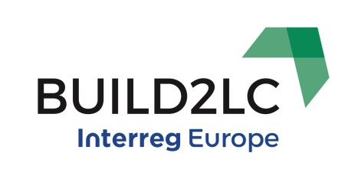**Build2LC Draft Action Plan Summary: Gloucestershire, UK**

**Note:** Please see the Full Policy Context and Delivery Plan for full details

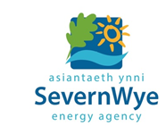

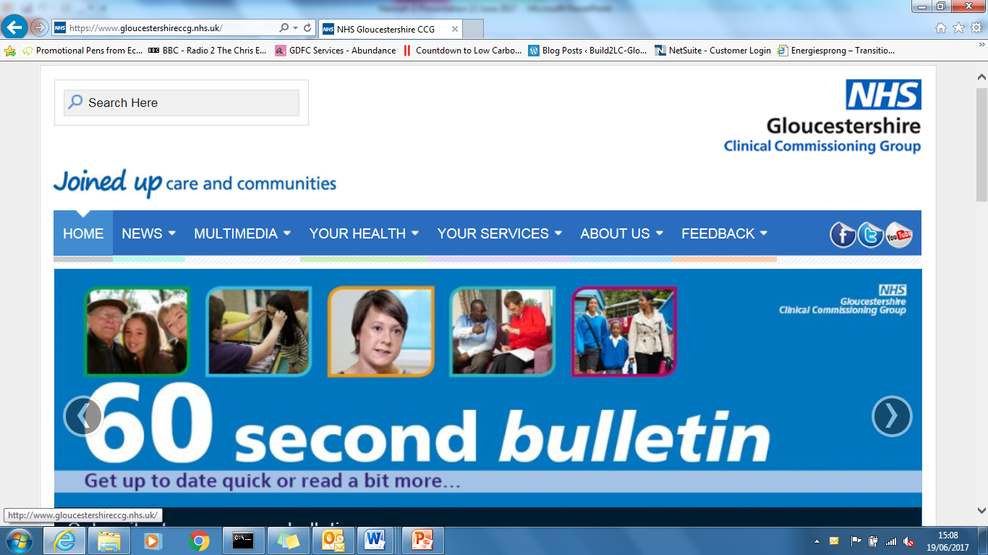

















**Risks and Issues**

* ‘**Influencing’ funds as well as the policy instrument as a whole.**
* **Aligning actions with performance indicators and measuring these.**
* Funding!
* Ensuring engagement of stakeholders.
* Ability to plan all actions in time.
* Changing priorities and timing of priorities for stakeholders.
* Changing staff within all organisations involved.
* Brexit.
* Could not hold all bi-lateral meetings with non-Build2LC partners.
* What happens if, despite best efforts, we cannot complete all actions to the full extent?