Annex 1 – Action plan template

Produced by each region, the action plan is a document providing details on how the lessons learnt from the cooperation will be exploited in order to improve the policy instrument tackled within that region. It specifies the nature of the actions to be implemented, their timeframe, the players involved, the costs (if any) and funding sources (if any). If the same policy instrument is addressed by several partners, only one action plan is required.

Part I – General information
Project: Boosting low carbon innovative building rehabilitation in European regions

Partner organization: Public Investment Development Agency

Other partner organizations involved (if relevant): -

Country: Lithuania

NUTS2 region: Lietuva

Contact person: Inga Kaliakinaitė
email address: inga.kaliakinaite@vipa.lt
phone number:+370 616 58568

Part II – Policy context
The Action Plan aims to impact: € Investment for Growth and Jobs programme
€ European Territorial Cooperation programme
• Other regional development policy instrument

Name of the policy instrument addressed: Lithuanian operational programme for the European Union funds’ investments in 2014-2020

Part III – Details of the actions envisaged
ACTION 1

- The background (please describe the lessons learnt from the project that constitute the basis for the development of the present Action Plan)

Population of Lithuania
The number of inhabitants of Lithuania is decreasing substantially over the past years, compared to the year 2010, the population has decreased by 8% in 2016. The declining population numbers are to a certain extent influenced by international migration. Lithuania has recorded substantial higher emigration numbers than immigration of persons. Especially the year 2010 when 83,157 persons left the country and only 5,213 persons registered themselves in Lithuania from abroad. The net international migration over the period 2003 to 2015 recorded a negative number of 388,590 persons. Looking at the internal migration within Lithuania, the constant trend over the past years is that more people moved into urban areas at the expense of rural areas in Lithuania. The consumption expenditures per household member per month on housing, water, electricity, gas, and other fuels accounted for 19.24% in 2012, a substantial increase compared to the ca. 13% in the years 2004 and 2008. Of the 43.74 EUR per month per household member spent on housing, water, electricity, gas and other fuels in 2012, the main expenditure is on heating with 12.91 EUR, followed by electricity (8.86 EUR). In absolute numbers, the average consumption expenditures per household member per month increased by 244% from the year 2004 to 2012.
Energy Sector in Lithuania
Lithuania’s total energy generation capacity is 4,021 MW, of which 68.6 percent is thermal plants, 25.5 percent hydropower plants, and 5.9 percent renewables. The dominant fuels are natural gas, firewood, and other wood waste fuels. Following the 31 December 2009 closure of the Ignalina Nuclear Power Plant, the country's main source of electrical power has been the natural gas-fired Elektrėnai Power Plant. Lithuania now depends on imports. As of 2012, 63 percent of electrical power was imported, and proposals have been made to construct another nuclear power plant in Lithuania. Although the country’s energy intensity fell by 50.4 percent during the period from 1995 to 2004, energy intensity per unit of GDP remains 2.5 times higher than the EU average. The National Energy Independence Strategy 2020-2050 cites energy independence as one of the country’s most important goals for 2020. Energy efficiency (EE) policies will be crucial to Lithuania’s efforts to decrease energy imports and reach its goal of energy security. The largest share of final energy consumption is the household and transport sectors at 33 percent each. Households consume the largest share of heat, namely 54 percent. District heating (DH) covers 63 percent of the total heated area in Lithuanian cities. 57 percent of district heating companies are fully owned by the municipalities. The remaining 43 percent of DH companies operate under various public-private partnerships (PPP) arrangements.
District Heating Sector DH tariffs are not fully cost-reflective, as increases in fossil fuel prices are not passed on to the consumers, which makes many DH companies not financially viable. As far as heating sector is concerned, in Lithuania all cities have well developed district heating (DH) systems, which are a heritage of planned economy times. Most of the systems are implemented more than 40 years ago and serve more than 50% of final heating demand in total, which has remained constant over the last years. Even though DH system offers several advantages over individual heating solutions, such as possibility to utilize waste heat, better environmental pollution control, higher efficiency, convenience for end-users, etc. Lithuania currently faces several issues:
1. Around 70% of DH production is based on natural gas, which is fully imported from the single country – Russia, threatening insecurity of supply. In relation to this, the current focal area is how to reduce the consumption of natural gas and thereby dependency on imports. It is restricted though by the biggest DHplants in Vilnius, Kaunas, etc., which operate natural gas CHP plants. In smaller cities though, biomass in DH production is the dominant fuel and its share is increasing constantly.
2. A significant part of district heat is produced in DH boilers, whereas the restcomes from CHP plants located in the main cities (43% and 56% of heat production in 2010 respectively). Thus, an increasing focus is being currently given to promotion of CHP plants, which produce both heat and electricity and provide substantial advantages in terms of efficiency, reduced pollution, etc.
3. An important issue in the DH sector is old and outdated distribution network, reaching the age of over 30 years. However, during the last decade modernization of DH distribution system has been carried out and heat losses have been reduced from 25.1% in 2000 down to 15.7% in 2010.
4. Too slow multi-apartment buildings renovation, residential, remains the core issue in the heating sector, which hinders improvements in energy efficiency, reduction in heat production as well as fuel dependency.
However, high energy consumption in the residential sector suggests that the energy subsidies are creating additional costs for the government. Implementing EE measures in buildings would reduce unnecessary energy consumption and help to reduce additional costs.
The Residential Housing Sector
The Lithuania’s building stock comprises of around 500 thousand residential buildings.
Residential buildings can be divided into two main groups:
- One- and two-apartment buildings (assumed to be individual houses);
- Three- and more apartment buildings (multi-apartment buildings including residential buildings for social groups).
Table 1: Lithuanian residential building sector in 2011
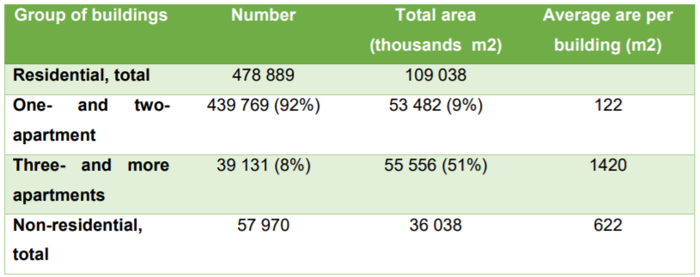

As far as multi-apartment buildings are concerned, 15% of total area belongs to 1-2 floor multi-apartment buildings, 65% of the area – 3-5 floor buildings with the rest belonging to buildings with more than 5 floors. An average area per apartment in multiapartment buildings is around 63 m2, whereas for individual houses typical area is around 122 m2. In Lithuania, 39,131 multi-apartments buildings contain three or more apartments (2012). Around 35,000 buildings were built according to the technical standard valid until 1993. One of the main features of that period is massive low-quality constructions of brick built and concrete-block multi-apartment buildings, which are characterized as being energy inefficient and tend to have low energy performance category, due to low thermal resistance of envelopes, outdated inefficient one-pipe heating systems and lack of proper ventilation. In these buildings, annual heat consumption is twice as high as in multiapartment buildings built after 1993. Differences in heat transfer coefficient values show the differences according to the building period of construction.

Table 3: Heat transfer coefficient values per building codes in force
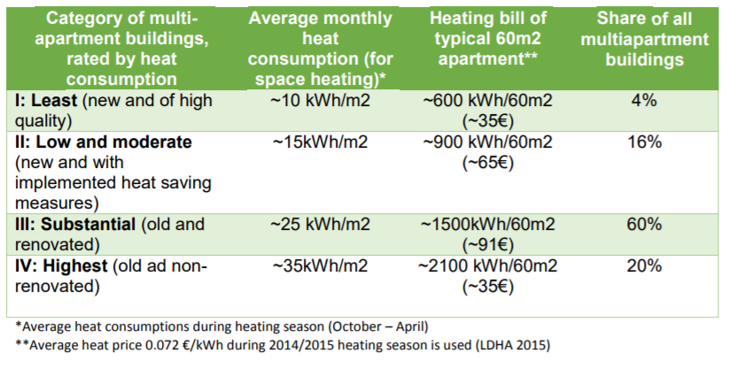
Most buildings are in poor condition and lack proper management. They haveinefficient heating systems. Average energy consumption in the residential sector was 187 kWh/m2 per year in2008; for houses built before 1993 it is 160-180 kWh/m2 per year. These figures fall below the EU averages, there is still significant potential for energy savings due to Lithuania’s lower per-capita energy use compared with EU levels. Before 2000, final energy consumption in households was decreasing by 3.5 percent each year, but it increased by 2.8 percent per year from 2000 to 2008. The total savings potential by 2020 (with 2009 as the reference year) is 17 percent of the final energy consumption. To achieve these targets will require investing approximately 870 mil. EUR to renovate the least efficient buildings, which consume about 200 kWh/m2 per year. It would require implementing following EE measures: modernization of heat substations, installation of balancing valves/controls, and individual Smart metering system in each apartment.
General Situation for Energy Efficiency Investments in Multi-apartment Buildings
During the socialist time the urban areas grew tremendously in population. Whereas in 1945 only 15% of the population lived in urban areas, in 2007 the urban areas counted more than two third of the total population. Approximately 66% of the Lithuanian population lives in multi-apartment buildings built before 1993 (more than 800,000 apartments in 38,000 multi-apartment buildings). 97% of the apartments are privately owned.
District heating (DH) covers 63 percent of the total heated area in Lithuanian cities. 57 percent of district heating companies are fully owned by the municipalities. The remaining 43 percent of DH companies operate under various public-private partnership arrangements. Heat supplied by DH accounts for 51 percent of the housing stock. 26,636 buildings receive DH heat, of which 73 percent (19,357) are multi-apartment buildings. The number of DH consumers increased from 477,462 to 657,818 (73 percent) in the period 2001 to 2012. Compared with other Nordic countries, Lithuania has very high heat consumption for all buildings.
Although the housing sector consumes 33 percent of final energies, it has the largest energy saving potential (around 48 percent according to a study of the Vilnius Gediminas Technical University). Multi-apartment buildings consume about 9.5 TWh of energy per year, but refurbished multi-family buildings can save about 4.75 TWh per year. Many of these multi-apartment buildings are in poor condition. The main problems these buildings are facing are old and inefficient heating systems and engineering equipment, big energy losses. From a recently published survey, it showed that more than 57 percent of Lithuanians households are not satisfied with their houses, mainly because of expensive heating and insufficient comfort level. The urgent need for upgrading and modernization of especially multi-apartment buildings, including the rational use of energy resources has been acknowledged by the Lithuanian government by approving the Lithuanian Housing Strategy in 2004 with a multiapartment building renovation (modernization) program. The Programme aimed to increase energy efficiency in no less than 4000 multi-apartment buildings by 2020, and to ensure that cumulative annual heating costs and return on investment cost after the renovation do not exceed the heating costs which was before renovation.
For the implementation of rehabilitation of multi-apartment buildings, the Government of the Republic of Lithuania approved Multi-apartment buildings renovation (modernization) Programme. The Programme aimed to:
- increase energy efficiency in multi-apartment buildings;
- ensure that cumulative annual heating costs and return on investment cost after the renovation do not exceed the heating costs which was before renovation.
Multi-apartment buildings modernization programme is being coordinated by the Ministry of Environment with the support from Housing Energy Efficiency Agency (HESA).
In line with this programme Deep renovation model is implemented in Lithuania. In order to achieve energy efficiency in multi-apartment buildings it is very important to give an opportunity for the final beneficiaries to install not only deep renovation measures but also the other measures such as Shallow renovation including Smart metering system.
In order to reduce heat consumption up to 20-25 percent it is necessary:
1. to balance the internal heating system.
2. to balance the hot water system.
3. To install the thermostatic valves on heating devices.
4. To install the heat cost allocators for each apartment (heat exchangers).
5. To install Smart metering system for the simultaneous display scanning from dividers and hot water meters apartment (according to 2012/27 / EU Efficiency requirements of the Directive).

Shallow renovation
The main point of Shallow renovation is the renovation of the existing heat point (unit) connected to central heating system.
With a Shallow renovation about 25% of energy may be saved and will pay off within five or eight years or even shorter time. This is the most environmentally friendly way. Additionally, after arranging heating systems and balancing the distribution of heat, the comfort conditions are improved, but the heating bill is significantly reduced.
The renovation of the heat point (unit) allows to save energy as no hot water is taken from the network and it allows to reduce the temperature of the water circulating in the network, thus optimizing the heating system.
Shallow renovation measures would include works performed only at the heat points (units). There are approx. 20% of non-renovated heat points in multi-apartment buildings in Lithuania. The main advantage of modernized heat points (units) is that they do not related to the heat supplier because control and automation measures is controlled by the internal heating system of the building, depending on the outdoor air temperature. Renovated heat point has the ability to take exact amount of heat from the heat networks, how much and when it is necessary to maintain the heating.
The benefits are twofold: increasing energy efficiency in an individual multi-apartment building and decreasing the losses of the heating networks in the supply pipelines, as it gives heat suppliers the opportunity to reduce the temperature of the supply pipe to 10-15 ºC.
Smart metering system
Increased dependence on imported energy having closed down the Ignalina nuclear power plant, soaring energy prices, obsolete and inefficient energy infrastructure (especially district heating systems, inefficient and aging buildings, old generation lighting systems have an adverse impact on the well-being of population, exacerbate the country’s energy independence and energy security problems.
Reduction of energy consumption and evasion of energy loss are one of the most important goals of the European Union, since decreasing energy consumption leads to more economic opportunities opening up. In order to reduce energy consumption and increase the efficiency of the use thereof, it is important to mobilize the public, decision-makers and market participants.
Cost-effective and efficient use of energy, reduction of adverse energy impact on the environment are one of the most important challenges and priorities of the country seeking for efficient and sustainable development of the economy. The optimization of the smart systems for energy efficiency, diagnostic, monitoring, metering and the installation of related technologies can quite significantly contribute to resolving the above-listed challenges.
In the last years, efforts to maximize energy efficiency in buildings have focused on improving the elements of the envelope -walls, windows, roofs- and on improving installations -heating, ventilation, cooling and lighting. As these energy saving measures are increased, the influence of users behavior on energy consumption is higher. Individual metering and billing for heating costs is one of the most effective solutions to intervene in such behavior. Installation of individual metering of heating is not in itself an improvement of energy efficiency of the installation, but it is a measure that promotes energy savings because it changes the way it is used the heating system and allows more efficient use of the systems.
Lessons learnt from the project
During the project bi-lateral meeting Lithuania learned from Andalusia Energy Agency (Spain) good practices. The aim of the Incentives Programme for Sustainable Construction in Andalusia managed by the Andalusian Energy Agency was to facilitate the rehabilitation of existing buildings through energy saving and efficiency and renewable energy measures and to promote a culture based on the sustainable energy rehabilitation of buildings. The Incentives Programme for Sustainable Construction in Andalusia was fully developed with the collaboration of 8.300 private companies, “collaborating partner companies” liaising in integrative public-private collaboration with the Agency in the management and processing of incentives, which facilitated the administrative procedures to request incentives by end users.
During bi-lateral meeting in Spain Energy Efficiency Companies Association (A3e) Representative presented their experience and benefits in Smart metering implementation.

- Action (please list and describe the actions to be implemented)
Multi-apartment buildings are renovated according to the Multi-apartment building modernization programme. The energy efficiency measures for the renovation are indicated in this programme and these measures are financed from Lithuanian operational programme for the European Union funds’ investments in 2014-2020 (hereafter – OP 2014-2020).
The main action will be related with modifications of the Multi-apartment building modernization programme including and supplementing the programme with measures such as:
- Shallow renovation;
- Smart metering system.
Deep renovation model will be maintained but it will be suggested to apply mandatory measures such as renovation of heating systems and (or) installation of smart metering systems in 2 cases:
- When the multi-apartment buildings are recognized as cultural heritage (e.g. are located in old town) and/or it is complicated and sometimes there are too many difficulties to install deep renovation measures (insulation of walls/roofs, replacement of windows etc.).
- When the value of multi-apartment building is very low (e.g. in the poor regions of Lithuania) and/or when there is no possibilities to evaluate or there is a high risk that all the renovated multi-apartments will be inhabited (due to high emigration rates) during the loan maturity date (up to 20 years)
Central heating with individual metering combines many of the benefits of central heating -greater efficiency- and the individual heating - flexibility- because it has individual meters that record the consumption of each resident and is billed on the basis of that consumption. As a general rule, a fixed monthly payment directed to maintenance of central heating system is done and the variable rest according to the consumption. Installation of allocators increases the motivation of inhabitants to regulate indoor temperatures and thereby reduce heat consumption. Individual metering allows the resident to lower the temperature in the apartment, and then, pay less than if the tenant chooses to have a higher temperature. In addition, individual metering compensates for the risk that the resident opens windows to lower the temperature.
Buildings supplied from a district heating network or a central source servicing multiple buildings must be equipped with a central heat meter installed at the heating exchanger or point of delivery. As regards final customers residing in multi-apartment buildings, whether such buildings are supplied from an external source or a common source within such buildings, individual heat meters for each apartment or unit in such buildings must be provided. However, the individual heat cost allocators must be installed on each radiator in the individual apartments/units of those buildings. It is very important to ensure that final customers are provided with individual meters that accurately reflect their actual energy consumption and provide information on actual time of use. Individual metering of consumption in each apartment puts tenants in control of their own bills for heating.
Smart metering automatically collects, transport, analyze and manage the data gathered from individual meters and other intelligent devices. Using a combination of digital sensors, network and data management, and advanced analytics, you can understand demand in near real time, identify and respond to outages faster, improve productivity and safety by automating tasks, and ensure compliance with regulations.
1. Smart metering data can make consumers more aware of the effect of their behavior on the consumption and can be used for automatic regulation of heat consumption.
2. Smart metering data enables development of new, dynamic and flexible business models.
3. Smart metering data makes it possible to monitor the state of the existing district heating network in real time. This is highly valuable for the operation the network. For example, it is possible to identify, where an effort to reduce heat loss has the highest value.
4. Smart metering data enables efficient and robust choices in the designing of new district heating networks.
The proposals of the amendments of the Multi-apartment building modernization programme will be presented to Ministry of Finance, Ministry of Environment and Housing Energy Efficiency Agency (HESA).

- Players involved (please indicate the organizations in the region who are involved in the development and implementation of the action and explain their role).
Ministry of Finance – is the Managing Authority and is in charge of the implementation and coordination of OP 2014-2020.
Ministry of Environment - is Executive Authority of the OP and is in charge of the implementation and coordination of the Multi-apartment building modernization programme.
Housing Energy Efficiency Agency (HESA) - provides consulting services and assistance for homeowners on matters related to the renovation (modernization) of multi-apartment buildings. It also evaluates and approves submitted investment plans and procurement documents, cooperates with municipal authorities, engineering consultancy companies, educational institutions, non-governmental organizations, etc.

- Timeframe
2018- 2019______________________________________________________________________________________________________________________________________________________________

- Costs (if relevant)

____________________________________________________________________________________________________________________________________________________________________________

- Funding sources (if relevant):
____________________________________________________________________________________________________________________________________________________________________________

Date:____________________

Signature: _______________________

Stamp of the organization (if available): ____________________________________

