The Ivace and Aidimme will provide arguments for the National Circular Economy Strategy through the TRIS initiative

04/12/2018
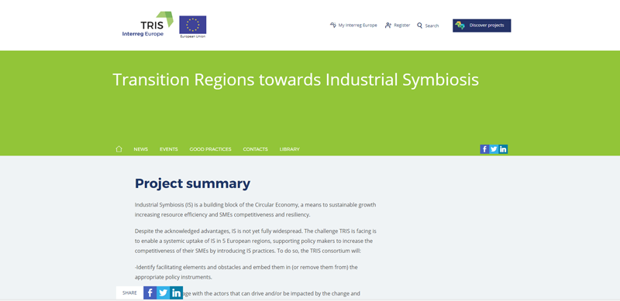
News archive of the IVACE

The Valencian Institute of Business Competitiveness, Ivace, and the Aidimme Technological Institute, as representatives of the Valencian Community, are developing, together with specialists from four European regions, the Transition Regions Towards Industrial Symbiosis (TRIS) project.

The TRIS project will provide arguments for the future Circular Economy Strategy.

It is an initiative that, in addition to the benefits in key areas such as the production and management of industrial waste, efficient production processes, access to innovative production technologies and processes, and the launch of new business lines and new markets, will provide arguments for the future National Circular Economy Strategy.

One of the main actions of the project is to sit down in work sessions (IS labs) to the different competent actors and find ways to overcome these challenges.

Pilot tests during 2018
A specific study on the subject reveals that Pan-European Industrial Symbiosis would generate 3 trillion Euros in additional sales and cost savings for Europe, along with important environmental benefits.

Manuel Sánchez, responsible for the project in Aidimme, highlights "the importance of breaking with the linear model of economic growth, proposing a change towards the circular economy, which seeks to close the circle of economic activities taking into account all phases of the cycle of life of a product: from production and consumption, to the management of waste and the market of secondary raw materials ".

Currently, the Ivace and Aidimme are working on the possible completion of pilot tests throughout 2018, with the intention that the development of incentive measures take place in 2019, in areas such as matching the interests of companies, intermediation in industrial areas, feasibility studies prior to the R & D activities and the implementation actions themselves, carried out in the cooperation modality.
Please follow the link to read the full submission - http://www.foroadr.es/todas-las-noticias/9563-el-ivace-y-aidimme-aportaran-argumentos-para-la-estrategia-nacional-de-economia-circular-mediante-la-iniciativa-tris

