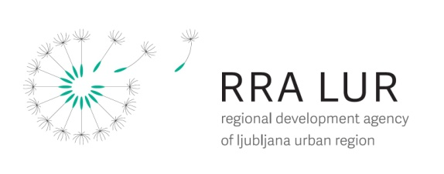

Project CRE:HUB

“Policies for Cultural Creative Industries: the Hub for Innovative Regional Development”

Workshop for the presentation of measures to strengthen the cultural and creative sector

Date: 18th May 2018
Location: City Hall, Mestni trg 1, 1000 Ljubljana, Slovenia
Time: 10:30 till 13:30

The workshop was held in the cooperation with decision and policy makers to verify the feasibility of proposed measures that were developed in collaboration with cultural and creative sector stakeholders from the region. First part of the workshop was dedicated to the presentations of the: 1) CRE:HUB project, 2) findings of regional and SWOT analysis, 3) Roadmap document, 4) best practices and 5) measures proposed by stakeholders.
In the second part of the workshop the participants who were the representatives of the ministries and representatives of Centre for Creativity verify the feasibility of the measures and proposed the possible implementation.

Prepared by: Tina Pezdirc Nograšek, project manager for RRA LUR/22.5.2018;

