DOSSIER
8th INTERREGIONAL EVENT
CEiiA, Portugal
10 – 11 May 2018
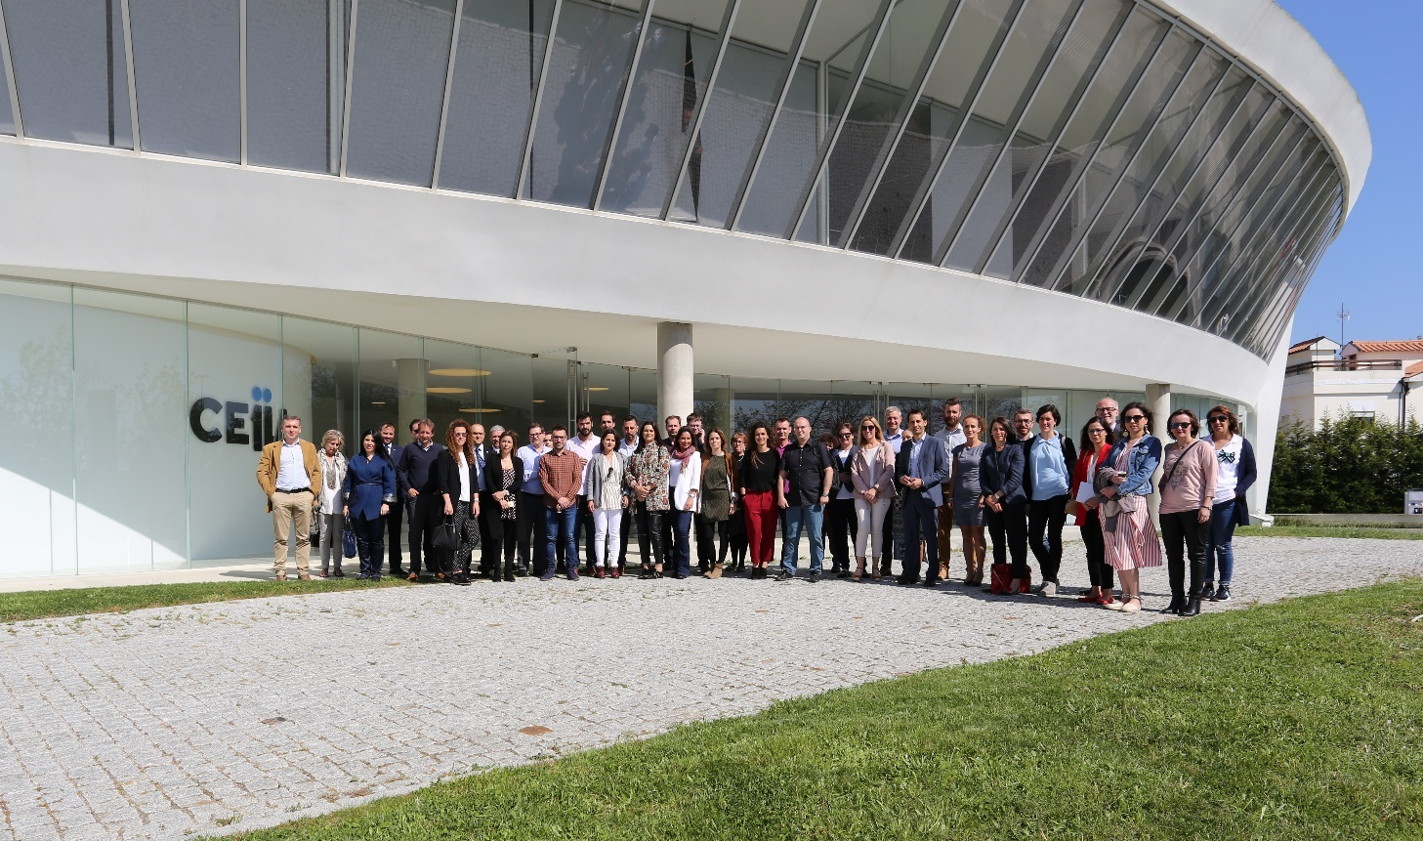

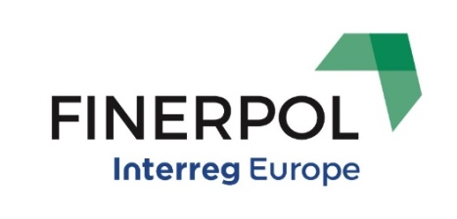
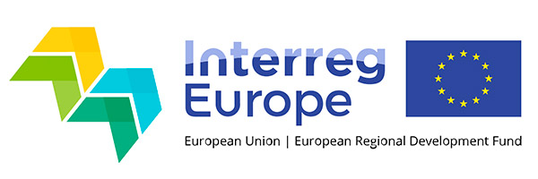

INDEX
Introduction 3
8th interregional event summary 4
Agenda 5
Public seminar “financing energy efficiency in urban rehabilitation” 8
Learning camp 15
INTRODUCTION

Buildings account for 40% of energy use and 36% of CO₂ emissions in the European Union with older buildings being up to 20 times less energy efficient than new builds. Currently about 35% of EU buildings are over 50 years old. Increasing investment in energy efficiency and renewable energy for buildings is a major challenge to meet European Union targets to reduce carbon emissions. However, austerity measures and a more risk-averse investment climate have slowed the rate of investment considerably.
The Financial Instruments for Energy Renovation Policies (FINERPOL) Project aims to promote energy policies oriented to increase energy efficiency of existing stock, by improving access to investment finance. It is supported by the European Regional Development Fund provided through the Interreg Europe Programme.
The first phase of the project is now finished. During this phase partners and stakeholders exchanged experience in an interregional learning process, which led to the development of 7 regional Action Plans to overcome barriers to the energy retrofit of public and private buildings and public lighting, making use of EU funds and other sources, to attract investment in energy efficiency renovations. For the next two years, each partner will implement the proposed actions and monitor the results.
FINERPOL is a partnership project of six European countries, with Spanish company Extremadura Energy Agency as Lead Partner.
Project partners:
- AGENEX - Extremadura Energy Agency, Spain
- General Direction of Industry, Energy and Mines, Extremadura Regional Government, Spain
- Plymouth City Council, UK
- Western Macedonia Region, Greece
- City of Prague, Czech Republic
- University Centre for Energy Efficient Buildings, Czech Technical University in Prague, Czech Republic
- CEiiA – Centre of Engineering and Product Development, Portugal
- Autonomous Province of Trento, Italy

8TH INTERREGIONAL EVENT SUMMARY

On May 10 and 11, the cities of Matosinhos, Porto and Vila Nova de Gaia hosted the event that marked the end of the first phase of the FINERPOL project.
The event brought together project partners, stakeholders, local, regional, national and European management entities in the thematic areas of housing, energy and urban rehabilitation, as well as entities of the financial sector, addressing the financing of investments in energy efficiency.
On the morning of the 10th, an internal project meeting took place, where the partners shared the status of project outputs, including Good Practices, Ex-Ante Assessments and Action Plans. Strengths and weaknesses of the Learning Process were identified and financial and communication issues were discussed.
CEiiA - Centre of Engineering and Product Development - City Lab, as a project partner, promoted a public seminar on “Financing Energy Efficiency in Urban Rehabilitation”, in the afternoon of the 10th, in its facilities. Several financing modalities were presented, as well as examples of successful implemented projects, from different European regions.
On the morning of the 11th, partners and stakeholders gathered for a Learning Camp promoted by AGENEX, the Lead Partner. Through group dynamics, all participants had the opportunity to reflect on the Action Plans presented by each partner.

AGENDA
10 May (Thursday)
Venue: Av. D. Afonso Henriques, 1825, 4450-017, Matosinhos (CEiiA)

Project meeting

09:30 – 09:35 Welcome message by the Lead Partner
09:35 – 10:00 Project management
Information on Progress Reporting
Actual financial status
Evaluation
10:00 – 10:45 Phase 1 Activities Summary
Best Practices / Good Practices
Ex-ante Assessments
Action Plans
Sharing experience
10:45 – 11:15 Phase 2 Activities
Phase 2 Monitoring Methodology
Next steps
11:15 – 11:45 Coffee break
11:45 – 12:15 Project communication
State-of-play
Phase 2 dissemination strategy
12:15 – 12:30 Conclusions
12:30 – 13:00 Learning Camp introduction
13:00 – 14:00 Lunch
Public Seminar “Financing Energy Efficiency in Urban Rehabilitation”

13:30 – 14:00 Reception and registration
14:00 – 14:05 Welcome by CEiiA
14:05 – 14:40 Housing and Energy Renovation Policies
New generation of housing policies in Portugal – Ana de Campos Cruz (IHRU)
Energy Efficiency in Urban Rehabilitation – Ana Santos (DGEG)
14:40 – 16:30 Financing Energy Renovation
NORTE 2020 – Northern Region Operational Programme - Fernando Gomes (CCDR-N)
GoParity - Luís Couto (GoParity)
Debate
Innovative energy efficiency services and Energy saving fund - Jaroslav Klusák (City of Litoměřice, Czech Republic)
Suitable financing models for public lighting investment - Miroslav Šafařík (PORSENNA o.p.s., Czech Republic)
Debate
16:30 – 16:45 Coffee break
16:45 – 17:45 Energy Renovation Good Practices and related projects
Vila d’Este district - Carla Pires (Gaiurb)
Rainha D. Leonor social housing neighbourhood - Vasco Peixoto de Freitas (Vasco Peixoto de Freitas, Lda)
“Casas Em Movimento” in the context of the Living Lab Matosinhos - Guilherme Silva (Casas Em Movimento) and Catarina Selada (CEiiA)
Bruno Kessler Foundation - Luigi Crema (Bruno Kessler Foundation, Italy)
17:45 – 18:00 Closing session
20:00 Dinner

11 May 2018 (Friday)
Venue: Cais da Estiva, Porto

9:30 – 13:00 Learning Camp
Financial Instruments
Action Plans
Monitoring Methodologies
13:00 – 15:00 Lunch

PUBLIC SEMINAR “FINANCING ENERGY EFFICIENCY IN URBAN REHABILITATION”

The seminar was opened by Helena Silva, Chief Technical Officer at CEiiA, who explained the evolution of CEiiA's scope of activity over the last 12 years. CEiiA was created with the goal of supporting the competitiveness of the Portuguese automotive industry. Since then, CEiiA enlarged the activity, and is now focused on aeronautics, mobility, naval/offshore and automotive.

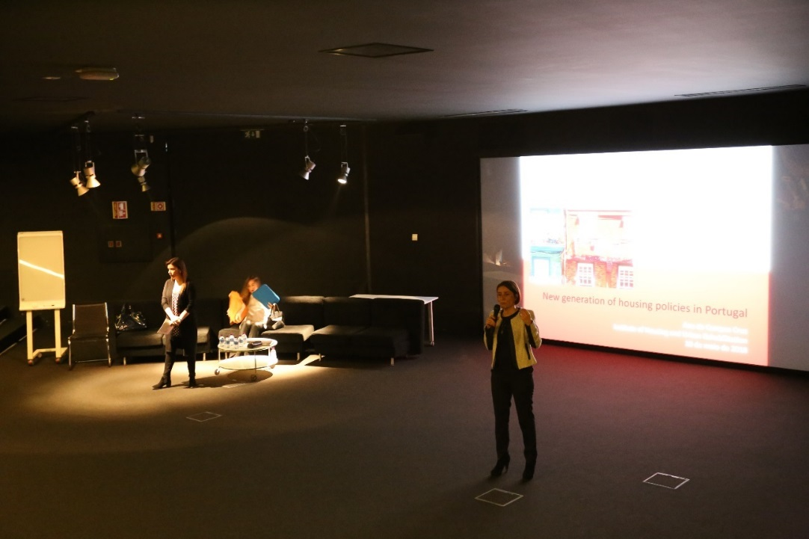

Ana de Campos Cruz, from the Portuguese Institute of Housing and Urban Rehabilitation presented the New Generation of Housing Policies that is being implemented in Portugal, namely the motivation for its implementation and the financial instruments created under its scope. The presentation then focused on the Reabilitar para Arrendar – Habitação Acessível (Rehabilitate to Rent – Affordable Housing) Programme, which aims to finance (through loans) the rehabilitation of buildings with an age equal to or greater than 30 years, which, after rehabilitation, should be destined predominantly for housing purposes. The programme purpose, funding sources, eligibility criteria, financing conditions, application process and results were described to the audience.
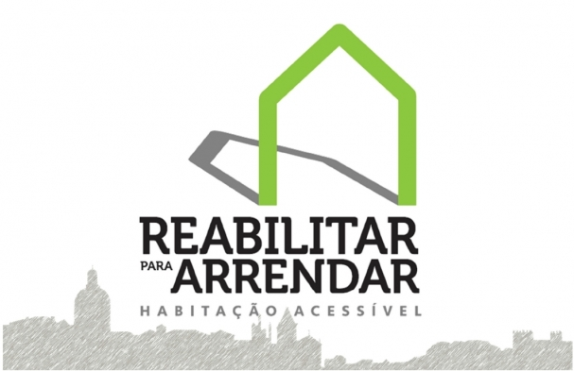
Ana Santos, from the Portuguese General Directorate of Energy and Geology, presented the Portuguese energy targets and the actual Portuguese situation in terms of dependency on energy imports, energy consumption, energy efficiency investments, building stock state of conservation, energy certification. IFRRU 2020 and “Casa Eficiente 2020” (Efficient House 2020) were also mentioned as two recently created financing instruments with great potential.
IFRRU 2020 - Financial Instrument for Urban Rehabilitation and Revitalization - mobilizes the appropriations approved by the Regional Operational Programmes and the Operational Programme for Sustainability and Efficiency in the Use of Resources (PO SEUR), of PORTUGAL 2020, with the objectives of revitalizing cities, supporting the physical revitalization of space dedicated to disadvantaged communities and to support energy efficiency in the housing sector. The appropriations also include those from the European Investment Bank (EIB), the Council of Europe Development Bank and financial management entities (Santander Totta, BPI and Millennium BCP), which provide the financial products (loans or guarantees) through which urban rehabilitation operations are financed.
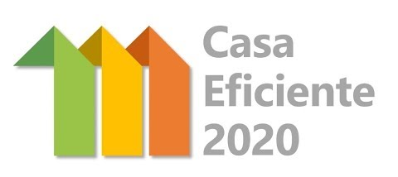
The "Casa Eficiente 2020" Programme aims to provide loans on favourable terms for operations that promote the improvement of the environmental performance of private housing, with a focus on energy and water efficiency, as well as on urban waste management. The programme is financed by EIB and the participating commercial banks (Caixa Geral de Depósitos, Millennium BCP and Novo Banco).
Fernando Gomes, from the Commission for Regional Coordination and Development of Northern Portugal, presented de Regional Operational Programme, with a special focus on the Investment Priority 4.3 "Supporting energy efficiency, smart energy management and the use of renewable energy in public infrastructure, including public buildings and the housing sector", which is the one addressed by CEiiA in the scope of the FINERPOL project. Some of the fragilities identified for this programme, notably through contributions from local stakeholders, were mentioned as well.

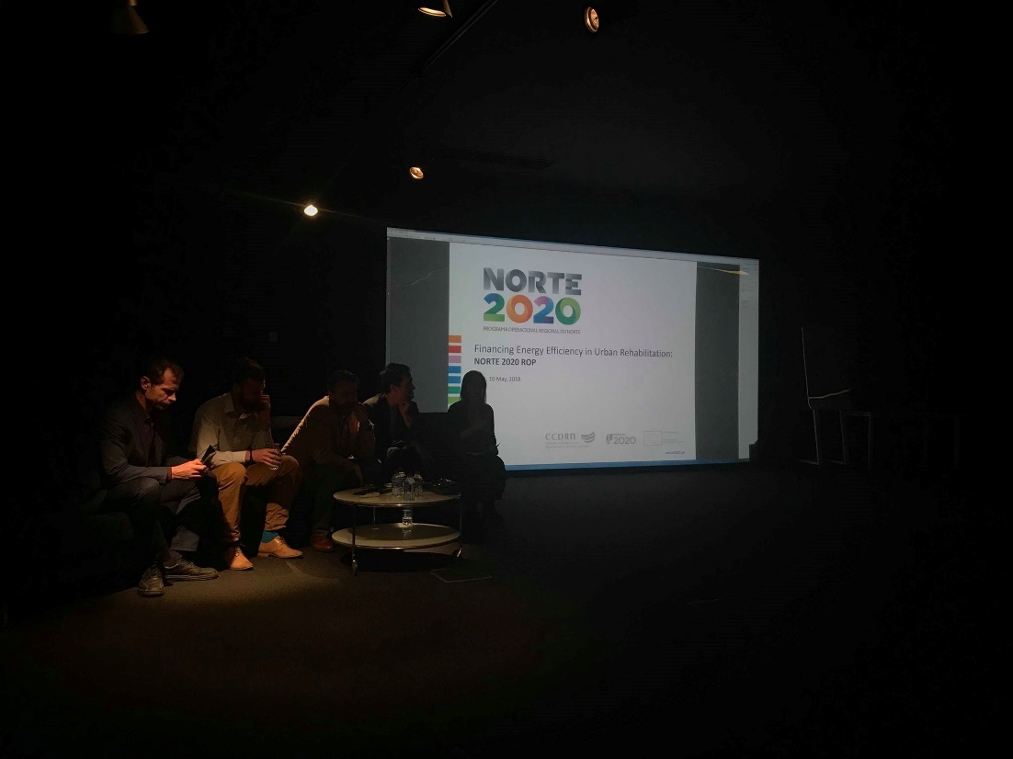

Luís Couto presented GoParity, an online Peer-to-Peer lending platform that connects citizens and impact investors with sustainable projects offering competitive returns. By combining organizations interested on energy efficiency and/or renewable production, with investors and the best field technicians on the market, this platform, using an alternative finance model (crowdfunding), is shaping a new economy that leads the way to energy independence, job creation and sustainable development.

Jaroslav Klusák introduced the H2020 INNOVATE project and shared the experience gained with the local Energy saving fund of the City of Litoměřice, in Czech Republic. The INNOVATE project aims to overcome market barriers to deep energy-efficient retrofits of private housing stock by developing and rolling out integrated energy efficiency service packages targeting homeowners in 11 target territories from 10 EU Member States.
Miroslav Šafařík, also from Czech Republic, presented a review of the existing financing models, including self-financing (regular municipal budget), debt-financing (very low long term loans available), third party financing (EPC model), subventions (National or European Funds) and project financing (contracting etc.). Some practical examples of public lighting retrofitting across Central Europe and a pilot installation of dynamic control of public lighting in Czech Republic were also shared.
Carla Pires, from Gaiurb, the entity responsible for Urbanism, Social Housing and Urban Rehabilitation of the Municipality of Vila Nova de Gaia, Portugal, presented the Vila d'Este project, a large-scale energy renovation project of a densely populated neighbourhood, funded by the previous Regional Operational Programme. After the renovation, the indoor temperature of the apartments is always above 18ºC, which is the considered comfort temperature in the Portuguese thermal regulation, for the winter.

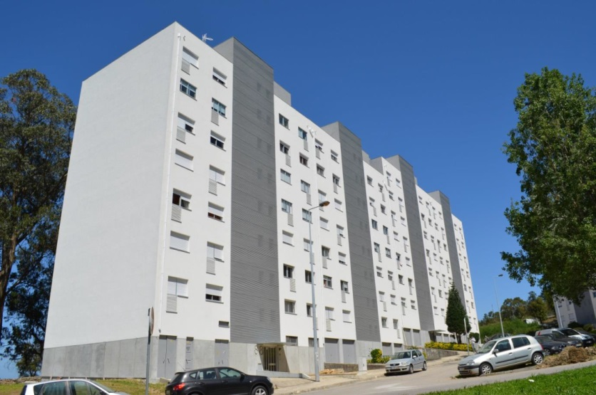

Vasco Peixoto de Freitas presented the Rainha D. Leonor project, which will make this neighbourhood in the Municipality of Porto the first A + energy class neighbourhood in Portugal. The winner of the public tender will build high quality social housing that will resettle all the current residents and in exchange can later build a private housing block whose sale will follow the current real estate values, thus financing the project.

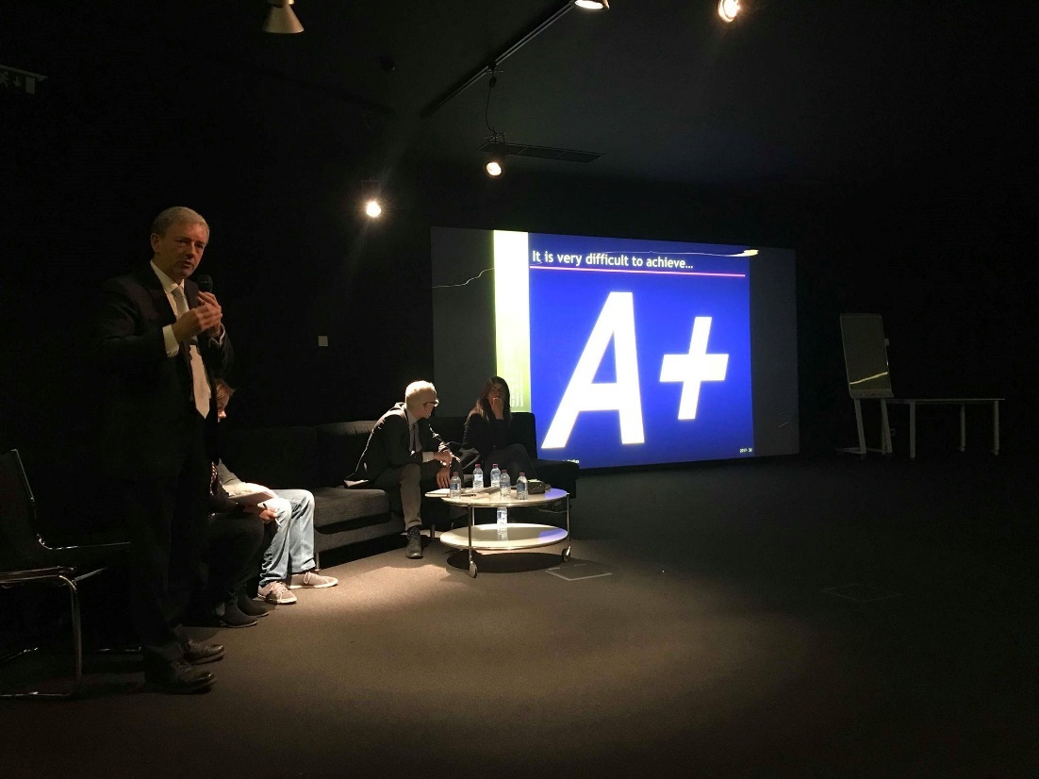
Catarina Selada, from CEiiA, presented the Living Lab Matosinhos, and Guilherme Silva presented “Casas em Movimento” (Houses in Motion).

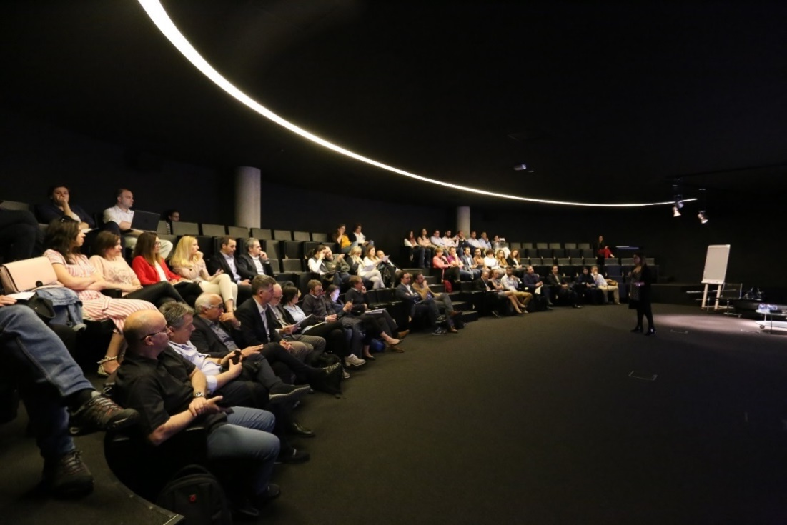

A Living Lab is a space for testing, experimenting and demonstrating, technological, organizational and social solutions in real-life context oriented towards the decarbonization of the city. The Portuguese government launched, in 2017, a call for proposals for the creation of living labs in case-study cities and the Municipality of Matosinhos was one of the winners of this challenge. “Casas em Movimento” is one of the partners associated to the Living Lab Matosinhos. Casas em Movimento is a world-innovator company for rotational buildings. It embeds a new concept of living architecture, which integrates innovation and sustainability. The movements of the structure can result from following the Sun (production of energy in average 5 times superior to the house’s needs) or from direct control of its user.

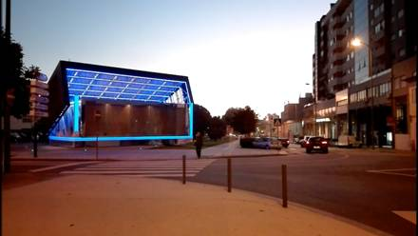

Luigi Crema, from the Bruno Kessler Foundation, Italy, presented the activities developed in Applied Research on Energy System (ARES). ARES promotes R&I on new energy solutions and aims at transfer them to the market collaborating with partners at industrial and territorial levels.

LEARNING CAMP

Each partner presented its Action Plan to the remaining partners and stakeholders, giving the motivations and objectives to be achieved with its implementation.

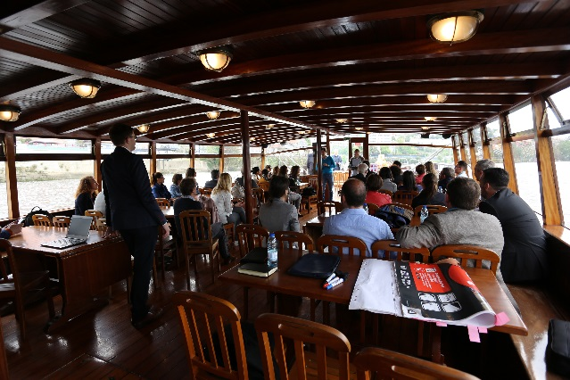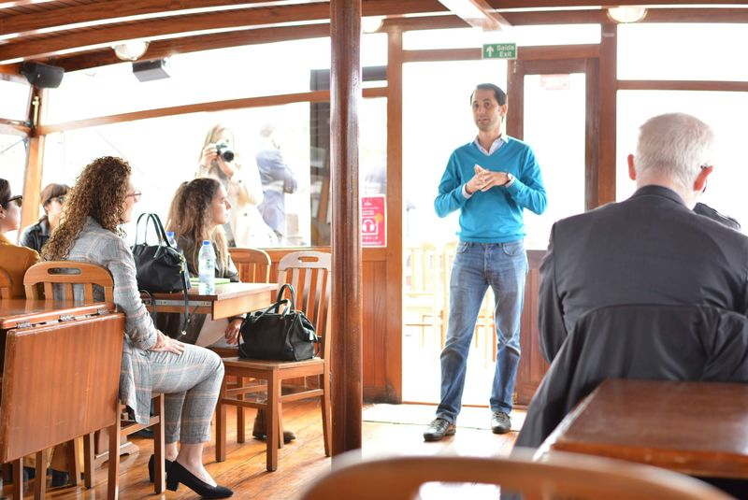
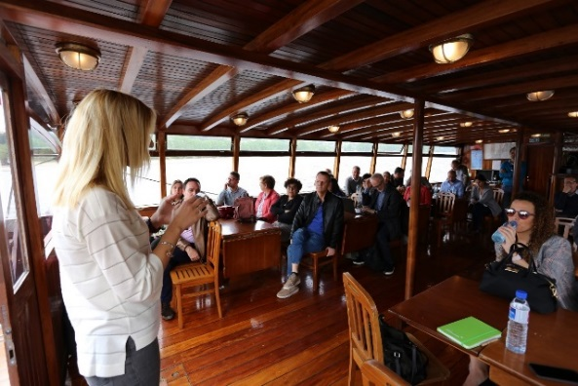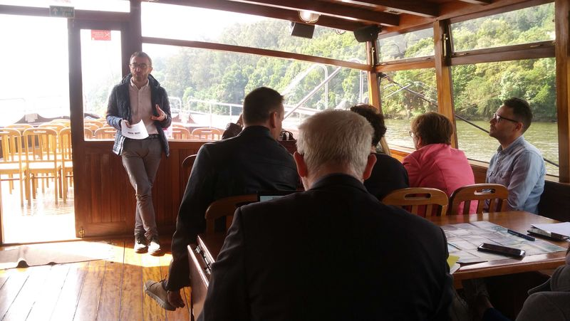
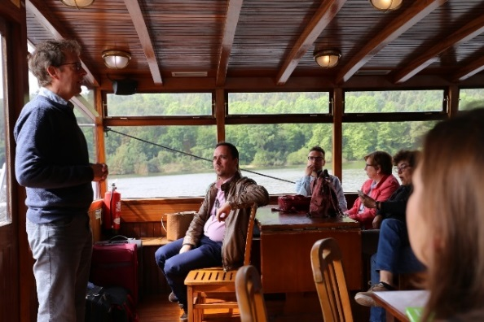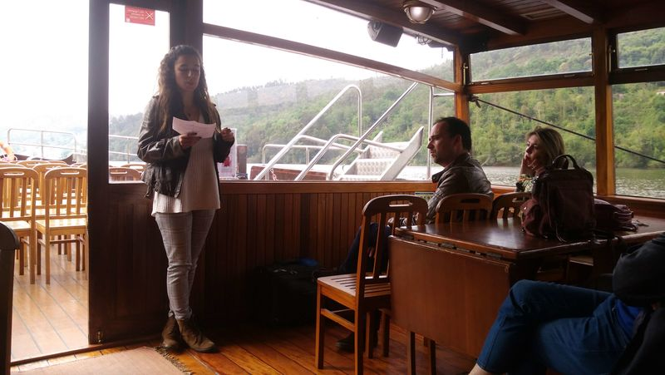
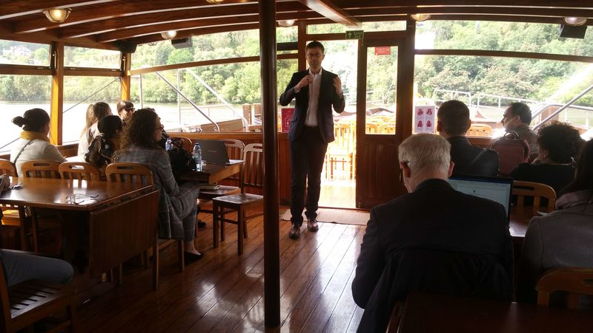
Seven groups were formed, with one representative from each partner at each group. Seven sheets, corresponding to the seven Action Plans, were distributed among the groups, with the following topics:
- Advantages/ Innovation
- Disadvantages/ Risks
- What to do better?
- Energy Efficiency Suitable/ Other Use
- Possible Partners
- Probability of implementation
- Target Groups
- Positive Influence/ Impacts
- Motivation
The sheets were passed from table to table so that each group filled out a different topic for each action plan.

