Policy Clinic Report – San Sebastian 24-26 October 2017
The policy instrument:
Basque Country Regional Operational Programme 2014-2020.
The policy clinic theme:
Eco-systems
The change the city is seeking to make:
Project and governance changes.
The city challenge set for the policy clinic:
“ECO-SYSTEMS: Developing a common approach to collaborative making and urban manufacturing with educational institutions, Universities and Vocational Training institutions
List of attendees:
Name | Organisation | Name | Organisation
Steve Harding - Director | BCU | Lloyd Broad | Birmingham City Council
Laura Veart - Project Manager | BCU | Iain Mansell | GBSLEP _ stakeholder
Tom Cahill-Jones - Policy Expert | BCU | Ian Hill | Birmingham City Council - Expert
Helena Cvenkel | BSC Kranj | Heather Law | Birmingham City Council
Jozef Lavička - support officer | Bratislava City Council | Ainhao Aldasoro | Fomento de  San Sebasatian
Katarína Fajčíková - policy researcher | Bratislava City Council | Yesenia Otamendi | Fomento de  San Sebasatian
Michela Michilli | Lazio Region | Renata Lisovska- Urbanovič | Vilnius City Council
Valentina Diana | Lazio Region | Rūta Matonienė | Vilnius City Council
Andre Martins | Lisbon City Council | Lina Koriznienė | Vilnius City Council
Jelena Marković | Zagreb City Council | Justina Užumeckaitė | Vilnius City Council
Frane Šesnić | Zagreb Stakeholder
Kristian Ravić | Zagreb Stakeholder

Summary of Policy Clinic Agenda
DAY 1
- WELCOME AND INTRODUCTION TO THE POLICY CLINIC

- PRESENTATION OF POLICY CLINIC CHALLENGE

SESSION 1
- Innovation and Talent Strategy San Sebastian: A new innovation model Mr. Euken Sesé Sarasti, Managing Director of Fomento San Sebastian

SESSION 2
- Donostia Innovation League – challenge with schools. (FSS) Case study and World Café http://www.fomentosansebastian.eus/donostiaopeninn/es
SESSION 3

- Study Visit to WeekINN Technology Pop-Up Tent: collaborative and demo space for entrepreneurs, companies, students.
DAY 2

SESSION 4

- REFLECTIONS ON DAY 1 (Tom Cahill-Jones presentation)

- EACH PARTNER PROVIDES ONE ACTION FOR SAN SEBASTIAN

Partner Discussion
Session 1 Summary
Mr. Euken Sesé Sarasti, Managing Director of Fomento San Sebastian gave a summary of the organization and the eco-system in San Sebastian.
Fomento is the economic development agency of the city which is 35% funded by the city council.
• Population of the city is 186,000
• 19,000 companies
• Low unemployment
• 87% service sector
• 31.6% graduates
• 2 million tourist a year
• R&D worth €195 million with strong innovation agenda
• Ambition to link innovation agenda with tourism

Session 2 Summary
Summary of the conclusions from the world cafe session on the contribution of education to the innovation eco-system.
Interaction with schools
-Key message was to develop beyond projects into sustainable relationships and to work out funding models to make this happen.
-Consider opening up co-working facilities to include young people and to link with incubators. Consider pop up spaces or tents in schools.
-Libraries of the future could be new maker spaces. Start collaborative working and learning young - good strategy.
- Develop skills in both “traditional” and new areas such as computer coding to reflect what industry wants.
-Try to find space to do this in the curriculum.

Tertiary, Third Sector & Vocational Education
Key responses:
- Diverse range of “third” places providing training and how to best resource these spaces
- Include youth centres, libraries, community organisations and NGOs
- Focus on the “river idea” as a theme
- Role of libraries and digital learning in the city
- Consider providing a formal qualification based on practical experience around Innovation participation - Example of Google Garage and certificate in digital skills
- Training those who train in this space
- How to bring synergies with requirements of formal learning in schools and universities
- Social dimension - build up social capital in communities
- Focus on “Challenges” linking schools, universities and citizens

Universities
San Sebastián growth sectors to focus on:
• Medical devices
• Close to market Innovation
• Testing and prototyping
• Hydrogen fuel cells
• Experimentation

- The concept of design thinking could be a lever to enable closer working with Universities
- The idea of “curiosity” as a key driver for academics
- Consider STEAM approaches
- Focus on skills and enterprise in universities
- Skills focussed on learning by doing at undergraduate and post graduate levels
- Eco systems in the city where learning by doing is key
- Teacher training and supporting the learning by doing approach and introducing city and /or Company challenges
- Collaborative projects San Sebastian and universities
- Focus on city challenges
- Apply for Funding on joint projects which are collaborative in nature
- Building the eco-systems together
- Culture change in universities may be needed
- Invest in personal relationships
- Seek funding to free up academic time
- Focus on these aspects and respect regulations within the sector

Actions and Synthesis of findings
Agreed policy actions for the host city and partner cities
- Rome
For San Sebastian:
- Gather the three innovation projects (from Innovation League)
- Exhibition to attract stakeholder
For Rome: Design thinking approach to TIBER river
- Vilnius
For San Sebastian:
- City as a customer creating demand for technical solutions
- Signing supply agreement with universities
For Vilnius: Seed funding for informal education and after school activities
- Bratislava
For San Sebastian:
- Interconnections between young people, science, public and companies
Bratislava: How to involve young people in the innovation eco-system
- Zagreb
For San Sebastian
- Mobile living labs
- More engaged silver economy – Peer to peer and train the trainer
- Young and old engaged in digital
- Collaborative budget
- Innovative Procurement
For Zagreb: How to involve young people
- Birmingham
For San Sebastian:
- Change the culture (not just PR)
- Eco-system – more receptive to universities with schools
- Public services - innovate (i.e. start at home)
- Communications – funding vision and sectors to attract talent
- How to sell businesses to young people
For Birmingham: How to make business more innovative. Low skills and high unemployment.
- Lisbon
For San Sebastian:
- Increase participation of citizens
For Lisbon: Overcome tourism economy, move to knowledge and innovation economy at a younger age.
- Kranj
For San Sebastian
- Involve citizens in scoping of challenges
For Kranj: Importance of Industry and services not just beauty. How to involve citizens in the process

BCU Reflections Summary (link back to ERDF policy changes and makerspaces)
BCU notes the challenges that exist in connecting Fomento with educational institutions.
These include one-off funding which could cause projects to appear impermanent; the difficulty in identifying those topics that resonate with schools, universities and vocational training institutions; the lack of an impactful evidence base for collaborative making; the lack of shared understanding of how collaborative making could be supported in San Sebastian; the difficulty in finding space within university schedules.
BCU also acknowledges the need to retain and attract talent.
Considering the actions presented by the partners attending the policy clinic, BCU feels that the following points should be considered:
In order to improve governance of the policy instrument, to better support collaborative making.
Concentrate on building an evidence base with strategic partners, showing the impact of collaborative making.
Example: invite university researchers to undertake a specific study that results in data to support future investment
Result: Policy is informed, resources are more effectively allocated and the university sector feels integral to the process
Develop mutually beneficial relationships with universities, civil society, and the maker community.
Example: holding meetings, workshops or discussion groups on the premises of universities and maker spaces. Inviting open discussion of topics allowing input from different perspectives.
Result: universities and maker spaces feel more able to approach Fomento with new ideas and shared projects.
Acknowledging the excellent work already being undertaken by Fomento, identify ways to mainstream the activities concerned with making.
Example: on proving the benefits of the Donostia project in achieving the city’s strategic aims, bid for core funding to sustain and grow the activities, turning the project into an ongoing programme reaching a wider stakeholder group.
Result: making becomes embedded in the strategic direction of the city and related activities can be promoted more effectively. If funding is secured from educational ministries, making becomes a driver for skills development and retention.
Create a participatory budget, with the aim of funding projects in which making can provide solutions to issues that matter to San Sebastian’s community.
Example: a place or sector in need of development identifies a challenge being faced by their community. Fomento opens a portion of their budget to the people concerned and invites them to vote on how it should be spent, with options focused on activities promoting the societal cohesion brought about by collaborative making.
Result: the community feels empowered and making is seen as a possible way to improve local issues.
Suggestions for new projects funded by the policy instrument (these could be considered for inclusion in the proposed programme)
A project which seeks to develop innovative thinking across topics shared by Universities, schools and SMEs.
Example: a project which supports the development of digital health technologies
Result: universities complete research, pupils learn skills that help future employment, SMEs create products and prototypes that lead to commercial success.
A project which promotes the benefits of design thinking.
Example: a series of workshops are held in which citizens learn about the benefits of solving problems from a user perspective. The workshops include development of skills around creativity and the practical resolution of problems.
Result: citizens feel more able to prototype and imagine solutions to challenges.
A project which places talented makers within organisations that don’t usually employ makers.
Example: an engineering company takes a person trained in sculpture on secondment. The person selected was suggested by a university, school or vocational institution.
Result: Through being exposed to a different perspective, the company alters its product line, generating new business.
An exhibition that promotes the great activity already being undertaken by San Sebastian’s makers.
Example: Fomento invites a University expert to help curate a Maker Faire. A portion of the exhibition focuses on making within schools.
Result: Links are established between Fomento, universities and schools. Making becomes accessible to young people and students.

Photos of policy clinic and study visits

Figure 1 Talent House venue for Policy Clinic
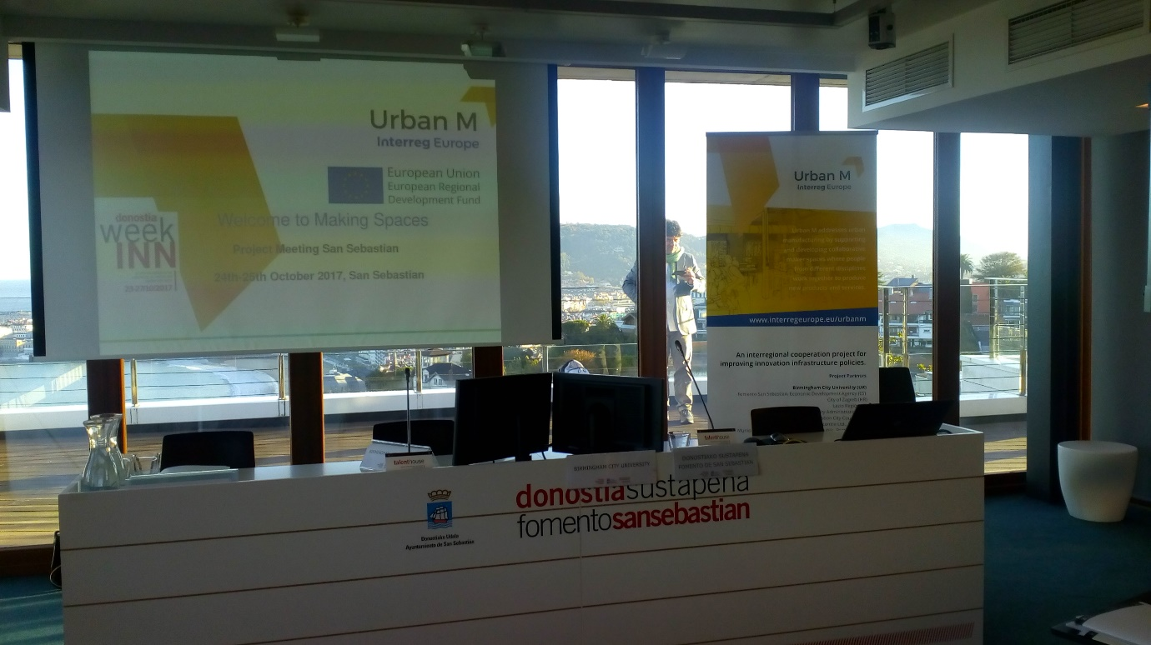
Figure 2 Policy Clinic meeting
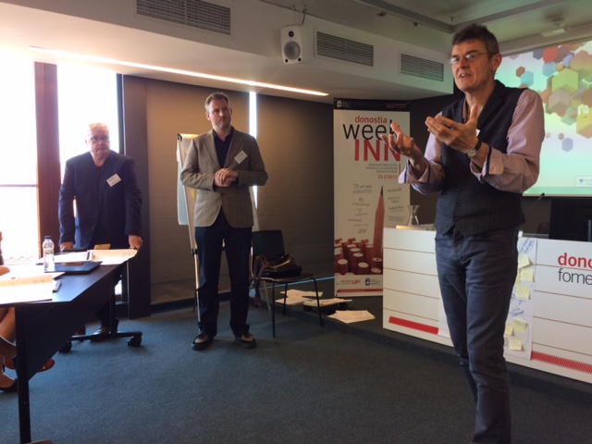

Figure 3 Innovation League presentation
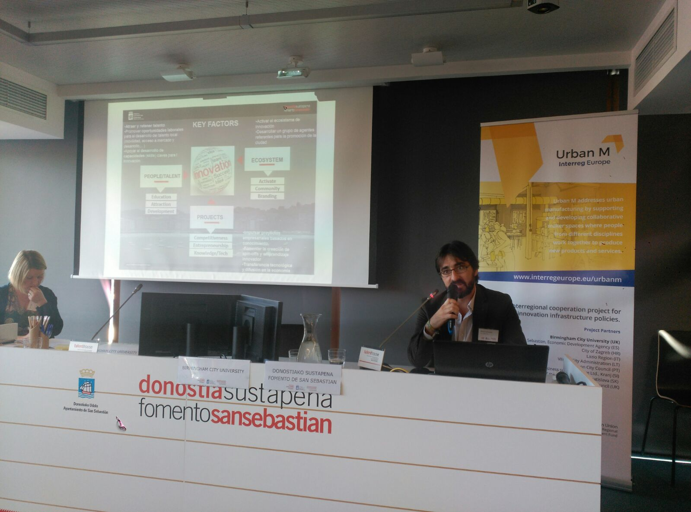
Figure 4 WEEK-INN Technology Pop UP Tent
