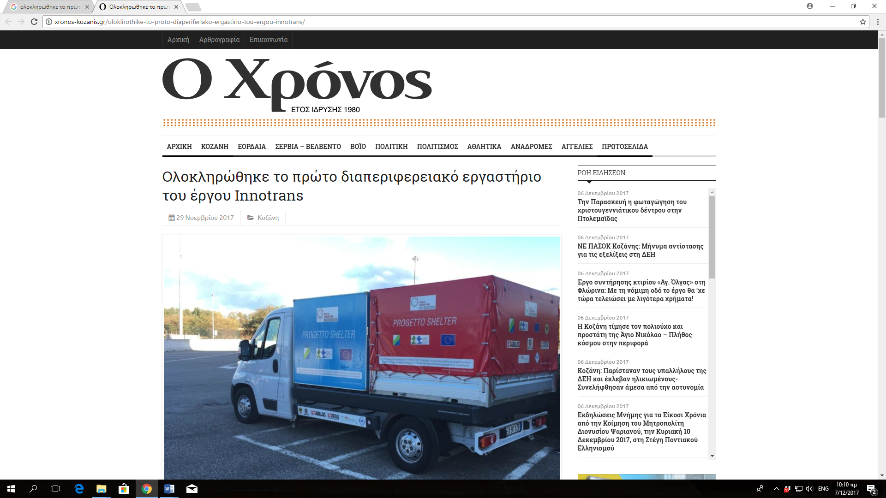
http://xronos-kozanis.gr/oloklirothike-to-proto-diaperiferiako-ergastirio-tou-ergou-innotrans/
https://nextnet.gr/blog/%CF%80%CE%B5%CF%81%CE%B9%CF%86%CE%AD%CF%81%CE%B5%CE%B9%CE%B1-%CE%B4%CF%85%CF%84-%CE%BC%CE%B1%CE%BA%CE%B5%CE%B4%CE%BF%CE%BD%CE%AF%CE%B1%CF%82-%CE%BF%CE%BB%CE%BF%CE%BA%CE%BB%CE%B7%CF%81%CF%8E%CE%B8/
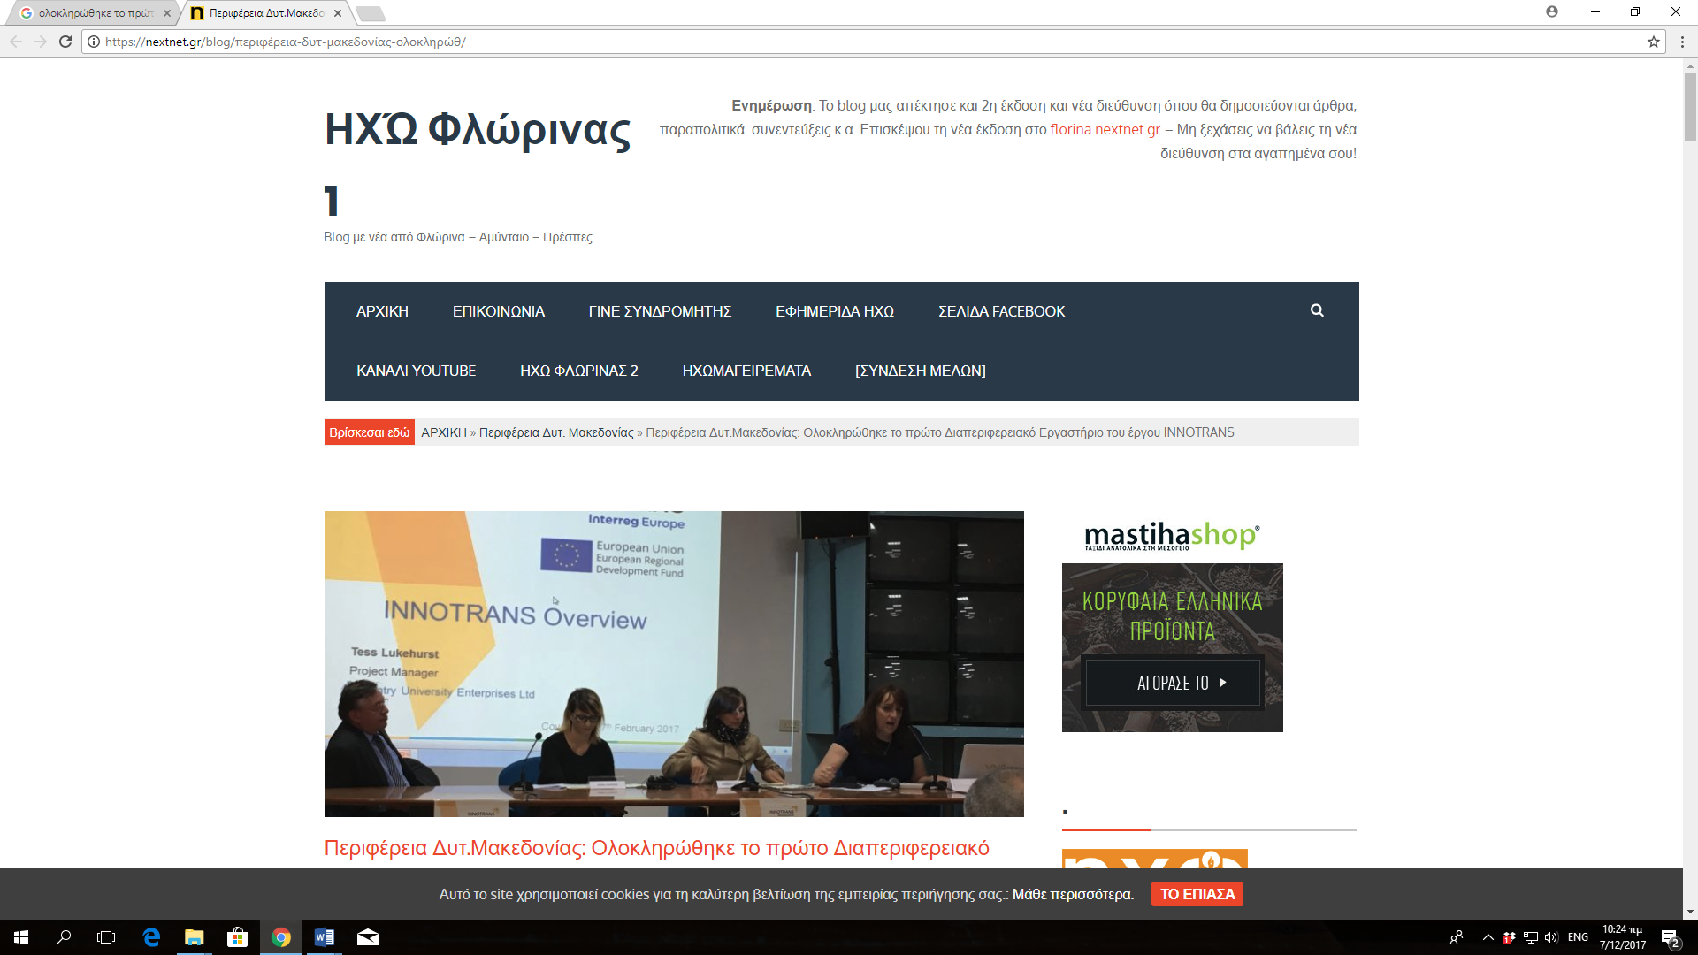
http://info4.gr/newsportal/western-macedonia/9091/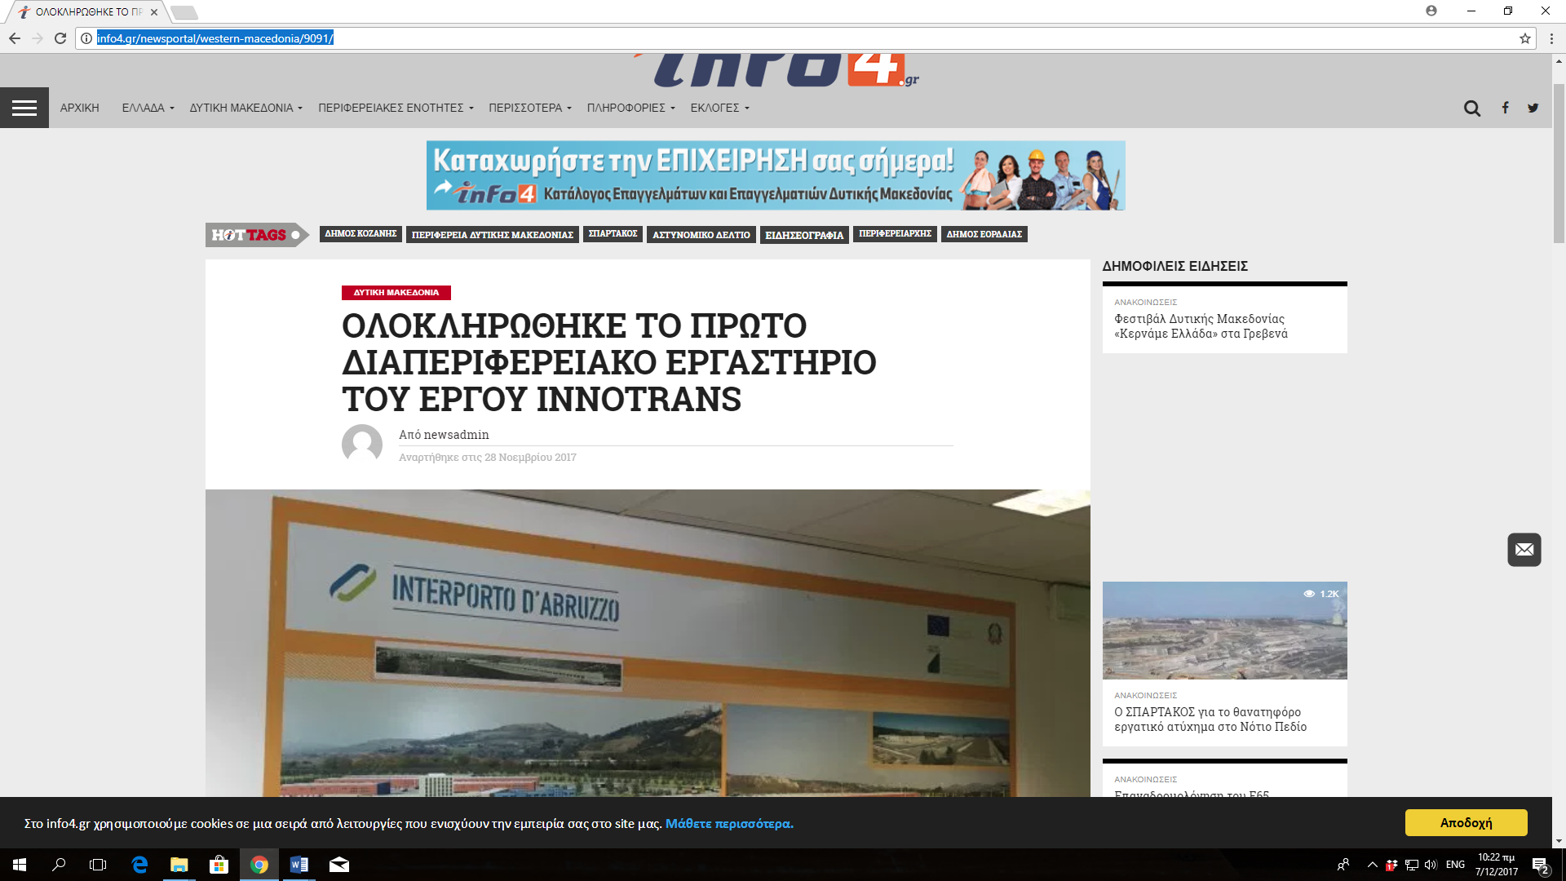
http://energeiakozani.blogspot.gr/2017/11/innotrans.html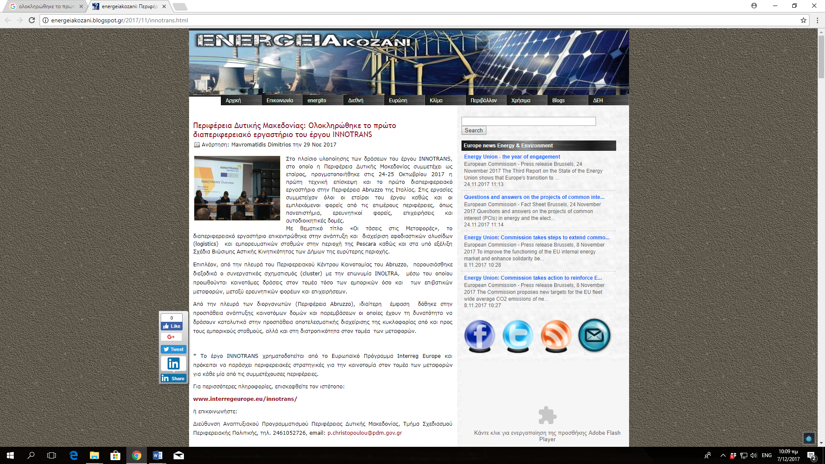
http://kozan.gr/archives/75189 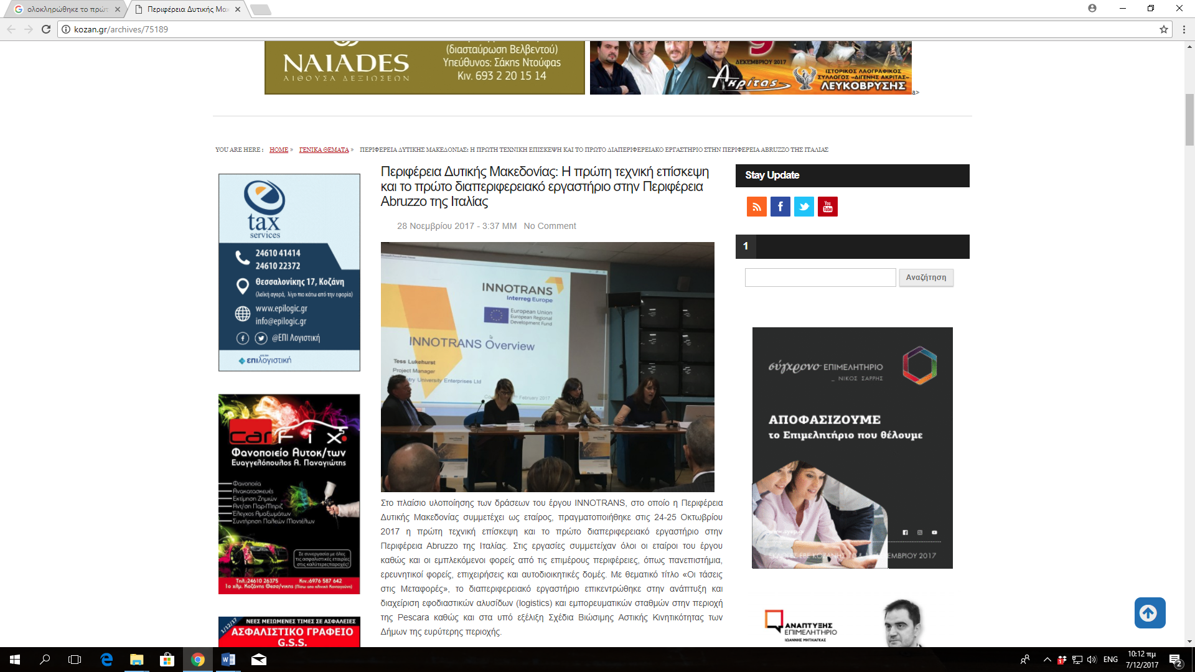
http://www.pdm.gov.gr/oloklirothike-to-proto-diaperiferiako-ergastirio-tou-ergou-innotrans/
