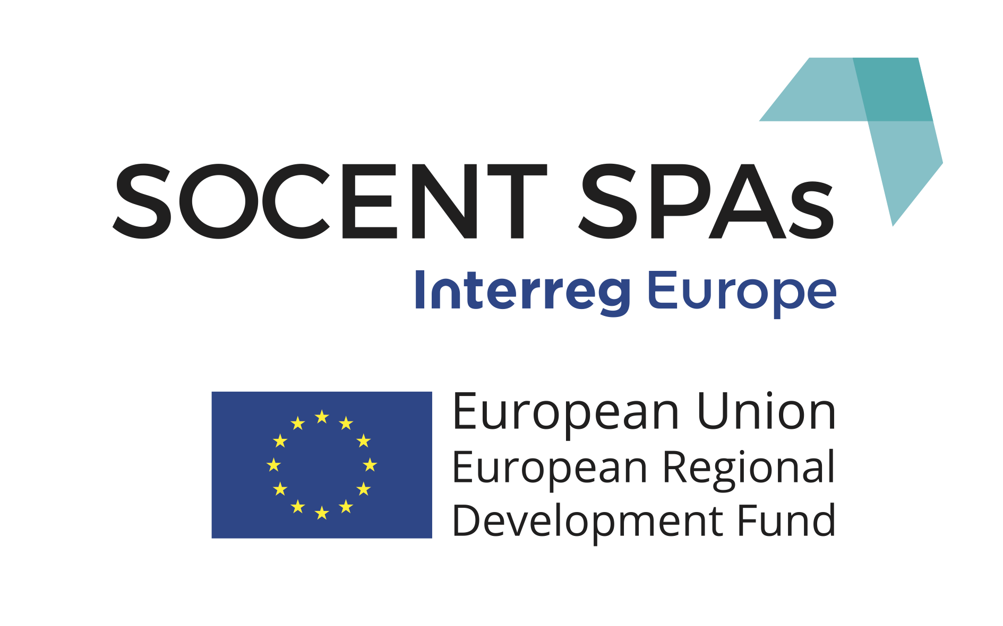
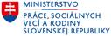

SOCIAL BUSINESS IN SPARSELY POPULATED AREAS – REGION GEMER, SLOVAKIA

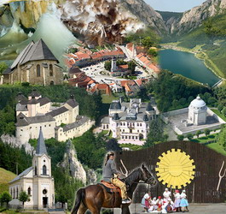

MARCH, 2017

This report was based on project “SOCENT SPAs: Social Business in Sprarsely Populated Areas“ (PGI02359) within a program Interreg Europe.

The author is responsible for content of this study and it does not have to mirror opinions of program Interreg Europe.

The authorities of program Europe Interreg are not responsible for any use of information included in this study.

Danube EuroConsulting s.r.o.
Innovative solutions for development
In co-operation with partner of project MPSVR SR

Content
1. Connections, purpose and structure of the study 4
2. Posture, methodics and restrictions 8
3. Restrictions of region Gemer 8
4. Analysis of situation of social business in region 21
4.1 Legal framework of social business in Slovakia 21
4.2 Current situation of social business in Slovakia and in region Gemer …...........25
4.3 Current proposed situation of development of regions taking into account employment and social business 27
4.4 Current options of funding for development of employment and social business in regions 33
5. Legislative restrictions and proposal of specific measures in order to support social business in districts of Gemera 35
a) Measures on level of autonomous region 35
b) Measures on national level 36
6. Conclusions, recommendations and measures which should be accepted for inclusive increase in area of social business especially in sparsely populated areas – recommendations for partner of project MPSVR SR 39
Literature, legislative and links 44

List of abbreviations

MAS Local Action Group
MDVRR SR Ministry of Transport, Construction and Region Development of the Slovak
republic
MF SR Ministry of Finance of the Slovak republic
MH SR Ministry of Economy of the Slovak republic
MPRV SR Ministry Agriculture and Rural Development of the Slovak republic
MPSVR SR Ministry of Labour, Social Affairs and Family of the Slovak Republic
MSP Small and Medium Enterprise
NP National project
OP KŽP Operational program The Quality of the Environment
OP ĽZ Operational program Human Resource
RP Regional Contribution
RO MPSVR Line authority MPSVR SR
SIH Slovak Investment Holding
SZRB AM Slovak Guarantee and Development Bank Asset Management
ŠÚ SR Statistical Office of the Slovak republic
ÚPSVR Labour Office
VÚC Autonomous Region
VUC BB Autonomous Region Banská Bystrica
VUC KE Autonomous Region Košice
EÚ Europen union
UoZ Jobseeker
ÚPSVaR Central Labour Office

1. Connections, purpose and structure of the study

This study is based on project “Social Business in Sprarsely Populated Areas“ PGI02359 - SOCENT SPAs'.

The study reflects current situation of region Gemer based on incoming – leaving data - unemployment rate/employment rate, demographics of the region, current situation on labor market in focus on social business, analytical works within existing documents within existing national legislation of development of enployment and recommendations within missing measures for development of region.
The restrictions of region are focusing on restrictions of each of defined districts for the purpose of this study – district Rimavká Sobota, district Revúca and district Rožňava. The districts Rimavská Sobota and Revúla belong to autonomous region Banská Bystrica within territorial division in the Slovak republic (SR) while district Rožňava belongs to autonomous region Košice.

District Rimavská Sobota is struggling with high rate of registered unemployment in long term, cause of which is needed to be found in unbalanced economic development, in extintion of key subjects of the regional economy, in process of poorly managed restructuring of the economy, in the lack of capital resources, in unfit demographic profile, on low qualification level of population and in business of qualification manpower from the district.

District Revúca belongs to districts with the highest rate of unemployment within whole Slovak republic in long term. The rate of registered unemployment was 20,5 % to March 31st 2016 according to Central Office of Labour, Social Affairs and Family (ÚPSVAR) in Revúca. The half of jobseekers - UoZ (51 %) has got incomplete education or has got only complete primary education and this fact has got a great effect on their employability. The high part of population in material need is also connected with problem with unemployment and separately long-term unemployment. The part of number of recipients of aid in material need and contributions to dosage with joint assessment persons is exceeding the average in SR more than fourfold and average in autonomous region Banská Bystrica more than twofold.

District Rožňava is one of districts with the highest rate of registered unemployment in long term. Its height was moving between 29,58 % - 20,36 % in 2013 – 2016 while the rate of registered unemployment in Slovakia was moving between 14,68 % - 9,89 % in the same time. The causes of the high rate of registered unemployment are needed to be found in unbalanced economic development, in the lack of capital resources, in unfit demographic profile, on low qualification level of population and in business of qualification manpower from the district.

Common measures of development for all districts:
a) The structure of unemployment and human resource
- long-term unemployment
- not suitable qualification structure and low educational level of jobseekers
- lacking working habits and low quality of manpower
- leaving young qualification people
- unfavorable educational and social structure of population
- bad living conditions of disadvantaged groups of population including marginalized romany communities

b) Lacking infrastructure and bad condition of public buildings (objects)
- lacking traffic infrastructure, missing 1st class roads
- unfit or uncompleted technical infrastructure in many villages (missing water supply, sewerage, wastewater treatment plants)
- lacking technical/environment infrastructure of surrounding villages
- bad technical condition and inaccessibility of cultural-historical monuments, bad technical condition and low energy efficiency of public buildings

- Resting of developing potential of districts
- lacking use of local resources (natural, cultural)
- lacking care about tourist infrastructure, cultural-historical monuments, missing relationship and experiences of inhabitants within business in tourism and raising of attractiveness of area to visitors

d) Bad connection between education and demand of labour market
- lacking adaptability of educational institutions to needs of labour market without connection with employers and their needs
- orientation of educational system which does not reflect the structure of branches according to needs of labour market
- the lack of integrated educational and preventive programmes for young people

e) Weak support of business environment including social economy
- the lack of capital for development of business and support of production new job opportunities
- weak innovative activity which manifest itself in obsolescence of technology and objects, their high energy intensity and low competitiveness
- weak support and inaccessibility of EŠIF (European structural and load funds) resources for micro and small business (high cofinancing)
- inflexibility and slow restructuring and adaptation of establishments to penetration of competitive commodity into domestic market
- lacking usage of potential of social economy
- lacking usage of social aspect in the course of public procurement as tool of support of local economy
- weak support of starting businessmen and small and medium establishments
- low attractiveness for investors

A chapter dedicated to analysis of situation of social business in region is touching the legal framework of social business in Slovakia in connection with legislation in EU.

Social economy appears in different forms in national legislation in EU. The majority of countries in EU have got a terminology of social economy spread in different legislation. The most common terminology which is touching social economy subjects in legal surrounding of countries in EU is defined as – non-profit sector, association, foundation, cooperatives, guilds, trading companies, the aim of which is not earning money. Criteria which fulfill basic defined signs of social economy subjects in national legislation are:
- autonomous, self-govering, organization which is not dependent on state
- economic activity of production and selling of goods and services into market
- explicit social aim which brings benefits to community or specific group of people
- reinvestment of majority of profit or excess in next achieving socially profitable aims
- independent decision making about capital contribution (1 member – 1 vote)
- tendency to paid work
- significant measure of economic risk
- initiative founded by citizens, collectively, federal ownership
- participation of memners (as employees, clients,...) in property and funding

Current situation of social business in Slovakia is coming from uncomplimentary situation – missing separate law about operation of social business. The situation of social business in region Gemer can be implemented only within national, current valid legislation.
For the purpose of this study and missing legislation for social business, the next chapter is only focused on potential participants – subjects which could implement social business after editing of legislation.

Current options of financial support for social businessmen are considerably limited. Considering missing legislation for social economy and considering unclear limit of definition of social business (there is only definition of subjects of social economy), support which is purely intent on subjects of social economy often intersects with support for different business and non-business subjects.

A plan of specific measures with aim of support of social business in districts are divided into measures in level of autonomous region, which result from competences which are given to corresponding autonomous region. Considering that districts are in two autonomous regions (BBSK, KESK) within regional division, measures come from common plans defined in Action plans, but also within processed current Programmes economic and social development of corresponding region.

Measures on level of state authorities with aim of support of social business can be divided (for the purpose of this study) to measures within favour undeveloped regions, measures within usage of social aspect in the course of public procurement and measures for support of action of social economy subjects.

2. Posture, methodics and restrictions
The study reflects current situation of region Gemer based on incoming – leaving data - unemployment rate/employment rate, demographics of the region, current situation on labor market in focus on social business, analytical works within existing documents within existing national legislation of development of enployment and recommendations within missing measures for development of region. Considerable restriction is current missing legislation about social business, this area is focused on basic elements of social business which fulfill common signs of social business in coutries of EU.

3. Restrictions of region Gemer
Historical area of Gemer takes one of the south parts of middle Slovakia. The overwhelming part of area lies in Slovenské Rudohorie, the north part lies in Horehronské podolie, the south part lies in Rimavská kotlina, the east part lies in Rožňavská kotlina and in Slovenský kras. Malohont as current its part lied in middle part of Slovakia in river basin of river Rimava, between Gemer and Novohrad. Malohont was at the beginning of the 14th century connected to Hontianska stolica. That was a territory abnormality because Novohradská stolica was separating Malohont from Hont and distance like this brought many problems and conflicts. After several conflicts in 1786 was Gemer connected to Malohont and Gemersko-malohontská stolica came into existence. The economic life in past was secure by mining and metallurgy focused on mining iron ore. In 1852 Rimavsko-muránska ironwork company came into existence, one of the biggest producers of raw iron and iron products in Hungary. Crafts which were connected with ironwork also expended (sword making, smithery, locksmithery) and others village crafts. Gemer and Malohont were very important for slovak national life, it was birthplace and relocate of many slovak celebrities who developed and secured conservation and development of slovak education and culture in towns and villages. Region have got many historic landmarks which attract attention of visitors from home and from outland.

Region Gemer includes districts Rimavská Sobota, Revúca and Rožňava which are an subject of this study. Districts Rimavská Sobota, Revúca belong to autonomous region Banská Bystrica within regional division.

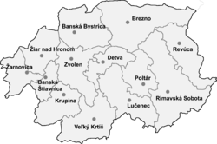

Picture 1: Autonomous region Banská Bystrica
(districts Rimavská Sobota a Revúca)

District Rožňava belongs to autonomous region Košice within regional division.
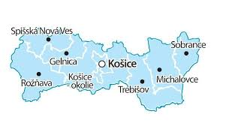
Picture 2: Autonomous region Košice (district Rožňava)

It is a known fact that in districts Rimavská Sobota, Revúca and Rožňava is the highest rate of unemployment within Slovakia for years. In past (before 1989 - Velvet Revolution) there were big manufactories here, e.g. sugar refinery, brewery, canneries, meat packer. In stagnant parts of region occured significant structural changes in industry and agriculture and the result was extinction of old companies which emploied many emlpoyees. The capacities of new business subjects could not absorb available size of manpower in this part of region. These changes manifested in next deepening of unemployment. Labour market in Gemer is characterized by long lasting lack free work positions, young manpower leaving to towns and deepening of poverty of marginalized groups of citizens mainly in south districts of region.

Restrictions of region – district Rimavská Sobota
It has got 1 471,08 km². Rimavská Sobota is the thirt biggest district in Slovakia according to area, it has got oblong shape in direction northwest – southeast. The long south border is also state border with Hungary. The core of district is Rimavská kotlina which passes into Slovenské rudohorie in north. It passes into Cerová vrchovina in south.

Table 1: Settlement structure of district Rimavská Sobota
Sizing structure of villages |  | Number of villages
1999 or less citizens |  | 101
Thereof | 0-199 citizens | 32
 | 200-499 citizens | 37
 | 500-999 citizens | 26
 | 1000-1999 citizens | 6
2000 and more citizens |  | 6
Thereof | 2000-4999 citizens | 4
 | 5000-9999 citizens | 1
 | 10000-19999 citizens | 0
 | 20000-49999 citizens | 1
Source: Statistical Office SR, 2017

District Rimavská Sobota belongs between bigger districts in Slovakia according to number of citizens, but it hardly reaches the half of slovak average by population density. 84 577 citizens live here and the average population density is 57 citizens per km² (data from December 31st 2015).

There are 107 villages in district, of this 3 towns. District is characterized by low urbanization – 55% of citizens live in country-house which is 12% over slovak average.

Photo 1: City Office of the biggest town in region Gemer – where dominated food industry in the 2nd half of 20. century
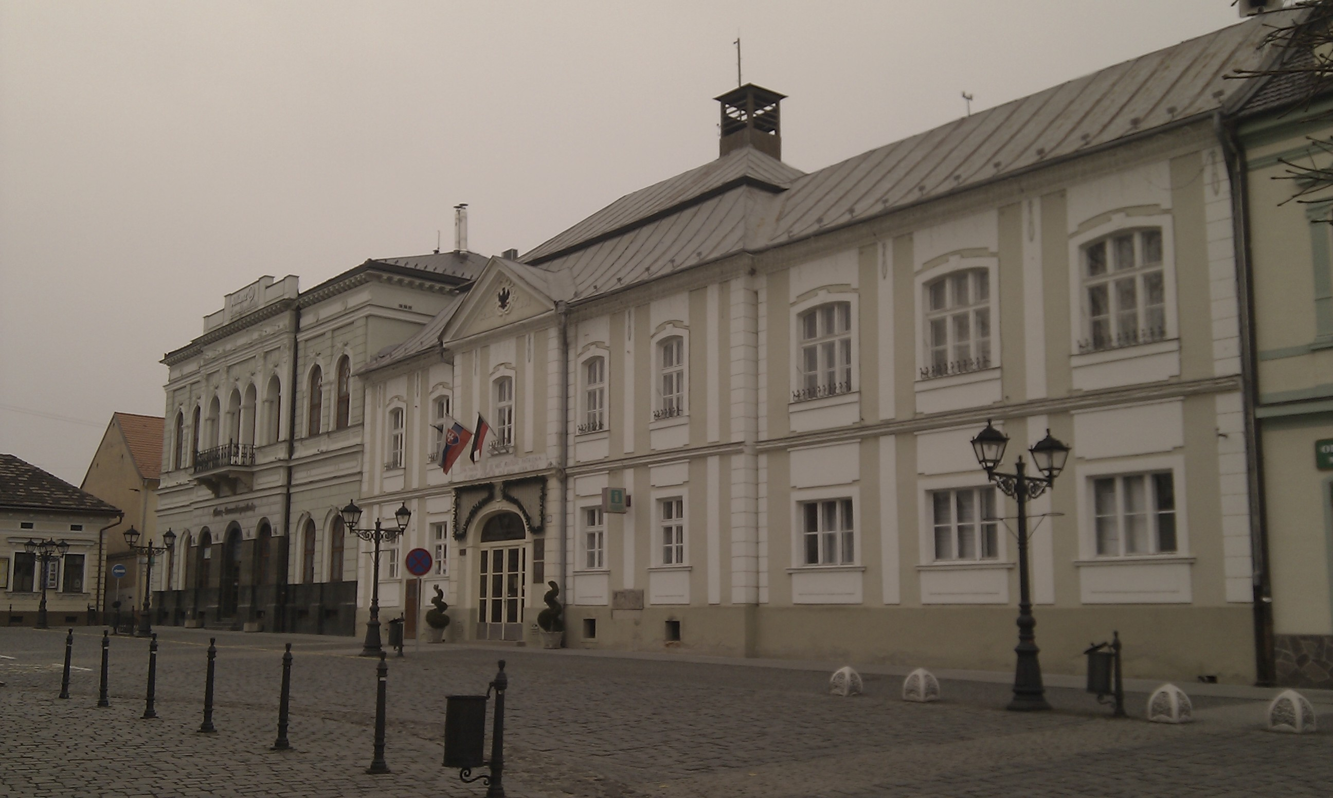
Source: own creation

District Rimavská Sobota is struggling with high rate of registered unemployment in long term, cause of which is needed to be found in unbalanced economic development, in extinction of key subjects of the regional economy, in process of poorly managed restructuring of the economy, in the lack of capital resources, in unfit demographic profile, on low qualification level of population and in business of qualification manpower from the district. Previous focus of the middle and south on the agriculture and food industry which recorded significant decrease in transformation process caused that Rimavská Sobota got into line of districts with unfit sectorial structure, which cannot be fixed without radical system measures nowadays.
The reasons of high and long lasting unemployment of manpower with low education and in young age (48% of jobseekers are 30 to 49 years old) are the lack of job opportunities and/or demotivating remuneration, lacking made technical infrastructure, missing bigger employers as leaders of regional economy and little diversified structure of economy, the lack of services including services for free time activities, low investment activity in district and missing stronger potential regional investors, existence of demotivating factors, such as execution, for instance.

Chart 1 – Development of rate of registered unemployment on different regional levels in period 2007-2017 (data rom the end of February)
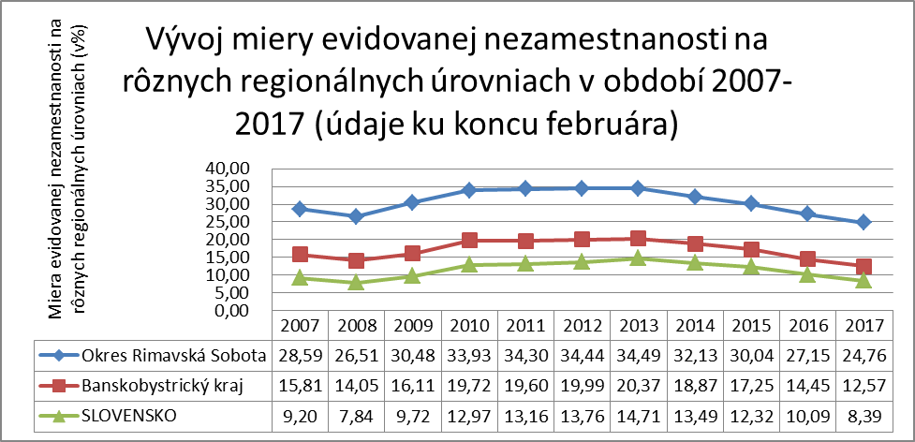
Source: UPSVAR 2017

Table 2: Long lasting unemployment on different regional levels – situation from February 28th 2017
 | Number of UoZ together | Thereof registered UoZ more than 12 months | Part of UoZ registered more than 12 months
District Rimavská Sobota | 11150 | 7641 | 68,53
Region Banská Bystrica | 46883 | 26384 | 56,28
Slovakia | 267219 | 130458 | 48,82
Source: UPSVAR 2017

Chart 2 – A change of long lasting unemployment in district Rimavská Sobota – part of UoZ registered more than 12 moths (in %)

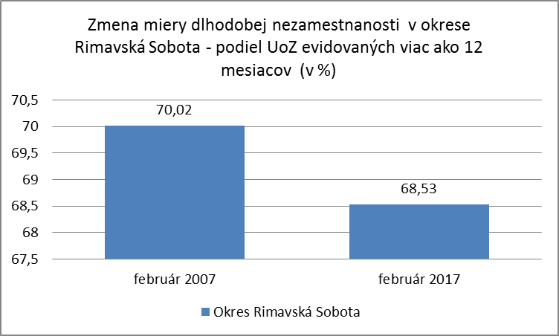
Source: UPSVAR 2017

Restrictions of region – district Revúca
District Revúca belongs to biggers districts of Slovakia according to area. It is about 110 km² more than average district in SR. It has got strongly oblong shape in direction northwest – southeast. The south border is also state border with Hungary.

Table 3: Settlement structure of district
Sizing structure of villages |  | Number of villages
1999 or less citizens |  | 39
Thereof | 0-199 citizens | 11
 | 200-499 citizens | 16
 | 500-999 citizens | 9
 | 1000-1999 citizens | 3
2000 and more citizens |  | 3
Thereof | 2000-4999 citizens | 1
 | 5000-9999 citizens | 1
 | 10000-19999 citizens | 1
 | 20000-49999 citizens | 0
Source: Statistical Office SR, 2017

District has got rugged surface – several geomorphological wholes passe into district. Upland relief prevails in south part of district. There are limestone mountains with extremely attractive karst formations in the south part of area.

There are 42 villages in district, of this 3 towns. District is economically very unbalanced and its south and north part do not have constructed practically any bond.

Photo 2: Jelšava – a town with rich mining and ironworks tradition and craft production
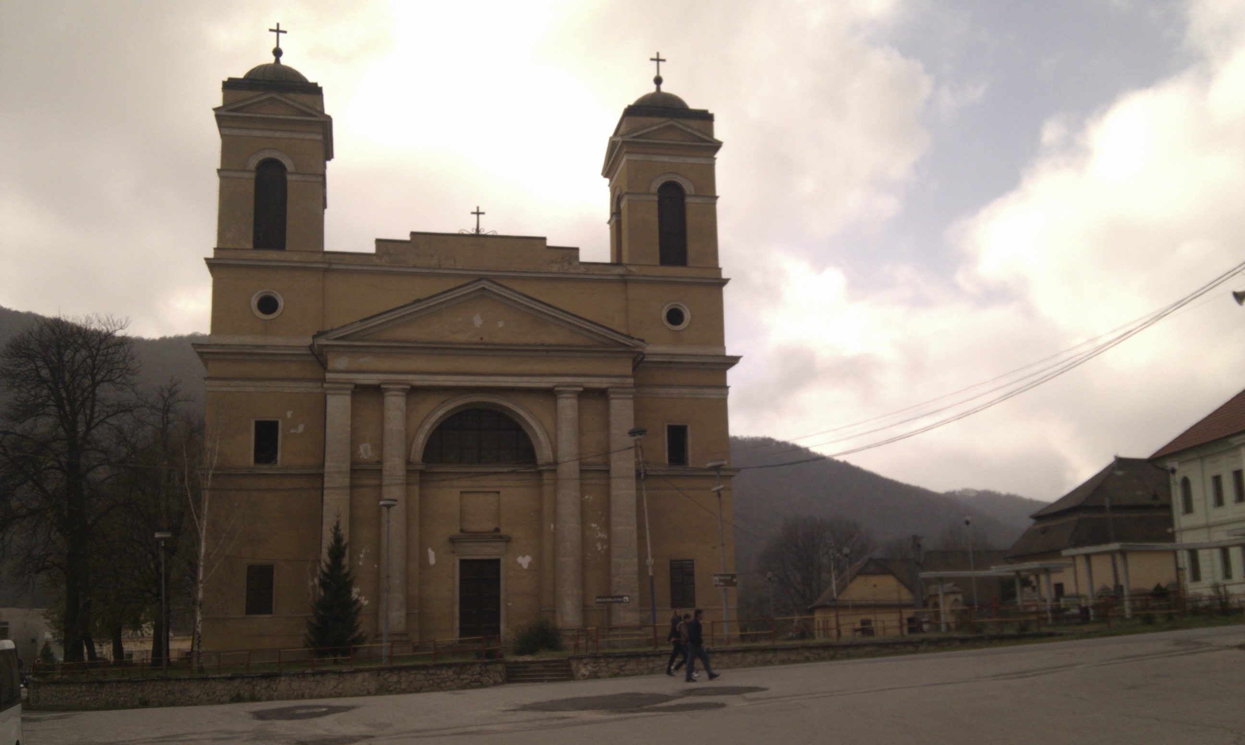
Source: own creation

District Revúca belongs to districts with the highest rate of unemployment within whole Slovak republic in long term. The rate of registered unemployment was 20,5 % to March 31st 2016 according to Central Office of Labour, Social Affairs and Family (ÚPSVAR) in Revúca. The half of jobseekers - UoZ (51 %) has got incomplete education or has got only complete primary education and this fact has got a great effect on their employability. The high part of population in material need is also connected with problem with unemployment and separately long-term unemployment. The part of number of recipients of aid in material need and contributions to dosage with joint assessment persons is exceeding the average in SR more than fourfold and average in autonomous region Banská Bystrica more than twofold. Almost every sixth citizen of the district was in 2015 reliant on social assistance benefits.

Chart 3: Development of rate of registered unemployment on different regional levels in period 2007-2017 (data rom the end of February)
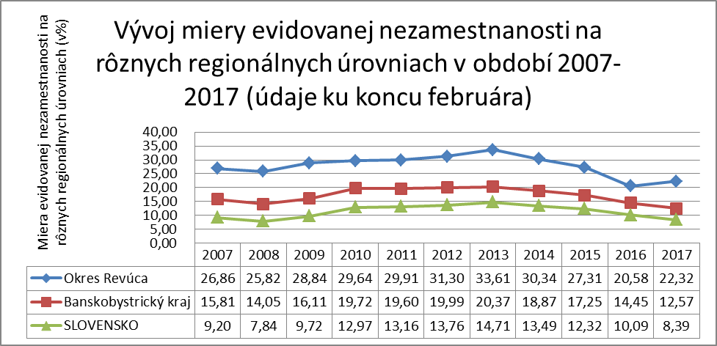
Source: UPSVAR 2017

Adverse factors which concern high unemployment are structure of unemployed but also bad economy preparedness of region for coming investors and investment. Significant restriction for development of the region is the lack of 1st class roads and highways. Town is not on the main road of the rail transport and highway transport. Investors do not show interest about district Revúca because of bad infrastructure, rugged terrain and distance from main roads.
Table 4: Long lasting unemployed on different region levels, February 28th 2017
 | Number of UoZ together | Thereof registrated UoZ more than 12 months | Part of UoZ registered more than 12 months
District Revúca | 4957 | 2980 | 60,12
Region Banská Bystrica | 46883 | 26384 | 56,28
Slovakia | 267219 | 130458 | 48,82
Source: UPSVAR 2017

Chart 4: A change of long lasting unemployment in district Revúca – part of UoZ registered more than 12 moths (in %)

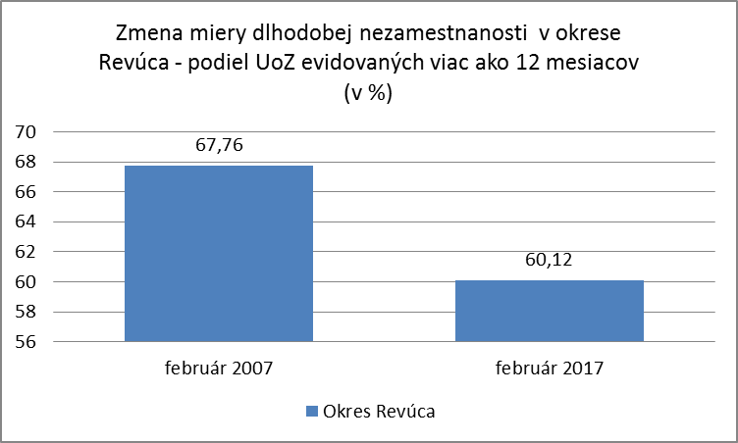
Source: UPSVAR 2017

Revúca has got unique natural potential, nevertheless tourism infrastructure is underdeveloped and number of accommodation facilities is considerably undersized. Condition and quality of environment in district Revúca affect mainly mining and processing of magnesite in area Jelšava – Lubeník which are source of significant damage of environment and quality of citizens' lives. Cadastral areas of town Jelšava and villages Lubeník, Chyžné, Magnezitovce, Mokrá Lúka, Revúcka Lehota belong to area of management of quality of air. In this activity with accompanying production significant number of dusty and gaseous emissions there is significant damage of farmlands, forests and forest lands. The most significant negative factor are solid magnesium emissions which in specific terrain conditions significantly make worse the quality of air and depending on climatic conditions contaminate closer or wider area. This area is perspective of development of processing industry nowadays and also make suppositions of next development of employment of district.
Restrictions of region – district Rožňava
District Rožňava belongs to autonomous region Košice according to regional-administrative division. District Rožňava belongs to 12 district of SR which have got bigger area than 1000 km². It has got 1 173,34 km². An administrative office of the district is town Rožňava which is also the most important economic centre of the district.
The area of the district is mostly mountainous, almost all surface is occupied by geomorphological units of Slovenské rudohorie. The highest point is 1476 meters above sea level. The district is characterized by geological structure (Spišsko-Gemerský kras has got very attractive relief).
District Rožňava belongs to medium-sized districts of SR according to number of citizens, but the population density is very low, it doesn't even reach a half of slovak average. The average population density is 53 citizens per km² (data from December 31st 2015).

Table 5: Settlement structure of district
Sizing structure of villages |  | Number of villages
1999 or less citizens |  | 57
Thereof | 0-199 citizens | 11
 | 200-499 citizens | 20
 | 500-999 citizens | 20
 | 1000-1999 citizens | 6
2000 and more citizens |  | 5
There of | 2000-4999 citizens | 3
 | 5000-9999 citizens | 1
 | 10000-19999 citizens | 1
 | 20000-49999 citizens | 0
Source: Statistical Office SR, 2017

There are 62 villages, of this 2 towns (Rožňava, Dobšiná) in district. 60% of citizens of district live in country-house which is 17% over slovak average.

The main source of the district are minerals, but the mining decline for years. Forests are big wealth of district, they occupy 60% of the area. The district has got rather good conditions for agriculture production, mainly for growing of cereals. There are meadows and pastures in higher positions which are 65% of farmlands.

Photo 3: Krásnohorské Podhradie – there are three factors which illustrate village and also whole Gemer: beautiful nature, rare historical monuments and serious social problems
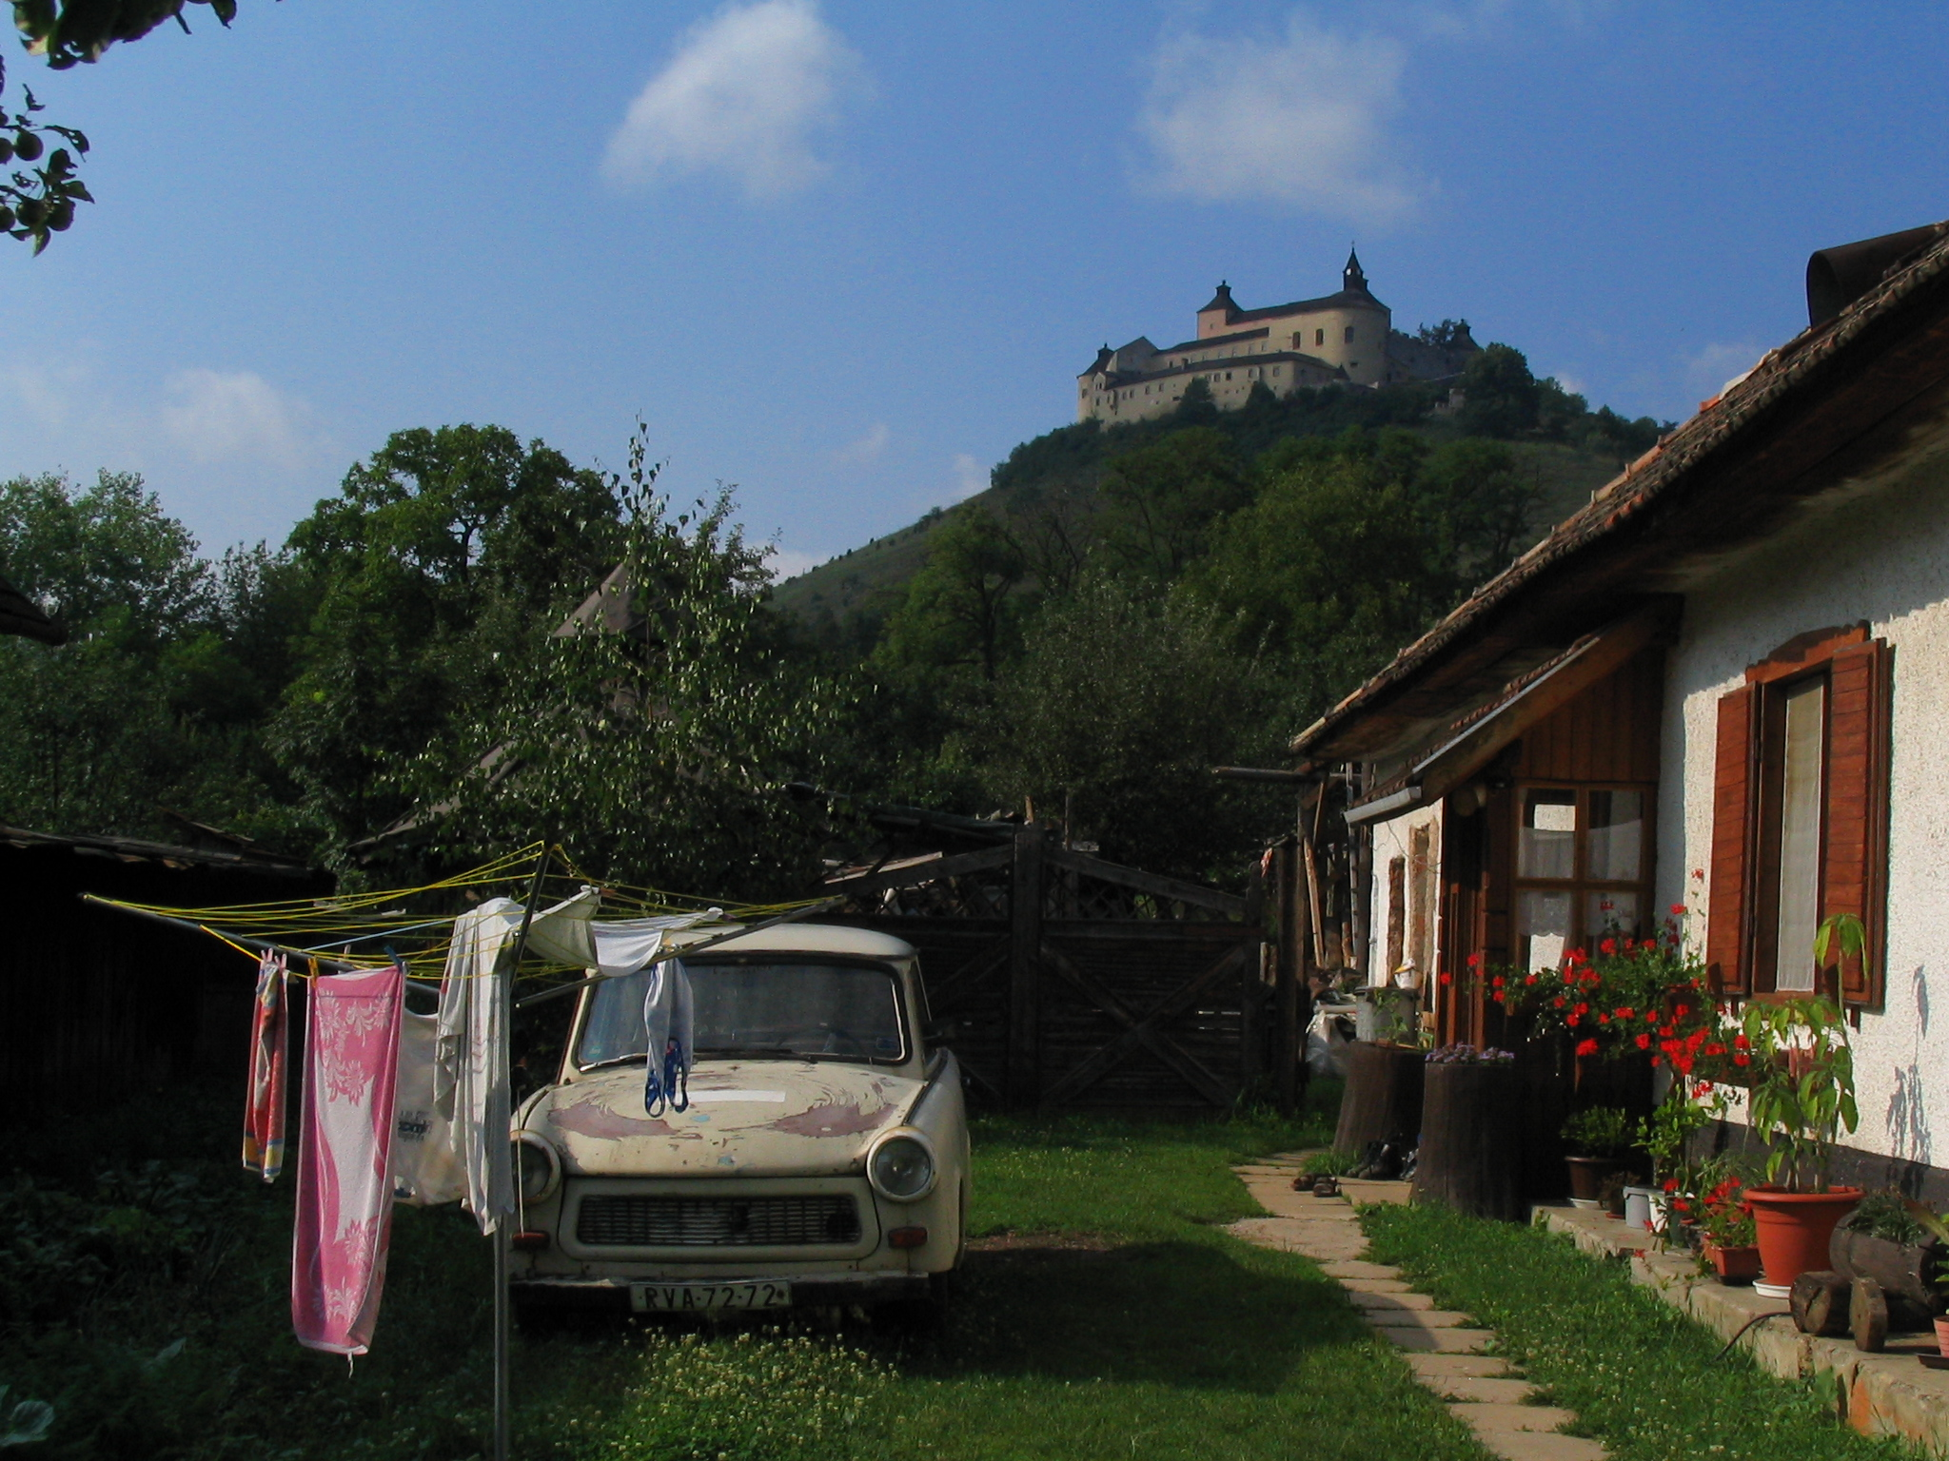
Source: own creation

Dinamically changing national structure belongs among main specificities of district Rožňava. Also absolute and relative increase of the part of Roma population for last 20 years helps dynamics. District Rožňava is one of districts with the highest rate of registered unemployment in long term. Its height was moving between 29,58 % - 20,36 % in 2013 – 2016 while the rate of registered unemployment in Slovakia was moving between 14,68 % - 9,89 % in the same time. The causes of the high rate of registered unemployment are needed to be found in unbalanced economic development, in the lack of capital resources, in unfit demographic profile, on low qualification level of population and in business of qualification manpower from the district and high number of Roma ethnicity. The most important representation of industrial activity and services in region are in town Rožňava. There are facilities of local, town, district and regional meaning within education, health service, culture, sport, social care and also business and services. The facilities are satisfying. The kinds of wholesale and retail which fulfill daily needs of citizens are quickly developing. There is representation of engineering industry in industrial structure of district, also of textile industry (production of knitted and cotton clothing), production of hygienic products, paper production (production of notebooks), food production. There are remains of mining of limestone and gypsum.
There are 9 high schools, of this 2 grammar schools, 5 secondary vacational schools, 2 vacational schools. Secondary vacational schools offer many sections which are relevant for labour market but they lag behind requirements of employers because of their technical facilities and it is needed to fix it. The problem is also demotivation of students to finish education after they finish compulsory education and missing offer of training activities for unqualified manpower.

Chart 5: Development of rate of registered unemployment on different regional levels in period 2007-2017 (data rom the end of February)
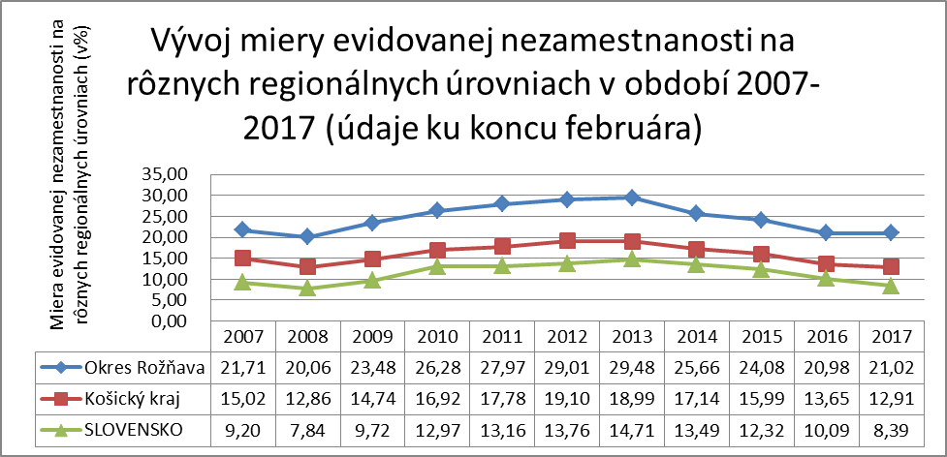
Source: UPSVAR 2017

District Rožňava has a potential to develop tourism of supraregional meaning in areas: visitor servise in UNESCO cave localities, road access of caves in Kras, product innovations for Slovenský raj, Gothic thematic trip, castle Krásna Hôrka, Krásnohorské podhradie and manor-house Betliar, conceptual building of experience programmes and products based on mining history and restoration of vine growing as the base for vine tourism.

Table 6: Long lasting unemployed on different region levels, February 28th 2017
 | Number of UoZ together | Thereof registered UoZ more than 12 months | Part of UoZ registered more than 12 months
District Rožňava | 7066 | 4583 | 64,86
Region Košice | 54895 | 31254 | 56,93
Slovakia | 267219 | 130458 | 48,82
Source: UPSVAR 2017

Chart 6: A change of long lasting unemployment in district Revúca – part of UoZ registered more than 12 moths (in %)
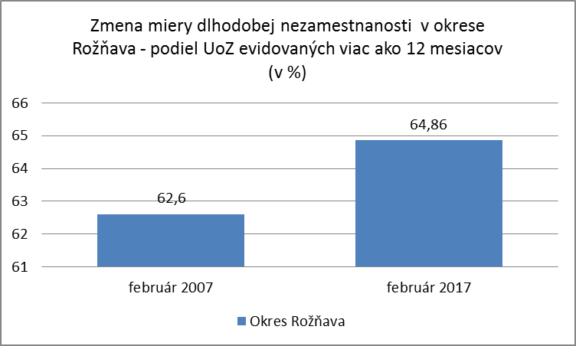
Source: UPSVAR 2017

Common restrictions of development for all districts:

a) A structure of unemployed and manpower:
- long lasting unemployment
- unfit qualification structure and low educational level of jobseekers
- lacking working habits and low quality of manpower
- leaving young qualified people
- unfavorable educational and social structure of citizens
- bad living conditions of disadvantaged groups of citizens including marginalized Roma communities

b) Lacking infrastructure and bad condition of public buildings (objects)
- lacking traffic infrastructure, missing 1st class roads
- unfit or uncompleted technical infrastructure in many villages (missing water supply, sewerage, wastewater treatment plants)
- lacking technical/environment infrastructure of surrounding villages
- bad technical condition and inaccessibility of cultural-historical monuments, bad technical condition and low energy efficiency of public buildings

c) Resting of developing potential of districts
- lacking use of local resources (natural, cultural)
- lacking care about tourist infrastructure, cultural-historical monuments, missing relationship and experiences of inhabitants within business in tourism and raising of attractiveness of area to visitors

d) Bad connection between education and demand of labour market
- lacking adaptability of educational institutions to needs of labour market without connection with employers and their needs
- orientation of educational system which does not reflect the structure of branches according to needs of labour market
- the lack of integrated educational and preventive programmes for young people

e) Weak support of business environment including social economy
- the lack of capital for development of business and support of production new job opportunities
- weak innovative activity which manifest itself in obsolescence of technology and objects, their high energy intensity and low competitiveness
- weak support and inaccessibility of EŠIF (European structural and load funds) resources for micro and small business (high cofinancing)
- inflexibility and slow restructuring and adaptation of establishments to penetration of competitive commodity into domestic market
- lacking usage of potential of social economy
- lacking usage of social aspect in the course of public procurement as tool of support of local economy
- weak support of starting businessmen and small and medium establishments
- low attractiveness for investors

4. Analysis of situation of social business in region
Until 2015 only social facility was defined in objective law which is one of the tools of active politics of labour market with aim of integration and inclusion of social disadvantaged jobseekers or marginalised communities. This legal framework consisted of definitions of characteristic features and legal conditions which an employment subject has to have and keep them to receive a status of social facility for the purpose of this law:
“(1) Social facility for the purpose of this law is legal person or individual who
a) employs employees who were disadvantaged jobseekers before admission to employment in number, which is at least 30% of total number of his/her employees
b) provide support and help to employees who were disadvantaged jobseekers before admission to employment, find job on open labour market
- at least 30% of funds obtained from income from business activity which would be used for business activity after settlement of all outgoes for appropriate taxing period according to declaration of taxes, every year uses to making new working opportunities or to improvement of working conditions
- is registered in register of social facilities.”

Social facility was within valid legislation focused only on making new working opportunities for disadvantaged jobseekers and on their retention. By the introduction of this legal structure Slovak labour legislation received legal tool of supported labour market.
The status of social facility in the course of fulfilling of conditions appointed by this law can receive any subject whether he/she is legal person or individual. The basic philosophy comes from the aim to allow employment of the biggest possible number of disadvantaged persons.

In 2015 for achievement of the aim to engage the biggest possible number of employers, the amendment of the object law was implemented and it came to specifying of the social economy subjects. The purpose was also to better anchor recipients – implementers of social business. Nowadays following statement is valid - Amendment of The Law About Services of Employment, valid December 15th 2015 :

„§ 50a
Social Economy Subject

- Social Economy Subject is legal person or individual who
a) is asking for his/her early social aim to reach measurable positive social effects in accordance with its charters, other rules or constituent documents by which it is established and
- provides goods or services to vulnerable, marginalised, disadvantaged or excluded persons or
- uses the method of production of goods or services which is its early social aim
b) use to reach its early social aim every year at least 50% of funds obtained from income from business activity which would be used for business activity after settlement of all outgoes for appropriate taxing period according to declaration of taxes
c) is managed responsibly and transparent, mainly by engagement of employees, clients and interested sides which are related to its business activities.

- The subject of social economy is legal person or individual s asking for his/her early social aim to reach measurable positive social effects in accordance with its charters, other rules or constituent documents by which it is arranged, satisfy the conditions according to paragraph 1 letter b) and c) and it provides financial support of social economy subject according to paragraph 1.”.

We can say that aforementioned defining of social economy subjects exist in national legislation, but law about operation of social business is still missing.
Current situation of social business in Slovakia and in region Gemer

Current situation of social business in Slovakia is coming from uncomplimentary situation – missing separate law about operation of social business. The situation of social business in region Gemer can be implemented only within national, current valid legislation.
For the purpose of this study and missing legislation for social business, the next chapter is only focused on potential participants – subjects which could implement social business after editing of legislation.

a) Villages and towns

b) Sheltered Workshops

c) Nongovernmental Organizations

d) Civic associations

e) Cooperatives

Current proposed situation of development of regions taking into account employment and social business
Action plans of social business in region Gemer – action plans of districts
According to Act no. 336/2015 Coll. The support of the least developed districts and the amendment of some laws (“Act no. 336/2015 Coll.”) districts Rimavská Sobota, Revúca a Rožňava, which are the subjects of this study, were included in list of the least developed districts (NRO) by Central Labour Office (UPSVaR).

District Rimavská Sobota
The Action plan of district Rimavská Sobota was approved by resolution of the government no. 254/2016.
For the purpose of this study, aims, measures and suggestion for implementation will be chose mainly from area of increase of employment and from area of support of social business.
The suppositions for fulfilling the Action plan is to lower the measure of unemployment in district Rimavská Sobota by creating of premises for development of local economy and creation of sustainable job opportunities with using potential of region. It is needed to create job opportunities which reflect specifics of disposable manpower and existing and potential economic subjects, to improve conditions for business mainly for small and medium size facilities (“MSP”) and recover local resources within many areas such as agriculture, primary processing of raw materials, mainly wood, industrial production, services, creative industry etc. to achieve the aim of Action plan.

The basic suppositions for development of districts is creation of new job opportunities which reflects the specifics of disposable manpower and adaptation of structure and qualification of jobseekers to requests of labour market:
- unemployed people are mainly low qualified manpower who are without job in long term while the main part of unemployed people are members of marginalised Roma communities, including communities with multigenerational poverty
- high growth of citizens in combination of poverty and long-lasting unemployment is big pressure on development of infrastructure, mainly housing
- educational system not enough reacts to local needs of labour market
- high measure of personal indebtedness leads unemployed people to find employment on grey market, not on formal labour market
- not enough using of potential of social economy, between labour market and socia aspect with procurement as a tool of support of local economy and also potential of targeted measures for long-lasting unemployed people
- development of district is not possible without insertion of qualified and young people, for that reason it is needed to improve not only creating, but also qualitative improvement of labour market in district.

The development of district Rimavská Sobota should be built on three pillars:
- on economic and administrative pillar with focusing on more effective using of its own and extraneous resources
- on development of micro, small and medium sized business and services for small and medium sized businessmen
- on culture, historical – monumental, natural and value pillar.

In defined measure no. 4 Realization of Natural projects of ÚPSVaR, with focusing on needs of sectors within creating of job opportunities, guidance, lifetime education and retraining, is one of submeasure of Creating of guidance centre and services of employment, task of which will be career and professional guidance, services for labour market, services for incubation programmes and services for social economy subjects. This centre expects specific services for unemployed people, but also for students (graduates), to who will be provided education, which will reflects needs of current labour market.

Precedence programme no. 6 “Support of regional and local economy including support of agriculture and forestry is focused on support of investments of MSP in development of business activities according to sectors – industry, production, energetics, building industry, trade and services with the aim to increase employment, to improve competitiveness and support of the export out of region. Next measures are focused on mainly to reconstruction, revitalization, construction of new object, in which should be running of production and processing of building stone, production of tea and healthy nutrition, establishment of business subject which provides the function of sales association of regional productions of craft production and others.

Measure 8. Support of social economy subjects expects establishment of communal facilities as subjects of social economy in specific towns and villages – Tisovec, Hnúšťa, Rimavská Sobota, Veľký Blh, Rimavská Seč, Jesenské, Radnovce, Rakytník, Hostice. The priority of their focusing will be public-beneficial work in following areas:
- environmental projects
- public spaces, green infrastructure
- available social housing
- available public infrastructure
- maintenance local traffic
- local supply and evaluation garbage

District Revúca
The Action plan of district Revúca was approved by resolution of the government no. 379/2016.
For the purpose of this study, aims, measures and suggestion for implementation will be chose mainly from area of increase of employment and from area of social business support.
The suppositions for fulfilling the Action plan and proposal for implementation are in Action plan defined like this: (Resource: The Action Plan of the least developed district Revúca)
the measure for development of human resource is focused on Improvement of access into labour market in district for long-lasting unemployed, young, low qualified, older and disabled people, this measure expect to build centres of education – centres of education which is focused on demand and practice, to build training centres as working incubators with focus on development of skills following secondary vocational schools in district and support of investment in pre-primary and primary education.

One of priorities (the D priority) is development of social economy, which expects support of establishment of at least 6 social economy subjects with the aim of creation of interim labour market specifically for members of MRK which will be focused on public-beneficial work in areas:
- construction helping and maintenance works, locksmith and plumbing works, carpentry works
- maintenance of local road communications, public spaces, communal facility
- building of footpaths, footbridges, parking loads and maintenance and improvement of environment of citizens
- pasta production
- fruit shop, repurchase of wild-growing fruit, herbs and mushrooms, processing of fruit by drying or milling, pressing into juice and syrup, wine and spirit production etc.
- production of concrete pieces (paving, columns, drainage channels and others) asphalting of potholes on communal roads
- care of forest fund and planting of trees, cleaning of forest paths, processing of calamity wood and seeding trees for fuel purposes
- care about cultural monuments
- hydromelioration works, flood measures, cleaning of water flows, ecological works and others focused on development of countryside.

District Rožňava
The Action plan of district Revúca was approved by resolution of the government no. 385/2016.
For the purpose of this study, aims, measures and suggestion for implementation will be chose mainly from area of increase of employment and from area of social business support.
The suppositions for fulfilling the Action plan and proposal for implementation are in Action plan defined like this: (Resource: The Action Plan of the least developed district Revúca)
Priority area (B) is focused on support of regional and local economy as the base for improvement of conditions on labour market. The aim is development of social activities of business and public sector, which effectively use disposable manpower and create sustainable job opportunities with the aim to reach better use of economic potential with reach on increase of employment. Measures are focused on support of introduction of new technologies in area of engineering, electrotechnical and food industry, processing of cellulose and paper industry, support of extended existing business subjects in area of food and mining industry and in area of services, encouraging of demand for renewable resources of energy and processing of waste material.
Within priority area Development of agriculture, forestry and downstream sectors it is expected to support local economy by connection of local production with processing and trade, to create synergy between agriculture, food industry and tourism. Projects also focused on increase of additional value of final regional products and their placement on market.
The priority area “D” is focused on modernization and completion of existing educational infrastructure with emphasis on security of its effective skill to flexibly react to needs of labour market and specific needs of local economy by improvement of status of jobseekers on labour market, increase of employability and employment of jobseekers and disadvantaged jobseekers, building of regional centre of vocational education with aim of improvement and attractiveness vocational preparation and retraining with emphasis on needs of labour market and creation of regional training centres focused on theoretical and practical preparation in areas which are required by labour market and which are reflecting the potential of local economy.
Measure E.2 – Social economy subjects expect the support of creation of at least 8 social economy subjects. Their activity will be focused on creation of new job opportunities in these areas:
- production of concrete semi-products and reconstruction of public areas and footpaths in autonomous regions
- reconstruction of local and utility road communications, environment projects (flood measures, remediation environmental loads, solutions of problems with inert waste material, fire-fighting protection)
- cleaning of forests and next processing of acquired material
- public areas and green infrastructure
- small works in construction and craft production
- support of formation of markets supplied by local suppliers
- support of observance of folk traditions

4.4 Current options of funding for development of employment and social business in regions

Current options of financial support for social businessmen are considerably limited. Considering missing legislation for social economy and considering unclear limit of definition of social business (there is only definition of subjects of social economy), support which is purely intent on subjects of social economy often intersects with support for different business and non-business subjects (support within OP ĽZ, subsidies, grants, tools within active politics of labour market). There already is basic framework of opportunities of support within targeted focus only on social economy subjects:

a) Financial instruments in combination with non-repayable contribution OP ĽZ

According to Ongoing report of process ex ante rating of opportunities of using financial instruments in Slovak republic, there exist significant financial gap between demand for financial products for MSP in general – including demand for investment into social business and offer of these products. Is obvious, that there is an extensive common order for support of social business from state. Following ex ante rating and following the Employment strategy was concluded the contract about funding between MPSVR SR and SZRB AM, supplement of which is document appointing investment strategy and planning for enforcement of financial instruments within appropriate OP ĽZ. Investment structure suggests support of projects in area of social economy by financial instruments, which can be realized also in combination with technical help and appropriate forms of irretrievable help.

b) Regional contribution

The law from November 11th 2015 about support of the least developed districts and about change and completing some of the laws edits conditions, system and forms of providing support of the least developed districts. Regional contribution is financial contribution provided from budgetary chapter of Ministry of Transport in accordance with the action plan of appropriate district. Projects of increase of employment and support of social business, which are defined in individual Action plans, they include supposed costs and suppose the hight of regional contribution. After processing of request for regional contribution which have to be approved by district council (in appropriate district), there can be another submission within Council for development of the least developed district, members of who are representatives of state council, autonomy and representatives of regions of undeveloped districts.

c) Operational program Manpower/active measures instruments on labour market

Within national projects of support of employment, which are implemented by appropriate district Labour offices, will be realized individual National projects, part of which is financial support with the aim to increase regional employment. In present is realized implementation of next National projects:
NP By Practice to Job – mentoring incorporation and practise at employer

NP Graduate Practice Starts Employment – financial contribution to graduate practice and support of next creation of new work opportunity
NP Successfully on Labour Market – support of employment of young people at first employer or self-employment
NP The Way Out of Circle of Unemployment – support of employment of long- lasting unemployed people
NP A Chance to Employment – support of employment of long-lasting unemployed and in other way disadvantaged jobseekers at public employers
NP We Want To Be Active on Labour Market – support of creation of new job opportunities for disadvantaged jobseekers who are over 50 years old
NP Placement of Long Term Unemployed Jobseekers on Labour Market with Use of Non-state Services of Employment
(more on www.upsvr.gov.sk)

d) General support from EŠIF

In present select specific support for social business absent, but it is possible to react to individual challenges and opportunities of support of European structures and investment funds (EŠIF), also by others instruments of EU and by domestic instruments of support, grants and so on. Within partnership agreement it is next operational programmes, use of which can contribute to support of social business: Integrate infrastructure, The quality of environment, IROP, Effective government, Programme of development of countryside (more on http://www.partnerskadohoda.gov.sk/)

5. Legislative restrictions and proposal of specific measures in order to support social business in districts of Gemera

a) Measures on level of autonomous region

Measures on level of autonomous region result from competences, which are given to appropriate autonomous region. Due to the fact that districts are within regional division in two autonomous regions (BBSk, KESK), measures result from common proposals, defined in Action plans, but also within processed current Programmes of economic and social development of appropriate region. The majority of measures, which can considerably help to develop social business concern to these areas:
- reassessment of setting of focusing of secondary schools mainly with focus on needs of district with the aim of harmony of education and needs of labour market
- security of support of creation of detached workplace of secondary vocational schools in NRO, which increase integration of children from socially disadvantaged environment into next educational process and increase applicability of graduates on labour market
- supporting and setting up of running of tourist buses (transport links) which connect centres of tourism, publishing of tourist discount cards, construction and reconstruction of roads and parking loads, which lead into centres of tourism, promotion and presentation of attractiveness and activities of tourism realized by autonomies and non-profit organizations
- recommendation local action groups to coordinate their capacities and financial resources with action plans
- reconstruction of road communications which belong to scope of autonomous region
- creation of conditions for formation of social economy subjects in providing of social services

b) Measures on national level

Measures on state authorities level with aim to support social business can be divided (for the purpose of this study) into measures in area of favouritism of undeveloped regions, measures in area of using of social aspect with procurement and measures for supporting of formation and work of social economy subjects.

Measures with aim of favouritism of undeveloped regions are set within action plans of undeveloped districts, but approved by resolution of the government with every approval of appropriate action plan.

Favouritisms of undeveloped regions are focused mainly on favouritisms in area of support of instruments through EŠIF, in case of different state subsidies. The most often defined measures are:
- invitation of new challenge to projects MAS, specific for districts which are classified as the poorly developed
- to include into portfolio of projects which are supported by Envirofond, explicitly projects of systems of waste water treatment by vegetation-gravel filters with emphasis on villages without public water supply and without connection of majority of citizens to public sewerage and secure point advantage of these projects from NRO with creation of evaluation and selection criteria within Envirofond
- to search opportunities for invitation of specific challenges to revitalization of brown areas and subjects (brownfields) for stagnant regions which suffer by results of structural economic and communal changes
- to secure consideration of needs of the least developed district, mainly with creation and submission of suggestions of evaluating and selecting criteria, also with approval of intentions of national projects: to incorporated point advantage from the least developed district into suggestion of evaluating and selecting criteria

Measures in area of use of social aspect with procurement are shown in all plans of development of regions. Lacking legislation (methodical help from Public Procurement Office) is considerable complication with development of social business. To support their social politics, authorities have got many ways of consideration of social aspect with procurement (support of employment of young people, support of balanced representation of men and women, fight against segregation in sectors and jobs, job opportunities for people from disadvantaged groups and so on), but they don't seize these opportunities, because integrated methodic with using this aspect is missing. In development plans, they are mainly defined measures in next ways:
- to process legislative suggestions and methodical guidelines for autonomies for security of realization of communally responsible acquisition of goods and services from regional producer and provider, including implementation of priority programmes and activities of Action plans of development of the least developed districts
- to provide methodical support for villages and towns to use procurement with social aspect.

Measures for supporting of formation and work of social business / social economy / and opportunities for specific financial support for social economy subjects. Due to a key theme of this study (social business) we mention most often defined measures in plans of development of poorly developed regions:
- to provide methodical help to autonomies and other subjects with foundation and working social economy subjects
- to secure statement of demanded project for supporting regional and local employment – grants for part of labor costs and support, guidance and leadership with foundation and running social economy subjects (complementary solution with realization of financial instruments by SIH, funded from OP ĽZ)
- to realize measures for increase use financial and non-financial instruments SZRB AM for support of business
- to secure statement of demanded project to support regional and local employment - to secure statement of demanded project for supporting regional and local employment – grants for part of labor costs and support, guidance and leadership with foundation and running social economy subjects
- create conditions for building centre of guidance and services for employment (competency centre) including career and professional guidance, services for labour market, incubation programmes and social economy subjects
- to secure use of scheme of state help for employment of disadvantaged people and considerably disadvantaged people in area of agriculture

6. Conclusions, recommendations and measures which should be accepted for inclusive increase in area of social business especially in sparsely populated areas – recommendations for partner of project MPSVR SR

Conclusions of this study will reflect mainly opportunities and competences of partner of project and it is MPSVR SR. Recommendations come out from strategic materials of SR, strategic materials of department, OPĽZ, they will partially meet areas where MPSVR SR has got competences by its representative (Court for poorly developed regions, Board of supervisors SIH and others).

Social economy is subject of permanent high interest of European commission, European economic and social committee (EESV), as well as ILO and OECD. European commission on October 25th 2011 published statement Initiative for social business – To create favourable environment for support of social facilities within social economy and social innovation, in which it suggests the key measures to support social business in Europe and it contains recommendations for governments of member states concerning improvement framework conditions for social facilities, which can lead to new opportunities and to creation of job positions. The strategy of changes, set in National strategy of employment, identify the key changes, which it is need to do to achieve final status of employment until 2020. In national strategy of employment are the task for support of social business set in next way:

4.3.1. To improve legislative environment for working of social economy by extension of legally anchored notion “social facility” by dimensions which are present in European documents and legislation in sort term (Statement EK Initiative for social business, Regulation on European funds of social business). Same in short term improve legislative and business environment for existing social economy subjects, such as e.g. sheltered workshops.

4.3.2. In middle-term time prepare and accept individual and complex legal edit about social economy. To prepare analysis within process of preparation of legislation, which will contain review of “best practices“ introduction of social facilities in other countries and opportunities of their use in Slovakia, assessment of to date development in this area in Slovakia, such as specific proposals for measures and their form of funding with emphasis on minimize potential lack.” To consider, for instance, anchoring the opportunity of restructuring of facilities within new legislative edit, to use changes of European legislation in the context of social aspect of procurement, including edit of competences of authorities of local and territorial autonomy, as well as to make existing contribution for individual employment activity can be used by jobseeker as deposit into common cooperative.

4.3.3. To finish preparation of financial support of social economy in form of Fund of social funds of development capital (FOSFOR) as individual sub-fund of Slovak Investment Holding (SIH).

4.3.4. To create infrastructure for logistic support of social economy subjects by creating incubator network of social facilities, providing advisory, legal and other subsidiary activity in order to make working of these facilities easer. To use experience from abroad while creating this measure, mainly from member states of EU with similar conditions as in Slovakia (Poland, Slovenia, Hungary).

4.3.5. In cooperation of fund FOSFOR and subsidiary infrastructure to support formation and realization of business aims/plans with emphasis on use of micro-financial and micro-grant programmes focused on supporting micro-facilities which fulfill criteria of social economy subjects. To pay individual attention to business aims with perspective of employing disadvantaged jobseekers including people from environment of marginalised Roma communities and people in adverse social status (homeless people).

4.3.6. To provide support in form of combination of funds and financial instruments from fund FOSFOR to starting and existing facilities, which fulfill signs of social economy subjects, in agriculture, in community energy and in other suitable unagricultural activities in countryside areas and less development regions.

The other tool to start social business should be demand-oriented challenge which should be realized by grants (irretrievable financial contribution). The aim should be to support foundation and development of social facilities and social economy subjects which support inclusion disadvantaged people into labour market, supporting activity and running of social economy subjects (support of social economy subjects by potential investments with establishment and sustainable running social economy subjects).

National project Institute of social economy is another planned pillar of supporting social business. The aim of national project is to create space for improvement of preparation of legislation of social economy and training of regional consultant, whose task will be to identify social economy subjects in region, explanation of operational rules of social economy subjects with processing requests within DOP challenge and follow-up guidance, which results from character of regional needs of created social economy subjects.

Legislative support in competence of MPSVR will be focused on preparation of law about social business. In present group of 7 members is creating legislation, thereof 2 representatives of MPSVR SR, 1 representative of MFSR, 4 representatives of nongovernmental subjects with experience from social business. Continuation of creation of legislative environment will be realized by project “Institute of social economy”. Approval process in NR SR is expected from October 2017.

Amendment to the Public Procurement Act with proposed changes in area of using social aspect in public procurement belongs to scope of Public Procurement Office, but with its creating is possible to participate by members of MPSVR SR, villages and towns. According to current available information amendment is preparing n scope of UVO and methodics to using of social aspect. MPSVR SR expects education of members of future social economy subjects by implementation of project “Institute of social economy”, this education should result from current amendment to this act.

Planned tools for support of social business mentioned above are planned tools which will support social economy subjects. With strict allocation of tools only for region Gemer (Rimavská Sobota, Rožňava, Revúca), it will be necessary to support tool mentioned in action plans of these districts. Tools mentioned in action plans may focus only on social economy subjects, but it is needed to consider also other subsidiary tools of regional economy development. The rest of tools concern also development of other areas (environment, transport infrastructure, etc.), it is needed to think about their additional character with the aim to develop region Gemer.

Literature, legislative and links
Action plans of districts Rimavaská Sobota , Rožňava, Revúca
Centre for Enterprise and Economic Development Research, Researching Social Enterprise – Final Report to the Small Business Service, July 2001.
CIRIEC, The Social Economy in the European Union. European Economic and Social Committee (EESC) N°. CESE/COMM/05/2005.
Dohnalová, M. Sociální ekonomika v evropském kontextu. Nauma, Brno, 2006.
Hunčová, M. Sociální ekonomika a sociální podnik v teorii a praxi. Občanské sdružení Vlastenecký poutník, Bruntál, 2008.
Hunčová, M. Sociální ekonomika v Evropě a ve světě. Občanské sdružení Vlastenecký poutník, Bruntál, 2008.
Národná stratégia zamestnanosti , MPSVR SR
Program hospodárskeho a sociálneho rozvoja BB VUC
Program hospodárskeho a sociálneho rozvoja KE VUC
Rychtář, K. Sociální ekonomika a družstva. Občanské sdružení Vlastenecký poutník, Bruntál, 2008.
Sociálna ekonomika ako inovatívny model ekonomického a sociálneho rozvoja, MPSVR, UNDP
Act no. 5/2004 Coll. on employment services
Act no. 25/2006 Coll. on Public procurement
Act no. 34/2002 Coll. on foundations
Act on Citizens' Associations
Act no. 336/2015 Coll. on Support of least-developed districts
Act no. 513/1991 Coll. on Trade Code
http://www.upsvar.sk/
http://www.gemer.org
http://www.oslovma.hu/index.php/en/historia/165-historia2-historia2/1026-historicke-zaujimavosti-v-gemeri-a-malohonte
http://www.upsvar.sk/
http://www.roznava.sk/
http://www.rimavskasobota.sk/
http://www.revuca.sk/
https://www.vucbb.sk/
https://web.vucke.sk/sk/

