BUILD2LC Project
Boosting Low Carbon Innovative Building Rehabilitation in European Regions

Regional SWOT analysis and identification of needs
- Guidelines -

Sevilla, 24 June 2016

Introduction to regional SWOT analysis and identification of needs
From the BUILD2LC form:
In relation to the SWOT analyses, in the first months of this period, a common methodology will be developed by the consortia for conducting these analyses, as well as for the identification and characterisation of best practices. This methodology will allow having a common framework and procedures for the analysis of experiences and best practices, ensuring that the information is homogeneous, facilitating their evaluation, comparison and transfer. Impact and transferability potential will be the main factor to be considered.
The regional SWOT analyses will allow project partners to know indepth their strengths and needs in the topics considered, being able to clearly identify the areas where best practices are to be identified,

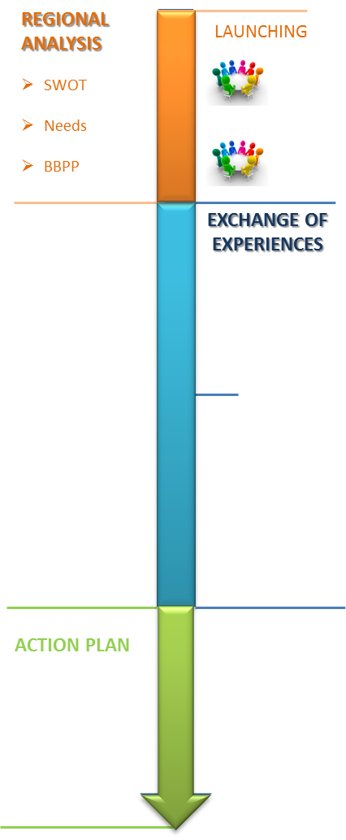This document is intended to provide a methodological framework for boosting Low Carbon Innovative Building Rehabilitation in European Regions and the selection of best practices to be done at a regional level.
In the framework of BUILD2LC: Regional Assessment, partners are required to identify the specific territorial needs related to low carbon innovative energy retrofitting of the building sector.
In line with the project's objectives, this analysis will take into particular account these topics:

- Professionalization of the construction sector
- Innovation
- Activation of demand and combating energy poverty
- New financial instruments

These guidelines will be used in the BUILD2LC project to assist the partners in drafting their own regional SWOT analysis, identification of needs.
This document also provides the partners with the templates to collect the information requested. The methodology proposed is oriented towards results being achieved. That is why these guidelines have been produced following the project deliverable structure, in order to ensure that all relevant aspects have been taken into account.
It is worth reminding that the present document focuses only on the regional assessment stage (from June 2016 to September 2016).

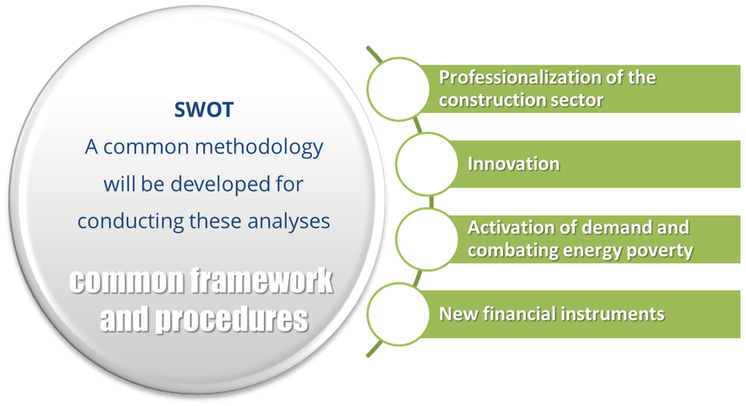

State of Art. Regional contextualization.

Objective:
To describe the starting scenario and the scope of energy rehabilitation in buildings in your region, focusing on regional needs:
- What is the region or specific territory to be analyzed?
- Pay attention on your “territorial context”
- How is buildings energy rehabilitation connected to the RIS3 (Smart Specialization Strategy) in your region?
- How is the current national and regional planning affecting your region, as well as –if available- future planning and expected policies 2014-2020 in the region?
- Main energy/buildings legislation (including national laws) affecting your region.
- Main financial and fiscal support at national and regional level
- Brief description of your regional market of Construction and Buildings
- Main related clusters, associations, technological centers, innovation nodes.
- Brief description of the professional status of your regional market

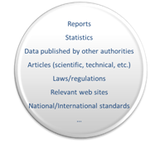Recommendation:
- Start outlining your best practices at this stage (event though you are at very beginning of the process).
- Try to characterize the sector at regional level both from the DEMAND and the SUPPLY side.
- Try to keep record of your sources of information or data used for this section (reports, statistics, websites, etc.). They will have to be mentioned in your deliverable.

SWOT Analysis

Objective:
To analyze regional strengths, weaknesses, opportunities and threats to determine where the region stands on these four key strategic areas to better determine what changes to make (when needed).

- Internal perspective: regional strengths and weaknesses on the basis of the previous analysis results.
  - Strengths: characteristics of the business that give it an advantage over others.
  - Weaknesses: characteristics that place at a disadvantage relative to others.
- External perspective: opportunities and threats at a national and international level, if any. On the basis of the information collected about target markets and trends, regulatory framework, R+D+i context, service suppliers, etc.
  - Opportunities: elements that could be exploited to its advantage.
  - Threats: elements in the environment that could cause trouble.

Strengths  - What are your advantages?  - What do you do well?  - What relevant resources do you have access to?  - What do other people see as your strengths?  Consider this from your own point of view and from the point of view of the stakeholders. Do not be modest. Be realistic. If you are having any difficulty with this, try writing down a list of your characteristics. Some of these will hopefully be strengths. | Weaknesses  - What could you improve?  - What do you do badly?  - What should you avoid?  Again, consider this from an internal and external viewpoint: Do other people seem to perceive weaknesses that you do not see? Are other regions doing any better than you? It is best to be realistic now, and face any unpleasant truths as soon as possible.
Opportunities  - Where are the good opportunities in front of you?  - What are the interesting trends you are aware of?  Useful opportunities can come from such things as:  - Changes in technology and markets on both a broad and narrow scale  - Changes in government policy and EU requirements  - Changes in social patterns, population profiles, lifestyles, etc.  A useful approach to looking at opportunities is to look at your strengths and ask yourself whether these open up any opportunities. Alternatively, look at your weaknesses and ask yourself whether you could open up opportunities by eliminating them. | Threats  - What obstacles do you face to get the results you want?  - Are the required specifications changing?  - Do you have bad financial problems?  - Could any of your weaknesses seriously threaten your plans?  Carrying out this analysis will often be illuminating - both in terms of pointing out what needs to be done, and in putting problems into perspective.

Recommendations:
- SWOT is not valuable unless a rigorous discussion takes place with background insight, and unless the analysis reflects the final views of the region. That is why Regional Authority’s support and stakeholders involvement is crucial at this stage (stakeholders’ group meetings). The findings resulting from this analysis should be circulated among, complemented and agreed by the regional stakeholders.
- A major purpose of any strategic discussion is to arrive at a deeper level of insight. Any response to threats and opportunities must be based on an intimate knowledge and understanding of the region's strengths and weaknesses.
- Each partner will provide information for a single SWOT (Strengths, Weaknesses, Opportunities, and Threats) analysis of their region, concerning the definition of the content of the thematic analysis (needs/expectations/experiences) on:
  - Professionalization of the construction sector
  - Innovation
  - Activation of demand and combating energy poverty
  - New financial instruments
- Main barriers and constraints to energy rehabilitation of buildings in their region should be identified.
- Take advantage of the Participatory round-table at your own Stakeholders regional breakfast meeting to raise the matters and get information. To start and boost the analysis, a methodology, including an indicative draft agenda as a guide for the meeting, was delivered by the LP to assist you.
- Main Key issues concerning the BUILD2LC topics project
- Main questions concerning SWOT of the region.
- Role of the Regional Stakeholder Group concerning the draft or ideas for the SWOT Analysis.

Needs

Objective:
Having the list of needs in energy rehabilitation in buildings of the region from the state of art and SWOT analysis.

Recommendations:
- Each partner will provide information for a single list of needs of their region. The list can be prioritized in order of importance.

Annexes
Annex 1. Template Regional SWOT analysis and identification of needs

- It is very important that the analysis reflects both perspectives. We need to know what is being demanded and what is being supplied in order to identify the actual needs.

