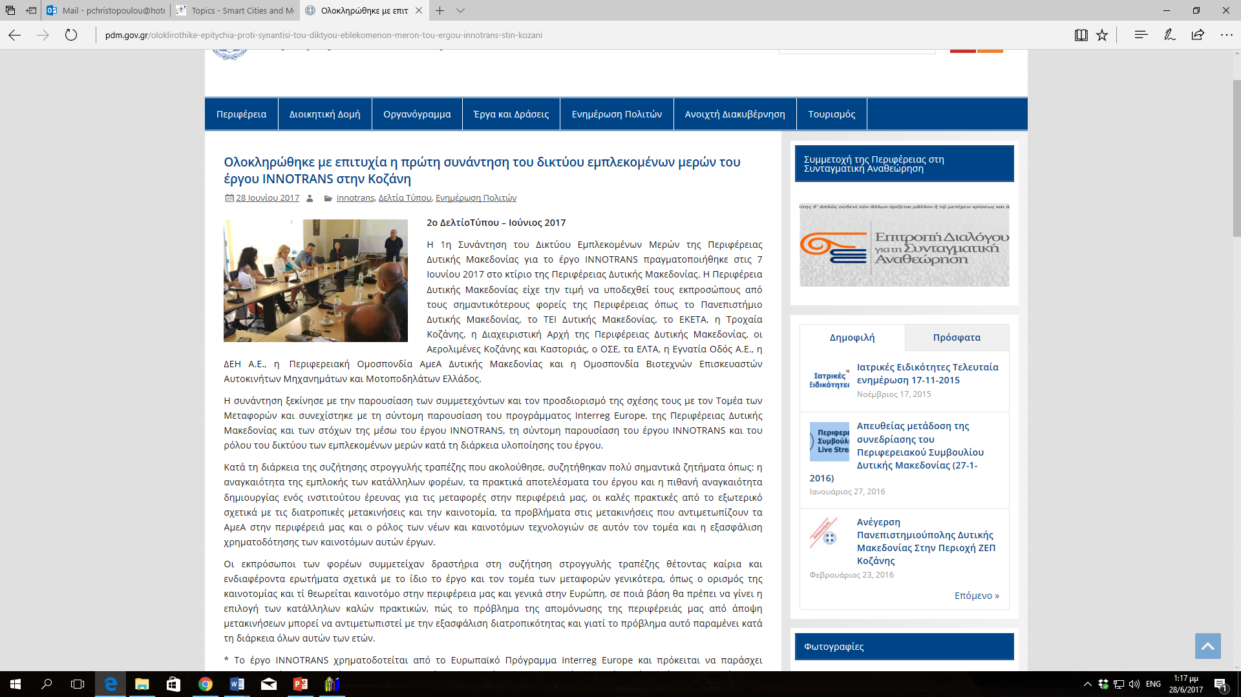
http://www.pdm.gov.gr/oloklirothike-epitychia-proti-synantisi-tou-diktyou-eblekomenon-meron-tou-ergou-innotrans-stin-kozani/
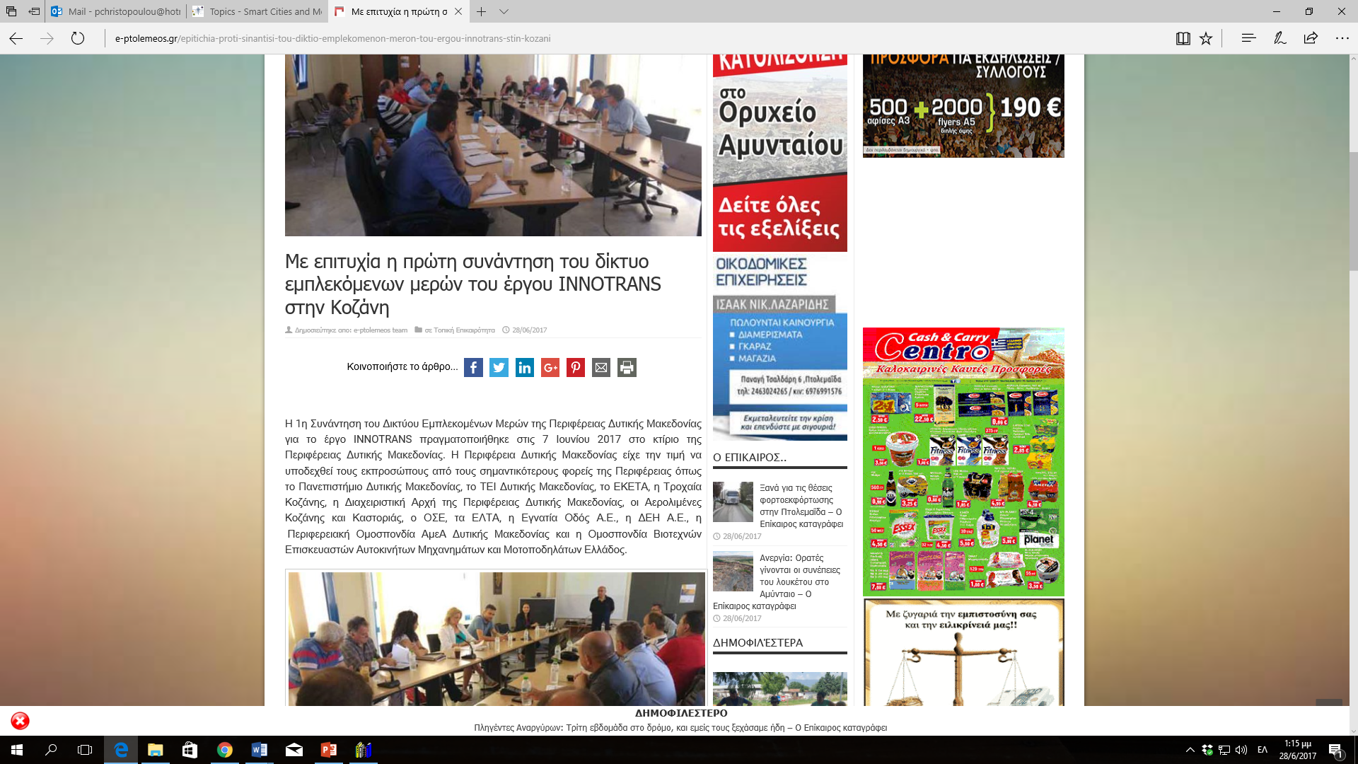
https://e-ptolemeos.gr/epitichia-proti-sinantisi-tou-diktio-emplekomenon-meron-tou-ergou-innotrans-stin-kozani/
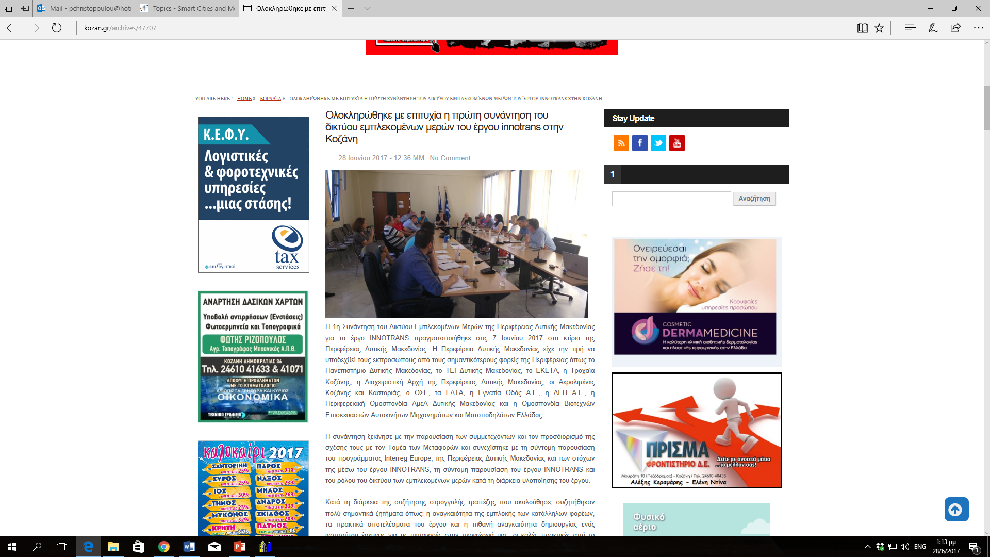
http://kozan.gr/archives/47707
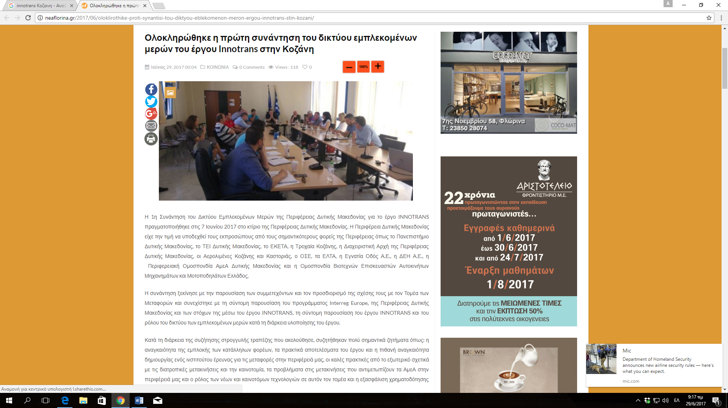
http://neaflorina.gr/2017/06/oloklirothike-proti-synantisi-tou-diktyou-eblekomenon-meron-ergou-innotrans-stin-kozani/
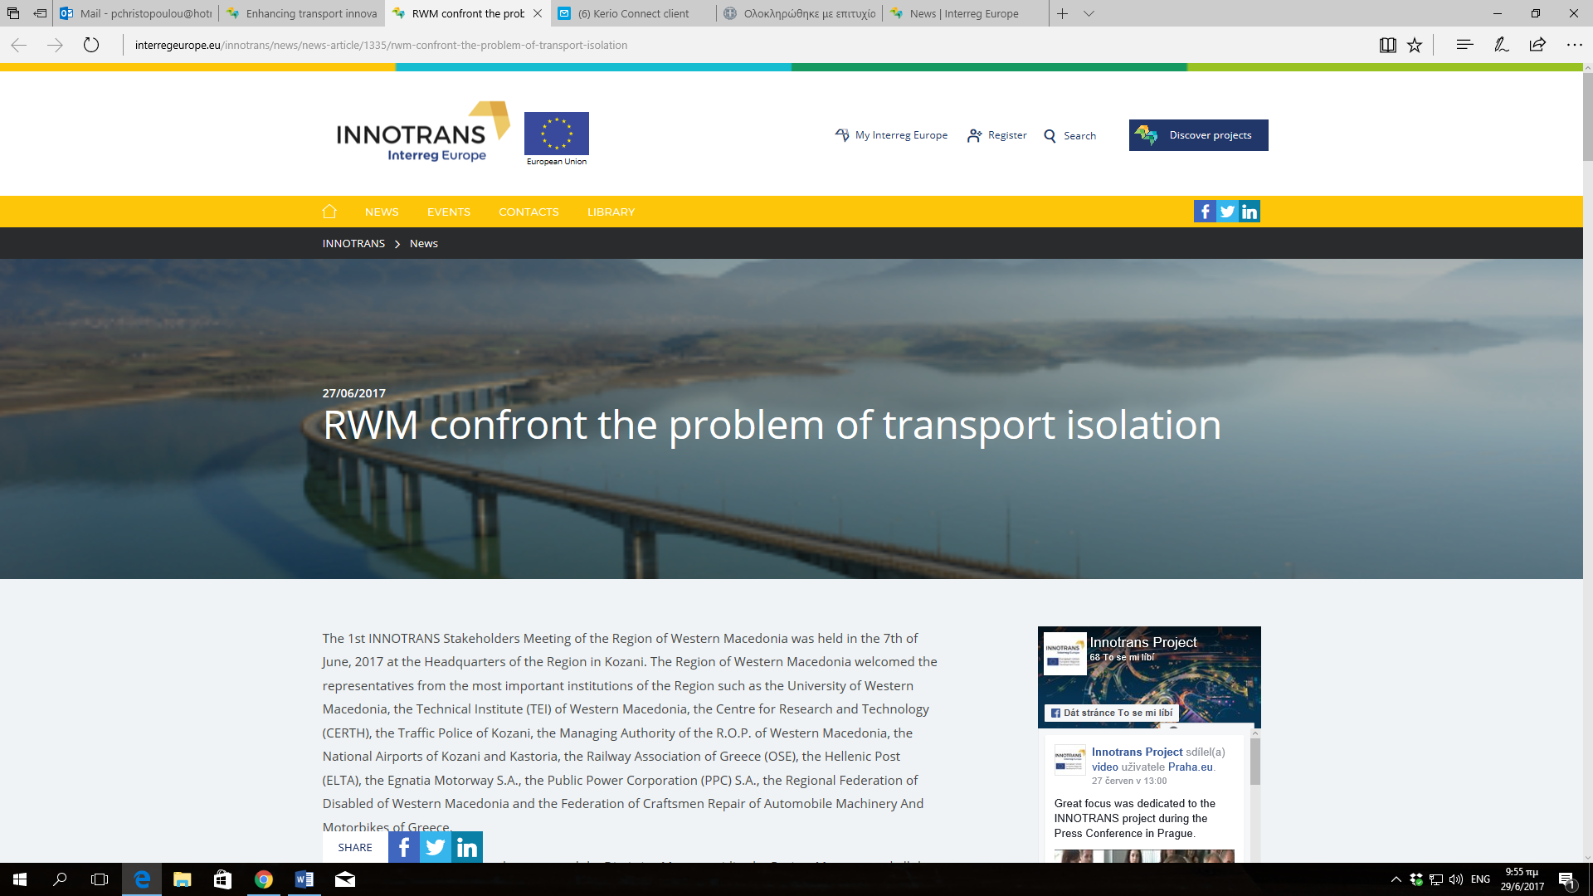
https://www.interregeurope.eu/innotrans/news/news-article/1335/rwm-confront-the-problem-of-transport-isolation/

