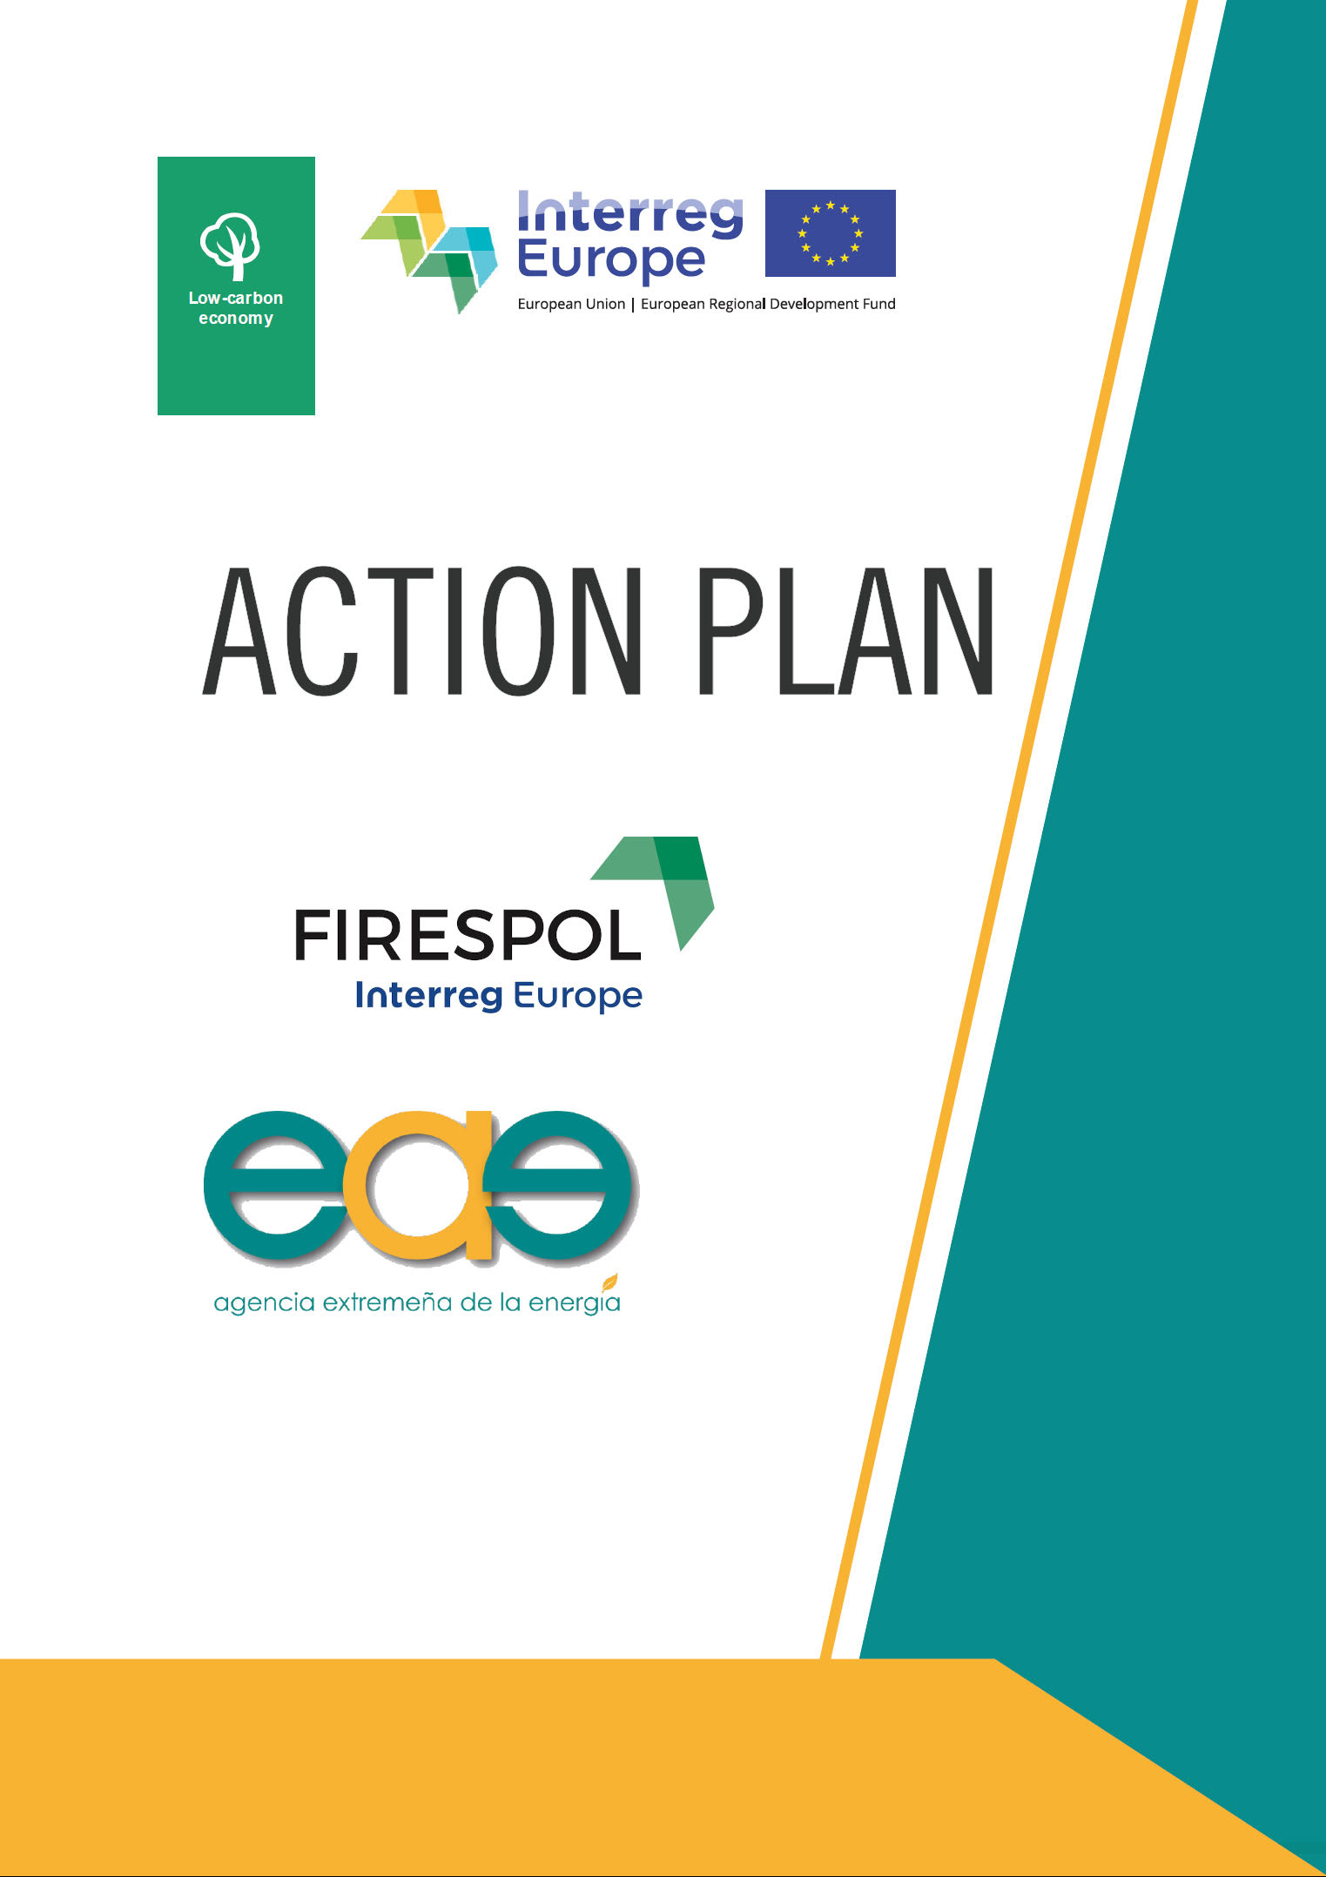
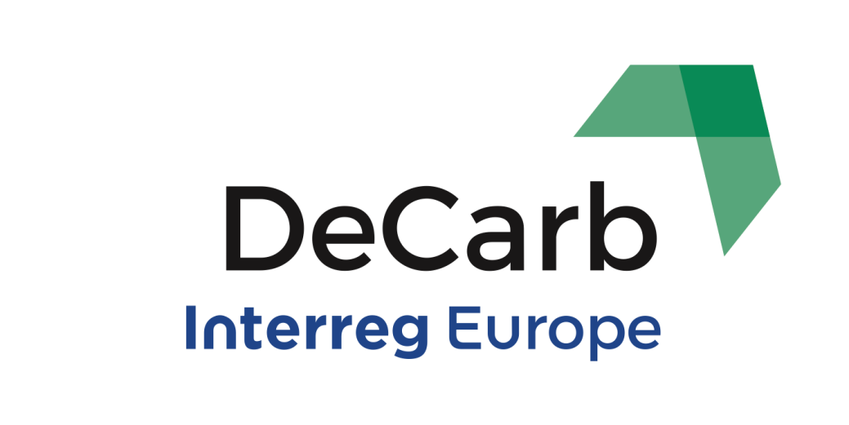
PORTADA
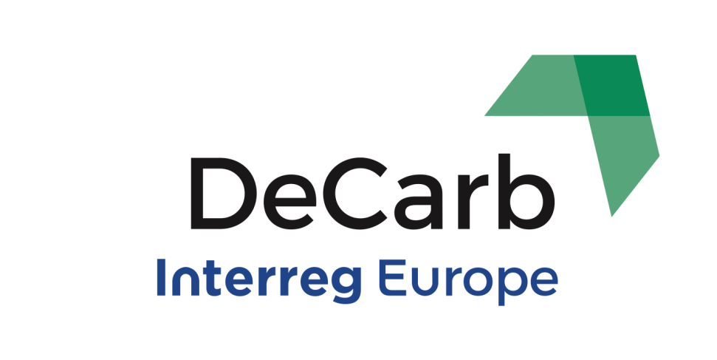
Implementation timeframe:
June 2021-May 2023

GENERAL INFORMATION
Project: DECARB

Partner organisation: Extremadura Energy Agency (AGENEX)
Other partner organisations involved (if relevant): Directorate General for Industry, Energy and Mines Regional Ministry for Ecological Transition and Sustainability. Extremadura Regional Government
Country: Spain

NUTS2 region: Extremadura (ES43)

Contact person: Rachel Claire Tully
email address: rctully@agenex.net
phone number: +34 924 262 161

This action plan has been design by Extremadura Energy Agency (AGENEX). The foreseen actions in it will be carried out with the coordination of the DG for Industry, Energy and Mines of Junta de Extremadura.

Action Plan DECARB – Extremadura Energy Agency
DECARB “Supporting the clean energy transition of coal-intensive EU regions” aims to support the transition from the carbon-intensive era towards the clean energy future, securing sustainable development, economic and societal stability, and a role in the 2030 energy mix.
DECARB project was approved under Interreg Europe’s third call and was funded with a total budget of Euro 1,967,112.00. Its implementation period began in June 1, 2018 and will end in May 31, 2023. The lead partner is the Regional Economic Development Agency of Stara Zagora (SZREDA), in Bulgaria, and the partnership is composed by eight more project partners:
PP2. Lodzkie Region, in Poland
PP3. Eszak-Alfold Regional Energy Agency (ENEREA), in Hungary
PP4. South-West Oltenia Regional Development Agency, in Romania
PP5. Ministry for Economic Affairs and Energy of Brandenburg, in Germany
PP6. House of Energy, in Denmark
PP7. Regional Association of Local Governments of Western Macedonia, in Greece
PP8. Energy Agency of Savinjska, Saleska and Koroska (KSSENA), in Slovenia
PP9. Extremadura Energy Agency (AGENEX), in Spain
DECARB supports partner regions by:
- Increasing the knowledge and abilities of public authorities and employees of Partners to define stable paths for the development of the post-carbon economy
- Planning the needs of the labour force retraining and land development after the end of coal mining
- Promoting the public dialogue to resolve conflicts and consensus building on the clean energy transition, involving the energy sector, social partners and citizens
- Increasing the awareness of public authorities and employees of Partners about the need to plan in advance a new energy mix (change in the share of various sources of energy production.
The general goals that are related to decarbonisation and that hope to be achieved throughout the project include:
- focusing the policy on modernizing the energy sector and replacing all fossil fuels
- release of investments and financing of renewable energy sources
- increasing the use of renewable energy sources (RES)
- increasing the environmental balance in coal-based mining
- provisions of skills and expertise in clean energy development through retraining
- strengthening the economic and social cohesion of regions by reducing the negative effects of decarbonisation processes
- tackling the negative economic impact and job loss
- supporting bottom-up synergies with the private sector
- increasing economic stability through the application of integrated support measures for regions
- adopting a local impact perspective by providing effective legal and technical support to entities operating in the region and implementing activities related to decarbonisation
- harmonizing the objectives of the regional energy policies with the EU policy in this area
With these goals in mind, each region that composes the consortium will develop their action plan and will implement it during the project’s second phase. This AP document will provide details on how the lessons learnt from the cooperation will be exploited to improve the policy instrument tackled within the regions. It will specify the nature of the actions to be implemented, their timeframe, the players involved, the costs associated and the funding sources.
The AP is the key document elaborated throughout the project, and it will integrate conclusions from the joint thematic studies and analysis; the stakeholder policy learning; the interregional learning and the capacity building. All this will develop in long-lasting results and impacts in Extremadura region.
For Extremadura, this action plan will help develop a comprehensive and effective regional policy to support and improve the process towards the energy transition; as well as funding schemes that will make this possible. This will be achieved through two objectives: (1) implementing new projects in Extremadura, and (2) achieving an improved management.
The development of the action plan for Extremadura has been based on the collaboration of those entities involved and capable of playing a key role in improving and “greening” the region’s energy system. The regional government, Junta de Extremadura, has participated and supported at all time the work developed by AGENEX. Input and assistance has also been provided by Extremadura’s Energy Cluster and by the University of Extremadura, among other relevant stakeholders for this project, as well as some help from external experts that have been hired for this specific matter.
The conclusions drawn from the ex-ante analysis of the social and economic impact of decarbonising the region are:
- In Extremadura the renewable electric production is higher than the region’s electric consumption; contributing significantly to greening the energy mix at national level.
- The main energy production in the region, as well as the one produced by renewable sources, is the nuclear power plant located in the north of Extremadura. This implies that the emissivity associate to the energy mix is low and decreasing as the share of RES is increasing.
- The most relevant emissions come from fossil fuels used in industrial processes, agro industry, transport and buildings, being these sectors the problem identified and in which the actions of this AP should focus on.
- The closure of the nuclear power plant is in the regional government’s agenda, meaning that a roadmap is needed to establish the phasing out of the plant and the socio-economic impact this would have in the area.
- The regulation that will enter into force related to the taxation on GHG emissions will severely affect the industry in the region and therefore the employment. This problem is highlighted in the tomato industry and has been identified throughout the project; therefore the AP will aim at seeking a solution for this problem.
Based on these conclusions and the actions defined, the overall goals that will be achieved with the implementation of this AP are: (i) to reduce the CO₂ emissions in the region activities that are the main generators; (ii) to increase the regional competitiveness in these areas and (iii) to ensure the safety, efficiency and independency from an energy point of view. Achieving these goals will help achieve the specific objective of decarbonising the energy system.

POLICY CONTEXT
The Action Plan aims to impact: Investment for Growth and Jobs programme
€ European Territorial Cooperation programme
Other regional development policy instrument
Name of the policy instrument addressed:
- ROP ERDF 2021-2027 Extremadura
The addressed policy instrument is the Regional Operational Program ERDF for Extremadura 2021-2027, and in particular addressing Thematic Objective 4: supporting the shift towards a low-carbon economy in all sectors.
This Investment Priority 4c supports energy efficiency, smart energy management and renewable energy use in public infrastructure, including in public buildings and in the housing sector. The increase in EE and the use of renewable energy in different sectors are two key aspects to achieve the reduction CO₂ emissions and reach a decarbonized energy system.

- PEIEC 2030, Integrated Energy and Climate Plan for Extremadura
The regional energy and climate plan, Plan Extremeño Integrado de Energía y Clima 2030, has set the clean energy targets to be met by 2030 but has not established how these goals will be reached. The measures and most importantly, the flexibility of these measures, based on the impacts that are being achieved, will be monitored and improved by AGENEX, together with the Regional Ministry for Ecological Transition and Sustainability.
As it will be explained in this Action Plan, AGENEX will improve the specific objectives in these policy instruments through different actions that will be implemented in the second phase of the project, from December 2021 to May 2023. Even if it is not addressed specifically, the actions developed will improve the governance of its implementation.

- Spanish Recovery Plan
The national recovery, transformation and resilience plan España Puede was approved in 2021 to mitigate the effects of COVID19 in Spain. An important percentage of these funds are destined to energy-related actions and they won’t be managed at national level but distributed to each region. Therefore, each regional government has a certain flexibility to make the most out of the funds received, even if these funds are national.

Main stakeholders involved:

- Extremadura Energy Agency
The Energy Agency of Extremadura (AGENEX) is a public entity, set up by regional and local entities of governmental and training nature, created in 2001 in order to promote the energy source diversification and the energy efficiency in Extremadura.
Its main mission is to support local and regional policy makers in the definition of strategies and directives allowing to achieve Regional, National and European targets in the field of energy. AGENEX seeks to boost the implementation of green technologies (both Renewable Energy Sources and Energy Efficiency) in the day to day of citizens, by promoting RTD projects, funding sectorial initiatives, supporting project promoters, etc. One important mission of AGENEX is the awareness-raising of general public, customers, users and decision makers of the entire society, in all issues concerning the energy transition and climate change mitigation.

- Regional Ministry for Ecological Transition and Sustainability. DG Industry, Energy and Mines. Extremadura Regional Government.

Junta de Extremadura is the public institution responsible for the regional government of Extremadura, Spain. At regional level, it is the highest-ranking organism in policy making and regional planning; and in the field of energy, this is done by the DG for Industry, Energy and Mines.
It is a government very committed with clean energy and it has a significant experience in innovation actions and initiatives in the field of energy efficiency promotion and innovative financing for Renewable Energy Sources.
DG for Industry, Energy and Mines has direct competencies in industrial promotion, energy generation, energy distribution, industrial management and mines. More precisely:
A) Energy planning, in accordance with the Spanish national energy regime.
B) The promotion of renewable energies.
C) Improvement of Energy Savings and Efficiency both in generation and consumption.
D) The management and control of the security in the industrial, mining and energy sectors.
E) The registration of companies in these sectors, as well as the inspection and sanctioning procedure of such activities.
F) Control of the quality of the electricity supply.

Additionally, it is responsible for launching and managing different support schemes, grants and programmes with the aim of promoting energy efficiency and renewable energy in various sectors of Extremadura region.

DETAILS OF THE ACTIONS ENVISAGED
Once the learning phase of the project has been completed, all the activities related to the exchange of experience have been carried out and the conclusions from the lessons learnt have been drawn; the actions that are included in the action plan for Extremadura have been defined. The main aim of this action plan is to implement those actions that are necessary to decarbonize the energy system as soon as possible and in the most efficient way.
In order to reach this final goal, while contributing to a fair and efficient energy transition, the plan includes actions and sub-actions to promote specific energy projects and potential schemes that will allow their implementation.
The OP recognises regional achievements on renewables, and pursues the further decrease of fossil-fuel dependency. Nonetheless, it leaves out of the picture other problems of the energy sector identified in the region: economic unsustainability and drop of clean energy jobs, dependency of fossil-fuels still exists in some sectors or the rapid increase in GHG emissions’ taxation that could endanger the little industry that is placed in Extremadura. Therefore, the expected improvements of the policies addressed are related to:
- Stimulate the deployment of new technologies and new mechanisms for clean energy projects, to bring down supply costs and create/maintain jobs.
- Provide regulatory support for economic and investment models that can make renewable energy sustainable.
Therefore, three main actions have been defined to reach the region’s objectives of becoming green and sustainable in the short and medium term:
- Development of an advisory office for the energy transition in Extremadura. This office will monitor the implementation of the PEIEC with the flexibility of adapting or changing measures originally planned, based on the impacts achieved. It will also provide information to the citizens, enterprises and municipalities on public funds and/or financial instruments available in the region to help face investments in Energy Efficiency and Renewable Energy projects in Extremadura; including advice on carbon capture and CO₂ emissions.
- Launch of a call for proposals that addresses the different sectors. Particularly, including a budget line for the regional industry to support the use of renewable energy as a solution to the problems and tax increase associated to CO₂ emissions.
- Definition of a regulatory framework that will encourage the creation of energy communities with renewable energy generation, including or not local authorities as part of these communities (public-private or private-private).

ACTION 1 – Development of an advisory office for the energy transition in Extremadura using improved ROP policy instruments
BACKGROUND
The inspiration for this action came from more than one partner in the consortium. On one hand, KSENNA (Slovenia) shared a good practice related to a new office established in the Municipality of Velenje that focuses on projects related to decarbonisation, prioritizing a sustainable economic development.
Additionally, the Green Hub Denmark experienced shared by the Danish partner House of Energy, goes a step further as it doesn’t only act as a key driver for decarbonizing the region, but it also encourages public-private collaboration. The potential for transfer is clear not only for Extremadura but for many other regions that are willing to achieve the climate objectives set for 2030 and beyond. The office will act in a similar way to this platform, as it will also connect relevant actors in the decarbonisation process; gathering information from the public sector on grants and support schemes, offering support to the potential beneficiaries and the general public of the possibilities available; and connecting private companies to develop the technologies needed for the energy transition.

ACTION
The first action consists on the development of a regional advisory office for the energy transition in Extremadura. This office will monitor the implementation of the PEIEC with the flexibility of adapting or changing measures originally planned, based on the impacts achieved and the region’s needs. It will also provide information to the citizens, enterprises and municipalities on public funds and/or financial instruments available in the region to help face investments in Energy Efficiency and Renewable Energy projects in Extremadura; including additionally advice on carbon capture and CO₂ emissions, increasing the competitiveness of those industries that are highly affected by changes in carbon regulation and taxes.
The activities or sub-actions needed to carry out this action are:
Activities:
  - Reaching the final agreement between AGENEX and Junta Extremadura for establishing the conditions of the advisory office
This task started in mid-2021 although the advisory office will not be established and operating until beginning of 2022. There have been several periodic meetings between the Regional Government, as the Managing Authority and AGENEX, as public entity that has been appointed to manage the office. This agreement was reached at the end of 2021.
  - Definition of the different activities and services provided
The advisory services and support will be provided to three groups of beneficiaries: to the general public to reach all citizens, to private actors and enterprises, and to public authorities at local and municipal level. This support will be given from a technical point of view, but also by offering the existing funding opportunities to face the investments in sustainable energy.
The sectors that will be addressed through this office are all those related to the energy transition in the region: energy efficiency, renewables, sustainable mobility, CO₂ reduction or green and circular economy.
  - Setting-up the office and its infrastructure
This office will allow centralizing all the different support schemes available: regional ERDF funds, national Recovery funds and any other financial mechanism available. It will also provide specific information depending of the type of project: sustainable mobility, energy retrofits in buildings, integration of RES for self-consumption in the residential, public and industry sector.
  - Launch of the virtual advisory office
Once the office and the specific services offered have been established, AGENEX will be responsible for its implementation and management through a mandate of the Regional Government. It will compile all the relevant information regarding open and upcoming calls for grants, consultation forms and links of interest.

PLAYERS INVOLVED
The main players involved in this action are: AGENEX as the responsible entity of managing the advisory office, dedicating staff to provide the service and updating the information and the calls available; the DG for Industry, Energy and Mines of the regional government as the funding body of all the interventions related to renewable energy and sustainable mobility; the DG for Architecture of the regional government as the funding body related to energy retrofits in buildings. For specific actions included in the PEIEC plan, it could be possible that other departments of the regional government could be involved and would work jointly to achieve the best results possible.

TIMEFRAME

COSTS
The costs associated to this action will be the staff costs involved in the advisory office to provide the support to citizens, companies, industry and public local authorities. It is estimated to have at least two technicians working full time, therefore approximately 60.000€ per year. The necessary infrastructure to implement the office will also be provided by AGENEX.

FUNDING SOURCES
The aim of this action is to make a better use of the funds available, ensuring they reach the entire region and its citizens. This improvement in the management includes combining the use of two funding sources: from the ROP ERDF 2021-2027 Extremadura and the national Recovery Funds from the España Puede Plan.

ACTION 2 – Improved call for proposals with a specific budget line that contributes to the decarbonisation in the industrial sector.
BACKGROUND
There are two problems identified throughout the project that seek to be solved by implementing this action: one is the long period that occurs from the time a grant application is submitted until the beneficiary receives the communication of approval, and the second relates to the high impact that agroindustry has in CO₂ emissions. Agriculture and agroindustry are the main responsible sectors for CO₂ emissions and therefore should be targeted to decarbonize the region.
During DEACRB’s exchange of experience in Aalborg (Denmark) in September 2021, one of the learnings discussed where related to how in other regions the application for grants is done completely in a digital form, and it allows each submission to be assess and approved or denied without having to wait for the call to close and be resolved at the same time. This accelerates the process significantly.
Additional learnings came from a good practice identified by the Ministry for Economic Affairs and Energy of the State of Brandenburg: the institute dedicated to reduce emissions in industrial processes, due to their high impact and the potential for reduction. This situation has a lot of synergies with the situation of the agroindustry sector in Extremadura.

ACTION
The second action is the launch of a call for proposals that addresses different sectors. Particularly, including a budget line for the regional industry to support the use of renewable energy as a solution to the problems and tax increase associated to CO₂ emissions. The call management will be improved by the Regional Government even if the funds are coming from the COVID recovery plans.
The activities or sub-actions needed to carry out this action are:
Activities:
  - Frequent meetings with the Managing Authority
Since the Phase 1 of DECARB project was coming to an end, AGENEX has held periodic meetings with the Regional Government to define the details of the actions to be included in Extremadura’s AP. Before the approval of the 6 months extension, the meetings were planned since March 2021 to July 2021, but additional meetings have been included during this extended period.
  - Call preparation and eligibility conditions
This activity is one of the most important ones to be able to implement this action, as the aim of it is not to only launch the call but to do so in an improved way. The improvements that will be included in the process are the following: related to the digitalization of the submission and related to the call resolution. Until now this is done following a scheme of subsidies awarded on a competitive basis but it would accelerate the process if it was done on a successive basis. Implementing this would facilitate and speed up the procedure.
  - Launch of the call
The call will be launched by the end of November 2021 and will be open until November 2023. The successive resolution will allow monitoring the cumulative impacts at the end of DECARB project.
  - Deadline for applications
The final deadline to apply for the grants is November 2023. This extended period will increase the number of applicants and will allow the entire budget to be requested. The results achieved in the project will be counted until the end of DECARB in May 2023.
  - Call resolution and expected investments
All applications will be resolved once they are submitted. This means that each case will be reviewed and approved or denied shortly after it is presented; allowing the process to be a lot faster and easier for potential beneficiaries. Until now, the administration had to wait for the call to be closed before being able to assess the cases.

PLAYERS INVOLVED
The key player involved in this action is the Regional Ministry for Ecological Transition and Sustainability of the Regional Government of Extremadura. It is the entity responsible for preparing and launching the call as well as the fund manager. The department through which this will be canalized is the DG for Industry, Energy and Mines. And AGENEX will provide the technical advice and support to make the call as efficient as possible, reaching the target group in which the problem has been identified and acting as technical assistance in the different activities that are needed to reach a correct action implementation.

TIMEFRAME

COSTS
The costs are mainly staff costs from the regional government. As the action is part of the work contemplated under the tasks of an entity like this, no additional costs will be considered. The staff costs for AGENEX to offer the technical support are not relevant as this support will only be given during the preparation of the call text and conditions.

FUNDING SOURCES
The funding sources are managed by the regional government of Extremadura but come from national level as part of the Recovery Funds received from the EU. The amount available for grants to invest in renewable energy which will improve their procedure before the end of DECARB project amounts to approximately 4M€. This includes private beneficiaries in the residential, entrepreneurial and industrial sector.
The improvements done to the call procedure are specific for the regional government and its ROP so, this improvement will be applied to all future calls regardless where the funds come from.

Date:____________________

Signature: _______________________

Stamp of the organisation (if available): ____________________________________

