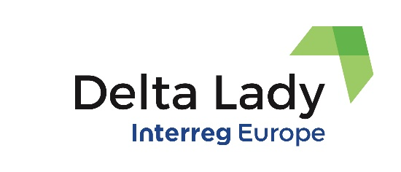
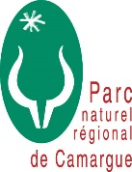
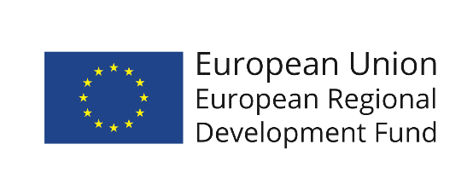

Action Plan for the Regional Natural Park of Camargue

Part I – General information
Project: Delta Lady – Floating cultures in River Delta
Partner organisation : Parc Naturel Regional de Camargue
Other partner organisations involved (if relevant):
Country: France
NUTS2 region: Provence-Alpes-Cȏte dÁzur
Contact person: Stephan Arnassant: s.arnassant@parc-camargue.fr
Dorine Mathieu: d.mathieu@parc-camargue.fr
Phone number: 0033+490971040

Part II – Project background and Policy context
The Action Plan aims to impact: € Investment for Growth and Jobs programme
€ European Territorial Cooperation programme
X Other regional development policy instrument

Name of the policy instrument(s) addressed: Charter of Commitment of the Camargue Regional Natural Park

- Project background

The Regional Natural Park of Camargue (PNR) is one of the partners of the Delta Lady project which aims to improve the regional policy instruments in delta regions to foster the capabilities of using ecosystem services in river deltas to strengthen regional economy.
Six delta regions that participate in the project are Rijn delta from the Netherlands, Camargue delta from France, Danube delta from Romania, Albufera delta from Spain, Po delta from Italy, and River Blackwater delta from Ireland. Nine partners from six countries represent a mix of regional and local public authorities as well as education and research institutes:
- University of Twente, the Netherlands (Lead Partner)
- Province of Fryslân, the Netherlands
- Regional Natural Park of Camargue Delta, France.
- Danube Delta National Institute for Research and Development, Romania
- ART-ER Emilia-Romagna Joint Stock Consortium Company, Italy
- Po Delta Park, Italy
- Council of Chambers of Commerce, Industry, Services and Shipping of Valencia Region, Spain
- Cork County Council, Ireland
- University College Cork, Ireland

The first phase of the project is dedicated to the interregional learning of partners and development of action plans, while the second phase is dedicated to the implementation and monitoring of the action plans developed by each delta region.
The policy instrument addressed by the Regional Natural Park of Camargue is the Charter of Commitment of the Camargue Regional Natural Park.
The improvement of this policy instrument is envisaged by its adaptation and integration of the pesca tourism into the draft Charter by the end of the project.

2) Policy context

The Regional Natural Park of Camargue (PNR) is one of the oldest Regional Natural Parks, the first Regional Natural Park of the South Provence-Alpes-Côte d'Azur Region, the third on the national territory, which officially came into being on 25 September 1970.
Open to the Mediterranean, the territory of the Regional Natural Park of Camargue covers three communes: Arles, Saintes-Maries-de-la-Mer and Port-Saint-Louis-du-Rhône. It covers more than 100,000 ha. and 75 km of seafront.
The PNR is a rural territory, open and inhabited, with a fragile balance, with a remarkable heritage. There is a place experimentation and consultation where nature conservation and development of human activities go hand in hand. Its purpose is to protect and bring to life the natural heritage, cultural and human aspects of its territory to build its future.
The operation of the park is ensured by about forty employees, the elected officials, the representative residents and socio-professionals to the Park Council.
For more than 10 years, the Camargue Regional Natural Park, in partnership with the inhabitants, the communities and the State, has been developing actions of knowledge, awareness and preservation of the marine environment and the traditional trades associated with Natura 2000 sites, marine reserve or fishing quarter, biotope protection zone and biosphere reserve. Each designation covers a specific management and animation method, a regulatory or consultation framework.
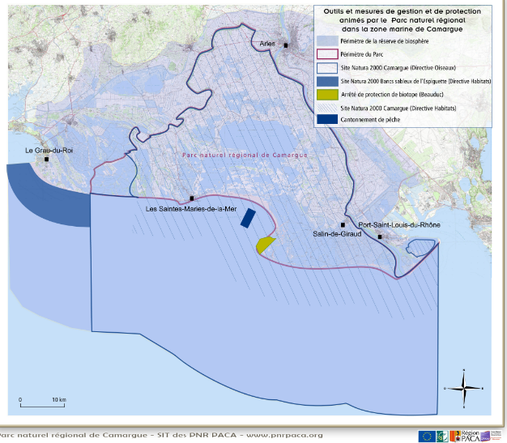

National context
Unlike the National Parks, the Regional Parks have no specific regulatory frameworks but a charter. Therefore, implementation of the Action Plan addresses the Charter.
The Action Plan with the Delta Lady project refers to the Charter of Commitment of the Camargue Regional Nature Park. The charter of a Regional Nature Park is the contract that concretizes the protection and sustainable development project drawn up for its territory. The territory of a Regional Nature Park is approved by decree of the Prime Minister taken on report of the Minister in charge of the Environment, for a renewable term of 15 years. It is managed by a mixed syndicate comprising all the communities that approved the Park charter.
The charter ensures consistency and coordination of actions carried out on the territory of the park by the various public communities. It engages the local authorities - the municipalities, the EPCI (Public establishments for inter-municipal cooperation), the Department(s) and Region(s) concerned - who have adopted it, as well as the State, which approves it by decree. The commitments of the State appear also in the charter. All the actors make up the committee union. In Camargue, the committee meets every two months to validate the various projects and the financial means attached to them.
The charter "materializes" the Park's territorial project. It determines the orientations of protection, enhancement and development of the territory in which the Park operates and the measures allowing them to be implemented.

The Aim of the Action Plan
The aim of the Action Plan is adaptation of the charter. Any adaptation of the charter needs a laborious procedure. At least three and a half years before the deadline validity of the charter, a procedure for renewal of the park classification must be initiated by the Region(s) concerned. This procedure is based on the revision of the charter by the Park, in view of evaluation of its previous actions and the analysis of the evolution of its territory. This allows to define a new project for the territory and to request a new classification decree. Hence, if the changes are successfully implemented, they are anchored for many years.

The revision of the charter is initiated by the Provence-Alpes-Côte d'Azur Region based on the Action Plan and led by the Regional Natural Park of Camargue in conjunction with its institutional partners and local stakeholders.
The revision will take place in 2 main phases between 2022 and 2026:
- Evaluation of the work carried out by the park since 2010 and analysis of the evolution of the territory.
- Construction of the territory project: definition of challenges and new ambitions.
- Proposal for implementation that is planned within Delta Lady project for the period of 2022-2023.

As part of the Delta Lady project, the Camargue Nature Park’s aim is to include pesca tourism in the future charter. As the process is long, it was proposed to elected officials during the meeting of the park committee union (February 2022) to record the integration of pesca tourism in the future charter by 2023. This proposal was adopted unanimously.
In Camargue, different fishing practices are observed in different places: in the sea, lagoons, coastline, gulf, and Rhône River. There has been a growing desire on the part of fishermen to structure themselves to propose tourist discoveries in order to have an additional financial income. Therefore, we considered important to think about structuring this activity so as not to damage natural resources. In addition, this should allow us to reduce the impact of human activities on areas already under pressure. Moreover, exchange of experiences with other partners during the interregional meetings of the Delta Lady project gave us more inspiration to focus on this action in our Action Plan.

The improvement of the Charter is seen in terms of inclusion of the pesca tourism in the draft of the future Charter.

The Park's current charter does not mention the use of some ecosystem services. Indeed, at the time of its writing, the question of the fishery resource (and the maintenance of reed beds) was not topical.
The reason for improving this charter is that there is currently no commitment regarding some aspects of the use of ecosystem services in deltas, which deserve to be developed and accompanied into their operational translation into projects.
Prepared in consultation with the inhabitants and users of the territory, the charter sets out the objectives to be achieved, the guidelines for the protection, and development of the park as well as the measures that enable to implement them. It ensures the coherence and coordination of the actions carried out on the territory of the park by the various public authorities.

This document is valid for 16 years, following a revision, currently a charter is in progress till 2026. PNR will contribute to the Charter in the process of its revision by introducing pesca tourism into the draft.

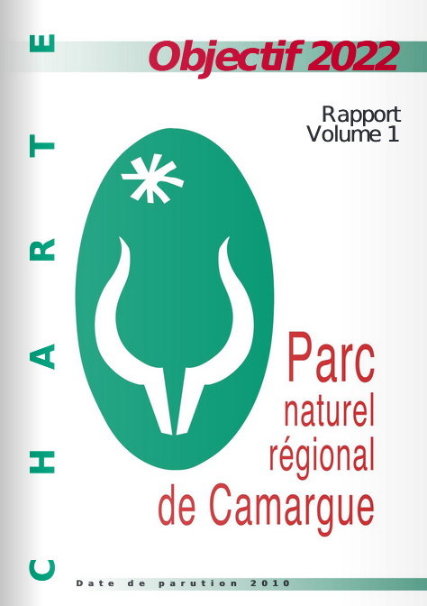

The charter is made up of several ambitions. Within the ambitions, several articles define the orientations that the Park wants to put in place.
The Charter must be validated by the Region. It is a strategic and political document.

The commitment of the Regional Natural Park of Camargue in the Delta Lady project allows to meet the following ambitions of the charter:
Guide the development of activities for the benefit of exceptional biodiversity
- Article 5: Sustain activities contributing to the maintenance and enhancement of the territory's biological heritage.
Promote fishing practices that respect resources and the environment
- Article 7: Engage the territory and its stakeholders in sustainable tourism

This charter must therefore be revised to be able to request the renewal of the classification of the territory as a PNR.
The revision procedure is subject to regulations specified in the Environmental Code.
Revising the charter consists in jointly constructing a new project for the territory, on the basis of preliminary studies. This draft charter is submitted to a public inquiry and then, after approval by the various communities, is submitted for the opinion of the National Council for the Protection of Nature, the federation of PNR then is the subject of an inter-ministerial consultation before '' be approved by decree classifying the territory as a PNR”.

For the period 2011/2026, the Camargue Regional Natural Park has set the following objectives:
- Manage the delta complex by integrating the foreseeable impacts of climate change,
- Guide the development of activities for the benefit of exceptional biodiversity,
- Strengthen territorial solidarity, social cohesion and improve the living environment
- Share knowledge and open the delta to Mediterranean cooperation.

The revision of the charter will begin in 2022. A review process is long, very structured and complex.

Four main stages punctuate a charter revision:

- The preparatory phase: definition of the study scope, organization of the methodology, resources, action report, official launch decision in conjunction with the Region and the State
- Development of the charter project: development and sharing of the diagnosis, assessment, consultation of elected officials, stakeholders and inhabitants of the territory to draft the strategic project, development of the Park plan and additional documents
- Intermediate validation: important phase of consultation with the various partners, mandatory intermediate opinions (National Council for the Protection of Nature (CNPN), Federation of Parks, Environmental Authority, etc.) which makes it possible to amend and enrich the project
- The final validation phase: after the public inquiry, it gives rise to membership deliberations and then to final examinations by the State before the signing of the Decree by the Prime Minister.

Through this commitment to the Delta Lady project, we aim to obtain results on the relevance of developing pesca-tourism. This therefore implies carrying out a diagnosis with the actors concerned and organizing specific monitoring of this activity.
Measures already exist on fishing activity:
- national rules: ban on taking fish in the cantonment, respecting a weight and size for fishing, reduced access to trawlers.
- regional rules (to come): project to create a regional reserve
The Park has no regulatory power over this activity. Its mission is organized under several themes:
- know and protect (surveillance, monitoring of different species, attendance counting, data collection and creation of inventories on the different environments and groups of species)
- Raise awareness (communication campaign for boaters, professional fishermen, etc.)
- Cooperate with other bodies.
The current Action Plan will improve the Park Charter by:
- integration of pesca-tourism in the new charter.
This implies the agreement of all the partners (fishermen, tourist office, regional and departmental tourism committee)
- new territorial projects
- improved governance in terms of structuring of governance specific to pesca-tourism:
- the development of new tourist and economic activities
- the recognition of ecosystem services within a Charter of Commitment

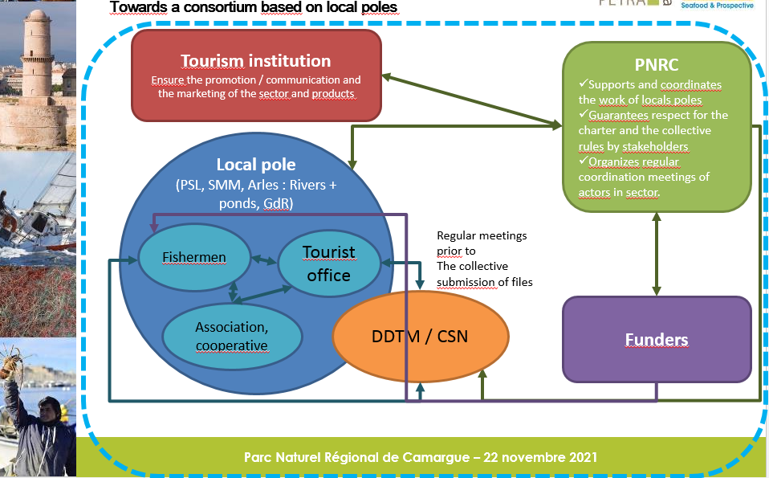

The Lessons learned
The Camargue Regional Natural Park is engaged in an INTERREG Delta Lady interregional cooperation project which aims to strengthen the economy in the Delta areas based on the natural and cultural capacities of the different regions.
The lessons were learnt from the exchange of experiences process during the 3rd partner meeting and interregional learning event of Delta Lady project in Po Delta Park in 2019 where the inspiration for the pesca tourism Action Plan came from. We could experience fishing activities in the Po Delta and how to promote a product (eel) and the related activities. Study visit to the Po Delta Lagoons of Comacchio Valley was a learning experience regarding the fishing activities.
The Good Practice of the Po Delta Park (Reinvestment of revenues from traditional fishing activities into habitat/species conservation: the case of Po River Delta Park fishing in Comacchio lagoon) was also a learning and inspiring practice.
Moreover, the inclusion and recognition of the ecosystem services concept into regional and local level policies in the case of the Irish partner (Cork County Council) was a learning experience that gave an example for our policy instrument to recognize ecosystem services in the Charter of Commitment.
The development phase of the Delta Lady project has made it possible to draw other lessons as well:
- A diversity of activities of the unique potential offer (fishing at sea, in ponds in rivers / shellfish farming)
- Very interested, in-demand and highly motivated fishing and marine farming professionals with project ideas
- 2 potential geographical sites, Port Saint Louis du Rhône (PSL) and Saintes Marie de la Mer (SMM) with a third at Grau du Roi.
- Customer base and existing demand, for all prices
- Tourism stakeholders ready to get involved in promotion-marketing actions
- Possible financing to equip the boats (PACA Region and CG13) as well as aid for the structuring of the sector (First, Thema and various calls for local projects, etc.)
We were able to obtain the information thanks to interviews carried out with all the partners and the creation of working groups on specific actions.

Part III – Details of the envisaged action

ACTION 1: Development of pesca-tourism activity at sea, lagoon and river environments and structuring of a sector

- Relevance to the project (please describe how this action derives from the project and in particular from the interregional exchange of experience. Where does the inspiration for this action come from?

This action was identified as a result of interregional learning during the Delta Lady project and lessons learnt from the exchange of experiences with partners, such as learning about ecosystem services concept and nature protection in Cork, the touristic activities in Spain, the economic activities in Italy, Friesland and Romania. Especially inspiring were fishing activities in Po Delta. The inspiration for this action derived during the 3rd Interregional Learning Event of the Delta Lady project held in 2019 during the Po Delta visit, where fishing experiences and promotion of a product (eel) were shared and experienced. Visit to the Po Delta Lagoon of Comacchio Valley and to the ancient fishing factory in Comacchio where the manufacturing of the fishing products of the Comacchio Valleys takes place was a learning experience. Another inspiration came from the Good Practice of the Po Delta Park which is related to the Reinvestment of revenues from traditional fishing activities into habitat/species conservation, the case of Po River Delta Park fishing in Comacchio lagoon.

In the Camargue, fishing is practiced in different environments: sea, Rhône River, ponds and lagoons.
This therefore involves different fishing techniques.
Climate change and human activities have an impact on natural resources: the fishery resource has been declining sharply for several years. The economic rents linked to the practice of fishing are also falling. Fishermen are therefore looking for activity to compensate for the financial losses.
As a Park, we must support professionals while promoting respect for the environment. This project must consider the needs of the socio-professionals to accompany them towards respectful practices.
For several years, fishermen and aqua culturists have sought to diversify their activities, particularly through tourism, in order to give a positive image of their professions and improve their income.
The regional fisheries committee invited the Park to participate in the project presentation meeting. This committee is an inter-professional body of which all professionals are members who fish, breed and harvest (excluding shellfish farming) in the maritime area. It brings together and represents the interests of fishermen and marine breeders in the region. Its vocation is to act for the strengthening of sustainable exploitation and promotion of the men and women of these sectors.

Following many requests from fishermen and positive feedback, we wanted to launch this action.

As explained at the start of the report, pesca-tourism is not included in the Park's current charter.
Working on this action made it possible to mobilize stakeholders in fishing and tourism as well as local elected representatives to take up this theme.
In the longer term, this will make it possible to include support for pesca-tourism activities in the new charter.
Two different sectors have come together through this project: fishermen and tourism stakeholders. This was not the case before.

The expected impact from this action is to be the inclusion of the pesca tourism in the draft of the Charter of Commitment during the revision process and Recognition of the ecosystem services in the Charter of Commitment.

- Nature of the action (please describe precisely the content of action 1. What are the specific activities to be implemented?)

This pesca tourism is tending to develop in the territories neighboring the Park. This is why it is necessary to conduct a study on the relevance of structuring this activity within a natural territory. This study should enable the PNR to measure the development potential of this sector and to define the conditions for its structuring.

The service provider's main mission will be:
- identify the motivations and demands of professionals in the sector with the objective of developing the activity.
- define the conditions for the development of pesca-tourism in the territory while taking into account existing practices in neighboring territories (Gard, Hérault, Var, Italy) and respect for biodiversity.
- analyze the regulatory, technical and social aspects to be respected for fishermen and assess the potential constraints.
- propose governance of the sector.
- propose a program of priority actions necessary for the short-term implementation of a structured pesca-tourism offer to be part of a complete tourist offer package.

This project started in September 2019 with:
- Creation of a specific working group composed of the Regional Committee of Fisheries, Tourist Offices, fishermen and shellfish farmers interested.
- First meeting of the working group on the 10/09/19 with the aim of identifying the demands of the professionals of the sector in the objective of the development of the activity in diversification of their activity.
- Integration of the conclusions of the Mediterranean Tourismed Interreg program which worked on this activity in France, Spain and Italy (2017-2019)
Discussed subjects :
- Regulatory constraint
- Specificities according to the environments and activities concerned (sea, lagoon, river, shellfish farming
- Terms of reference for the external assistance mission

This preparation is organized in two phases:

- Phase 1 (May – August 2021): Inventory, diagnosis and identification of potentials
The first phase of this study consists of carrying out an inventory of pesca-tourism activity in the territory and initiatives in this direction. It should provide a better understanding of the willingness of fishermen to engage in this activity.

Through this first phase, the service provider will have to carry out a viability study for the implementation of pesca-tourism activities. For this, you will be asked (at a minimum):
- Organize individual and collective meetings with fishermen to define the type of pesca-tourism to be carried out by fishermen, according to the types of boats and regional fishing methods (June – July).
- Identify and involve in discussions the private and public actors who are potential partners for the structuring of this sector.
- Determine all the criteria required for the practice of pesca-tourism (safety rules, boat characteristics, training of fishermen)
- Meet the players in the marketing of the sector and the products sold (tourist offices, existing service providers, Provence tourism, CRT, etc.).
- Evaluate the equipment of the boats and the costs of the arrangements to be made to meet the safety criteria.
- Evaluate tourism training needs and potential benefits.
- Propose local governance to animate the network of future professionals engaged in pesca-tourism.

- Phase 2 (September – October 2021): Definition of test routes and recommendations for the development of pesca-tourism
In a second part, the service provider will have to build a standard itinerary that can be offered to tourists.
This step will also allow the development of detailed methodological sheets on the procedures to be followed to develop pesca-tourism for fishermen (safety, training, arrangements to be made, awareness-raising speeches during outings, explanation of the species, etc.).

Finally, an action plan is drawn to identify and prioritize the action to be implemented in the territory.
These action sheets will specify in particular:
- a description of the action and its objectives,
- prospective clients,
- mobilizable funding
- the implementation schedule
- monitoring and evaluation indicators

- Stakeholders involved (please indicate the organisations in the region who are involved in the development and implementation of the action 1 and explain their role)
In the purpose to work in partnership, it seems important to us to involve all the relevant bodies in the field of fisheries and tourism:

- fishermen and their prud'hommies : include the artisanal fishermen of Camargue who are directly concerned by pesca tourism
- the Federation of Bouches du Rhône for Fishing and Protection of the Aquatic Environment which gathers amateur fishermen
- The Camargue Tourist Offices: to assess the expectations of tourists and the promotion of itineraries
- the Chamber of Agriculture of Bouches-du-Rhône because the fishermen who practice this activity in the ponds have an agricultural status
- The Regional Committee for Maritime Fisheries and Marine Farming who already works in other departments (Var in particular) on the development of pesca tourism
- The French Office for Biodiversity who leads fisheries resource conservation measures in marine protected areas
- Managers of Marine Protected Areas (MPAs) concerned by the activity and managers of these marine protected areas

- Timeframe for the action plan preparation

April 2021: Launch of the external assistance mission
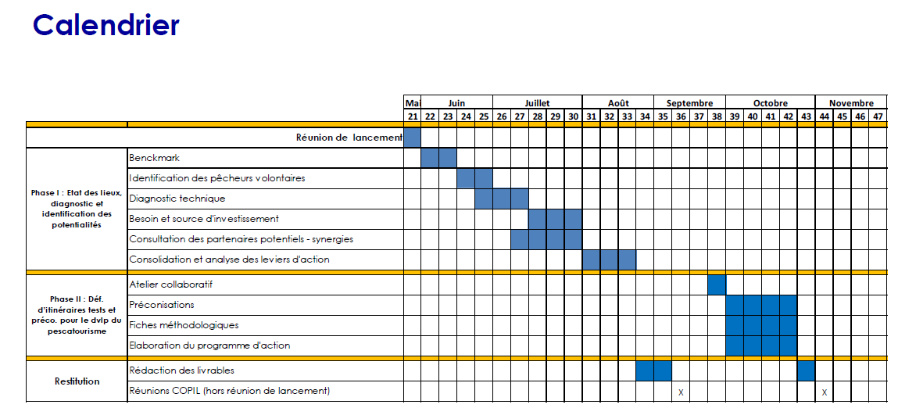
Meetings:
- May 28,2021: kick-off meeting with the design office and the Park
- June 25, 2021: meeting with fisherman, presentation of the project
- July 1, 2021: meeting with tourism stakeholders
- July 12, 16, 2021: individual interview between fisherman and design office
- July 20, 2021: meeting with tourism stakeholders

September 2021: Presentation of the proposed actions to the working group
October 2021: Completion of the study
November 2021: start implementation and monitoring of the action plan.

Details of the activities envisaged during the implementation
Monitoring
Activity 1: Development and diversification of the offer of sea trips (2022)
- Step to carry out this action activity:
1: provide technical support to fishermen (monitoring and support of necessary adaptations and equipment, support in obtaining permits, coordination with the DDTM (Directorate of Territories and the Sea), information on regulatory frameworks, opportunities for funding).
2: identify all the possible outings.
3: build structured outings with the tourist offices (departure time, duration, reservation system, price, etc.).
4: propose outings with the “Parc Values” label.

Activity 2: Organization and promotion on land of an offer geared towards tasting and gastronomy around fishing products (2022-2023)
- Step to carry out this activity:
1: associate all the professionals who already have an offer in this direction and local restaurants.
2: animate highlights around fishing: specific menus, workshop tasting highlighting all the signs of quality of the territory.

Activity 3: Promote fishing and shellfish products: development of the direct sales and short distribution circuits (producer stores, places direct sales, network of committed restaurateurs, collective catering) for make it accessible to tourists. Assess the relevance of the processing (cutting and packaging, smoking, canning, etc.) (2023)
- Step to carry out this action:
1: establish a diagnosis of the places where direct selling is possible as well as a census of fishermen who wish to engage in short circuits.
2: connect fishermen / shellfish farmers with distribution sites and the competent authorities for collective catering (registration in the territorial food plan).

Communication:
Activity 4: Marketing support (partial support / coordination of communication promotion actions, organization of a reservation and marketing system, creation of educational materials available on board and ashore) (2022-2023)
- Step to carry out this activity:
1: network tourism and fishing stakeholders to define the needs (images, content, desired organization for the reservation, etc.) for the creation of communication supports.
2: validation of common specifications and design of tools for promotion.
3: draw up an agreement with the actors of the promotion to validate the commitments of all project stakeholders.
4: co-construction of educational materials and distribution.

Activity 5: Development of a targeted and adapted training offer for professionals fishing and shellfish farming (language, storytelling, tourist reception, popular science, marine environment, etc.) (2022 – 2023)
- Step to carry out this action:
1: identify all the training needs for fishermen /shellfish farmers.
2: organize training cycles adapted to needs and availability professionals.
3: promote outings with the Parc Valeurs label

Activity 6: Integration of pesca tourism in the charter
Based on the experiences in pesca tourism changes in the charter will be introduced.
- Step to carry out this action:
- Make proposal for incorporation of the pesca tourism in the charter
- Reaching agreement within the charter committee about the incorporation of pesca tourism in the charter
- Announcement about the envisaged changes of the charter:
- It is necessary to overcome the strong constraints posed by individual initiatives (regulatory constraints, relations with institutions, complexity and additional burden / fishing profession) the approach must be taken collectively, at the scale of the territory (or at least of one micro territory).
- It is necessary to provide for the territorial integration of activities, in particular by developing sea/land links and partnerships between fishermen and tourist operators (town halls, restaurants, local guides, accommodation providers, etc.). This will make it possible to give visibility to the pesca tourism offer and to reinforce the image of the Camargue as a "natural and authentic" destination.
- Need to offer support to fishermen, to organize the coordination of the actors involved and pesca-tourism activities. It is necessary to co-construct an appropriate governance able to carry out this coordination.

Indicative costs (if relevant) (please estimate the costs related to the implementation of action 1)

Ingénierie PNRC: 15 000 euros

Funding sources (if relevant), (please describe how action 1 will be financed. Is it through the policy instrument(s) indicated in part II)

Date: 22/02/2022

Name of the organisation: Parc Naturel Regional de Camargue

Signature(s) – Laure BOU – Directrice adjointe

Stamp of the organisation (if available): ____________________________________

Activities | Step to carry out activity | Time frame
Monitoring
1: Development and diversification of the offer of sea trips | 1: provide technical support to fishermen (monitoring and support of necessary adaptations and equipment, support in obtaining permits, coordination with the DDTM, information on regulatory frameworks, opportunities for funding).  2: identify all the possible outings.  3: build structured outings with the tourist offices (departure time, duration, reservation system, price, etc.).  4: propose outings with the “Parc Values” label. | 2022
2: Organization and promotion on land of an offer geared towards tasting and gastronomy around fishing products | 1: associate all the professionals who already have an offer in this direction and local restaurants.  2: animate highlights around fishing: specific menus, workshop tasting highlighting all the signs of quality of the territory. | 2022-2023
3: Promote fishing and shellfish products: development of the direct sales and short distribution circuits (producer stores, places direct sales, network of committed restaurateurs, collective catering) for make it accessible to tourists. Assess the relevance of the processing (cutting and packaging, smoking, canning, etc.) | 1: establish a diagnosis of the places where direct selling is possible as well as a census of fishermen who wish to engage in short circuits.  2: connect fishermen / shellfish farmers with distribution sites and the competent authorities for collective catering (registration in the territorial food plan). | 2023
Communication
4: Marketing support (partial support / coordination of communication promotion actions, organization of a reservation and marketing system, creation of educational materials available on board and ashore) | 1: network tourism and fishing stakeholders to define the needs (images, content, desired organization for the reservation, etc.) for the creation of communication supports.  2: validation of common specifications and design of tools for promotion.  3: draw up an agreement with the actors of the promotion to validate the commitments of all project stakeholders.  4: co-construction of educational materials and distribution. | 2022-2023
5: Development of a targeted and adapted training offer for professionals fishing and shellfish farming (language, storytelling, tourist reception, popular science, marine environment, etc.) | 1: identify all the training needs for fishermen /shellfish farmers.  2: organize training cycles adapted to needs and availability professionals.  3: promote outings with the Parc Valeurs label | 2022-2023
6: Integration of pesca tourism in the charter | 1. Make proposal for incorporation of the pesca tourism in the charter  2. Reaching agreement within the charter committee about the incorporation of pesca tourism in the charter  3. Announcement about the envisaged changes of the charter: | 2022  2022  2023

Reed beds are out of focus

