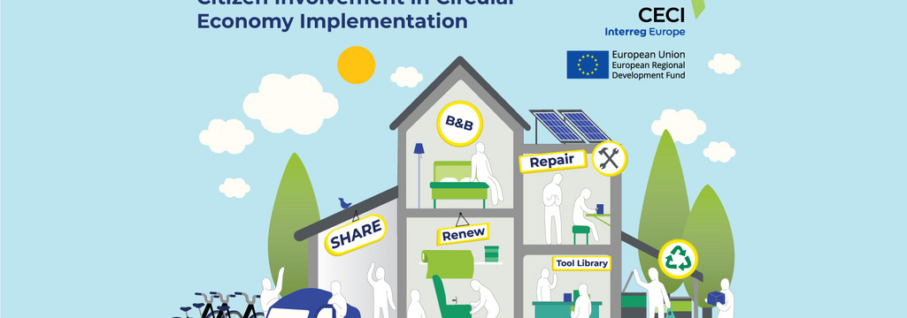
"CECI - EASY TO COOPERATE...: THE SOUTH IS MOVING THE LINES FOR ANOTHER ECONOMY!

How are you and I, citizens of Europe, involved in the development of new modes of consumption and production, stemming from the "circular economy"? Exchanging ideas on this subject with other European Regions with a view to improving public policies is the aim of the European interregional cooperation project called CECI. In spite of Covid-19 and lock down, the South Region is actively contributing to it and is promoting its exemplary citizen projects, including Super Cafoutch, Totem Mobi, La Roue and Synchronicity.

The subject is more urgent than ever in the face of the global health crisis which, for the past year, has been questioning our purchasing and consumption practices and our production methods. "Reducing, Reusing, Repairing, Recycling": the 4Rs rule alone sums up the philosophy of the circular economy. The Southern Region has placed this circular economy at the heart of its economic development strategy and its "CLIMATE PLAN" (https://www.maregionsud.fr/planclimat) adopted in 2017.

We all know that our planet today has limited, not to say extinct, natural resources. Moreover, the world's population is growing steadily and will reach 9.7 billion people by 2050. The South will not be spared by this staggering population growth and the challenges it implies. Instead of constantly buying new products, we can circulate, share and recycle them in a virtuous cycle... This is the circular economy. In the Southern region, it has become a real life and development project.

Let's go for the circular economy!

The economy must be at the service of the ecological transition: this is the credo of the Southern Region with its Climate Plan (1.4 billion euros), the common thread of all its actions. It thus accompanies the companies of Provence-Alpes-Côte d'Azur in this necessary transition in the face of the challenges of climate change, by helping them to undertake and produce differently, in a more environmentally friendly manner, from their first steps to the complete transformation of their economic model. But the Southern Region is also closely interested in the role of citizens in the deployment of the circular economy, in the actions they propose to consume differently. This is precisely the purpose of the CECI project at the European level, a cooperation project in which the South Region is participating.

Inspiring each other
CECI is the name of one of the 258 projects selected by a call for projects launched in 2019 by the European Union (specifically, through its interregional cooperation program Interreg-Europe)*. CECI stands for "Circular Economy & Citizen Involvement", in French, "Implication des citoyens dans la mise en œuvre de l'économie circulaire". Europe has endowed it with 1.592 million euros from 2019 to 2023, intended to co-finance innovative or exemplary projects proposed by its eight public partners (from six different countries)**. Up to 85% of a project's expenditure is eligible. CECI's lead partner is LAB University of Applied Sciences in Finland, as the city of Lahti has been designated European Green Capital for 2021 by the European Commission (after Lisbon in 2020 and Grenoble in 2022).
Why constantly reinvent hot water one by one, when we can move forward better and faster together? This is the principle of the Interreg-CECI program. It enables the sharing of solutions, ideas and good practices between partners. In short, CECI is common sense and collective intelligence applied to the circular economy and more particularly to the role played by consumers in developing it. We are interested in the way they engage in the development of new consumption models. In the end, what is expected of the CECI by the South Region and its other partners is to draw inspiration from observed and compared experiences (the "benchmark" principle) in order to draw up or improve their public policies. The South Region will integrate the outcome of this work into the new regional economic development, innovation and internationalization scheme that should be launched in 2021. They will of course also be able to inspire the orientations of the new 2021-2027 European programs.

How does it work?
In concrete terms, the CECI-Interreg project is divided into two phases:
In the first phase, over a period of three years, interregional meetings will bring together the partners in turn. The first took place from 2 to 5 December 2019 in Finland. The Southern Region was to host the second in June 2020, in Marseille, but the Covid-19 health crisis prevented this meeting from being held in person. The South Region has therefore repositioned itself to host its partners at the end of 2021 or 2022, under conditions that are hopefully more favorable (with visits to local projects in the field);
The aim of these exchanges and benchmarking is to draw up precise action plans and roadmaps;
In a second phase (the last year), the actions foreseen in the roadmaps will be implemented.
All current projects can be consulted on www.interregeurope.eu/CECI/
There is a database of regional good practices, presented by each partner in the form of "project sheets", which are available to the whole community with a view to initiating exchanges of experience or partnerships.
The meetings and workshops are the place for a real transfer of knowledge. They are both a great showcase for regional initiatives and a source of inspiration and reflection for their "duplicability"! For example, during the thematic workshop on sustainable urban mobility and shared mobility on 26 January, the CitiCAP project of the city of Lahti in Finland was presented. The idea is to give each citizen, according to his situation, a carbon quota not to be exceeded, with a reward in the form of "virtual" euros that can be used in local shops and services. For or against? Transposable or not? To think about
In France, Marseille “the Phocean city” is not to be outdone and abounds with projects, as everywhere else in the territories of Provence, the Alps and the French Riviera.

Super Cafoutch, a cooperative and participative supermarket in the city-center of Marseille
Original, supportive, cooperative, participatory: would Super Cafoutch be a model of trade in the future? It is at least the first supermarket of its kind in Marseille, which wants to be an "alternative to supermarkets to eat well at affordable prices". Pending its opening on a larger scale (800 m²), the "Super Cafoutch" is currently being tested by its pilot grocery shop (the Mini Cafoutch), whose creation in 2016 has been supported by the Southern Region. On its stalls, in the heart of the 2nd arrondissement, a wide range of food, hygiene and maintenance products, often local, organic and fair trade. It operates in the form of a self-managed cooperative. Consumers are the owners, with various subscription possibilities, from the formula "I do my 3-hour service every 4 weeks, I come to do my shopping, I have a vote at the General Meeting" to the investment in the business.
Synchronicity: for a desirable future in Marseille
Vincent Gay and Maxime Ducoulombier, co-founders of the cooperative society of collective interest of the circular economy Synchronicity, like to remind us: "Alone, we go fast, but together we go faster and further! »
The presentation of their company was on the program of CECI's 2nd international meeting, from November 4 to 6. Established in Marseille since 2019 and supported by the Southern Region, this cooperative company mobilizes a group of entrepreneurs, producers and developers around a panel of local services and logistics (storage, delivery, collection...) and shared solutions. The areas concerned: waste, short circuits (promoting purchases "in MY ZONE rather than AMAZON"), mobility that does not emit CO2 (carbon-free mobility) or research-innovation and employee management.
A total of 63 stakeholders are involved in Synchronicity, which aims to create a desirable future and make Marseille a sustainable city.
And so many other good practices stamped Le Sud
Totem-Mobi, another project supported by the South Region, is also included in the catalogue of European projects listed by CECI-INTERREG. This very dynamic Marseille-based start-up is now booming in the sector of self-service, short-term urban rental of electric mini cars. Finally, among the countless good practices in our region, let's mention the local currency La Roue, "complementary and citizen-friendly" (1 Wheel = 1 euro, with 3,000 users). Its creators claim it as a response to the Covid-19 crisis, insofar as it enables purchases to be relocated to the shops, farmers or companies that accept it (1,000 professionals) and, consequently, to reduce pollution linked to the transport of products while creating social links. CECI's newsletter, addressed to its European members, devotes an interesting article to this subject in its 3rd quarter 2020 issue. To be continued.
* financed by the "ERDF" (European Regional Development Fund) funds
**Belgium, Bulgaria, Spain, Finland, France, Czech Republic.
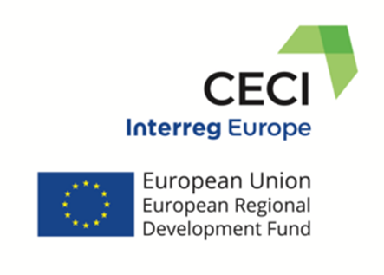

Read more:
The South Region's "Une COP d’avance": Climate Plan: https://www.maregionsud.fr/planclimat
The European Project CECI: www.interregeurope.eu/CECI/
The good initiatives mentioned are to be discovered on:
http://synchronicity.team/
https://laroue.org
https://supercafoutch.fr/ et https://www.interregeurope.eu/policylearning/good-practices/item/4105/cooperative-supermarket-supercafoutch/
www.totem-mobi.fr/

