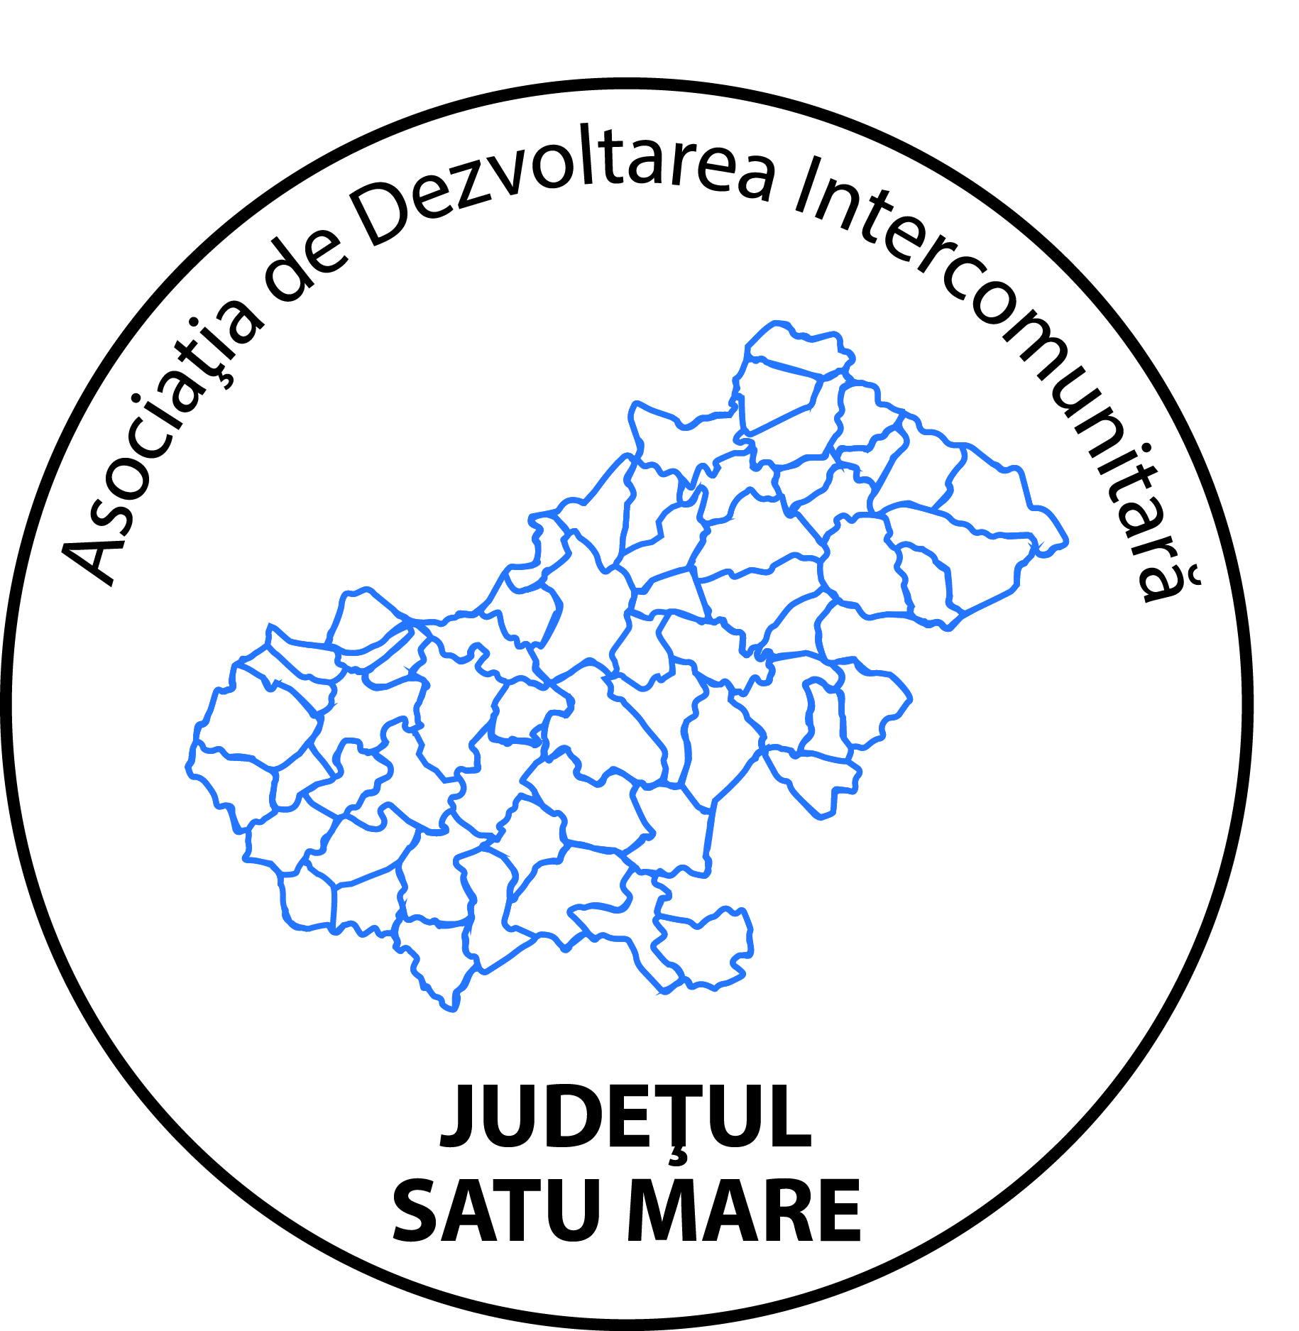
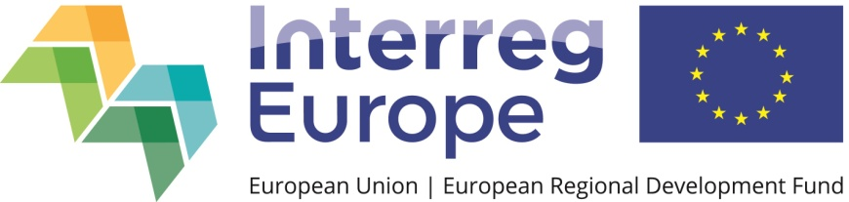

Networking locally in the field of cultural and natural heritage
The crisis caused by the outbreak of the COVID-19 pandemic has affected cross-border cooperation projects in the field of cultural and natural heritage. This is also the case of the EPICAH project implemented by the Satu Mare County Intercommunity Development Association, which in its action plan proposed to contribute to the creation of an informal cross-border structure through closer collaboration between responsible institutions in the field of cultural and natural heritage.
This activity in the action plan has been adapted to the new circumstances, so that at the moment it is considered useful to work more closely between local cultural institutions and institutions responsible for the environment protection, and to participate in locally created working groups. The implementation of this action proved to be even easier as other cultural organizations implementing cross-border projects set themselves the goal of creating a collaborative network and organizing workshops in which participants had the opportunity to discuss issues that they face as far as the promotion of the cultural and natural heritage is concerned, solutions and examples of good practices. Thus, the Satu Mare County Intercommunity Development Association participated in meetings of working groups set up within two projects funded through the Hungary-Slovakia-Romania-Ukraine Programme 2014-2020.
The first of these projects is 52 Carpathian lifestyle experiences: the reinvention of traditional work cultures, implemented by the Satu Mare Chamber of Commerce and Industry in partnership with institutions from Hungary, Slovakia and Ukraine. The aim of the project is to stimulate visits and create new living opportunities in cross-border communities, while developing and promoting unique tourist experiences, built around traditional cultures and lifestyles, as part of the Carpathian heritage destination. During a workshop with local participation, an attempt was made to identify the cultural goods and traditions from Satu Mare County that could be transformed into tourism products prepared for the market.
The second project is entitled Culture connect - cultural mobility in the border area, implemented by the Satu Mare County Museum in partnership with similar institutions in Ukraine and Slovakia, and which aims to promote the cultural heritage in the border area. Within this project, a workshop was organized on the promotion of the rural landscape in which relevant cultural institutions from Satu Mare County participated. The main conclusion was that a more efficient collaboration is needed between all the factors involved, so that all the values ​​of the county are promoted more dynamically and with concrete results.
The activities organized within these two cross-border projects prove that networking and the collaborative style has become a common way of working in projects aimed at promoting cultural and natural heritage, even if we are only talking about a local collaboration due to the restrictions imposed by the COVID pandemic. The Satu Mare County Intercommunity Development Association will continue to participate in such local initiatives in order to support the idea of networking but also to promote and disseminate good practices of the EPICAH project.

