# CESME Circular Economy Tool for companies –

# a suggestion on how to use the tool and proceed in a workshop with a company

## Introduction

To whom, what and why?

The CESME Circular Economy Tool has been primarily developed for **SMEs, who wish to gain an understanding of the new business opportunities enabled by circular economy for their company. The tool helps companies to develop, concretise and assess business model development ideas associated with circular economy. Circular economy ideas can be novel operating models, products and services or they might radically change the entire business model, such as a transfer to service business. The tool also offers support for the assessment of environmental and social impacts.**

The tool offers a lot of background information on circular economy and sustainable, responsible business and thus supports companies in the planning and envisioning of future business. The tool consists of two parts; the actual **tool section** presents methods and templates that the companies can use for brainstorming business ideas enabled by circular economy. The tool section also presents examples of other companies. The **Reading Materials section** at the end contains background information about circular economy and sustainable business as well as material that supports the templates.

The CESME Circular Economy Tool contains the following approaches:

* **Training**: To create an understanding of what circular economy is, how companies can implement circular economy in their business and how the impact of circular economy can be assessed.
* **Practical implementation**: Tool that support decision-making as well as practical instructions that the companies can return to as needed.
* **Future-oriented development**: As a company gains new understanding of circular economy and sustainable business, it also becomes better prepared to meet future business challenges. Although Finland has come far in the environmental and social responsibility of SMEs, the business environment is changing, and new needs (such as reporting) might arise, for example from partners. Circular economy and sustainable business can be seen as a part of the company’s risk management and strategic leadership.

In a nutshell, the tool helps companies to:

* **understand** value creation in circular economy and sustainable business (including the creation of both social and environmental value)
* **evaluate and visualise** new business opportunities enabled by circular economy and their effect on business operations
* **take enthusiastic action** in the creation of a new circular economy model.

The purpose of the tool is to give **support for the development and renewal of business** and to **present concrete opportunities** by means of business cases. **The key idea is that the companies find their own way of implementing circular economy** – whether it is a radical revision of the entire business model or small operational changes.

The tool is a part of the CESME programme, funded under of the Interreg Europe programme (<https://www.interregeurope.eu/cesme/>). The Finnish tool is partly based on the English-language CESME Circular Economy SROI Toolbox Business AGENCIES -document and the attached spreadsheets and calculation template.

The VTT Technical Research Centre of Finland employees responsible for the development of the tool are Principal Scientist, Project Manager Maria Antikainen ([maria.antikainen@vtt.fi](mailto:maria.antikainen@vtt.fi)), Research Scientist Katariina Palomäki ([katariina.palomaki@vtt.fi](mailto:katariina.palomaki@vtt.fi)) and Senior Scientist Saija Vatanen ([saija.vatanen@vtt.fi](mailto:saija.vatanen@vtt.fi)). The tool was customized to and tested with several South-Ostrobothnian companies, development companies, etc. We wish to thank everyone who participated in the development!

### Working method and progress

The CESME Circular Economy Tool is primarily intended for a **third party** (such as a developer, consultant or other facilitator) who will use the tool in collaboration with companies. However, the tool can nevertheless be used **independently in an SME**. That having been said, the biggest benefits from the tool and its methods are obtained when the work is directed and catalysed by a person who already has some understanding of circular economy and has prior experience on the steps of the tool.

The tool contains **six main steps.** Each step contains templates that can be used in a workshop held with the company or companies[1].

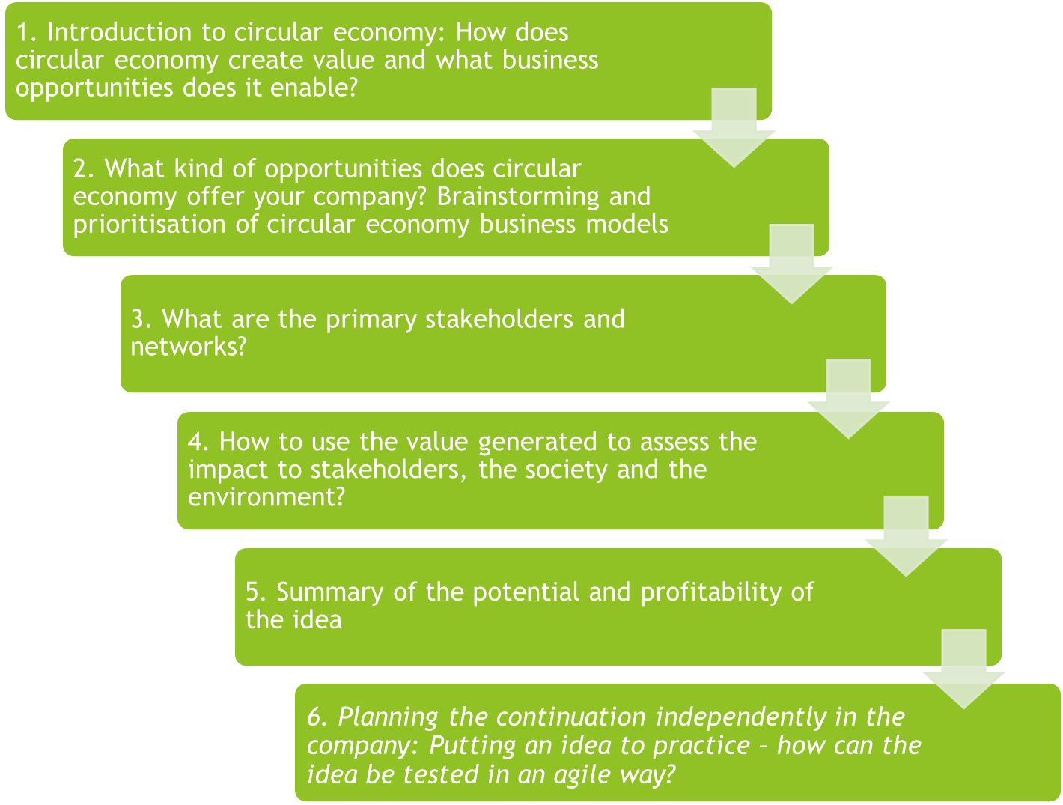

The tool is best used in a **workshop** with one or more companies. Several people from a single company can participate. The steps of the method are reviewed by means of discussions with the company representative(s) or, if the group is large, discussions in small groups. Each step uses the suggested **templates** for the step that guide the discussion and in which the discussion and observation are documented. The role of the consultant/facilitator is to present the support materials and case studies in the material, guide the discussion, ask questions to clarify the matter, encourage the participants to participate in the discussion, support in the documentation of the discussion and, after the workshop is over, finalise the materials created in the workshop and submit them to the participant in the format desired by them.

The methods described in the steps of the tools can be used in the workshop in **a customised way, tailored to the needs and hopes and of the company.** Thus, some steps can be omitted and special emphasis can be placed on steps that are identified as particularly important. The tool is **scalable** to the needs of the company: it can be used lightly, concentrating only on some steps and/or templates, or it can be used for in depth probing of the company’s opportunities and steps on the path of circular economy. In addition, the company can utilise the templates to evaluate a single potential business idea or several good ideas or new opportunities.

In addition to the materials, the workshops also give the participating companies **more understanding of the social, environmental and economical effects of their business as well as thoughts and ideas on how to align their business operations with the principles of circular economy and sustainability.** The company can keep using the tool along with their development processes and return to the various steps and templates of the tool as necessary to polish an idea or redirect the development effort.

## 1. Introduction to circular economy: How does circular economy create value and what business opportunities does it enable?

Step 1 introduces the **basic concepts of circular economy** and describes how the actualisation of circular economy can be assessed and what new **business opportunities** it brings.

What is circular economy?

We are very aware of the fact that our current economic system is unsustainable and we exceed the carrying capacity of the Earth multiple times. This causes several environmental challenges and leads to a resource shortage. Competition over resources manifests itself as price volatility and general uncertainty on the markets. Circular economy offers companies an important opportunity to **a) increase their competitiveness, b) reduce risks and uncertainties and c) make the transfer to sustainable business operations**, which creates value to the company, society and the environment alike. No sustainable company can afford to ignore this change.

Circular economy strives towards an economic model in which materials and products are produced **in a resource-efficient way, used as long and efficiently as possible and, at the end of their life cycle are reutilised as well as possible.** The lengthening of the **life cycle** is based on product updates, service as well as reuse and remanufacturing. Efficient use is achieved by offering products and resources as a service and, for example, renting and sharing them. In a circular economy, materials circulate and their value even increase. Technological solutions and service minimise waste generation, increase resource efficiency and the value of both materials and products.

In short, the **idea of circular economy** is:

* Products are designed to eliminate loss
* Materials are not wasted, but reused
* Renewable natural resources are used to a maximum extent
* Circular economy has ties to raw material production, materials processing, product manufacture, distribution, trade and consumption
* The importance of services increases, the significance of ownership decreases

In circular economy, environmental solutions play a key role, which is why **life cycle thinking and calculation** should be included as an essential part of the change. Life cycle thinking is particularly important in the assessment of the environmental effects of the object being reviewed (product, service, process, etc.). It takes into account the entire life cycle of the product, starting from raw materials procurement, and continuing to manufacture, distribution, use or consumption. The life cycle ends in so-called final processing which might mean reuse, recycling, remanufacturing, utilisation as energy or final deposition in a landfill. From the perspective of environmental effects, the product life cycle planning phase carries special weight, since it is estimated that up to 80% of the product’s environmental effects are created in this phase[2]. The next picture illustrates how circular economy is taken into account in the value chain[3].

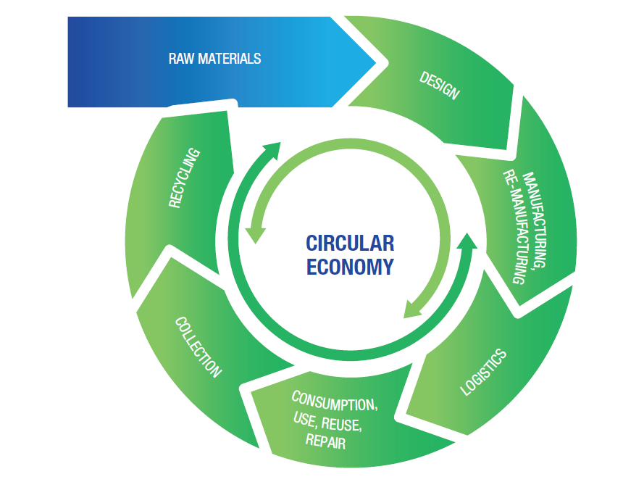

Circular economy is based on the idea that a company does not have to close the loop alone, but that it is closed in an ecosystem, i.e. in an interaction and collaboration with other actors. Hence, the shift to circular economy requires a major, systemic change. Even a single company can implement this shift by **small implementable steps**.

What does sustainable business mean?

Although the foundation of sustainable business consists of three parts, the environmental perspective of circular economy gets emphasised at the expense of the social and societal perspective. **The social and societal perspective** investigates a company’s business operations in light of human rights, stakeholder appreciation, responsibility of the supply chain and the impact of the actors in the chain on the environment and society, workers’ rights and safety and their equality, right to organise and freedom of expression. One of the organisations that publishes instructions on how to report the sustainability and responsibility of business operations is GRI[4], whose sustainable development standards have become the most popular in the world[5].

**Responsibility and sustainability**[6] is a way of taking into account the business environment and its actors in an increasingly comprehensive way while keeping business operations profitable. There are innumerable ways to implement responsibility and sustainability in business, and the range of means available in circular economy offers many approaches to increasing environmental friendliness, preparing for changes and saving dwindling resources.

Can your company afford to operate unsustainably?

What benefits can circular economy and sustainable business bring?

There is a lot of inefficiency in companies’ production operation and product life cycle, and thus a lot of untapped potential. The following table presents some assessments of the current situation in companies[7]:

|  |  |  |
| --- | --- | --- |
| Underutilisation of capacity | 58% of the companies reported that their products are idle over 20% of the time – and over half of these companies report that their products are idle at least 50% of the time. | The time during which the products are available is not utilised efficiently. Underutilisation might occur for example due to seasonal variation of opening times of companies. |
| Lost value at the end of the life cycle | 38% of the companies recycle over 80% of the waste generated in production. 38% of the respondents state that their recycling rate is less than 10%. | A large proportion of production waste is recycled, and production generates little waste in general. There is still room for improvement! |
| 87% of the companies that have a product return programme report that less than 5% of the products are recycled. | Many companies already recycle a large share of their products – and some none at all. |

Circular economy provides companies with several economic **opportunities** that can bring business benefits while also benefitting the environment and society. Some examples of business benefits are[8]: Circular economy innovations bring companies new opportunities for growth, and a business model aligned with circular economy can open the opportunity for increasing earnings from a product[9]. By forming new kinds of partnerships with other actors in the field, the companies can use resources more efficiently and thus increase their competitiveness. Reuse of materials enables companies to cut material costs. Often, the possibilities are directly linked to decisions on the company’s **business model,** which is discussed later. It can also be seen that actions aligned with circular economy and actions that improve resource efficiency help companies control their business risks both in the short and long term and gain both cost-savings in the short term and an improved resilience in the long term. In other words, circular economy methods enable companies to **foresee and prepare** for the future. Below is a list of the 10 main benefits of circular economy for companies[10].

|  |
| --- |
| Why circular economy and sustainability? – 10 benefits for a company   1. Save your company’s money, its customers’ money and subcontractors’ money 2. Better utilisation of the value of the products and resources you manufacture 3. Find new markets and customers 4. Build customer loyalty 5. Satisfy customers’ needs and expectations better 6. Improve safety and price stability in the distribution chain 7. Be an interesting employer that attracts commitment 8. Build reputation as a pioneer and as an innovative company 9. Act in compliance with regulations and predict the regulations 10. Offer better value to investors and reduce their risk |

What were the main challenges?

The transfer to circular economy is also associated with various **challenges**, such as potential short-term unviability of business aligned with circular economy, the lack of necessary information or incentives or, for example, the lack of shared methods or necessary infrastructure (in view of recycling and sorting, for example). Implementation of circular economy also requires collaboration in order to close the circle of circular economy. This involves partnerships that might even cross segment boundaries. Thus, companies must have the courage to come out of their silos and seek new partners without prejudice. Another challenge might be that suitable partners simply do not exist, and entirely new kinds of players are needed on the field. One of the key challenges in circular economy is the change in thinking, which requires **a strong vision and commitment** from the company management.

The most difficult challenge in circular economy – a change in mindset – can be overcome by everyone!

What special characteristics and opportunities have been identified in South Ostrobothnia as regards to circular economy?

The **Action plan for circular economy in South Ostrobothnia**[11] published in 2018 identified actions by which Southern Ostrobothnia takes systematic steps towards circular economy. The sets of measures are:

1. Making circular economy known and developing the associated networks and databases
2. Development of circular economy competence, education and innovation (of which one of the identified actions was the testing and development of the Circular Economy Tool in South Ostrobothnia)
3. Development of selected segment-specific actions
   * Bioenergy segment (such as the needs to develop the utilisation of agricultural and forestry biomasses)
   * Developing the practices of wood product segment (such as new business models and practices and a novel collaboration with companies to help them innovate and become international)
   * Collection of plastic and developing its reuse
   * Collection of textiles and developing their reuse

The segment-specific actions target segments that are important to South Ostrobothnia and contain a lot of possibilities for example in the utilisation of various sidestreams as well as recycling and reuse of materials. The tightening regulations, such as the EU waste directive, spurs the development of new innovations and business models. In addition to the action plan, both the regional programme of South Ostrobothnia (for 2018–2021)[12] and South Ostrobothnia’s strategy for smart specialisation (2014)[13] identify bioeconomy, food systems, smart technology and resource efficiency as key development areas.

Globally, the major share of the value of materials remains unutilised at present. Circular economy has enormous potential and it is also something that businesses and societies absolutely must reach due to the current situation. The focus areas above are considered most important ones on a regional scale, but the opportunities enabled by circular economy extend far wider – **circular economy can be taken into account in all business, in products, services and processes alike.**

Let’s brainstorm circular economy!

What ideas did you get when reading this chapter? Notes:

________________________________________________________________________________________________________________________________________________________________________________________________________________________________________________________________________________

## 2. What kind of opportunities does circular economy offer your company? Brainstorming and prioritisation of circular economy business models

In step 2, the ways which a company can follow circular economy in its operations are **identified and planned on a tangible level**. First, let’s review the business models and case studies of circular economy.

How can circular economy be implemented in business operations?

Circular economy can be taken into account in business in many ways. One of the ways is to think about how to **slow down the cycling of materials and products**, i.e. how to prolong the life cycle of a product by design that emphasises repairability, remanufacturability or durability. Offering services instead of products opens up opportunities to expand business to maintenance and repair services, which are profitable ventures for many companies. Another key method to implement circular economy is **closing the loop**, in which the emphasis is mostly on the reuse of materials and products. A third way is to **minimise the loop**, which involves resource efficiency and reducing waste to a minimum, even up to zero[14]. All these methods might involve technological solutions, such as platforms or novel services.

Business model development and possibilities enabled by circular economy can also be investigated by means of the business model classification shown in the figure below[15]. A company’s business operations can adopt elements from the following areas: using renewable raw materials, offering the product as a service, utilising digital platforms, optimising networks by means of traceability etc., lengthening the lifespan by e.g. redesigning the product and saving resources by improving the utilisation of wastes.

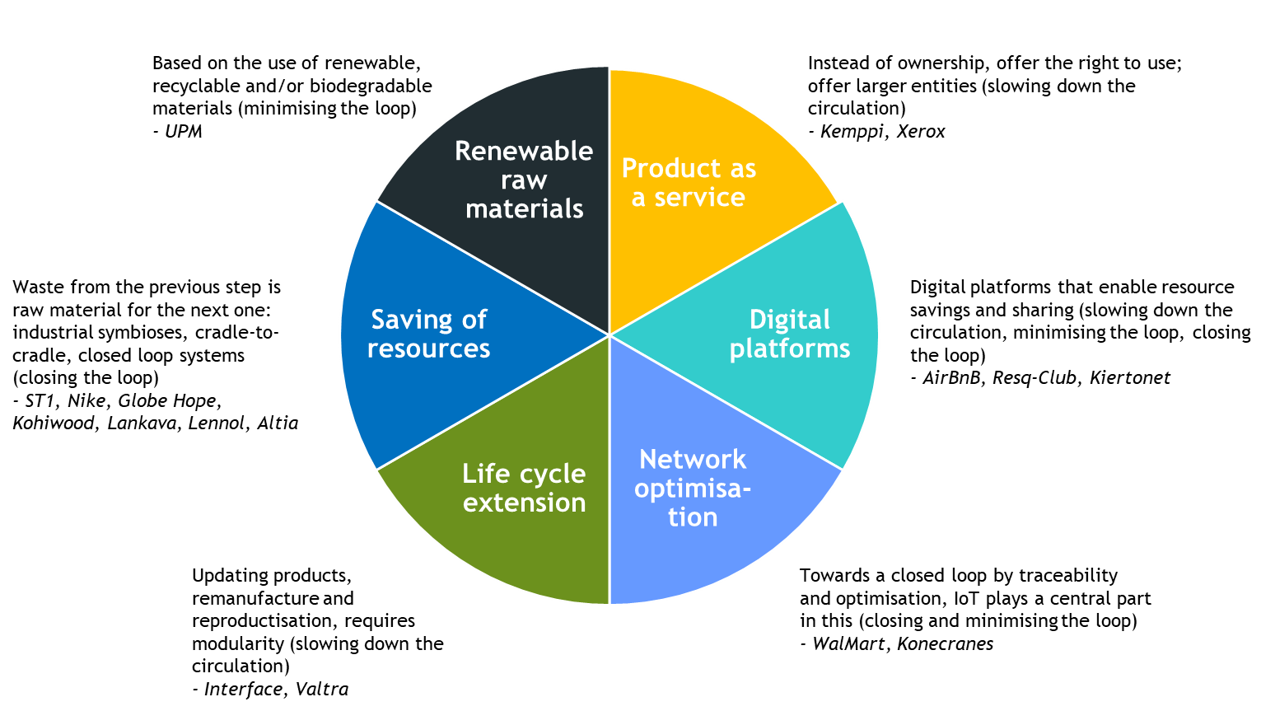

Another concept that concentrates on a more efficient use of materials and further utilisation is **6R**, that consists of the following parts: reduce, reuse and recycle, recover, redesign and remanufacture.[16]

Could some of these approaches be introduced as part of your company’s business?

Circular economy can be implemented in countless ways in business. Next, some business cases from Finland:

|  |
| --- |
| Life cycle extension  Kutepa Rubber Service Oy offers retreading and repair service for all heavy machinery tyres. The company can fix almost all kinds of damage and solid rubber tyres can be retreaded up to 10 times. Retreading greatly extends the lifespan of a tyre.[17]  Emmy.fi is a service for selling and buying used clothing. Selling is easy for the seller: the clothes can be delivered to Emmy’s own collection point or sent to Emmy by post. At Emmy, the clothes are photographed and priced and the information is entered in an online system, after which the clothes are sold in Emmy’s online store. For each piece of clothing, Emmy charges a provision and transport costs, and pays the remaining amount to the seller. The benefits of this service include:   * Manufacture of clothes requires large quantities of water, land and chemicals and causes greenhouse gas emissions🡪 prolonging the lifespan of clothes reduces these negative environmental effects * From the consumer’s perspective, the service makes it easy to recycle used clothes 🡪 a way of extending the lifespan of a piece of clothing.[18]   Valtra is one of the best known Finnish companies that engage in a profitable remanufacturing business. The Valtra Reman concept consists of remanufactured gearboxes and engines. The remanufactured gearboxes are equivalent to brand new ones. They are also quality inspected and contain the latest updates. Valtra’s product range consists of approximately 210 remanufactured gearbox, reversal units and Power Shift types. Remanufactured AGCO Power engines are available for almost all AGCO engine models. The return of gearboxes to Valtra is ensured by a deposit (approximately 50% of the price of the gearbox) that is paid to the customer in exchange of the used gearbox.   * The product life cycle is extended, while energy and materials are saved. In the case of gearboxes, the energy savings are 85% compared to the manufacture of a new product * Remanufactured gearboxes are a good and quick alternative to gearbox repairs that can be cumbersome * The customer can purchase a gearbox/engine at a lower price and with the same quality guarantee than a new one; the price of a gearbox is approximately 60% lower than that of a new one * Close collaboration and information sharing between mechanics and product development helps to improve the products * The benefits for resellers and maintenance services is an easy-to-schedule and rapid repair. [19] |

|  |
| --- |
| Saving of resources  Lankava, a company from Kauhava, manufactures rag rug yarns from recycled textiles by hand and by industrial cutting. The yarns utilise, for example, bedsheets discarded by households and institutions. The lifespan of textiles increases and the yarns can be used in a diverse range of crafts. [20]    Lennol products include seat cushions, covers, pillows, mattresses and acoustic panels that contain recycled materials.[21] |

|  |
| --- |
| Digital platforms  ResQ Club is a marketplace for selling food that would otherwise become food loss. Restaurants and cafés can report in the ResQ user interface any food that is about to become food loss. The consumer can then purchase the portion and retrieve it from the restaurant. ResQ Club charges a commission fee from the portion and pays the rest of the price to the restaurant. The benefits include:   * In the food service sector, approximately 75–85 million kilograms of food are wasted every day, and the optimum quantity of food is difficult to predict on a day-to-day basis 🡪 the co-operation between ResQ club and restaurants reduces food loss and thus helps to save the environment * Restaurants get an easy channel for monetising food that would otherwise be lost and can also reduce waste management costs and increase their visibility * ResQ customers can purchase restaurant-class food at a lower price[22].   Kiertoa Oy offers the Kiertonet.fi online auction service in which public organisations can sell their unnecessary property to private persons, companies and public organisations.   * The benefits are an extended lifespan of public property and thus a smaller carbon footprint * This way, property procured by taxes can be utilised efficiently. [23] |

|  |
| --- |
| Product as a service  Several clothing rental companies have been established in Finland in recent years. Vaatelainaamo Tanttu[24] from Seinäjoki is one of them. The idea of clothing rental companies is that a consumer pays a monthly fee and can then borrow a certain number of clothes/outfits.   * The consumer has the opportunity to get some variation in his or her wardrobe and find an outfit for singular special needs without the need to purchase and own the piece of clothing or outfit * The clothes are used more efficiently, which reduces their life cycle impact   Martela offers a comprehensive concept that cover the entire life cycle of an office. This makes the management of office spaces more efficient and helps Martela’s customers to act in a sustainable and environmentally friendly way. When the overall scheme is managed and future needs can be predicted well in advance, the operating costs of premises can be reduced.[25] |

Template 1 – BRAINSTORMING ABOUT FUTURE OPPORTUNITIES AND POTENTIAL:

The following template enables a company to examine its business operations in light of the previously presented business model classification of circular economy. The idea is to identify the matters that the company already performs in the spirit of circular economy and also to start the ideation process on what the company’s business operations could entail in the future and what the new ideas look like from a profitability perspective[26]. This is also a good opportunity to reflect on the changes in the operating environment and any general trends that might occur in the future: For example, can we expect that a change in regulations imposes new requirements for the operation in the future? How might the customers’ expectations change during the next 10 years or so? Have some changes occurred in the operators and their roles in the sector, and should the company react to them?

|  |  |  |  |
| --- | --- | --- | --- |
|  | Present | Future opportunities | Commercial potential |
| Product as a service | Does the company offer services at the moment? Which products are the services associated with? | Which products could be offered as a service? Could the services offer more extensive solutions for the customers’ needs? | What other financial opportunities could the change bring? How could the change be implemented profitably? |
| Life cycle extension | How is life cycle extension taken into account/enabled? Which products are associated with this and which are not? | Which of the products could be updated or remanufactured in the future? Which products could be made modular? | What would their business potential be? |
| Network optimisation | Is the order-/delivery network collaborating to close the loop? Are the networks efficient? How are streams monitored? | What kind of co-operation would be possible? Which partners or other actors in the network/ ecosystem would be the most potential ones for new collaboration? | What kind of savings could be obtained via optimisation of the network? |
| Digital platforms | What kind of digital platforms are utilised and how? Are some resources shared via platforms? | What kind of platforms could be utilised and with whom? How will this support other business? | What business potential do the platforms have? |
| Saving of resources | How efficiently are resources used? What material streams exist and what sidestreams are generated? Are they being utilised? What is the utilisation rate of devices and equipment? | How to utilise resources most effectively? Could resources be shared with other parties? Could resources be saved? | What kind of savings could be attained? |
| Renewable raw materials | Are we using recycled materials? | Where could we use recycled materials? | Could materials be procured affordably (for example from the sidestream)? |

Template 2 – PRIORITISATION OF IDEAS:

The Prioritisation of ideas table below helps the participants to drill down into the identified opportunities identified in the previous template and see which ideas have the most potential to be adopted as part of the company’s operations. **The idea does not have to be one that revolutionises the entire business model – it can also be one that increases the sustainability of a process or an everyday operating method** (such as reduction of packaging plastic, replacing raw material with recycled material, developing logistic solutions or utilising a side stream better). However, the potential and impact of each idea can be assessed on the business model level as well.

|  |  |  |  |
| --- | --- | --- | --- |
|  | Business opportunity 1 | Business opportunity 2 | Business opportunity 3 |
| PLEASE SPECIFY  *offering and its value to the customers, environment and society* | Describe the idea in more detail: what does it entail, why is it a good idea, what does it solve and how does it differ from other ideas |  |  |
| TO WHOM  *the market* | Who benefits from the idea, who would be ready to pay for it? |  |  |
| HOW  *key resources, competencies, partners* | How can the idea be implemented in practice? |  |  |
| REVENUE GENERATION MODEL  *how the idea is monetised in practice* | What do we sell, what costs and expenses can be expected and how can the idea be turned into profitable business? |  |  |
| Which business opportunity has the most potential? What benefits would it bring to our own business operations? |  |  |  |

Identifying the possibilities creates the basis for practical planning. When brainstorming for ideas for a business model based on circular economy, the focus should be in the **value proposition** for customers and stakeholders[27]. The next chapter discusses stakeholders and networks that are associated with the business opportunity.

What ideas did you get when reading this chapter? Notes:

________________________________________________________________________________________________________________________________________________________________________________________________________________________________________________________________________________

## 3. Identifying primary stakeholders and networks

What is a stakeholder?

In discussions about circular economy, the term ‘stakeholder’ means all parties that **have an effect on the operation of the company or who are affected by the company’s operations**. The investigation should not be limited solely to the economic perspective but should also take into account social and environmental factors. When investigating sustainable business practices, the environment could also be considered a stakeholder.

Why should stakeholders be taken into account?

Knowing the stakeholders is essential in order for the company to assess the **direct and indirect impact** that its operations and the planned changes have to its business, and even wider – both on short and long term. The impact can be extremely diverse: increase of profitability, change in the company image and brand value, changes in partnerships or an impact on the well-being of the community or the environment. Understanding and assessing the impacts, both positive and negative, is important for understanding the economic effects of circular economy and justifying the necessary investments.

Identifying the company’s own network and ecosystem relationships and assessing the experiences of stakeholders might sharpen the company’s view of its **values and the value proposition** it makes to different parties, i.e. what makes the company’s operations meaningful and how does to company want to profile itself.

Template 3 – IDENTIFYING STAKEHOLDERS AND ACTORS:

The following figure enables you to identify stakeholders by naming actors that correspond to the boxes. Which actors are associated with the new idea or are necessary in order to proceed with the development idea (for example in view of logistics or the availability of raw materials)? Which parties might be impacted negatively by our operations? Could we reach new customer groups with the new operation? With whom should we discuss the idea or to whom should we absolutely communicate it?

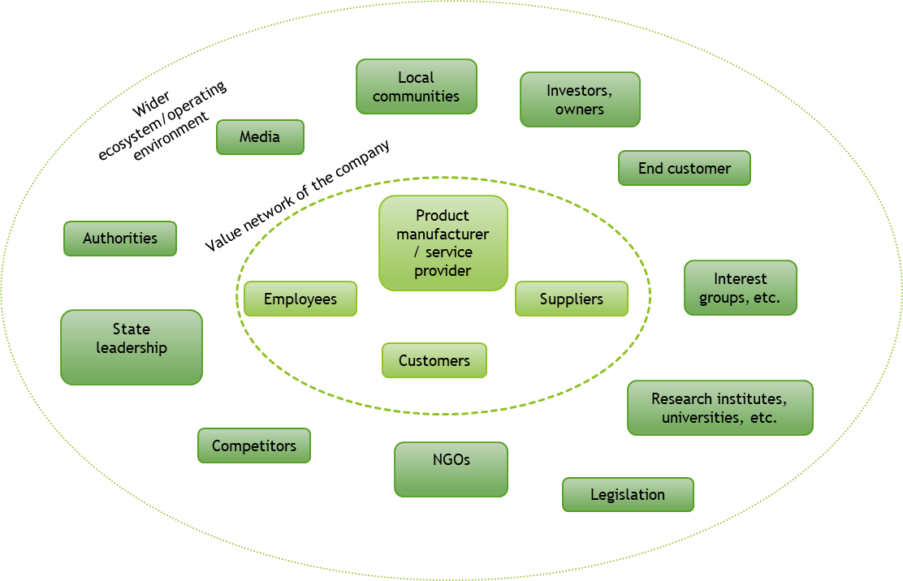

Why is it necessary to know the views and values of stakeholders?

A company does not exist in a vacuum, but affects the actors around it, and conversely, the actors operating in the company’s network and ecosystem impose a **continuous pressure to the company to change and develop**. Therefore, a company should continuously monitor the changes in its environment and assess its operations and decisions in view of the prevailing circumstances and future changes.

However, not all stakeholders merit equal attention. It is essential to identity the actors who are very interested in the company’s operations and/or have power to affect them. The 2 x 2 matrix below helps in stakeholder classification.

Template 4 – ASSESSMENT AND PRIORITISATION OF STAKEHOLDERS:

Examination in a 2 x 2 matrix (stakeholder analysis, power-interest matrix of stakeholders) supports the assessment and prioritisation of the actors in the network. The purpose of the task is to identify stakeholders, assess the opportunities (power) and interest of each stakeholder to affect the operation of the company: what significant does each stakeholder/actor have in the implementation of the new service or product and how much power and interest the stakeholder has.

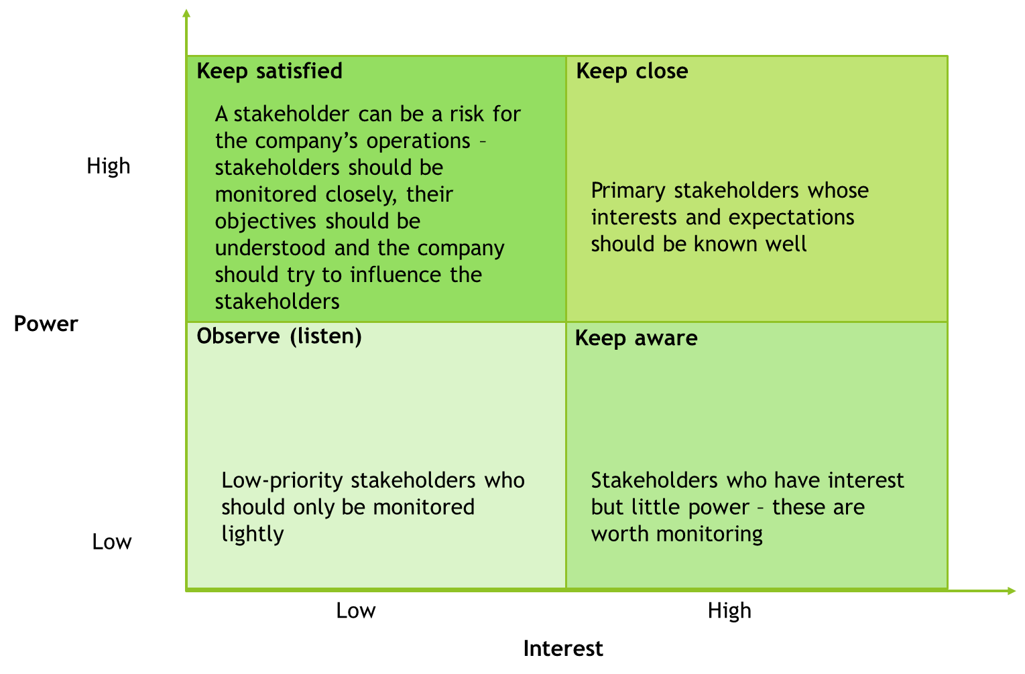

The company should examine its **strategy** in view of the companies in each field of the 2 x 2 matrix, and how the company could take the interests and power of each group best into account. The findings enable you to identify the stakeholder(s) that should be prioritised as most important (‘keep close’). Even deeper understanding on the most important stakeholder groups can be gained via a review of values.

Template 5 – REVIEW OF VALUES EXPERIENCED BY STAKEHOLDERS:

Take a look at the ‘keep close’ box of the 2 x 2 matrix above and transfer into the table below the names of the identified individual stakeholders/actors in the box that are significant for the operation of the company – these parties might have special power over the company or an exceptionally high interest in the operations of the company. The opinions, views and actions of these actors might have particular significance in view of the company’s operations and new business ventures, which is why the needs and expectations of these parties should be examined more closely. The impact of these needs and expectations on the company’s own operations should also be considered, including the measures that the company should take. In the table below, list the stakeholders/actors and the value perceived by each of them (economic, environmental or social/societal value) and any observations on what opportunities the value perceived by the stakeholder can create to the company and what measures are required on the basis of the observation.[28]

|  |  |  |
| --- | --- | --- |
| Key stakeholders/actors (‘Keep close’) | Value perceived by the stakeholder/actor (positive/neutral/negative) | Opportunities, actions |
|  |  |  |
|  |  |  |
|  |  |  |
|  |  |  |
|  |  |  |

What ideas did you get when reading this chapter? Notes:

________________________________________________________________________________________________________________________________________________________________________________________________________________________________________________________________________________

## 4. How to use the value generated to assess the impact to stakeholders, the society and the environment?

Why measure the impact?

When stakeholder-specific impacts have been identified, the company can then consider, whether the impact can be assessed or measured in some way and thus make both the impact and its assessment more tangible. The assessment and measurement of impacts can be done both **internally** in order to support the company’s management and decision-making as well as **externally** in order to take stakeholders into account and communicate with them. Understanding the impact of the company’s own operations on a general level and measuring the impact is essential in the following:

* that the company can actually verify and demonstrate the sustainability of its business operations, including its circular economy approach and benefits
* that the business benefits obtained from circular economy can be reliably assessed and monitored with sufficient precision
* that the company can develop and align its own operations as desired.

Therefore, the assessment and measuring of impacts should not be done just because it is possible. What is essential is to think **what the goals are: what results and impacts does the company really want to achieve.** **The company’s strategy and values** act as the “big picture” and guiding factors here: what is strategically important for our company and what kind of benefits we want to produce, perhaps in a wider scale to our operating environment and the society. The goals and their actualisation can also be communicated and reported to stakeholders, which increases **openness and transparency** and demonstrates the company’s values. This in turn might create a new kind of **brand and image** for the company.

How can the environmental impact of the idea be verified?

**A life cycle approach is important** in order to avoid suboptimisation and to be able to see the impact of the solutions more widely. Instead of suboptimisation, it is critical to review the **entire life cycle of the product**, starting from the manufacture of raw materials, and then on to production, the use of the product and ending in recycling or final disposal. Minimising environmental impact at some stage of the life cycle or in some environmental impact category should not increase environmental impacts in other stages of the life cycle or in a different impact category. For example, solutions that reduce energy consumption in the use phase might increase the quantity of materials consumed in manufacture and degrade recyclability. Therefore, the initial product design phase contains the best opportunities to affect the environmental impact of a product over its entire life cycle, for example by material choices. The principles of circular economy require that the product designers take the use phase and decommissioning of the product into account already in the design phase. This involves finding solutions to material recyclability or developing entirely new products or service solutions to meet the customers’ needs.

The environmental impact of products or processes is typically assessed by measuring emissions and resource consumptions, i.e. **indicators that should be minimised.** Environmental impacts are often expressed through a **footprint indicator** describing a negative impact, such as a carbon and water footprint. Calculation of footprint is an assessment tool for environmental effects and it can be used in multiple ways, for example in the design of sustainable products and production, communications and as support for decision-making. **Handprint** is a newcomer among the environmental impact indicators, but it will definitely see an increasing amount of use[29].

Creating reliable and comprehensive metrics poses a major challenge to companies, and the selection of environmental indicators depends very much on the product, service and process. It should also be borne in mind that several indicators might be needed to gain an understanding of the big picture. For example, **carbon footprint,** which measures the climate impact of the solution over its life cycle, is often used as an environmental impact indicator, but it is not sufficient as the only indicator in circular economy solutions. Instead, it must be supplemented with other indicators that measure, for example materials and resource efficiency. Compared to the carbon footprint, many matters associated with circular economy and resource loops underscore **local impact and stakeholders**. The next picture shows positive environmental impacts of three example products[30]:

|  |
| --- |
|  |

Template 6 – EXISTING/TARGET ENVIRONMENTAL EFFECTS:

Think about the potential impacts of the new business idea and/or what kind of an impact the company could strive to achieve with it. From the list of environmental benefits below, select the items which the idea implements or the company wishes to strive for. You can also write more detailed comments on the selections. Please note that this list is not comprehensive, since environmental goals vary significantly[31]!

|  |
| --- |
| * Minimisation of the use of raw materials, environmentally friendly materials * Minimisation of energy consumption (organisation’s own and external) * Minimisation of water use (organisation’s own and external) * Replacing non-renewable resources with renewable ones * Replacing primary materials with recycled materials * Minimisation of the use of hazardous materials * Emissions reductions over the life cycle (greenhouse gas emissions and other significant emissions) * Product life cycle extension * Minimisation of waste generation * Degree of recyclability * Designing products to be durable and easy to repair |

Template 7 – concretisation of goals:

On the basis of the knowledge gained in the previous steps, the next things to consider are the environmental benefits and effects the recognised business opportunity might offer or which environmental goals can be achieved with the recognised business opportunity. A numeric goal can be set to make the goal more specific. At this point in the brainstorming and planning process, the assessment is still very imprecise; the exact assessment of environmental impacts requires careful work and calculations.

|  |  |  |  |
| --- | --- | --- | --- |
| Environmental friendliness goal | Metric/metrics | Potential economic benefits | Other direct or indirect benefits |
| For example, reduction of mixed waste by 20% | Kilograms of mixed waste taken to a landfill | Savings | Image benefits |
|  |  |  |  |
|  |  |  |  |

How can the societal and social impacts of the idea be verified?

The societal impacts of a company affect many different stakeholders, such as company’s own employees, the employees of suppliers and other companies in the network, local communities and NGOs. The social and societal impact can be investigated via many kinds of goals and indicators, such as the number of workplaces created, the number of accidents at work, job satisfaction, employee turnover, amount of money invested in training and education, the amount of women in the organisation or results of customer satisfaction surveys.

In general, thanks to legislation, many of these issues are already at a high level in Finland. However, companies can engage in many kinds of **voluntary actions and investments** in the spirit of sustainable development. Companies can also create new good practices that generate benefits for employees, the local community or the company’s own supplier chain, for example. The inclusion of stakeholders and their needs in the **reporting and communications** of the company's activities is an important and responsible social activity, and the indicators enable the company to report on the values it considers important and how the company has invested in them. Such responsible business practices can **benefit the company’s brand** and bring a **competitive edge**.

Template 8 – EXISTING/SOUGHT AFTER SOCIETAL/SOCIAL EFFECTS:

Next, we will examine the impact and goals of the business idea from a societal and social point of view. The list below contains some goals that a company might already successfully implement in its operations or towards which it can strive. You can, of course, identify other goals as well. You can also write down more detailed comments about the observations.

|  |
| --- |
| * Employee satisfaction and wellbeing * Minimisation of work injuries and sickness absences * Employee turnover * Customer satisfaction * Emphasis on training and education * Creating new jobs * Ensuring equality * Participating in the development of the community’s wellbeing |

Template 9 – CONCRETISATION OF GOALS:

The next assignment consists of honing the goals identified in the previous assignment or otherwise: the goal is made more precise, metrics for measuring the impact of the goals are identified, and a preliminary estimate is made on the economic/other benefits that the goal brings when it is reached.

|  |  |  |  |
| --- | --- | --- | --- |
| Goal for societal/social impacts | Metric/metrics | Potential economic benefits | Other direct or indirect benefits |
| For example, reduction of sickness absences by 20% | Sickness absences | Savings in deputies/ better work efficiency | Increased employee satisfaction |
|  |  |  |  |
|  |  |  |  |

What ideas did you get when reading this chapter? Notes:

________________________________________________________________________________________________________________________________________________________________________________________________________________________________________________________________________________

## 5. Summary of the potential and profitability of the idea

In the fifth phase of the Circular Economy Tool, a summary is created of the lessons learned in the previous phases and, if possible, a decision is made on how to proceed with the idea. The idea must be **economically attractive and have potential** both in the short and long term in order to be turned into profitable business for the company.

How can the economic impact of the idea to the company be verified?

Circular economy must not be implemented at a loss or with only charity in mind. Instead, it must be profitable for the company and bring economic benefits. The previous steps have already demonstrated that by acting in the spirit of circular economy and sustainability, a company can achieve direct economic benefits as well as other indirect impacts, such as the development of a positive employer image and an improved corporate image. In addition to just the closest stakeholders of a company, such as customers and suppliers, benefits may also be generated over a wide range of actors in the company’s operating environment in a **win-win-win** spirit.

For example, the investments needed for a new **investment** can be calculated fairly easily. The direct costs of an investment are usually realised immediately or in the next few years, but impact assessment must consider a longer term, which makes reliable impact assessments a challenge. When making a decision on an idea that builds circular economy in a company, whether it is a small operative change or a more major investment, also the future benefits should be weighed with the direct investments as well.

Template 10 – ASSESSMENT OF OPERATIONAL CHANGE:

An operational change, such as an investment that has been made, can be assessed, for example, by **a cost-benefit analysis**. The cost-benefit analysis enables the economic potential of a project or novel business idea to be assessed, i.e. will the benefits gained from the planned project exceed its costs. The analysis involves a large matrix in which both the direct and indirect benefits and costs are being considered. One of the calculation models used in the approach is ROI calculation that is used solely for a more detailed review of the economic perspective. In a circular economy model, there are also other indicators that are monitored, such as environmental indicators and qualitative indicators for social benefits.

In the next table record the changes caused by the idea to business processes (the table already contains an example of engine remanufacture), the investments associated with the changes and other costs/expenses, the potential changes achievable by the change and an assessment of the risks involved with the change. The table helps the company to make a rough assessment on the changes needed[32].

|  |  |  |  |  |
| --- | --- | --- | --- | --- |
| Change in a business process | Investments | Other expenses/costs | Savings | Assessment of risks and uncertainties (1 lowest – 5 highest) |
| Repair operations | *More premises and supplies for reception and repair* | *More employees, potential training* | *Material costs* |  |
| Warehousing of parts/returned products | *Additional premises* | *Labour costs* |  |  |
| Companies that perform maintenance offer remanufactured devices | *Education* | *Might cannibalise the sales of new motors* |  |  |
| Logistics |  | *Subcontracting costs* |  |  |

What are the key benefits and challenges?

Template 11 – Crystallising the idea:

The idea should be crystallised and its benefits should be presented clearly and understandably for e.g. discussions in the company. Think about the three main benefits of the idea/change in business operations and write them down in the table below. You can consider all perspectives of sustainable business and circular economy (environment, societal/social, economic), but you should concentrate on the perspectives in which your company has the capability to proceed with to the testing phase and up to practical business.

|  |  |  |
| --- | --- | --- |
| Main benefits of the business idea | | |
| For the company | **For society and stakeholders** | **For the environment** |
|  |  |  |
|  |  |  |
|  |  |  |

Template 12 – Crystallising the idea:

It is also important to understand the main challenges – to an extent it is possible to identify them before putting the idea into practice. Which hurdles (“bottlenecks”) must the company overcome to proceed with the new idea and turn it into profitable business? What hurdles must be overcome?

|  |  |  |
| --- | --- | --- |
| Main challenges of the business idea | | |
| For the company | **For society and stakeholders** | **For the environment** |
|  |  |  |
|  |  |  |
|  |  |  |

What ideas did you get when reading this chapter? Notes:

________________________________________________________________________________________________________________________________________________________________________________________________________________________________________________________________________________

## 6. Planning the continuation independently in the company: putting an idea to practice – how can the idea be tested in an agile way?

Rapid experimentation or piloting can help the company to experiment the viability of the new business model by testing its most critical parts. The experimentations should be made on a small scale, cost-efficiently and in an agile way. Proper **planning** of the experimentation is essential for its success. The experimentation can be divided into five steps from planning to conclusions. The experimentation should be based on a central hypothesis that is tested by the experimentation. When one or more hypotheses have been selected, the planning phase starts. In the planning phase, it is important to decide on the practical implementation as well as the collection of data during the experimentation. Key success factors here are **partner** surveys and **communication** about the experimentation.

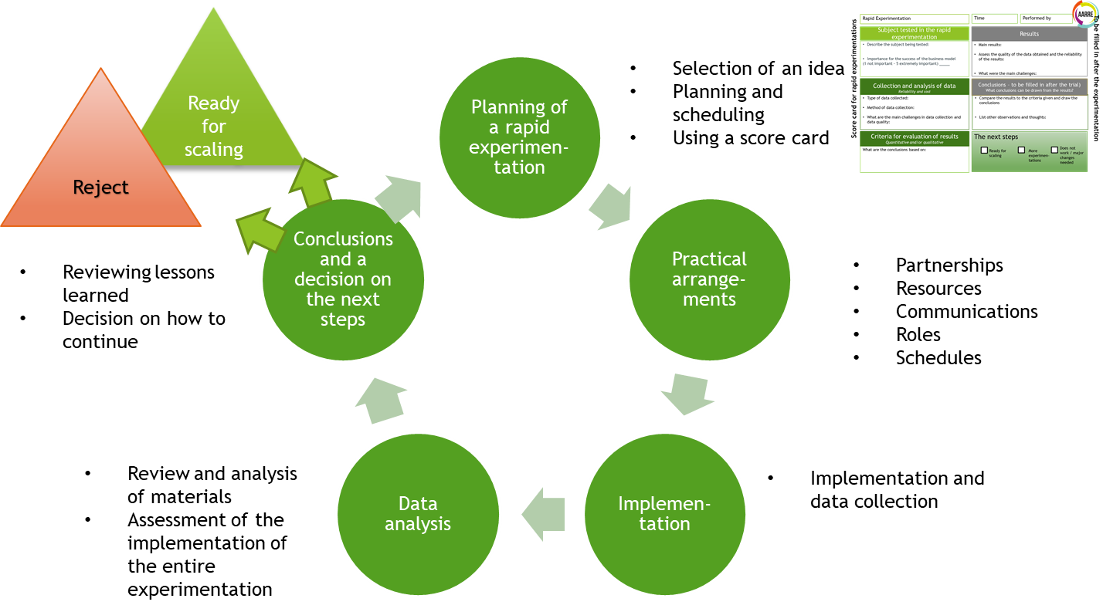

Template 13 – planning the experimentation:

The scorecard below can help in the planning of the experimentation. The left side is filled in when planning the experimentation, the right side when the experimentation is complete. A single experimentation can also test several things, in which case several cards are filled in. The information collected can also be qualitative, since the primary goal is to gain an understanding of the new model, in which case quantitative measurements can be difficult.

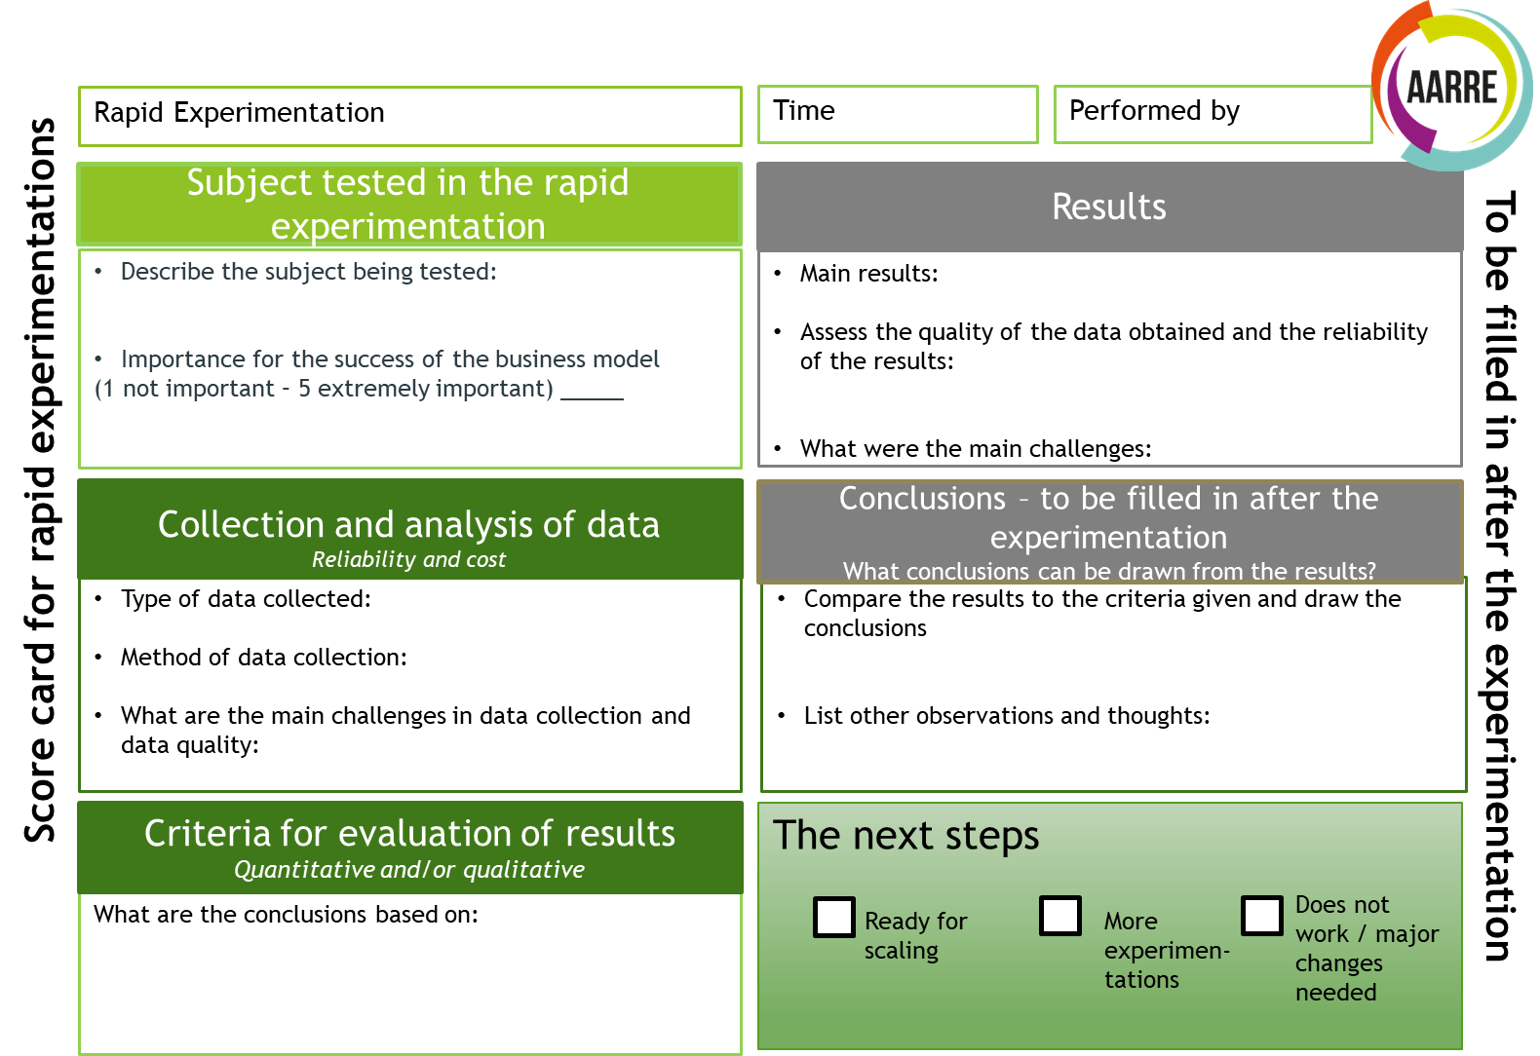

Piloting is followed by more detailed business and investment plans, discussions with partners, planning of resources and other intracompany matters. The idea is taken forward like any business idea. When promoting an idea associated with circular economy, the **wider perspective, impact and goal** of the idea should be kept in mind, so the company should return to the templates in the previous steps whenever necessary to clarify the vision and assess the impacts.

Circular economy and sustainable business is associated with many kinds of choices on **what to do, how and with whom.** When a company understands what sustainability and circular economy mean from the company’s own perspective, and when the company also understands the impact of its operations and is able to verify them, the company has valuable knowledge and should **communicate and report** it to its main stakeholders. The reporting requirement might also come from outside the company, for example from a corporate customer who have their own requirements for sustainable operations and who want the actors in their chain to commit to the same goals. At best, reporting on sustainability can support and build the company’s brand and improve interaction.[33] In the future, the company should think about how it could report and communicate on its actions that affect the environment, people and the society, while also expressing its goals and values more widely and transparently.

## 7. Finally

Circular economy will change our word and companies more than we can even imagine. New circular economy ideas and business model are being constantly developed, which will result in entirely new kinds of actors and markets, new partnerships, networks and ecosystems.

What’s more, companies of all shapes and sizes can introduce circular economy in their operations and develop along with the systemic change. We hope that CESME Circular Economy Tool has given you concrete ideas on how to develop your everyday operations and also some new business ideas for the future.

You do not have to do the brainstorming and development of operations alone inside the company – in some cases, it might be a good idea to arrange discussions with partners, for example. You can also get support from local development companies, corporate funding partners (such as Business Finland) and research and development institutions, such as universities of applied science, universities and VTT Technical Research Centre of Finland. Another key player in circular economy in Finland is Sitra, whose website contains a lot of information and case studies on companies that implement circular economy.

Enjoy your journey towards circular economy!

# READING MATERIALS

The reading materials contain additional information on circular economy and sustainability as well as support materials for the templates and additional assignments. The reading materials are arranged in the same order as the steps of the tool.

## 1. Introduction to circular economy – how does circular economy create value and what business opportunities does it enable?

In **circular economy**, the value bound to materials persists for as long as possible in the society, and economic growth does not depend on the consumption of natural resources. In addition to substances and materials, economic and intangible value will circulate and even increase. Value will be increased by closing material loops and minimising waste. In addition, the value of materials and products will be maintained, while new value is created through technology and services. At the same time, overall resource efficiency will be developed in all parts of the cycle. The system will be reviewed holistically (life cycle thinking) and the societal and environmental impacts will be evaluated for all parts of the value chain.

Circular economy brings **benefits** and new **opportunities** on the economical, environmental and societal level. Sitra’s circular economy roadmap[34] lists the following opportunities:

* Economic opportunities
  + Circular economy innovations bring opportunities for growing new business
  + A business model aligned with circular economy brings opportunities for earning more revenue from a product after it has been produced
  + Industrial symbioses increase resource efficiency and improve competitiveness
  + Reuse of materials reduces material costs
  + As the availability of raw materials improves, price fluctuations are reduced
* Environmental opportunities
  + The best environmental benefits are gained by replacing material cycles with more sustainable and energy efficient cycles
  + Sustainable use of limited resources (metals, minerals, sources of energy, water, timber, fertile soil, clean air, biodiversity)
  + Reduced use of natural resources reduces the environmental impact of product use
* Societal opportunities
  + New jobs created as a result of new business models and service orientation
  + An increase in tax revenue and exports brings more resources to the macroeconomy
  + Sharing of products and services makes them more equally available to households and helps them to save money
  + The ‘product as a service’ concept improves the customers’ service experience, since the responsibility of the maintenance of the product is transferred to the service provider
  + Sharing of products and services increases a sense of community and reduces loneliness

However, reaching circular economy requires a system-level change that contains several **challenges**. Some of the challenges associated with the transition period are:

* The complexity of promoting a systemic change and the so-called rebound effect (for example the improvement of resource efficiency in one part of the system result in an increase of production and material consumption on the systemic level)
* Economic challenges, i.e. potential unprofitability of circular business in the short term
* Imperfection of markets, such as the lack of the necessary infrastructure, competition, knowledge or incentives
* Regulatory incompleteness, such as incomplete legislation and its execution
* Social factors, such as incomplete knowledge and skills on circular economy
* Insufficient sorting of waste, difficulties in obtaining funding, lack of common procedures

**Sustainability:** Circular economy and sustainable development is also associated with the concept of sustainability, which consists of three perspectives: social, environmental and economic. Hart and Milstein[35] describe the development of sustainable business as follows:

The idea of **eco-efficiency** is to produce more from less, i.e. to design production to use as little materials, raw materials and energy as possible. Some estimates say that the product design phase determines up to 80 % of the environmental impact of a product. In addition to manufacture, eco-efficiency also takes into account product packaging and transport, and also comprises reusability, recyclability and maintainability. The idea is to reduce the harmful environmental impacts throughout the product life cycle. The assessment of eco-efficiency is described in standard ISO 14045.

**6R** is a concept for a more efficient use of materials and further utilisation. 6R consists of the following parts: Reduce, Reuse and Recycle, Recover, Redesign and Remanufacturing:

* Reduce refers to simplification of product design whose purpose is to make it easier to reutilise the product after its first lifespan is over
* Reuse minimises environmental load and maximises economic efficiency due to a reduced need for reprocessing
* Recycling refers to a process in which used material is returned to manufacturing. This can be achieved in several different ways depending on the structure and composition of the product. Examples include melting, shredding, separation, etc. Recycling is environmentally more friendly than virginal raw materials.
* Recover means returning the product back to use after its first lifespan is over
* Redesign is a significant step in light of the product lifespan. Redesign helps the use of the product after its lifespan is over.
* Remanufacturing refers to restoring the product to a state that corresponds to a new product

**Remanufacturing** is one way for returning used products or components back into use. The product is cleaned, disassembled, refurbished and reassembled to create an end result whose quality corresponds to the original product and can be granted a warranty that is equal to a new product. Therefore, remanufacturing can save materials and energy, reduce waste, ensure the availability of raw materials and meet the increasing demands for sustainable production. Estimates say that a remanufacturing process requires 85–95% less energy and materials than the manufacture of a corresponding new component. The essential factors to be considered when planning remanufacture are:

* How to arrange the recovery of the products back to the factory and how to ensure that the factory has a sufficient quantity of items to be remanufactured? Examples of options are leasing models or a deposit system.
* How to ensure that the company has repair expertise?
* How should warranty operations be arranges? Strict quality control procedures are required.
* Product design: modularity, durable materials, assembly and disassembly.

It has been estimated that the growth potential of remanufacturing for the Finnish mechanical workshop industry is up to EUR 300–400 million by 2025. This estimate is based on the additional sales generated by business models based on circular economy, such as an increase in leasing sales thanks to novel pricing, service and business models and the possibilities for reuse improved by modularisation and predictive planning (modularisation typically brings cost savings of 5–10%).[36]

**Sharing economy:** Sharing economy is a circular business model that opens interesting opportunities for companies. In consumer-oriented business, sharing economy has progressed rapidly, creating successful business models. Although there is still a lot to be desired in the utilisation efficiency of many resources, the benefits of sharing have not yet been realised in the B2B world. Potential benefits of sharing economy include**:**

* Increased cost-efficiency, if the resource utilisation rate can be increased
* The amount of money invested per company is lower, if an investment is funded by several companies
* The amount of company-specific collateral needed for investments falls, which also helps the companies to assemble the collateral
* The investment can be repeated rapidly, since the machines wear out quicker. This enables the machine base to be kept modern.
* Companies learn better, since their employees visit other companies more frequently, increasing collaboration and causing companies to learn from each other
* Companies can establish and invest in a joint learning system that helps them to learn new technologies
* Employee satisfaction might improve thanks to a more diverse range of duties, and meeting new people is often stimulating
* Risks are divided across several companies, which helps investment decisions, among others
* New companies can obtain resources at a lower cost and risk
* Might increase a sense of community and thus the market force of the community
* Increased sense of community might give opportunities for improving the efficiency of operations
* All in all, sharing economy can foster the development of ecosystems and new companies

Sharing economy also contains its share of challenges. The following are some examples of typical challenges[37]:

* Companies might face challenges in enterprise resource planning that are associated with the availability of resources at exactly the required time. This problem affects both the provider and recipient of resources.
* To prevent industrial espionage, critical resources and various manufacturing methods cannot be loaned to outsiders. Prioritisation rules must be developed for situations in which several companies need the resources at the same time.
* IPR questions might also become a hindrance
* Managing the use of resources necessitates the construction of some sort of a management system. Such a system might prove out to be surprisingly complex. For example, organising the service and maintenance of machines and equipment might also create new problems. The users might not have sufficient skills to use the borrowed machines.
* Borrowing employees involves a risk of the employee leaving the company as a result of the borrowing

What can the companies share? The resources of an industrial company can be divided into four main categories:

1. People
2. Machinery and equipment
3. Real estate
4. Materials

These in turn can be divided into subcategories in many different ways. The following picture is a resource map of an industrial company that presents an example of categorising the resources.



In principle, companies can share any resources between each other. Moreover, companies can procure resources from external service providers and subcontractors. Industrial companies have traditionally sought to own and control all resources that are important for them. Nevertheless, some operations have always been outsourced to some extent for several reasons. The current industrial paradigm is undergoing a shift in this respect.

Employees at customer interface can see opportunities for sharing common resources in many different ways. Trading warehouses and distribution logistics offer opportunities for efficient pooling of resources. Various alliances in which companies build a common portfolio of offerings to the market enable them to offer complementary product families to the customers. What comes to supplier networks, many companies can build at least partly shared supplier and subcontractor network. This way, the suppliers can get more volume that brings cost efficiency, which is also seen in prices. A shared network also offers opportunities for developing and operating new kinds of communication platforms.

The following picture shows the resource portfolio of a company as a 2 x 2 matrix that classifies resources on the basis of their shareability and the possibility of using resources shared by other companies. The bottom left corner of the matrix consists of resources that are, in principle, easiest to share with other companies. By contrast, the top right corner consists of resources that are not shared with other companies.



In other words, the resources in the picture are classified on the basis of their significance to business and the level of competence/specialisation they require.[38]

**Business models for circular economy** can be categoried in many ways. One of the ways is to divide the business models into three parts: slowing down the circulation, closing the loop and minimising the loop. The table below describes ways of implementing these approaches and presents examples of businesses in each[39].

|  |  |  |
| --- | --- | --- |
|  | *Ways to implement* | *Examples of companies* |
| *Slowing down the circulation* | *Offering performance or service instead of selling a product*  *Solutions that seek to increase the life cycle of the products, starting from design (repairability, durability, updateability, opportunity to remanufacture)*  *An advertising and sales approach that seeks to minimise consumption, repair services and warranties* | *Liiteri: a rental and sharing service for tools (http://liiteri.net/)*  *Martela: user-centric working environment as a life cycle service (https://www.sitra.fi/cases/kayttajalahtoinen-tyoymparisto-elinkaaripalveluna/)* |
| *Closing the loop* | *Maximising the value of used products*  *Gathering and acquisition of waste materials and resources and their modification to create new value*  *Industrial symbiosis: residual output from one process is used as raw material for another. Geographic proximity is a key factor here* | *Destaclean: Garden stones made of wood-based recycled material (http://www.puukivi.fi/)*  *Emmy: Turnkey model for selling used clothes (https://www.sitra.fi/cases/avaimet-kateen-malli-kaytettyjen-vaatteiden-myymiseen/)*  *Lankava: Rag rug yarns from recycled textiles* |
| *Minimising the loop* | *Making more with less resources and producing less waste, emissions and pollution*  *Resource efficiency and a zero-waste approach are an integral part of everything the company does* | *Altia: Pioneer of bioeconomy and circular economy, efficient use of resources, Green Company of the Year*  *Lakeuden Ympäristöhuolto*  *Kohiwood*  *Shareit Blox Car: Promoting peer-to-peer rental of cars (https://www.sitra.fi/cases/autojen-vertaisvuokraamisen-edistaminen-palvelulla/)* |

## 2. What kind of opportunities does circular economy offer your company? Brainstorming and prioritisation of circular economy business models

**The business model canvas for circular economy[40]** has been developed in view of the requirements posed by circular economy to business.

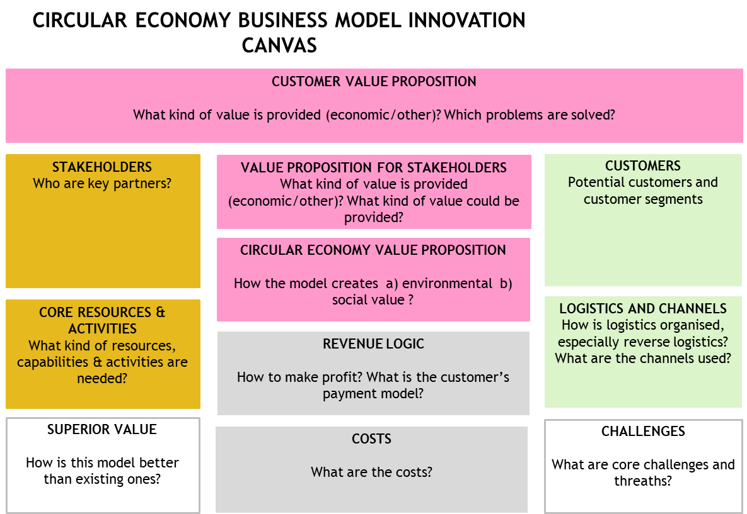

**Circular economy toolkit:** Companies can use the Circular Economy Toolkit available online at [www.circulareconomytoolkit.org](http://www.circulareconomytoolkit.org) to identify the benefits and opportunities gained and generated by business operations aligned with circular economy. Designed in University of Cambridge, the Circular Economy Toolkit is a tool that helps companies to identify new opportunities to save both the company’s own resources and environmental resources and make environmentally sustainable decisions. The tool investigates opportunities afforded by circular economy throughout the product life cycle[41].

On the site, the company can complete a quick assessment of opportunities in the Assessment tool[42], and the site also contains instructions on how to arrange a workshop. The quick Assessment tool can also be filled in as part of the workshop. However, it is a good idea to practice how to use the Assessment tool and experiment with different inputs before presenting the tool to companies.

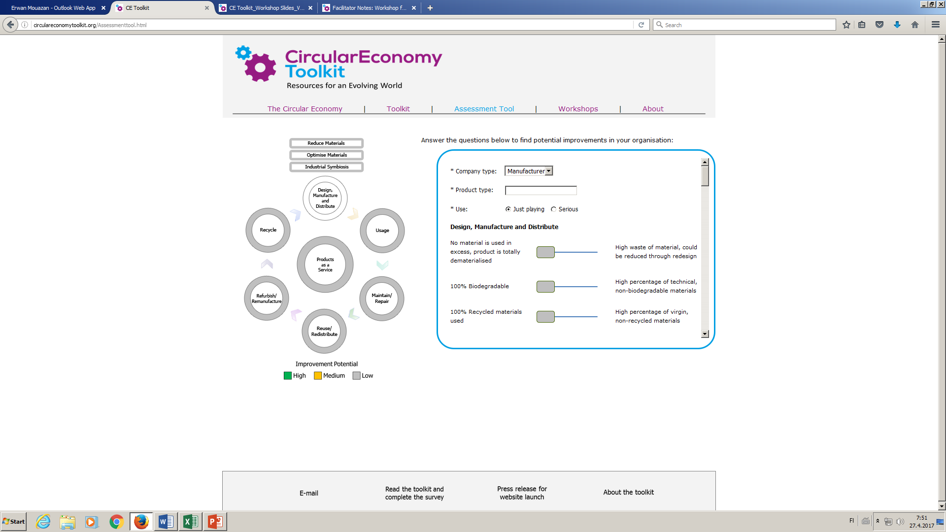

## 3. What are the primary stakeholders and networks?

**Value mapping tool:** The purpose of the value mapping exercise is to identify values perceived by the primary stakeholders of the company. The primary stakeholders or important individual actors are named around the perimeter. The following matters are considered for each of these parties: the positive effects to the party as a result of the new business/planned change, the effects that the party might perceive as negative and the opportunities that are lost completely.[43] This experiment can be made by stepping into each actor’s shoes and considering the company’s plans through the actor’s experiences, or (if possible) by discussing directly with the actor.

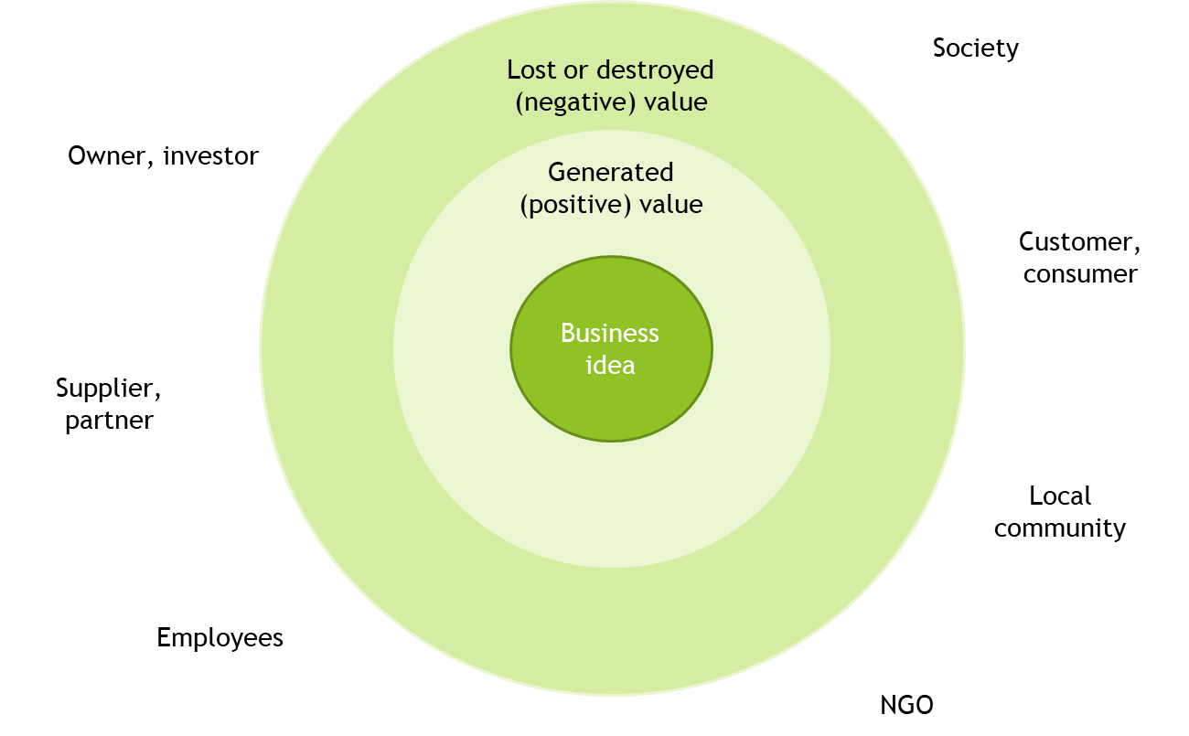

## 4. How to use the value generated to assess the impact to stakeholders, the society and the environment?

**Problems associated with measurement:** Consideration is required on why the measurement takes place, what is sought with the measurement, what is essential, how is the measurement implemented and at what level will the assessment take place. Measurement is challenging: for example, how can the impact on employees be converted to a monetary amount? The systematic approach to measurement is also associated with a long-term perspective: the data and knowledge collected is used not just for measurements and documentation, but also for aligning the company’s operations over longer periods of time.

**Selection of indicators:** An indicator helps a company to assess the realisation of the goals it sets. The impacts experienced by stakeholders should be assessed in all areas of sustainable development (economic, social and environmental) and therefore indicators should be in place for all of these areas. Indicators can target different levels: product or service, process, production facility or even a country. When evaluating indicators, it is a good idea to keep in mind the following characteristics of a good indicator:

* relevant and easy to understand
* stable (external factors do not affect the indicator very much)
* measurable
* traceable
* statistically significant

Other important factors to consider in view of the identified indicators and their monitoring are:

* How and when will the measurement take place and how often, by what methods and what is the data source
* What are the principles of assessment – what is the obtained value compared to, how will the obtained result be classified (on what scale, against which criteria, etc.)

**Environmental impact assessment, life cycle assessment:** A widely used method in the assessment of environmental impact is life cycle assessment (LCA) that is based on life cycle thinking. Impact on climate change (carbon footprint is also often used) means the quantity of greenhouse gases emitted during the life cycle of the product. The life cycle assessment can focus on greenhouse gases, and the output of these calculations indicates the carbon footprint. The most important greenhouse gases are carbon dioxide, methane and nitrous oxide. Greenhouse gas emissions are calculated as carbon dioxide equivalents, by means of multipliers specified by the Intergovernmental Panel on Climate Change (IPCC). To make carbon footprint calculations reliable, they must be based on the standard ISO 14067 and the life cycle assessment standard ISO 14040-44

European Commission has published instructions for the assessment of the environmental footprint. The instructions cover the entire life cycle of a product from the perspective of both the Product Environmental Footprint (PEF) and the Organisation Environmental Footprint (OEF). The environmental footprint is based on existing, tested and commonly used methods, standards and guides.

**Assessment of positive environmental impacts, handprint:** A handprint is a positive metric that can be used along with the footprint metric that indicates environmental burden. Many companies have already reduced their own footprint. Furthermore, an increasing number of companies are developing products or processes aimed at reducing the footprint of the customer's product or service. In such cases, their activities also have a positive environmental impact. Handprint means the positive environmental impact created by the company’s operations, and carbon handprint means the mitigation of the carbon footprint of other actors, i.e. the reduction of climate impact.

**The GRI (Global Reporting Initiative) standard[44]:** The purpose of reporting on corporate responsibility is to offer relevant information to the readers and increase their awareness of the company’s operation, goals and achievements. The GRI standard is utilised widely in responsibility reporting both in companies, organisations, public bodies, municipalities and authorities. GRI strives to create a framework for social and environmental reporting that is equivalent to the framework that governs reporting on financial statements.[45]

A central theme in GRI reporting is the principle of essentiality, according to which the purpose of the reporting is to present things that are essential to the organisation being reviewed. GRI has been designed to be adaptable to the organisation’s operations. For example, SMEs can report only the pertinent parts of their operations. GRI also examines the value chains of companies.

Environmental indicators:

|  |  |
| --- | --- |
| Objective | Examples of indicators |
| Materials | Use of materials by weight or quantity, use of recycled materials, recycled products and their packaging materials |
| Energy | Energy consumption (the organisation’s own and external), energy intensity, reduction of energy consumption, reduction in the need for energy of products and services |
| Water | Total water intake by water source, water sources which are significantly affected by the organisation’s water intake, recycled and reused water |
| Natural diversity | Sites that are located in nature conservation areas or in areas significant for natural diversity, impact of the operations on natural diversity, conserved and remedied habitats |
| Emissions | Greenhouse gas emissions (direct and indirect), emission intensity of greenhouse gas emissions and reduction thereof, emissions of ozone-depleting substances, emissions of oxides of nitrogen and sulphur, other significant emissions into atmosphere |
| Emissions into bodies of water and waste | Emissions into bodies of water, total quantity of waste, significant spills, transports of hazardous waste, bodies of water impacted by wastewater emissions and runoff |
| Compliance with environmental legislation | Breach of environmental legislation and environmental regulations |
| Environmental assessment of suppliers | The proportion of new suppliers whose environmental impact has been assessed, negative environmental impact in the supply chain and implemented actions |

Societal/social indicators:

|  |  |
| --- | --- |
| Objective | Examples of indicators |
| Employment | Number of new jobs |
| Occupational health and safety, employment relationships | Number and frequency of accidents, number of sickness absences, health care costs, employee turnover, work satisfaction, employee benefits |
| Development of the personnel’s competence; training and education | Placements in training, average number of training days per employee, programmes associated with development, development discussions |
| Equality, diversity | Number of women in the organisation, ratio of female salaries to male salaries |
| Customer satisfaction, customer health and safety, health and safety impact of the products and services | Customer satisfaction measurements, brand comparisons and reputation surveys, violation of the requirements set for products and services |
| Community and charity | Investment in the community in EUR |

Economic indicators:

|  |  |
| --- | --- |
| Objective | Examples of indicators |
| Financial performance/financial results | Generation and distribution of direct economic added value, economic consequences of the climate change and other risks and opportunities for the organisation’s operation, pension cover, financial assistance received from the public sector |
| Local practices | The ratio of usual initial salaries to the local minimum wage, proportion of people in the upper management whose origin is in the local community |
| Indirect economic effects | Infrastructure investments and offered services of general investments, main indirect economic effects and their extent |
| Purchase practices | Purchases from local suppliers |
| Anti-corruption approach | Business units who have undergone a corruption risk analysis, communication and training associated with anti-corruption policies and procedures, incidents of corruption and the measures taken as a result |
| Restriction of competition | Legal actions associated with a breach of competition law regulations, cartels and abuse of dominant position in the market |

**Models for calculating economic potential of circular economy business models**

Economic potential can be assessed in many ways, and a good example of this is traditional cost accounting, which is a natural part of business, and therefore companies are familiar with it. Some calculation methods and models that are better in line with circular economy have been developed. Below are some hints and tips for calculations:

* Read a short summary on the cost-benefit analysis for example in Wikipedia[46]
* Sitra’s Circular Economy Playbook contains a template for business benefits of circular economy[47] (Value Tool)
* Return on investment in per cent (so-called ROI) = 100 * [ [net income](https://www.almatalent.fi/tietopalvelut/tunnuslukuopas/kannattavuus/nettotulos-ja-nettotulos-prosentti) + financial costs + taxes (12 months) ] / average capital invested.

1. The website of Regional Council of South Ostrobothnia contains materials for the tool that can be used by the facilitator (in Finnish). The materials contain background information, case studies and templates. The materials also contain empty templates to be printed or filled digitally.
2. For more information about eco-efficiency and sustainability, see the Reading Materials section.
3. Antikainen, M. et al. 2016. Talous kasvuun uusin ajatuksin - Kiertotalouden keinovalikoima käyttöön. [Economic growth based on new ideas – Bringing the circular economy into play.] VTT – Policy Brief 1/2016. Available at: <https://www.vtt.fi/Documents/uutiset/Kiertotalous_VTT_Policy_Brief_1_2016.pdf>.
4. www.globalreporting.org
5. The goals and indicators of the GRI standards are also described in the Reading Materials section.
6. For more information of what the concept of sustainable development entails, see the Reading Materials section.
7. The assessments are based on a query by Sitra. For more information, see the Circular economy playbook (Sitra, Teknologiateollisuus & Accenture, 2018. Circular economy business models for the manufacturing industry - Circular economy playbook for Finnish SMEs. Helsinki. Available at: http://www.kasvuakiertotaloudesta.fi/)
8. The examples are described in more detail in the Reading Materials section and in Sitra’s Circular Economy Roadmap, (available at: <http://media.sitra.fi/2017/02/27175308/Selvityksia117-3.pdf>).
9. According to Sitra’s estimate, the value added by circular economy to Finland’s macroeconomy by 2030 might be at least three billion euro annually. For more information, see Sitra’s website: https://www.sitra.fi/aiheet/kiertotalous/.
10. https://www.scp-centre.org/can-benefit-circular-economy/
11. The Action plan for circular economy in South Ostrobothnia is available at <https://www.epliitto.fi/images/CESME_Toimintasuunnitelma.pdf>.
12. The regional programme is available at <https://www.epliitto.fi/images/A58_Etel%C3%A4-Pohjanmaan_maakuntaohjelma_2018-2021_web.pdf>.
13. The strategy for smart specialisation is available at <https://www.epliitto.fi/images/B_64_Alykas_ja_erottuva_Etela-Pohjanmaan_alykkaan_erikoistumisen_strategia.pdf>.
14. For more detailed descriptions of these business models, including business cases (slowing down, closing and minimising the loop), see the Reading Materials section.
15. Modified from source Accenture 2014. Circular Advantage. Available at: <https://www.accenture.com/t20150523T053139__w__/us-en/_acnmedia/Accenture/Conversion-Assets/DotCom/Documents/Global/PDF/Strategy_6/Accenture-Circular-Advantage-Innovative-Business-Models-Technologies-Value-Growth.pdf>
16. For more information about 6R and remanufacturing, please see the Reading Materials section.
17. For more information on tyre retreading, see Kutepa’s website: <http://www.kutepa.fi/rengaspinnoitus/>.
18. For more information about Emmy’s business model, see the Sitra website: <https://www.sitra.fi/caset/avaimet-kateen-malli-kaytettyjen-vaatteiden-myymiseen/>. Picture and further information from Emmy’s website at <https://store.emmy.fi/pages/kaytettyjen-merkkivaatteiden-taivas>.
19. For more information in Valtra’s remanufacturing model, see the Valtra website at (<https://www.valtra.fi/palvelut/huolto-ja-korjaus/reman.html>) and Sitra website at (<https://www.sitra.fi/caset/tehdaskunnostetut-traktoreiden-vaihdelaatikot/>).
20. For more information, see the Lankava website at: <https://www.lankava.fi/>
21. For more information, see the Lennol website at: <https://www.lennol.fi/>
22. For more information about ResQ, see the Sitra website (<https://www.sitra.fi/caset/mobiiliteknologiaa-hyodyntava-ruokapalvelu/>) and ResQ’s own website (<https://www.resq-club.com/fi/>).
23. Information on Kiertonet: <https://kiertonet.fi/tietoa-kiertonetista>
24. Vaatelainaamo Tanttu’s website: <https://vaatelainaamotanttu.blogspot.com/>.
25. For more information, see the Martela website at: <https://www.martela.fi/>
26. The internet contains a range of freely available tools for identifying the benefits obtained and generated by companies in their business operations that are aligned with circular economy. An example of this is the Circular Economy Toolkit, about which the Reading Materials section contains more information.
27. The brainstorming session can be enhanced by means of a business model canvas that emphasises circular economy. The Business Model for Circular Economy tool is available in the Reading Materials section.
28. Another tool for investigating value is a so-called value mapping tool, in which for each stakeholder, the potentially generated (positive) value, destroyed (negative) value and lost value opportunities are identified. A simplified version of this is available in the Reading Materials.
29. For more information about the calculation of a handprint, see the Reading Materials section.
30. Final report of the AARRE project: <https://www.vtt.fi/sites/AARRE/aarre-loppuraportti>.
31. Also the GRI standard discusses the measurement of environmental impacts as well as the goals and indicators set for operations – the environmental goal and indicators in the GRI standard are presented in the Reading Materials section. They might also serve an inspiration in the completion of this step.
32. A more detailed investigation can be made, for example, with the ’Value case tool’ Excel sheet (available at: <http://www.kasvuakiertotaloudesta.fi/wp-content/uploads/2018/09/CE2018_Value-case-tool_v1-0.xlsx>), which is designed for surveying the value potential of the business model and for a more detailed assessment of the business potential, cost effects and investment needs, for example. The tool is a part of the ’Circular economy business models for the manufacturing industry’ guide published by Sitra, Teknologiateollisuus and Accenture (Sitra, Teknologiateollisuus & Accenture, 2018. Circular economy business models for the manufacturing industry - Circular economy playbook for Finnish SMEs. Helsinki. Available at: <http://www.kasvuakiertotaloudesta.fi/>)
33. For more information and instructions on responsibility reporting, see: Kurittu, K. 2018. Yritysvastuuraportointi - Kiinnostavan viestinnän käsikirja. Helsinki, Alma Talent.
34. Sitra 2016. Kierrolla kärkeen - Suomen tiekartta kiertotalouteen 2016-2025. Sitran selvityksiä 117. Available at: <http://media.sitra.fi/2017/02/27175308/Selvityksia117-3.pdf>
35. Hart, S.L. & Milstein, M.B., (2003) Creating sustainable value. Academy of Management Executive, Vol. 17, No. 2. pp. 56-67.
36. For more information about the opportunities afforded by circular economy: Sitra, 2014. Kiertotalouden mahdollisuudet Suomelle. November 2014. Sitran selvityksiä 84. Available at: <https://media.sitra.fi/2017/02/23221555/Selvityksia84.pdf>.
37. For more information about sharing economy, see the final report of the SHARE project (Industry sharing platform for boosting transition towards circular economy) at <https://www.vtt.fi/sites/SHARE/share-loppuraportti>.
38. For more information, see the final report of the SHARE project (Industry sharing platform for boosting transition towards circular economy) at <https://www.vtt.fi/sites/SHARE/share-loppuraportti>.
39. The categorisation and descriptions adapted from Kraaijenhagen, C., Van Oppen, C., Bocken. N., 2016. Circular business. Collaborate & Circulate. Circular Collaboration, Amersfoort, The Netherlands. Available at: circularcollaboration.com
40. Antikainen, M. & Valkokari, K. 2016. A framework for sustainable circular business model innovation. Technology Innovation Management Review, 6(7): 5-12.
41. The life cycle view is on page: <http://circulareconomytoolkit.org/Toolkit.html>.
42. The Assessment tool can be found at: <http://circulareconomytoolkit.org/Assessmenttool.html>.
43. The template is based on the following sources: Bocken, N.M.P., Short, S., Rana, P. & Evans, S. 2013. A value mapping tool for sustainable business modelling. Corporate Governance 13(5), pp. 482–497 and

    Evans, S., Rana, P. & Short, S. 2013. SustainValue Deliverable 2.4 – First stage prototype tools and methods, capable of being fully used by industrial partners. Published 5th September 2013. Available at: <http://www.sustainvalue.eu/publications/D2_4_Final.pdf>.
44. https://www.globalreporting.org/
45. A comprehensive look at the GRI standard and reporting: Kurittu, K. 2018. Yritysvastuuraportointi - Kiinnostavan viestinnän käsikirja. Helsinki, Alma Talent.
46. Wikipedia. Cost-benefit analysis. Available at: <https://fi.wikipedia.org/wiki/Kustannus-hy%C3%B6tyanalyysi>
47. Sitra, Teknologiateollisuus & Accenture, 2018. Circular economy business models for the manufacturing industry - Circular economy playbook for Finnish SMEs. Helsinki. Available at: <http://www.kasvuakiertotaloudesta.fi/>)