Wildlife Economy
“A nature-based economy
is an attractive, viable and sustainable economic strategy
for regions rich in natural heritage.”

Communication Plan
Version 1 – 30/08/2019

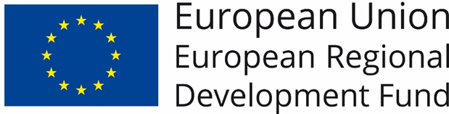

Our main communication objective :
“Active involvement of the target groups and efficiently communicate project information and results.”

The main message :
“A nature-based economy is an attractive, viable and sustainable economic strategy for regions rich in natural heritage.”

WLE provides excellent opportunities for appealing communication through photos and videos of the project regions (through collaboration with nature photography collective Wild Wonders of Europe), which can be used in all communication activities. For questions about the use of photos and videos, please contact Kristjan Jung, Communications Manager at Rewilding Europe, kristjan.jung@rewildingeurope.com
The project website: https://www.interregeurope.eu/wle/

Contact point for the project communication:
Regional Landscape Kempen and Maasland
Kristel Neyens
E: kristel@rlkm.be
T: +32 (0)89 65 56 68
i

#
The hashtags for use on your social media channels that provide the link with Interreg Europe:
- Facebook and Twitter: @interregeurope
- Instagram: #interregeurope
- Linkedin: #interregeurope

Communication Managers
Province of Limburg | Diandra Hupkens | da.hupkens@prvlimburg.nl
Regional Landscape Kempen and Maasland | Kristel Neyens | kristel@rlkm.be
Rewilding Europe | Laurien Holtjes | laurien.holtjer@rewildingeurope.com
Rewilding Europe - Sweden
Environmental Action Germany
County Administrative Board in Norrbotten
Municipal Community Europaregion Pomerania reg. Ass.
Alava Provincial Council

Communication objectives (CO):
CO 1 Persuade policy makers that the quality of nature areas can be improved whilst creating viable economic activities rooted in these natural qualities by adopting the wildlife economy model, so they will commit to implementation: 4 RAPs signed in 2020.
CO 2 Engage key stakeholders constantly and actively in the development, implementation and monitoring of the RAPs: at least 80% of stakeholder groups represented in the stakeholder meetings and activities.
CO 3 Inform local communities and economic actors in the partner regions and beyond about the importance of nature conservation and the potential of a WLE as a viable economic strategy.
CO 4 Engage a European community of experts and stakeholders discussing the project topic.
CO 5 Communicate between project partners.

Target groups (TG):
TG 1 Managing Authorities and key decision makers in regional, national and EU authorities
TG 2 Stakeholder groups including entrepreneurs, nature organizations and local and regional authorities
TG 3 Citizens and economic actors in the partner regions
Wider public
TG 4 Key experts in national and EU authorities and institutions dealing with the project topic;
Other national and European projects, to promote cross-fertilization with other projects dealing with the same topics and challenges;
General and specialized networks, to provide the widest opportunity to favour exchange of experience.
TG 5 Project partners / internal communication.

Checklist of publicity requirements
- The logo must always be visible in a prominent place (on the first/landing page, visible, without scrolling, on all electronic and mobile devices) and of a comparable size to other logos used.
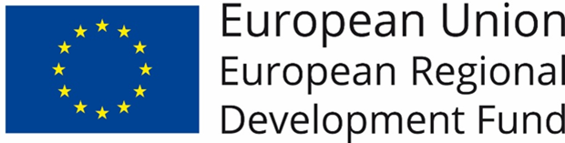
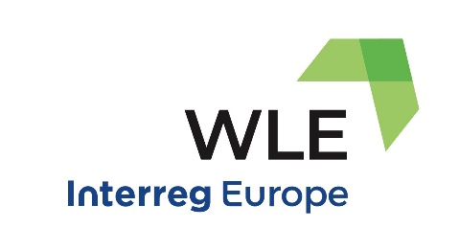
Use the Interreg Europe logo set This already respects all the programme requirements!

- All partner institutions inform about project on their website (if such website exists)
- All partner institutions' websites linked to Interreg Europe/ project website
- All partner institutions place the A3 project poster at a location readily visible to the public
- ERDF support mentioned on all documents used for the public or the participants in the project's operations/activities
- Project website updated at least once every six months

