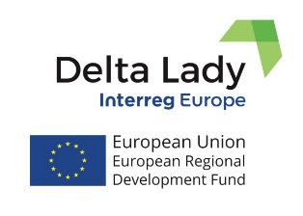
Press Release
March 2019

The 2nd Interregional Learning Event and Partner Meeting of the Delta Lady in the Albufera Natural Park, Valencia.
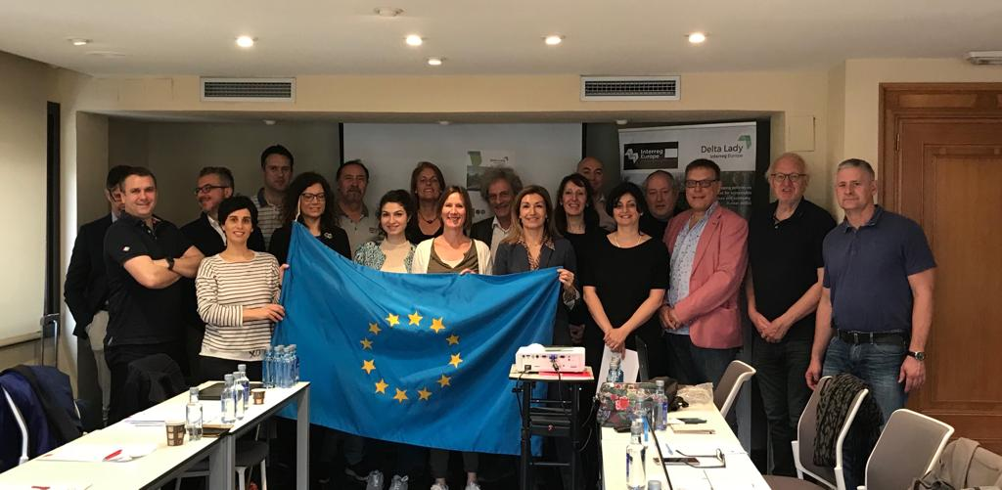
The Delta Lady project partners met in Valencia on 5-6 March 2019, to exchange experiences on sustainable use of ecosystem services in their delta regions. The Council of Chambers of Commerce, Industry, Services & Shipping of the Valencia Region (CCCV) hosted the Interregional Learning event which was combined with the study visit to the Albufera Delta, partner meeting and the Steering Group meeting. 25 participants attended the event: 17 project partners, 5 stakeholders and 3 external experts. 2 stakeholders were from the Province of Friesland (NL), 1 from General Directorate of European Funds (ES), 1 from the University of Ferrara (IT) and 1 from Southern Regional Assembly from Ireland.
The first day of the event (March 5) was held in the Albufera Natural Park (PNA) office, followed by the study tour to the Albufera Delta. Partners presented and discussed innovative uses of the ecosystem services of the deltas based on the preservation of the natural and cultural heritage. The study tour to the PNA started with the "Racó de L'Olla" Interpretation Center, the Bird Observation Point, the Tancat de l'Albufera farm and the Gola del Pujol.
The second day of the event (March 6) was held in the premises of the Council of Chambers of Commerce in Valencia. The morning session started with the Steering Group meeting. The group members addressed and discussed administrative issues related to the project after which the rest of the partners joined the meeting, continued by external experts' presentations: among them, presentation of the managing director of the technical office of the PNA, the professor of the UPV (Technical University of Valencia) specializing in wetlands and sustainable tourism, the manager of the DO "Arroz de Valencia", the secretary of the Association Guides Birding Comunitat Valenciana, the manager of the Marca Parcs Naturals of the GVA, and the manager of the company Arroz Tartana.
For this two-day meeting, the CCCV had support, collaboration and participation of the head of the Regional Policies Service of the European Union, of the General Directorate of European Funds of the Generalitat Valenciana. For more information, please, contact Yoram Krozer (krozer@xs4all.nl +31 6 51 23 13 71) or Maia Lordkipanidze (m.lordkipanidze@utwente.nl +31 58 284 9002).

University of Twente, CSTM, Project leader
Delta Lady (Floating Cultures in River Deltas)
Project funded by Interreg Europe programme
https://www.interregeurope.eu/deltalady/
https://www.facebook.com/InterregDeltaLady/

