INFO- BUILD2LC
Boosting Low Carbon Innovative Building Rehabilitation in European Regions
Interreg Europe - Low Carbon Economy
http://www.interregeurope.eu/build2lc/
Newsletter n. 4
June 2018
Editorial Bi-lateral meetings to help give shape to the Action Plans
After sharing the available results during last third semester, we count on a very complete database to be exploited for the utmost benefit of all the involved regions. In this newsletter we tell you what we learnt in-deep from each other, how we did it and the way we envisage likely to apply this knowledge in the respective Action Plans.

Last six months the involvement of the BUILD2LC partners has been even more intense than in previous periods due to the high number of policy learning events organised, mainly bi-lateral and also multi-lateral meetings between partners, both on-site and by electronic means. We must stress the high quality of these meetings that counted not only on the project partners, but especially on their directly related stakeholders. This has allowed putting the respective stakeholders more directly in contact with peers from different regions all over the EU to promote the interregional network of stakeholders of the project and to foster the exchange of information ensuring, this way, future collaborations beyond the duration of BUILD2LC.

There were two bi-lateral and five multi-lateral meetings on-site, as well as other two by electronic means or by videconference to save costs . These meetings have allowed partners to deepen in their learning process collecting details on how to adapt and monitor specific good practices. In total, through these meetings, 25 exchanges of good practices have been registered. So far, all partners have participated in, at least, two bi-lateral meetings, according to what was planned; and even some of them in three. Even though, and according to the general partnership request, more bi-lateral meetings are expected to come for next semester to enrich the ouctome of the project.

In addition, the partners held the needed internal regional stakeholder meetings, drafted the preliminary version of the action plan and attended the scheduled Interregional Coordination Meeting in Ljubljana (Slovenia) during 13 March 2018, where the action plans were shared. The project Policy Board was also invited to this meeting to specifically discuss the needs and barriers in implementing the measures included in the draft Action Plans.

In this semester
WHAT’S NEW?
- Bi-lateral meeting between REGEA and AIK (Croatia) and VIPA from Lithuania in Croatia to boost financial instruments from ESCOs and PPP projects, 4 October 2017.
- VIPA (Lithuania) goes to Andalusia to learn more from the AEA good practices. 9-10 November 2017.
- LEAG (Slovenia) and REGEA (Croatia) meet to learn experiences from each other. 20 November 2017.
- BUILD2LC celebrates it first electronic bi-lateral meeting (SWEA, Gloucestershire receives expert advice from Croatia). 13 December 2017.
- VIPA (Lithuania) hosts a large multi-lateral meeting to spread knowledge on their financial instruments experiences. 16-17 January 2018.
- Second electronic bi-lateral meeting. SWEA, Gloucestershire gives expert advice to Croatia. 6 February 2018.
- Gloucestershire shows the way to Slovenia and Poland in tackling with energy poverty concerns. 7 February 2018.
- Ljubljana (Slovenia) hosts the Action Plans Coordination Meeting! 13 March 2018.
- Massive multi-lateral meeting hosted by Slovenia. 14 March 2018.
- Andalusia and Podkarpackie learns from Croatia. Bi-lateral meeting at Bračak Energy Centre, Croatia. 15 March 2018.
- RRDA holds its stakeholders meeting to raise awareness about the energy efficiency in buildings
- RJH held its stakeholders meeting in Östersund to take advantage of the transferred good practices. 25 October 2017.
- Gloucestershire (UK) gathers their stakeholders to boost the action plan development. 22 November 2017.
- Slovenian stakeholders meeting to work on improving local energy policies tackling with energy poverty. 22 December 2017.
- REGEA organizes in Zagreb the 4th stakeholders meeting to present and sharing the results of Interregional Thematic Seminar held in Gloucester (UK). 6 February 2018.
- Regional stakeholders meeting in Vilnius after the Coordination Meeting. 29 March 2018.

FOCUS ON
- Action Plans were drafted and shared after remarkable bi-lateral meetings.

Bi-lateral meeting between REGEA and AIK (Croatia) and VIPA from Lithuania in Croatia to boost financial instruments from ESCOs and PPP projects

REGEA and its National stakeholder the Agency for Investments and Competitiveness, AIK, both from Croatia received on 4 October 2017 expert advice from VIPA, Lithuania, at the REGEA headquarters, the Bračak Energy Centre, Zabok, Croatia.

This meeting was focused on the financial instruments development both for Energy Services Companies (ESCos) and Public Private Partnerships (PPP) projects. Firstly, Kristina Vaskeliene and Žaneta Maskaliovienė from VIPA outlined the work of the Lithuanian Energy Efficiency Fund (ENEF) including:

- Necessary steps for developing the Fund (ex ante study)
- Legal and financial structuring of the institution
- Types of projects that can be funded via ENEF.

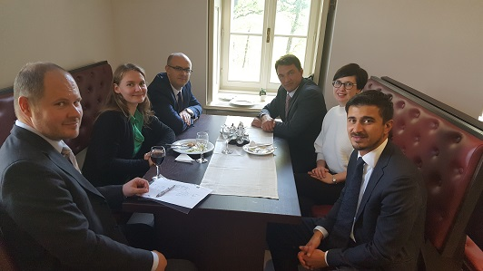
The receiving attendants were from AIK and REGEA. AIK is an agency of the Croatian Government, whose main tasks are to provide investors with full services for the implementation of (energy) investment projects, to propose measures for the improvement of the business environment (within the Operational Programme for ESIF) and to promote Croatia as a desirable investment destination. Most of the projects in this area have been financed via grants (subsidies) so far. The main objective is to move away from grant mechanisms towards Financial Instruments, especially revolving funds that could help leverage private sector resources.

However, in the current economic climate, financial intermediaries in the private sector (ESCOs) are limited by solvency constrains and strict risk management requirements. These factors may make it more difficult for investment projects to secure financing. High level of uncertainty in regard to economic outlook and financial position of enterprises resulting in the negative effect on the availability of finance, especially for SMEs, as banks are highly risk averse. There are several national schemes for energy efficiency, but they are not always applicable for the energy efficiency measures needed in large scale projects (PPP).

Results

The implementation of a financial instrument in full as it was presented by VIPA would present a challenge to both managing authorities and financial institutions in Croatia. There are, however, certain parts of the Energy Efficiency Fund (guarantee scheme for ESCOs and PPP projects) that AIK will explore in detail and discuss internally with the Ministry of Finance in order to be implemented over the next few years (through Operational Programme for ESIF). Croatia is new to Financial Instruments, so it is reasonable to expect that, even if implemented immediately, as suggested during the meeting, the actual results expected would be actually achieved over a certain time frame. This is due to the natural need of “learning by doing” for all the involved actors (ESCOs, financial institutions, beneficiaries, etc.) in respect to operational, legal and procedural aspects, apart from the time required to set up the immediate procedural, procurement and legal framework for implementation.

VIPA therefore, recommends that, in order to facilitate the achievement of the general objectives set out in the Operational Programme, and of the specific objectives arising from the various national programmes from managing authorities, to consider to pair Financial Instruments with the more consolidated grants programme, in particular targeting those categories of beneficiaries and projects which cannot be reached through them. Consequently, the implementation of such projects by using grant schemes might be necessary before the potential for use of financial instruments could be confirmed.

VIPA (Lithuania) goes to Andalusia to learn more from the AEA good practices

VIPA (Lithuania) visited AEA (Andalusia, Spain) during 9 and 10 November 2017 in the frame of a bi-lateral meeting to get detailed information mainly on these four good practices from the Spanish partner:

- Evaluation of the Incentives Programme for Sustainable Construction in Andalusia
- Participative and open governance of the Sustainable Construction Programme in Andalusia
- Technological Corporation of Andalusia: regional RTDI funding Public-Private Partnership
- Spanish ESCO market: key partners to achieve an energy transition
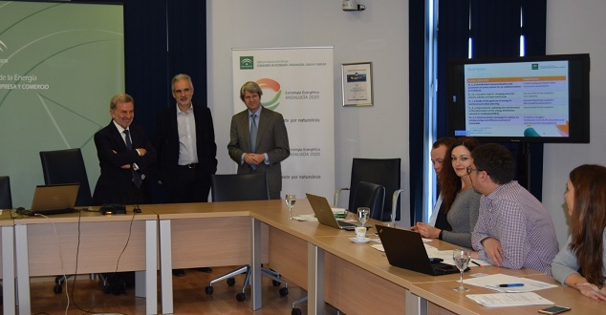
The first day was launched with the institutional welcoming by the AEA General Manager. Later, it was given an introduction to the Energy Strategy for Andalusia 2020, stressing the planning development through participative and open governance process. There was also an introduction to the Incentives Programme for Sustainable Construction in Andalusia and we could know of the experiences from the private sector initiatives on Sustainable Construction from FADECO contractors.
The Sustainable Construction Programme was explained just after the lunch.

The second day was devoted to know more from how to finance research and projects. We visited the headquarters of our stakeholder the Technological Corporation of Andalusia (CTA) that gave a magister lesson on PPP research initiatives. CTA is a strategic partner for innovation. It helps businesses, universities, public authorities and other bodies to successfully achieve their R&D objectives and valorise the results.
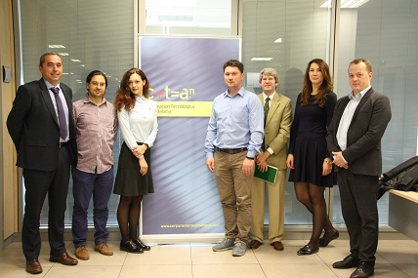
Coming back to the AEA premises, we heard the opinion from the National Association of ESCOs (ANESE) on the Andalusian ESCO market and the Ex-post energy evaluation, certification and energy audit by the Energy Efficiency Business Association (A3e).Finally, Dr Ignacio Contreras from Spanish Institute of Financial Analysts offered an expert vision on the available Real alternatives to public funding on energy rehabilitation of buildings.

We hope that these experiences were inspiring for Lithuania!

LEAG (Slovenia) and REGEA (Croatia) meet to learn experiences from each other.

This cross-fertilizing bi-lateral meeting working in both ways, was held in Maribor, Slovenia, on 20 November 2017.

On one hand, Eco Fund, The Slovenian environmental public fund, explained the performed work on tackling with energy poverty through ENSVET (the Energy Advisory Network for households) and the AERO measure (Assistance for Energy Deprived Households). Eco Fund is a state-owned body specialized in providing financial incentives for environmental investments set in 1993, as one of public mechanisms for environmental policy enforcement following the example of EU member states, leading in sustainable development and green technologies. The main goal of ENSVET is to increase interest and private investment in renewable energy sources and the rational use of energy through a network of regional advisory offices.

Recently, ENSVET added a new scheme for low-income households called AERO, which is a service that is provided in cooperation with social work centres. To counter the rise of energy poverty, especially among low-income households, AERO was launched in 2014 as a cooperative pilot project between ENSVET and Slovenia’s Social Work Centres, which serve as a contact point. The aim is to help socially-deprived groups to improve energy efficiency at home. Households that receive regular welfare (social/financial) support, through Social Work Centres are encouraged to apply for assistance from ENSVET. ENSVET provides free of charge home visits by its energy advisors (to take necessary measurements and make calculations) and a free package of equipment for soft measures (switch divider, protective wrapping, sealants, etc.), reducing the use of energy and water.

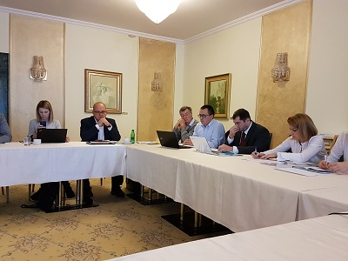
On the other hand, the Croatian DOOR organization, a NGO founded in 2003 and devoted to Sustainable Energy Development, gave expert insight on how engaging citizens in Energy Poverty in Croatia, as the good practice Through Knowledge to a Warm Home. This is a project implemented by DOOR in collaboration with a local government, City of Petrinja. The project has succeeded in establishing energy advice as a new social service on regional level with the intention to combat energy poverty through a change in regional policy. 80 households were equipped with simple low-cost energy efficiency measures (ca. 100 EUR investment per household: LED light bulbs, reflexive foils behind radiators, thermometers, rubber draft proofing for windows, aerators for water taps, switch electrical cables, timers for electrical boilers, draft proofing for below doors); all households received energy advice on how to rationalize their energy use. Those measures resulted in annual savings of 700 kWh per household.

A significant indicator of success is the change in regional policy. As a result of the project energy advising was added as social service to the regional Plan of development of social services in Sisak-Moslavina county with direct link to the national Operational programme delivering ESF.

BUILD2LC celebrates it first electronic bi-lateral meeting (SWEA, Gloucestershire receives expert advice from Croatia)

On 13 December 2017 SWEA and the German Society for International Cooperation – GIZ, held a videoconference to transfer a good practice by means of a non-presential meeting. The transferred good practice is the System for monitoring, measuring and verification of energy savings (SMiV).

In order to measure achieved savings in a unified and proper manner and in accordance with the applicable Croatian laws on energy efficiency, the Center for Monitoring Business Activities in the Energy Sector and Investments - CEI has, in cooperation with the German Society for International Cooperation - GIZ, developed a System for measuring and verifying energy savings (SMiV) to which all plans and implemented energy efficiency measures are entered. The main purpose of SMIV is to monitor the implementation of the National Action Plan for Energy Efficiency.

Public administration, companies that have energy performance contracts, as well as the Fund for Environmental Protection and Energy Efficiency, are obliged to enter all implemented energy efficiency measures. This means that for every implemented measure there will be a method of reporting and verification of real savings and the predictions will be easily compared with actual achieved results. SMiV calculates energy savings based on predefined calculation methods for which it needs a set of input values. This would be the bottom-up approach so the predefined measures are called Bottom-up methodology.

VIPA (Lithuania) hosts a large multi-lateral meeting to spread knowledge on their financial instruments experiences

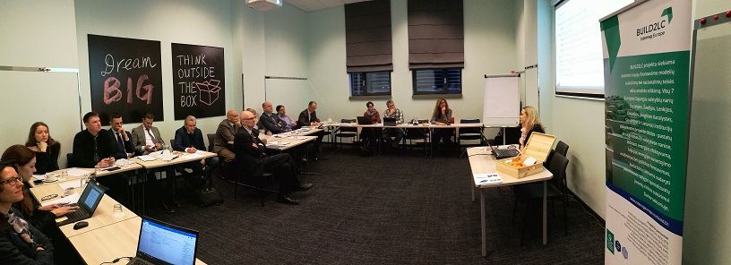

On 16-17 January 2018 VIPA made a huge effort on organizing a multi-lateral meeting for three BUILD2LC partners in Vilnius, Lithuania, to assist Gloucestershire, Slovenia and Andalusia in the successful management of financial instruments to renovate buildings. During two days there were a good number of expert speeches that outlined the whole story of Financial Instruments in Lithuania since the nineties.

The introduction and welcome speech was made by VIPA CEO, Gvidas Dargužas.

The EU Investment Department of Ministry of Finance, presented the set-up, lessons learned while implementing the financial instruments in Lithuania. She compared 2007-2013 and 2014-2020 programming periods. The investments and achieved results of 2007-2013 period were presented, emphasizing that the first experience was gained setting up JESSICA for energy efficiency projects and JEREMIE for SMEs financing.
The EU Assistance Management Department of Ministry of Environment, presented the implementation of Multi-apartment buildings renovation programme in Lithuania.
TGS Baltic, Lawyer of EIB, presented the example of supporting energy efficiency improvements – Leveraged Fund Lithuania.
The Project Implementation Division of HESA, presented the Multi-apartment modernization program in Lithuania stressing the role of the municipalities and administrators.
The Publicity Programme Implementation Division of HESA, presented the promotion, communication and public awareness of the multi-apartment buildings renovation process in Lithuania.
The Department for Development of Financial Services of Šiaulių Bankas, presented the experience of the bank in implementing energy efficiency projects.
The Investment and Development Division of VIPA,presented the concept and scope of securitization and its main problems including the fundamental conflicts of interest between participants.
VIPA, presented the modernization of public buildings in Lithuania and establishment of KŪB Platform and the Energy efficiency fund (ENEF) which covers central public buildings and street lighting modernization.
The Assistance Programme Division of VIPA, presented the repayable assistance, an innovative financial instrument
The Law firm Glimstedt, presented the facility managed by EBRD – ELENA.

Finally, the Andalusian stakeholders from the National Association of ESCOs of Spain (ANESE) made the presentation about ESCOs and the key partners to achieve an energy transition in Spanish ESCO market and from the Spanish Institute of Financial Analysts, proven good practices of financing of energy rehabilitation in buildings and dwellings, both in order to finalize the bi-lateral meeting held in Andalusia with VIPA just two months ago.

Second electronic bi-lateral meeting. SWEA, Gloucestershire gives expert advice to Croatia.

SWEA (Gloucestershire, UK) hosted electronically on 6 February 2018 REGEA, Croatia, to provide expert advice on tackling energy poverty.
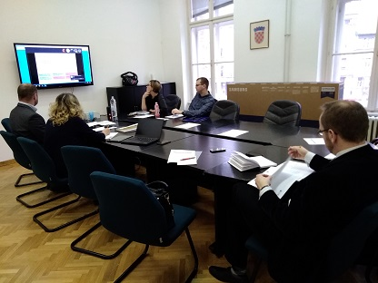
The main challenge in Croatia is to develop a definition of energy poverty which fits the real needs of the country and to define indicators for the definition. The definition of energy poverty should be than used as a criteria for selection of households which will receive support (subsidies or similar).It is important to find a definition that is administrative feasible and at the same time available to a wider population range than covered by legally defined measure. Also, when developing the definition of energy poverty, it is crucial to adopt the definition to local context of the country because the definition has to be based on specific issues of the area.

Croatia found very useful the mastering of Dr Harriet Thomson, EU Energy Poverty Observatory, regarding the practical aspects of energy poverty, its definition and actual measures for its alleviation. There was also a discussion on the Views and experiences of national strategy from a domestic energy advice service provided by SWEA.

The attending entities were, from the UK, the EU Energy Poverty Observatory and SWEA. From Croatia, REGEA, the Ministry of Construction and Physical Planning, Croatia, the Ministry of Demography, Family, Youth and Social Policy, Croatia, the Society for Sustainable Development Design NGO, the Croatian Green Building Council, Croatia), the Energy Institute Hrvoje Požar and the Regional Energy Agency North.

Gloucestershire shows the way to Slovenia and Poland in tackling with energy poverty concerns

LEAG, Slovenia, and RRDA, Poland, attended this bi-lateral meeting organized by SWEA, UK, on 7 February 2018 to gain crucial knowledge for the preparation of the Slovenian action plan. LEAG is concerned on how to motivate local communities to take actions on fuel poverty. Special attention was given to provide funding for these actions. The meeting was attended by two representatives of LEAG and other two of RRDA, who passed the knowledge to the involved Slovenian stakeholders.
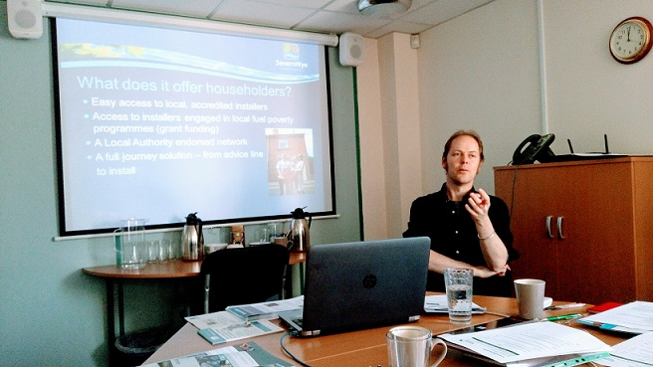
The meeting began with the essential definition of energy poverty and some ways to raise the profile nationally and regionally by SWEA, followed by the discussion on What are other measures are available to reduce energy poverty, how do they work and what are the pros and cons? It was also showed the practicalities of setting up a network like Link to Energy, the Target 2050 & Countdown (a remarkable good practice brought from SWEA), a practical guide to Warm & Well: The purpose, structure, delivery requirements, partnerships and funding as well as a meeting with different members of the Warm & Well Team to see on-site what they do.

Massive multi-lateral meeting hosted by Slovenia

We took advantage of the partner’s Coordination Meeting to present the draft Action Plans the day before to gather all the partners around the Slovenian table on 14 March 2018.

The morning session included the transference of three Slovenian good practices:
- System Dominum, Complete renovation of apartment buildings by Tomaž Krištof, Studio Krištof d.o.o. Mr. Krištof presented his solution for renovation of +60-years-old multi-apartment buildings that have now too small/dysfunctional apartments, insufficient energy savings and questionable earthquake safety.The System Dominum solution includes the enlargement of the floor area of the existing apartments by setting up a new building envelope and a possible extension adding new apartments on top.
- Eco Fund, Slovenian Environmental Public Fund by Katarina Kafadar, Eco Fund. Mrs. Kafadar presented the state-owned Eco Fund, the biggest specialized institution providing financial incentives for environmental investments in Slovenia.
- Mr. Franko Nemac, introduced the wooden-made sustainable kindergarten Preddvor.

An extended session took part in the afternoon (site visit) to know more about Eco Fund in their headquarters. The attendant partners and stakeholders received more information about its work and functions. The general objective of Eco Fund is financing environmental investments trough different measures, which have environmental but also socio-economic effects. During the 2-hours meeting Mr. Hinko Šolinc, Eco Fund director, explained the available financial mechanisms available in Slovenia for renovations of buildings (public and private) and presented Energy Advisory Network (ENSVET) that is free for households all over Slovenia.

Andalusia and Podkarpackie learns from Croatia. Bi-lateral meeting at Bračak Energy Centre, Croatia.

This multi-lateral meeting where AEA and RRDA learnt from REGEA was held at the Croatian partner headquarters at Zabok, Croatia, just the day after the Coordination Meeting at Ljubljana, 15 March 2018.

Regarding Andalusia, Spain, the existing public building stock of the Regional Administration of Andalusia plus those owned by municipalities sum up to ca. 20.000 public buildings including hospitals, secondary education schools, universities, retirement homes, sport facilities, general office buildings, etc. Only a tiny fraction of them are considered to be energy-efficient. Some particular cases show that there is a high potential in energy and economic savings that might be achieved just by implementation of currently available technical solutions. Therefore, Andalusia has the opportunity and the need to set a comprehensive and rigorous plan to boost the energy rehabilitation and retrofitting of their public buildings involving the mandatory political leadership and the public bodies’ collaboration. AEA was interested in the ZagEE good practice on energy rehabilitation of public buildings to learn from how to plan a PDA programme to renovate public buildings.

Therefore, this bi-lateral meeting was very useful to get expert insight and detailed information on how the ZagEE project was planned and developed, especially regarding their experience with different and innovative financial mechanisms and how these worked alongside existing structures and mechanisms for the retrofitting of public buildings. Andalusia has plans to apply, as the Croatian partner did, to a MLEA PDI programme-alike (Mobilising Local Energy Investment - Project Development Assistance), as ELENA, managed currently by the European Investment Bank. The ZagEE PDA was used to fund preparatory activities while financing of the capital investment, e.g., to develop a buildings stock database (register), a comprehensive database of buildings which included all information and data available from previously performed energy audits as well as from regular gathering of data on energy performance and consumption of buildings within the City of Zagreb. This PDA funded as well all the preparatory works prior to remove any brick, as the energy audits for every of the buildings planned to be included in the renovation under the ZagEE scope.. Andalusia found very interesting the details on the financing of the study phase to select the buildings under scope.

A very important detected barrier to highlight is the very low collaboration capacity between different public bodies, a key requirement that was fulfilled successfully by ZagEE and from which we can learn how. In addition, we found very useful to find a clear political leadership in this project. To enable this, AEA ensured that the aim of this action is fully aligned with the Andalusian existing policies both on energy and buildings.
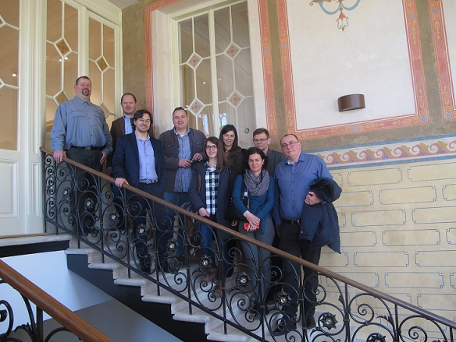
On the other hand, this meeting brought positive results to RRDA from Podkarpackie region (Poland). The Polish stakeholders are working to create a project similar to the Bračak Energy Centre renovation experience, in Poland. The project will improve the quality of lives of local citizens by creating new services, such as an educational centre, a business incubator and a local restaurant, what will in turn contribute to increase employment and regional development. It is expected that the project will raise public awareness on the efficient use of natural resources and the importance of sustainable development on a continuous basis.

Ljubljana (Slovenia) hosts the Action Plans Coordination Meeting!

On 13 March 2018, the Coordination Meeting to exchange the seven draft action plans from the BUILD2LC partners was organized in Ljubljana.

The participants presented their respective draft action plans, which are the result of the previous cooperation of all project partners, including the good practice exchanges and the celebrated bi-lateral meetings. Participants in the project want to introduce knowledge and innovations to their local, regional and national environments by presenting examples of good practices and experience. With this, the project approaches the completion of the first part of the activity, which aims to prepare the action plans of each of the project partners. In the continuation of the project, a two-year implementation of activities and monitoring of results will follow. The project is at a very appropriate moment when partners can qualitatively identify obstacles and concrete challenges for energy efficiency projects and, of course, succeed them in the future.

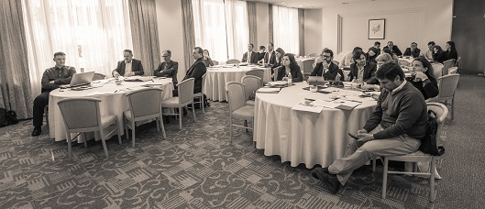

While in Andalusia they are learning intensifying cross-sectoral cooperation and looking for various financial resources for energy-rehabilitation projects for public buildings - their scope includes as many as 4,500 regional administration buildings and some 20,000 buildings owned by local government - Lithuania has more challenges in introduction of smart meters in private buildings. They both are looking into the possibility of introducing new ways of financing, such as energy contracting (ESCO), but the question is: is the ESCO model really the right solution for any energy efficiency project?

Mary Morgan and Neil Penny of the Clinical Commissioning Group of National Health (UK) further explained how the problems of energy poverty in the UK are addressed in Gloucestershire, which link them both with the physical and mental health of the population, but in the context of their program of eradicating energy poverty.

Very different stakeholders, from both the public and private sectors, to NGOs and, of course, end-users, are also involved in their energy efficiency projects in Poland. However, according to RRDA (Poland) in their case, like the Andalusians and the Lithuanians, they are mainly devoted to finding new sources of innovative financing.

On the other hand, in Croatia, in the fight against energy poverty, energy consulting services has been used since 2017, with consultations to thousands of test households. In developing this activity, Croatians also recognized the opportunity for additional jobs.

In Slovenia, energy consulting has been used for a very long time, which has been recognized by the project partners as very effective. In the margins of the BUILD2LC project meeting in Slovenia, the director of the LEAG, Anton Pogačnik, emphasized that participating in the European project is an excellent opportunity to gain additional knowledge and experience that will be transferred to the local environment.

The working day finished with an afternoon Policy Board session in parallel Roundtables gathering the BUILD2LC topics: professionalization of the construction sector, innovation, activation of demand and combating energy poverty and new financial instruments. The Policy Board of the project has discussed the needs and barriers in implementing the measures included in every regional action plans and the experts gave answers to the interested participants regarding specifics at their preparation.

This partners’ meeting was followed the day after by a multi-lateral meeting to exchange in-depth good practices from Slovenia.

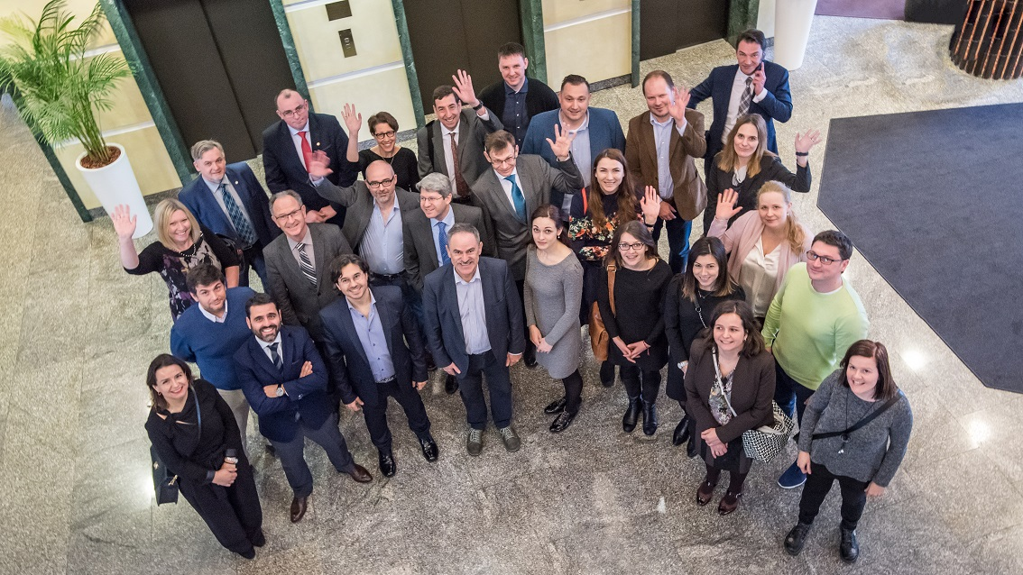
RRDA holds its stakeholders meeting to raise awareness about the energy efficiency in buildings

The 4th RRDA stakeholders meeting was organized in Rzeszów, Poland. The meeting took a workshop form and was titled: "Energy efficiency in buildings - from simple rules for complex solutions". The main purpose of the meeting was to raise awareness about the energy efficiency in buildings. Remarkable good practices from partner countries and regions were presented. The meeting was attended by members of the Regional Stakeholders Group, including the representatives of the Podkarpackie Region Marshal's Office, the Podkarpackie Energy Agency, the Voivodship Fund for Environmental Protection and Water Management in Rzeszów and the Podkarpackie Renewable Energy Cluster.

After the welcome by the Regional Managing Authority, a workshop allowed to make a discussion on the subject of demand activation and tackling energy poverty. The discussion also concerned the subject of widespread energy poverty. Based on the data of the Polish Central Statistical Office, energy poverty affected in 2016 around 4,6 million people, 12,2% of Poles.This phenomenon is considered to be a state issue given the difficulties with fulfilling energy needs (heating, hot water, electricity) due to low incomes or the characteristics of the dwellings.
Simple and effective ways to save energy at home and this way reducing the energy bill were also presented during the workshop. The last part of the workshop was an open-ended matter: How to read an energy audit of a building?

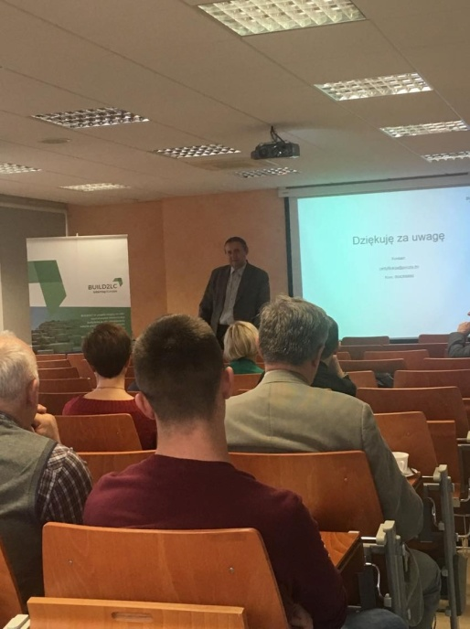
Participants shared their observations and comments. There was an exchange of opinions and initial proposals for new solutions to be worked out during the project. The solutions will improve the functioning of the Regional Operational Program of Podkarpackie Voivodeship.

The meeting provided many interesting conclusions and allowed the participants to familiarize themselves with current legal norms and challenges for the future in the topic of Energy efficiency in buildings in Poland. An energy audit should be carried out by an energy auditor. The details of the scope and form of the energy audit are specified in the Ordinance of the Minister of Infrastructure of March 17, 2009.

RJH held its stakeholders meeting in Östersund to take advantage of the transferred good practices

The session organized in Östersund on 25 October 2017 started out with fresh developments and news from the BUILD2LC interchange of experiences and ideas. Among the attendants there were local authorities representatives from the municipalaties of Östersund, Berg and Krokom, public housing companies as Krokomsbostäder AB, Östersundshem, Bergs hyreshus and Strömsunds Hyresbostäder, some private real estate companies as KBAB, Ragundahem, Korsta Fastigheter AB and also the Mid Sweden University

Anneli Kamb from RJH explained the process and the time-line of the project in connection to the regional Action Plan. A group discussion concerning needs and ideas of the action plan was held. The Ideas from the good practice “Your green Future” from SWEA (Gloucestershire, UK) were discussed in particular. The group also discussed their own experiences of earlier similar actions involving students. There was also a real interest to find ways of importing some of the activities in the SWEA good practice due to the need to raise interest for technical professions among young people.

RJH also presented the results from the Interregional Innovation Meeting held in Östersund in middle September. The group showed particular interest in the good practice from the Passive House Platform presented by the Andalusian representative of the Spanish Passivhaus Platform (Spain) during the meeting. The group was also interested in the discussion that took place during the stakeholder meeting concerning a common standard for certifications of passive houses.

Following there was an inspirational session with Willy Ociansson, a building technique expert teaching eco driving of buildings. Willy presented how technical installations and the building's envelope can work together to reduce energy demand while at the same time feeling comfortable indoors.

After the lunch break, Willy Ociansson continued presenting various examples of common mistakes made by building technicians when adjusting insulation as well as the heating- and ventilation systems and providing examples of how small modifications can make a big difference for the building´s energy consumption. The presentation was very much appreciated by the group.

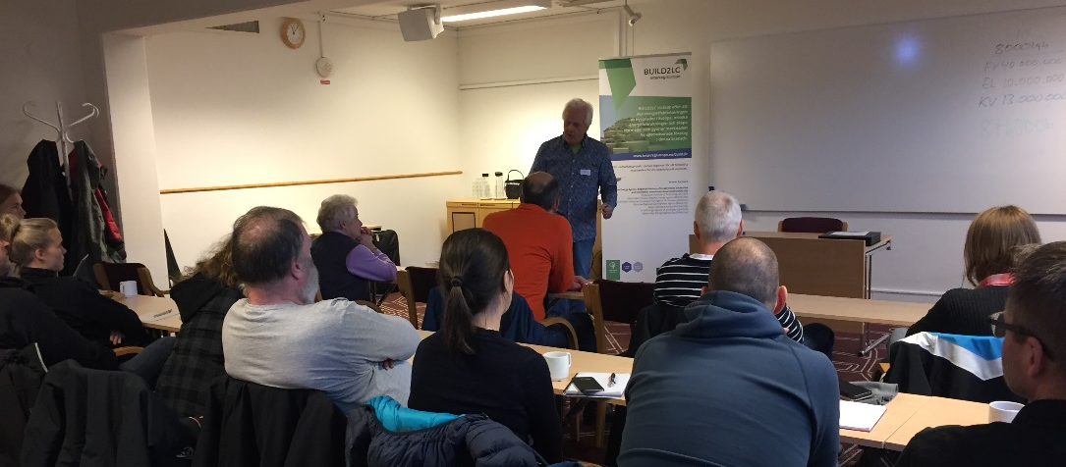
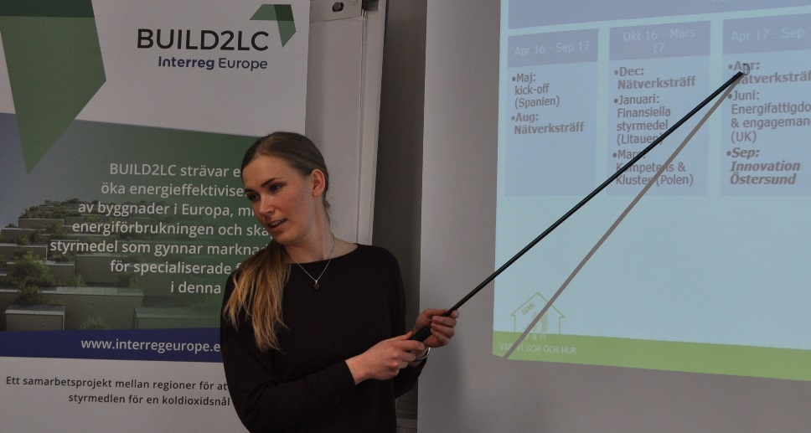
Later in the afternoon, Carina Martinsson, Energy manager at Krokomsbostäder AB, the real estate company of Krokom municipality, presented a case study where they have used “Totalmetodiken”, a tool for renovation projects formerly introduced at an earlier stakeholder meeting by the energy renovation expert Emma Karlsson, WSP. Totalmetodiken is used to select the most profitable energy saving measures and Krokomsbostäder have used the method in the planning process of a big school renovation project with very fruitful results.

The day was finalized with a presentation of a new research project by Itai Danielski, senior lecturer and researcher at the Mid Sweden University at the department of Department of Ecotechnology and Sustainable Building Engineering. The research project will evaluate the sustainability effects from a new building project of a multi-apartment building in Sundsvall. The apartment building is designed with an atrium and is expected to give multiple positive sustainable effects: from energy savings due to less external walls to natural ventilation and air cleaning effects as well as natural sewage water cleaning system and social sustainability effects. There was great interest in the project with many questions and a high interest to follow up the project.

Gloucestershire (UK) gathers their stakeholders to boost the action plan development

SWEA (Severn Wye Energy Agency) organized on 22 November 2017 the stakeholders meeting in Gloucester, UK, to review the Action Plan progression and reinforce the group with the results of bi-lateral and partnership meetings. The focus of the meeting were put on three main questions:
o What do we need to do?
o What money do we need to find and where from?
o Who is taking forward each action?

SWEA began by explaining the draft nature of the Action Plan draft and suggested participants review and give feedback on this while it is in this flexible state. It was explained that the current draft is a collation of ideas from stakeholders: Steering Group member and relevant stakeholders are able to change any aspect of the plan that they have taken ownership of. The Action Plan is due to be implemented from September 2018. Therefore, stakeholders will need to agree and lead on the implementation plans for relevant actions with the support of Severn Wye.

The need for the local Action Plan to influence policy was also explained. Influence can take three forms: implementation of a new project; improved governance (how the policy instrument/activity is managed); change in strategic focus of a policy (changing what’s done).

Later, SWEA summarised the activities which have taken place lately, including:
o Producing the: Topic report on citizen involvement, energy culture and energy poverty.
o Submitting contributions for the Innovation Map.
o Attending the Consortium Meeting in Sweden.

Action Plan Review & Progression
The majority of the meeting was spent reviewing each action with a view to agreeing:
o Links to policy and funding
o Key stakeholders
o Developing an implementation plan
o Ownership of each action

Bi-lateral & consortium meetings
Sharing good practice is an important part of the project and a number of Skype and presential good practices meetings will be held over the next couple of months. Action leads will be contacted about Skype meetings to see if they would like to join the meeting.

Stakeholders were also invited to join the meeting in Lithuania and key stakeholders will be needed to attend the Coordination Meeting in Slovenia on 13-14th March.

Slovenian stakeholders meeting to work on improving local energy policies tackling with energy poverty

On Friday 22 of December 2017, the stakeholders group meeting of BUILD2LC took place in Kranj, Slovenia. Organized at the premises of LEAG, the main topic was how to connect achievements of BUILD2LC with local authorities and companies that deal with residents facing energy poverty.

MSc. Marko Hočevar, from the Municipality of Kranj, took opportunity to present outcomes from an ELENA project. Although the project is successful, the main problem is financing deep building renovations with long pay-back periods. Mr Hočevar addressed the National Government to encourage public private partnerships counting on the help of subsidies or other available public financing tools.

Mr. Luka Šink from Domplan d.d. - Kranj, a facility management company, expressed concerns over rising energy poverty problems in buildings managed by the company. Up to now the situation is being handled and can assist tenants in coordination with the Slovenian Public Fund “Eco Fund”. However, it is envisaged for the future a clear need of better cooperation with other organization and the need to improve relationships also on the other fields, as energy consultations on renovations of multi-apartment buildings.
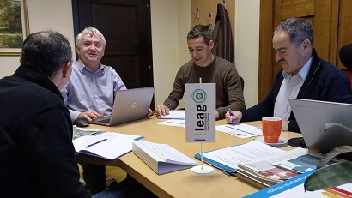
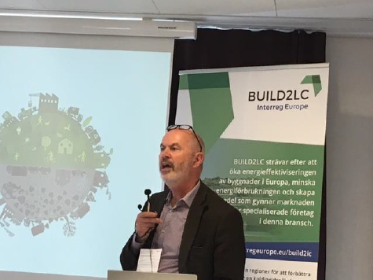
Mr. Matjaž Grmek, energy manager at LEAG, explained how is being currently working extensively on the preparation of new Local Energy Concept for the Municipality of Kranj. The main found challenged relies in the acquisition of real data trhu energy use monitoring data, currently incomplete or non-existent. Mr Grmek claimed from the National Ministry on standardization of energy data acquisition from public buildings.

Finally, the Managing Director of LEAG, MSc. Anton Pogačnik, assured to present these findings and conclusions to the pertinent National Ministry of Infrastructure and explained that LEAG is leading the consortium of Slovenian local energy agencies during first semester of 2018. This platform and the expected Coordination Meeting to be held in Slovenia during 13 and 14 March will support additional enthusiasm and opportunities to promote BUILD2LC results.

REGEA organizes in Zagreb the 4th stakeholders meeting to present and sharing the results of Interregional Thematic Seminar held in Gloucester (UK)

The North-West Croatia Regional Energy Agency, RGEA, organised its stakeholders meeting at the Ministry of Construction and Physical Planning premises in Zagreb on 6 February 2018.

REGEA presented the experiences brought from the Interregional Thematic Seminar in Gloucester, UK, several good practices from some other partners and the outcomes from the bi-lateral meeting between REGEA and SWEA, UK, that was held via Skype shortly before.

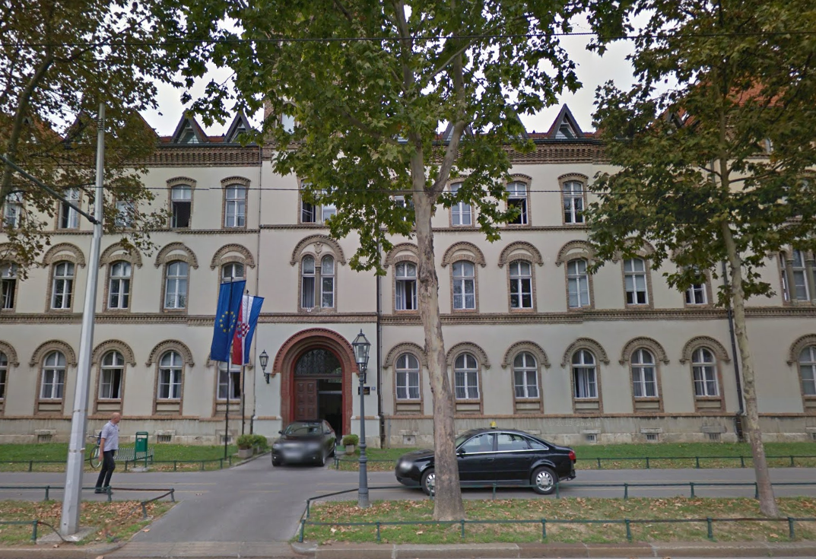
The meeting was attended by representatives of the Ministry of Demography, Family, Youth and Social Policy, the Ministry of Construction and Physical Planning, the Regional Energy Agency North, the Energy Institute “Hrvoje Požar” and several non-profit organizations involved in energy poverty tackling in Croatia -the Society for Sustainable Development Design and the (Croatian Green Building Council- all of them representatives of members of the Work group for Energy Poverty in Croatia.

After the presentation of experiences and the selected good practices, there was a fruitful discussion on many issues related to energy poverty issue in Croatia. All the attendants agreed on the need to set a clear definition of what energy poverty means in Croatia. After that, the developing of the Action Plan will focus much better on how to reduce energy poverty and protect vulnerable consumers.

Identified challenges in the current system for the protection of vulnerable customers were lack of definition of vulnerable consumers, lack of coordination between local and central government in providing support to vulnerable customers, poor targeting of social measures, lack of statistics on vulnerable customers that would minimize the chance of system abuse, lack of information exchange between Ministry of Finance (income information) and Ministry of Social policy administering the aid for vulnerable customers and the lack of a model to determine the appropriate amount of support each household should receive.
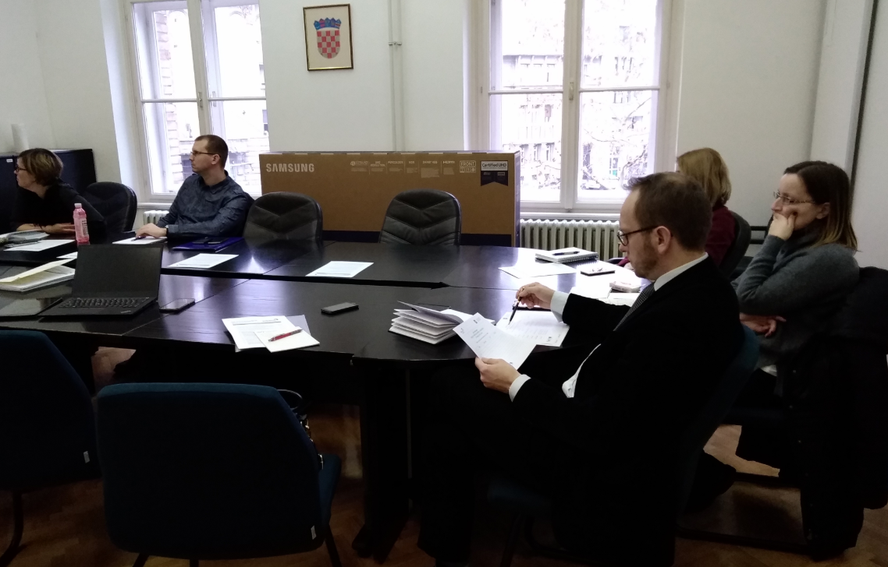
After all were heard their suggestions for the preparation of the action plan and the proposals of basic actions that the energy poverty action plan shall include, it was agreed that this Plan will be developed by the Society for Sustainable Development Design.

Falta el meeting de SWEA 28 de Febrero. Se insistió a Brian.

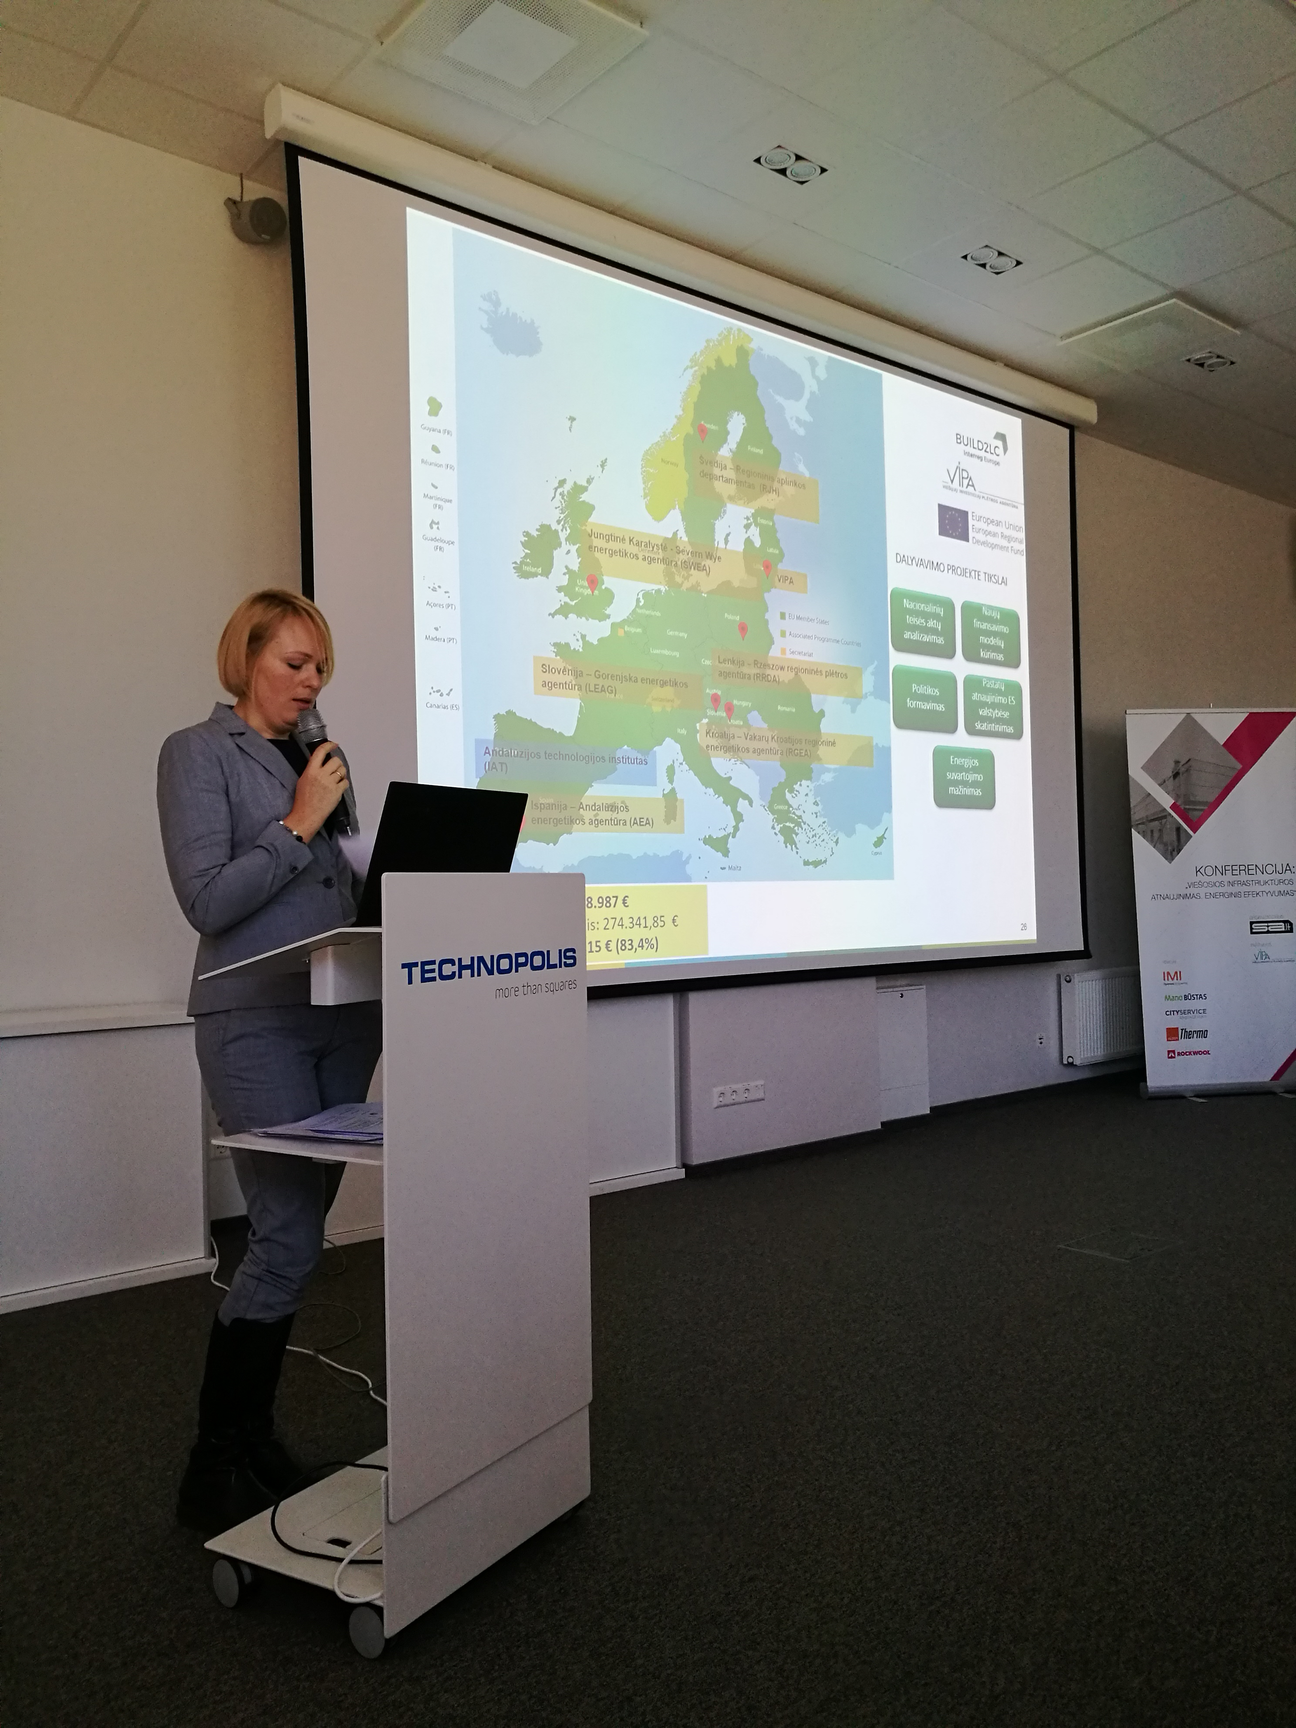
Regional stakeholders meeting in Vilnius after the Coordination Meeting

On 29 March 2018 VIPA organized a stakeholders meeting in Vilnius to inform about the progress of BUILD2LC project and share the information about interregional seminar in Ljubljana and introduce VIPA’s draft Action plan. It was clearly identified the shallow renovation measures which have to be adopted in Lithuania and how to implement them. The additional needs were also identified for the proper implementation of Action plan.

Stakeholders highlighted some common ideas, insights and suggested several examples of possible changes and modifications in legal acts for the adaptation of the Action plan. This meeting was also useful to detect harnessing factors in the transference process and to optimize the action plan, which is, in the end, the cornerstone deliverable of the project.

Focus on: :
Action Plans were drafted and shared after remarkable bi-lateral meetings

Based on the cornerstone the Guide of Good Practices , with a collection of 72 successful cases at European level in the field of sustainable construction and rehabilitation, the several bi-lateral meetings, both distance and presential, for the benefit of an intense exchange of knowledge among the partners and, generally speaking, on all the information exchanged and knowledge during previous semesters, the project partners drafted their respective Action Plans.

One of the main objectives of the Interreg Europe projects is the detection and the exchange of good practices that can be replicated in the rest of Europe. But this effort might go to waste if this knowledge has no influence on the respective local, regional or national policies. This is why we need the Action Plans.

Each partner did their best preparing a first draft using a multidisciplinary team specifically set up for that purpose in every organization with the active participation of every stakeholders group. The drafts clearly identify the measures to be adopted in each region and how to implement them and the additional needs of information. These drafts were shared in the Coordination Meeting in Slovenia with the expert advice from the Policy Board, specifically invited to discuss the needs and barriers in implementing the measures included in the Action Plans.

Next events
- Phase 1 final partners meeting in Málaga, Spain, 12-13 September for the presentation of the respective Actions Plan.
- Bi-lateral meeting for good practices exchange between RJH and AEA in Andalusia. 9-10 May 2018.
- BUILD2LC presents good practices on energy efficiency at the Energy Efficiency in Buildings Seminar in Málaga, Andalusia, Spain. 7 June 2018.
- Bi-lateral meeting for good practices exchange between SWEA and AEA in Andalusia. 19-20 June 2018.
- Bi-lateral meeting for good practices exchange between REGEA and AEA in Andalusia. 17-18 July 2018.
- Bi-lateral meeting for good practices exchange between AEA and LEAG in Slovenia. 5-6 September 2018.
- Interregional Cooperation for Energy Transition , Inter-project Collaboration with Interreg Europe and Business Case competition. Florence, 27 June 2018.
- Policy Learning Event on Energy Efficiency. Organized by the Interreg Joint Secretariat. Florence, 28 June 2018.

As the date approaches more information will be available in Build2LC website https://www.interregeurope.eu/build2lc/

Consortium
Lead partner
Andalusian Energy Agency.
Partners
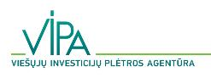 | 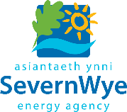 | 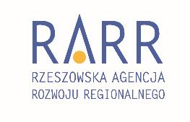 | 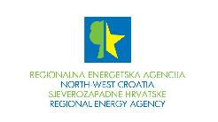
Public Investment Development Agency (VIPA) | Severn Wye Energy Agency Ltd (SWEA) | Rzeszow Regional Development Agency (RRDA) | North-West Croatia Regional Energy Agency (REGEA)
 | 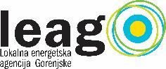
Region Jämtland Härjedalen (RJH) | Local Energy Agency of Gorenjska (LEAG)

Contact:
BUILD2LC Project Coordinator
Joaquín Villar
joaquin.villar@juntadeandalucia.es

This is the fourth edition of the BUILD2LC bi-annual newsletter. If you do not want to receive the BUILD2LC newsletters, please reply to this email writing “unsubscribe” in the subject line.
This publication has been produced with the financial assistance of the European Union under the Interreg Europe programme. The contents of this document are the sole responsibility of the Andalusian Energy Agency and can under no circumstances be regarded as reflecting the position of the European Union or of the Programme’s management structures.
The Interreg Europe programme of the European Union is an initiative of territorial cooperation for the period 2014-2020 which aims to encourage cooperation between regions of the European Union. The aim is to help European regions to design and implement regional policies and programmess more effectively, particularly Growth and Jobs programmes of the European Structural Funds and Investment, but also programmes of the European Territorial Cooperation, through the exchange of experiences, knowledge and best practices between stakeholders of all European regions. The programme has four thematic objectives: research and innovation, SME competitiveness, low-carbon economy, the environment and resource efficiency. The Interreg Europe programme covers the entire territory of the European Union, Norway and Switzerland.
BUILD2LC is part of the Interreg Europe programme (www.interregeurope.eu), with a total budget of 1,658,987 euros, and co-financed with European Regional Development Fund up to 83.46%.

