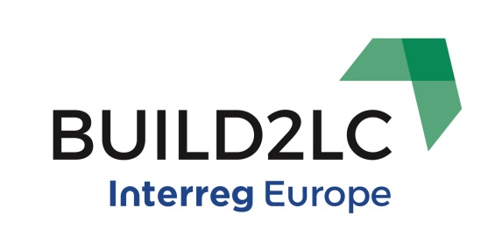

Bi-lateral Meeting Agenda
Bilateral Meeting: Public Investment and Development Agency of Lithuania (VIPA) receiving from Andalusian Energy Agency (AEA), Spain
9th – 10th November 2017
Day 1 – 9th November 2017
Main Venue: AEA headquarters, 1st floor. Isaac Newton, 6. 41092 Seville, Spain

- Coffe available during the morning session
09:00 Arrival – Institutional welcome opening
09:15 The AEA role as the Andalusian administration tool
10:00 Sustainable Construction Programme in Andalusia –
Contents lay-out under confirmation.
13:00 Lunch near the AEA premises
14:30 Stakeholders point of view and discussion
16:30 Close

Attendees:
AAE, Andalusia – Joaquín Villar, Carlos Serra
VIPA, Lithuania – XXX
Andalusian Stakeholders - XXX

Day 2 – 10th November 2017
Main Venue: AEA headquarters, 1st floor. Isaac Newton, 6. 41092 Seville, Spain

- Coffe available during the morning session
09:15 Incentives Programme for Sustainable Construction in Andalusia –
Contents lay-out under confirmation.
11:15 Trip by taxi to the city centre
11:30 Interview with financial entity (tbc). Funding the next incentives programme framework
13:00 Lunch at the city centre
14:30 Stakeholders point of view and discussion
16:30 Close

Attendees:
AAE, Andalusia – Joaquín Villar, Carlos Serra
VIPA, Lithuania – XXX
Andalusian Stakeholders - XXX

