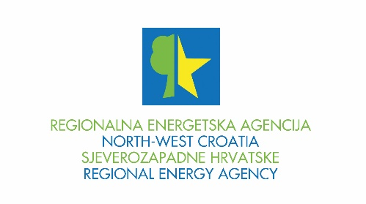
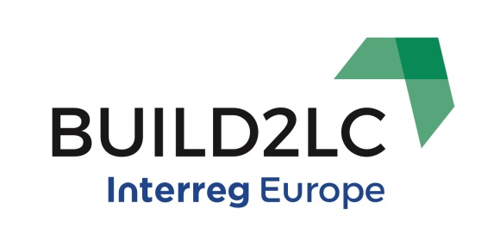

Bi-lateral Meeting Agenda
Bilateral Meeting: REGEA and AIK, Croatia receiving from VIPA, Lithuania
Wednesday 4th October 2017
Venue: Bračak Energy Centre, Zabok

14:00 Financial instruments for ESCOs and PPP projects – Kristina Vaskeliene and Žaneta Maskaliovienė will outline the work of the Lithuanian Energy Efficiency Fund (ENEF), including: necessary steps for developing the Fund (ex ante study), legal and financial structuring of the institution, types of projects that can be funded via ENEF.
16:00 Lunch
17:00 Close
Attendees:
VIPA – Kristina Vaskeliene and Žaneta Maskaliovienė
AIK – Damir Juričić, Slavko Čolak
REGEA – Velimir Šegon, Josip Čengija, Ivan Pržulj

