March 9, 2018

The waste workshop of the TRIS project has the participation of 3 General Managers

On the 26/02/2018 a fourth workshop took place to explore the project, which was dedicated to a key theme in the Industrial Symbiosis (IS) the reuse and recycling of waste. In effect, the use of waste from a company or companies act as a raw material or entry resource for other activities and subject to conditions the workshop sought to clarify these areas.

For this it counted on the participation of agents involved in the waste cycle: administration, research entities (IVIA, AIDIMME), large waste producers, chamber of commerce, waste managers and local entities.

General Director of Economy began by remembering the term sustainability consists of an intersection of three spheres: economic, social and environmental, and therefore IS should take into account these three facets when deploying the set of activities incentives, the Regional Plan seeks.

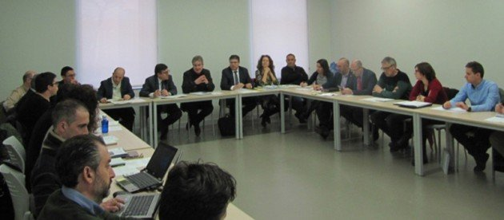

A presentation was produced considering the status of the recovery or use of waste against disposal in landfill. An example was provided in the case of agro-food waste exposed by Rodolfo Canet, in the framework of a LIFE Project exposed by AIDIMME.

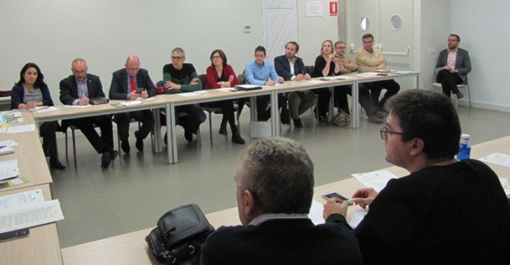

The Director General of Canvi Climátic went on to describe the legislative framework linked to waste and by-products - contextualizing it in the operational scope of the National Circular Economy Strategy - as well as its foreseeable evolution, based on the initiatives already underway. The EU are trying to modify several directives that present common interests in the matter of recycling: such as landfills, waste framework, packaging, etc.

Special emphasis was placed on the Ministry's initiatives for the declaration of "end of the condition of waste", as well as the sectoral interests / actions that may lead to the classification of certain waste as "by-products". This intervention served as the basis for the session to identify barriers in the use of waste.

It exposed the vicissitudes of a company for the use of a waste as a marketable product (SRG), the views that a waste manager (ACTECO), an association of managers (AGENOPE), and a municipality (Xilxes) have about of the generation and reuse of waste and updated the situation of the stock of by-products by the Chamber of Commerce of Valencia.

The ideas discussed were included in an initial DAFO of the implementation of the industrial symbiosis that will circulate to all attendees for qualification, modification or complementation.

At the end of the workshop the approach for the implementation of the regional industrial symbiosis plan was briefly described, based on a sector study in which AIDIMME and IVACE are currently working and in the eventual realization of pilot tests throughout 2018.

It is intended the development of incentive measures take place in 2019, in areas such as matching the interests of companies, intermediation in industrial areas, feasibility studies prior to R & D activities and the implementation actions themselves, carried out in the cooperation modality.

The Interreg TRIS project advances in the elaboration of an action plan in Industrial Symbiosis, through an interregional cooperation approach:

- Involving the actors involved in a structured participatory process
- Identifying both facilitating elements and obstacles to their integration or elimination of the corresponding policies.
- Launches NDO initiatives tangible to reach SMEs.

Please follow the link to read the full article - http://www.noticiashabitat.com/2018/el-taller-de-residuos-del-proyecto-tris-cuenta-con-la-participacion-de-3-directores-generales/

